
CONFIDENTIAL CS/NOV 2026/CSC429

UNIVERSITI TEKNOLOGI MARA FINAL EXAMINATION

COURSE
COURSE CODE
EXAMINATION TIME
COMPUTER ORGANIZATION AND ARCHITECTURE

CSC429
NOVEMBER 2026
3 HOURS

INSTRUCTIONS TO CANDIDATES

- This question paper consists of two (2) parts: PART A (10 Questions) PART B (1 Question)

- Answer ALL questions in the Answer Booklet. Start each answer on a new page.

- Do not bring any material into the examination room unless permission is given by the invigilator .
- Please check to make sure that this examination pack consists of: i) the Question Paper
  - an Answer Booklet - provided by the Faculty

- Answer ALL questions in English.

DO NOT TURN THIS PAGE UNTIL YOU ARE TOLD TO DO SO

This examination paper consists of 5 printed pages.

PART A (80 MARKS)
Answer ALL questions in this part.

QUESTION A1 (5 marks)
Convert 286610 to octal. Show your complete workflow.

QUESTION A2 (5 marks)
The Difference Engine was a mechanical computer designed by Charles Babbage in the 19th century. It was one of the earliest examples of a mechanical calculator, built to automatically compute mathematical tables for naval navigation.
- What device was the successor of the Difference Engine?
- Describe the difference in function between the Difference Engine and Mechanical Calculating Machine.
- Briefly explain the available technology that existed in the computer generation of Difference Engine.

QUESTION A3 (5 marks)
- List THREE (3) characteristics of Symmetric Multiprocessor (SMP).
- Describe ONE (1) advantage of Symmetric Multiprocessor (SMP) interms of availability.

QUESTION A4 (5 marks)
Given the following Figure 2.

Figure 2
- Label the addressing technique illustrated in Figure 2.
- Explain how the addressing technique in 9(a) is used.
- List ONE (1) advantage and ONE (1) disadvantage of the addressing technique in 9(a).

QUESTION A5 (10 marks)
- Discuss THREE (3) main key factors for memory selection.
- List TWO (2) examples for internal cabling memory and TWO (2) examples of system memory.

QUESTION A6 (10 marks)
- Differentiate the involvement of CPU in the interrupt-driven I/O technique and Direct Manipulation Access
- Define interrupt.
- Discuss what happens during a context switch.
- Elaborate on the benefit of a context switch.

QUESTION A7 (10 marks)
- Draw a complete machine cycle by giving the exact location of each phase.
- Briefly, describe each phase in the machine cycle.

QUESTION A8 (10 marks)
Processor contains a number of registers used for temporary storage of data. Describe FIVE (5) types of registers.

QUESTION A9 (10 marks)
- Describe THREE (3) types of interfaces to external devices.
- Explain TWO (2) types of interrupt.

QUESTION A10 (10 marks)
Answer both parts. Show your complete workflow.
a) Convert 156510 to hexadecimal.
b) Convert BDC16 to decimal.
- Convert 156510 to hexadecimal.
- Convert BDC16 to decimal.

PART B (20 MARKS)
Answer the question in this part.

QUESTION B1 (20 marks)
Question 1 is based on Figure 1 and Table 1.
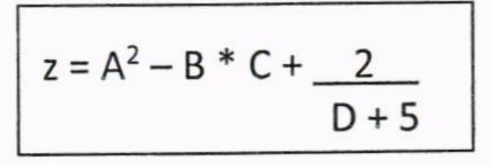
Figure 1
write an appropriate program using correct assembly language notations to compute the equation snbwn in Figure 1 using instructions for zero-address, one-address, and three- address. The available instructioni are provided in Tabte 1. The register labeled A, B, C, and D are fixed, white registers x, y, and z can be used temporarily. The final answer must be stored in register z.
Table 1: Machine instruction
Zero-address | One-address | Three-address
PUSH p | LOAD p | ADD (p,q,r)
POP p | STOR p | suB (p,q,r)
ADD | ADD p | MUL (p,q,r)
SUB | SUB p | DIV (p,q,r)
MUL | MUL p
DIV | DIV p

