
CONFIDENTIAL CS/NOV 2026/CSC429

UNIVERSITI TEKNOLOGI MARA FINAL EXAMINATION

COURSE
COURSE CODE
EXAMINATION TIME
COMPUTER ORGANIZATION AND ARCHITECTURE

CSC429
NOVEMBER 2026
3 HOURS

INSTRUCTIONS TO CANDIDATES

- This question paper consists of two (2) parts: PART A (10 Questions) PART B (1 Question)

- Answer ALL questions in the Answer Booklet. Start each answer on a new page.

- Do not bring any material into the examination room unless permission is given by the invigilator .
- Please check to make sure that this examination pack consists of: i) the Question Paper
  - an Answer Booklet - provided by the Faculty

- Answer ALL questions in English.

DO NOT TURN THIS PAGE UNTIL YOU ARE TOLD TO DO SO

This examination paper consists of 5 printed pages.

PART A (80 MARKS)
Answer ALL questions in this part.

QUESTION A1 (5 marks)
- How classification of parallel processor is constructed?
- Give ONE (1) example for each parallel processor architecture.

QUESTION A2 (5 marks)
- Discuss TWO (2) major technologies in the fourth computer generation and their impact on the modern computer.
- Give ONE (1) example of using artificial intelligence (A1) in everyday life.

QUESTION A3 (5 marks)
Convert 144010 to binary. Show your complete workflow.

QUESTION A4 (5 marks)
Given the following Figure 2.

Figure 2
- Label the addressing technique illustrated in Figure 2.
- Explain how the addressing technique in 9(a) is used.
- List ONE (1) advantage and ONE (1) disadvantage of the addressing technique in 9(a).

QUESTION A5 (10 marks)
- Describe the function of each computer bus type.
- Discuss TWO (2) benefits of synchronous bus timing.

QUESTION A6 (10 marks)
- List the phases in the machine cycle,
- Discuss the function of the different CPU components in the machine cycle.
- What will happen in the machine cycle if access to the main memory is blocked?

QUESTION A7 (10 marks)
- ldentify the correct access method based on the following scenario Scenario Access method Readi files. I Accessi c file from a folder. a Streami files line line. AS ecific file block usi an index in a la e file. Accessin toas Jum cific frame or a timestam in the video. tn
- Rank the following memory types based on the most to the least storage capacity' Main memory, Tape, Ll Cache, Hard drive, ReBister, L3 Cache
- Discuss the term volatile from the perspective of computer memory.

QUESTION A8 (10 marks)
Keyboard is the most common means for computer interaction.
- Explain TWO (2) types of characters that keyboard provides.
- Describe THREE (3) categories of input and output module. Give an appropriate example for each category.

QUESTION A9 (10 marks)
- Describe THREE (3) types of interfaces to external devices.
- Explain TWO (2) types of interrupt.

QUESTION A10 (10 marks)
Answer both parts for the same expression. Assume an 8-bit byte.
Expression: 30 - (-25)
- Calculate 30 - (-25) using sign and magnitude.
- Calculate 30 - (-25) using 1's and 2's complement.

PART B (20 MARKS)
Answer the question in this part.

QUESTION B1 (20 marks)
Question 1 is based on Figure 2 and Table 1.
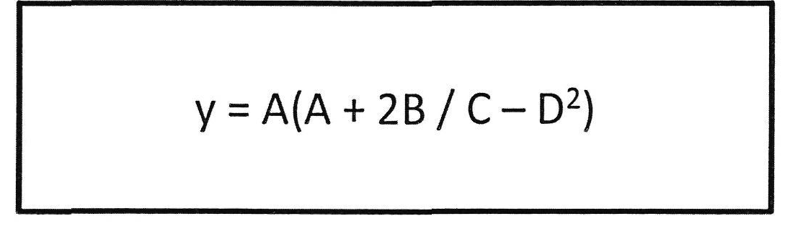
Figure 2
Write the appropriate programs using correct assembly language notations and comments to compute the equation represented in Figure 1 using zero-, one-, and three-address instructions. The instructions available for use are provided in Table 1. Register A, B, C, and D cannot be modified, and registers x, y, and z can be used as temporary registers. However, the final answer must be stored in Register y.
Table 1: Machine Instruction
Zero-address | One-address | Three-address
PUSHp | LOADp | ADD (p,q,r)
POPp | STORp | SUB (p,q,r)
ADD | ADDp | MUL (p.q.r)
SUB | SUBp | DIV(p,q,r)
MUL | MULp
DIV | DIVp

