
CONFIDENTIAL CS/NOV 2026/CSC429

UNIVERSITI TEKNOLOGI MARA FINAL EXAMINATION

COURSE
COURSE CODE
EXAMINATION TIME
COMPUTER ORGANIZATION AND ARCHITECTURE

CSC429
NOVEMBER 2026
3 HOURS

INSTRUCTIONS TO CANDIDATES

- This question paper consists of two (2) parts: PART A (10 Questions) PART B (1 Question)

- Answer ALL questions in the Answer Booklet. Start each answer on a new page.

- Do not bring any material into the examination room unless permission is given by the invigilator .
- Please check to make sure that this examination pack consists of: i) the Question Paper
  - an Answer Booklet - provided by the Faculty

- Answer ALL questions in English.

DO NOT TURN THIS PAGE UNTIL YOU ARE TOLD TO DO SO

This examination paper consists of 5 printed pages.

PART A (80 MARKS)
Answer ALL questions in this part.

QUESTION A1 (5 marks)
Question 1 is based on the following Figure 1.
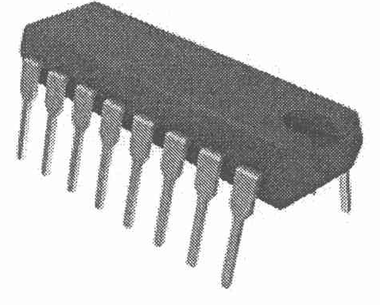
Figure 1: Component X
The development of component X led to a drastic increase in speed and efficiency of computers. Component X is a single, complete electronic semiconductor circuits contained on pieces of silicon, and sometimes called as chips.
- What is the name of component X?
- In which computer generation was component X introduced?
- Who is the inventor of component X?
- State ONE (1) input device and ONE (1) output device that was introduced in the same generation as component X.

QUESTION A2 (5 marks)
Calculate -31 - (-12) using the sign-and-magnitude method. Assume an 8-bit byte. Show your complete workflow.

QUESTION A3 (5 marks)
- How classification of parallel processor is constructed?
- Give ONE (1) example for each parallel processor architecture.

QUESTION A4 (5 marks)
Given the following Figure 2.

Figure 2
- Label the addressing technique illustrated in Figure 2.
- Explain how the addressing technique in 9(a) is used.
- List ONE (1) advantage and ONE (1) disadvantage of the addressing technique in 9(a).

QUESTION A5 (10 marks)
- Describe THREE (3) types of interfaces to external devices.
- Explain TWO (2) types of interrupt.

QUESTION A6 (10 marks)
Answer both parts. Show your complete workflow.
- Convert -6.75 to IEEE 754 single precision. Give the answer in hexadecimal.
- Convert the IEEE 754 single-precision value 0x42C90000 to decimal.

QUESTION A7 (10 marks)
- When is an l/O module installed?
- What will happen if the l/O module is not installed?
- Explain ONE (1) category of l/O module
- What does it mean by 'hot connection'?
- List THREE (3) common interfaces to external devices.

QUESTION A8 (10 marks)
- Describe the function of each computer bus type.
- Discuss TWO (2) benefits of synchronous bus timing.

QUESTION A9 (10 marks)
- Discuss the main function of cache memory.
- How can the data stored in the cache and main memory be synchronized.
- Contrast between SRAM and DRAM based on the following characteristics: Type of storage ii, Availability of charges leak price Example of location of memory usage

QUESTION A10 (10 marks)
Given that the size of the data bus is 32 bits, the size of the address bus is 8 bits, and the size of the control bus is 4 bits.
- Determine the size of the word and provide relevant justification.
- Determine the size of the register and provide relevant justification.
- Discuss what will happen if system interconnection is blocked from the perspective of the machine cycle.
- Elaborate the role of CPU interconnection.

PART B (20 MARKS)
Answer the question in this part.

QUESTION B1 (20 marks)
Question 1 is based on Figure 4 and Table 3.
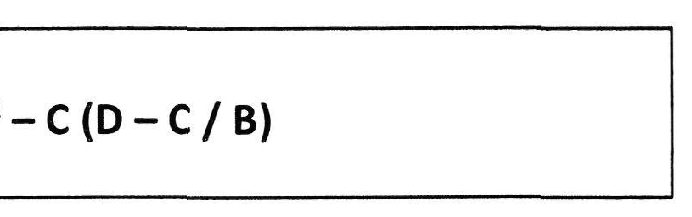
Figure 4
Write the appropriate programs using correct assembly language notations and comments to compute the equation represented in Figure 4 using zero-, one-, and two-address instructions. The instructions available for use are provided in Table 3. Note that Register A, B, C, and D cannot be modified, and Register x, y, and z can be used as temporary registers. However, the final answer must be stored in Register z.
Table 3: Machine Instruction
Zero-address | One-address | T\vr.-address
PUSHx | LOADx | MOVE (x,y)
POPx | STORx | ADD (x,y)
ADD | ADDx | SUB (x,y)
SUB | SUBx | MUL (x,y)
MUL | MULx | DIV(x,y)
DIV | DIVx

