
CONFIDENTIAL CS/NOV 2026/CSC429

UNIVERSITI TEKNOLOGI MARA FINAL EXAMINATION

COURSE
COURSE CODE
EXAMINATION TIME
COMPUTER ORGANIZATION AND ARCHITECTURE

CSC429
NOVEMBER 2026
3 HOURS

INSTRUCTIONS TO CANDIDATES

- This question paper consists of two (2) parts: PART A (10 Questions) PART B (1 Question)

- Answer ALL questions in the Answer Booklet. Start each answer on a new page.

- Do not bring any material into the examination room unless permission is given by the invigilator .
- Please check to make sure that this examination pack consists of: i) the Question Paper
  - an Answer Booklet - provided by the Faculty

- Answer ALL questions in English.

DO NOT TURN THIS PAGE UNTIL YOU ARE TOLD TO DO SO

This examination paper consists of 6 printed pages.

PART A (80 MARKS)
Answer ALL questions in this part.

QUESTION A1 (5 marks)
Question 1 is based on the following placard in the Computer History Museum.
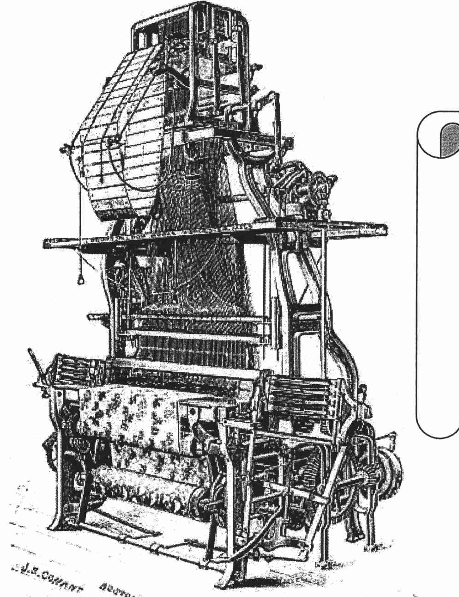
Figure 1: Machine X
The Jacquard System was developed by Joseph Marie Jacquard to automatically produce the intricate woven patterns. The deck of punched cards that controls the Machine X is located at the left center on the far side of the figure. In the early days of software piracy, the intricate fabric design card decks would be stolen by competing textile mills.
- Name the Machine X in Figure 1.
- In which computer generation was Machine X developed?
- Name the possible computer component that has similar function as the deck of punch card in Machine X.
- Identify the input and output for Machine X.

QUESTION A2 (5 marks)
Complete the following taxonomy of parallel processor architecture with appropriate example.
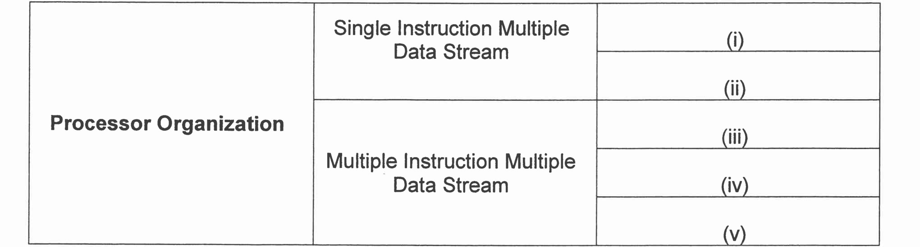

QUESTION A3 (5 marks)
Given the following Figure 2.

Figure 2
- Label the addressing technique illustrated in Figure 2.
- Explain how the addressing technique in 9(a) is used.
- List ONE (1) advantage and ONE (1) disadvantage of the addressing technique in 9(a).

QUESTION A4 (5 marks)
Convert -20.125 to IEEE 754 single-precision format. Give the answer in hexadecimal and show the sign, exponent and mantissa fields.

QUESTION A5 (10 marks)
Describe FOUR (4) type of access methods based on hardware implementation of the storage device. Provide ONE (1) appropriate example for each access type.

QUESTION A6 (10 marks)
- Discuss the TWO (2) processes in the machine cycle that are governed by the main memory.
- List TWO (2) operations that are comprised in the Execute phase.
- Explain what happens in the Program Counter (PC) and Instruction Register (IR) during the Fetch cycle.

QUESTION A7 (10 marks)
- Describe TWO (2) types of interrupt.
- Briefly explain THREE (3) interfaces to external devices.

QUESTION A8 (10 marks)
- Registers are one of the main components of a CPU. Define the term registers, and list TWO (2) types of registers.
- Briefly explain the Fetch and Decode operations of a Machine Cycle.
- Buses are the most common type of system interconnection. Discuss ONE (1) difference between a dedicated bus and multiplexed bus.

QUESTION A9 (10 marks)
- Describe THREE (3) types of interfaces to external devices.
- Explain TWO (2) types of interrupt.

QUESTION A10 (10 marks)
Answer both parts. Show your complete workflow.
- Convert 100.5 to IEEE 754 single precision. Give the answer in hexadecimal.
- Convert the IEEE 754 single-precision value 0x3EC00000 to decimal.

PART B (20 MARKS)
Answer the question in this part.

QUESTION B1 (20 marks)
Question 1 is based on Figure 4 and Table 3.
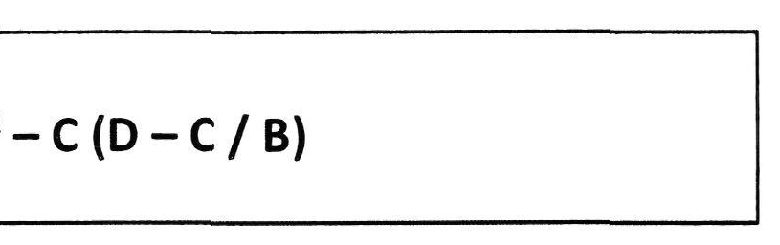
Figure 4
Write the appropriate programs using correct assembly language notations and comments to compute the equation represented in Figure 4 using zero-, one-, and two-address instructions. The instructions available for use are provided in Table 3. Note that Register A, B, C, and D cannot be modified, and Register x, y, and z can be used as temporary registers. However, the final answer must be stored in Register z.
Table 3: Machine Instruction
Zero-address | One-address | T\vr.-address
PUSHx | LOADx | MOVE (x,y)
POPx | STORx | ADD (x,y)
ADD | ADDx | SUB (x,y)
SUB | SUBx | MUL (x,y)
MUL | MULx | DIV(x,y)
DIV | DIVx

