
CONFIDENTIAL CS/NOV 2026/CSC429

UNIVERSITI TEKNOLOGI MARA FINAL EXAMINATION

COURSE
COURSE CODE
EXAMINATION TIME
COMPUTER ORGANIZATION AND ARCHITECTURE

CSC429
NOVEMBER 2026
3 HOURS

INSTRUCTIONS TO CANDIDATES

- This question paper consists of two (2) parts: PART A (10 Questions) PART B (1 Question)

- Answer ALL questions in the Answer Booklet. Start each answer on a new page.

- Do not bring any material into the examination room unless permission is given by the invigilator .
- Please check to make sure that this examination pack consists of: i) the Question Paper
  - an Answer Booklet - provided by the Faculty

- Answer ALL questions in English.

DO NOT TURN THIS PAGE UNTIL YOU ARE TOLD TO DO SO

This examination paper consists of 6 printed pages.

PART A (80 MARKS)
Answer ALL questions in this part.
QUESTION 1 (5 marks)
The Von Neumann Architecture was first described in a seminal First Draft of
a Report on the EDVAC. The document describes a design architecture of a general-
purpose electronic computer that serves as the basis for almost all of modern computers.
- List TWO (2) main components of a Von Neumann Architecture.
- Von Neumann computers are general purpose computers. Define the term general-
purpose computers.
- Name ONE (1) of the earliest computers built based on the Von Neumann Architecture.
QUESTION 2 (5 marks)
The integrated circuit is an important milestone that marks the achievement in the history of
computer development.
- ln which computer generation that the integrated circuil was first introduced?
- State the name of the inventor of the integrated circuit.
- What are the THREE (3) main components of integrated circuits?
QUESTION 3 (5 marks)
- \Mat is a bit?
- Given a system of vacuum tubes where each tube represents a single bit with two states:
ON=1 and OFF=O. ldentify the number of vacuum tubes needed to store the value of gro.
Show your workflow to justify your answer.
- Binary system.
- Octal system.
QUESTION 4 (5 marks)
Given the following Figure 1.
- Label the addressing technique illustrated in Figure 1.
- Explain how the addressing technique in 9(a) is used.
- List ONE (1) advantage and ONE (1) disadvantage of the addressing technique in
9(a).
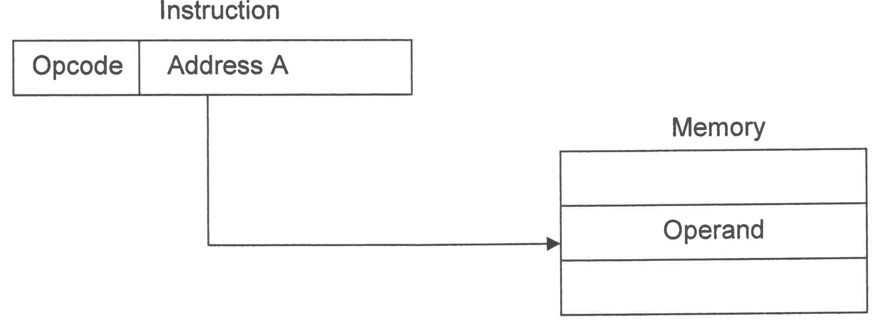
Figure 1
QUESTION 5 (10 marks)
- Discuss the THREE (3) input-output techniques available in the computer system.
- Universal Serial Bus (USB) has a "hot connection" to the devices. Briefly explain what is
meant by "hot connection."
- Why is there a need for the I/O module to be the mediator between the CPU and devices?
QUESTION 6 (10 marks)
- Differentiate SRAM and DRAM from the perspective of the following characteristics,
- The way the bits are stored.
- Speed.
- Location it is being used.
- Why does DRAM need refreshing?
- Comparing DRAM and SRAM, which memory would be placed higher in the memory
hierarchy? Give your justification to support your answer.
QUESTION 7 (10 marks)
- List FOUR (4) classification of multiple processor architecture.
- Symetric Multi Processor (SMP), Non Uniform Memory Access (NUMA) and Cluster are
part of the X multiple processor architecture. Identify X?
- Differentiate the multiple processor architecture for SMP and Cluster. In your opinion,
which architecture is easier to manage and control by giving appropriate justification.
QUESTION 8 (10 marks)
- Identify the correct concept of computer organization or architecture in the following
scenario.
Scenario
Concept
Deals with the logical aspects of the
system, including instruction sets,
data formats, and addressing modes.
Defines the functionality, capabilities,
and programming model.
Concerned with how the computer
will execute the tasks and implement
the functions.
Involves the hardware layout, circuits,
control signals, memory access, and
timing.
- Describe THREE (3) CPU registers involved in data processing, such as arithmetic
operations.
QUESTION 9 (10 marks)
- Draw a complete machine cycle by giving the exact location of each phase.
- Briefly, describe each phase in the machine cycle.
QUESTION 10 (10 marks)
Each generation is well known for its technology and machine invented. Complete the
following Table 1 with appropriate answers.
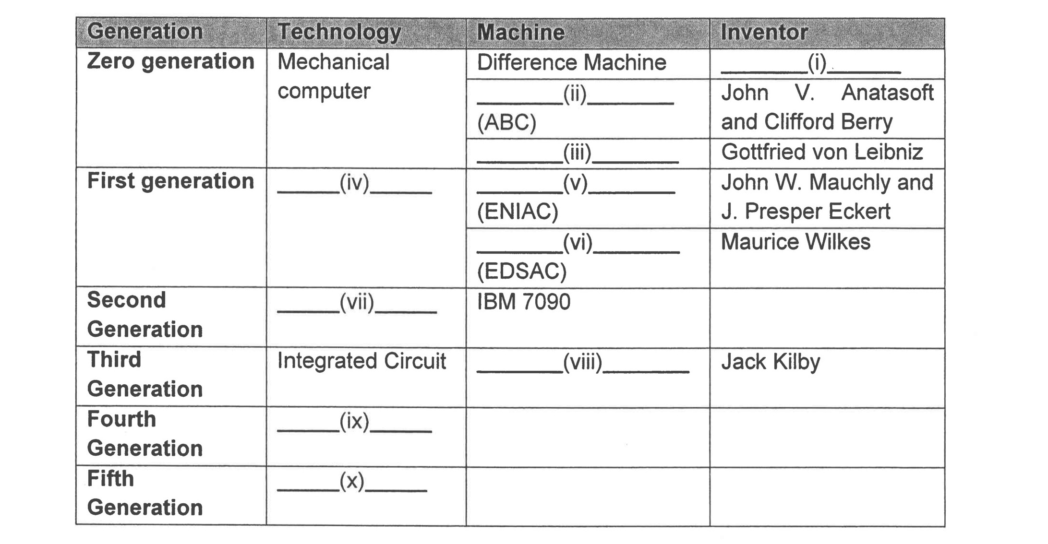
Table 1

PART B (20 MARKS)
Answer the question in this part.
QUESTION 11 (20 marks)
Question 1 is based on Figure 2 and Table 2.
Write the appropriate programs using correct assembly language notations and comments to
compute the equation represented in Figure 2 using one-, two- and three-address
instructions. The instructions available for use are provided in Table 2. Note that Register A,
B, C, D, E and F cannot be modified and Register X, Y and Z can be used as temporary
register. Final answer must be stored in Register X.
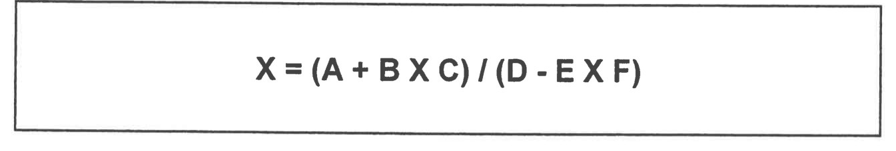
Figure 2
Table 2 : Machine Instruction
i Nia dress |  | address
LOAD M | MOVE (X e Y) | MOVE (X e Y)
STORE M | ADD (X k.. X + Y) | ADD (X e Y + Z)
ADD M | SUB (X e X - Y) | SUB (X e Y-Z)
SUB M | MUL (X e X x Y) | MUL (X e Y x Z)
MUL M | DIV (X e x / Y) | DIV (X e Y / Z)
DIV M

