
CONFIDENTIAL CS/NOV 2026/CSC429

UNIVERSITI TEKNOLOGI MARA FINAL EXAMINATION

COURSE
COURSE CODE
EXAMINATION TIME
COMPUTER ORGANIZATION AND ARCHITECTURE

CSC429
NOVEMBER 2026
3 HOURS

INSTRUCTIONS TO CANDIDATES

- This question paper consists of two (2) parts: PART A (10 Questions) PART B (1 Question)

- Answer ALL questions in the Answer Booklet. Start each answer on a new page.

- Do not bring any material into the examination room unless permission is given by the invigilator .
- Please check to make sure that this examination pack consists of: i) the Question Paper
  - an Answer Booklet - provided by the Faculty

- Answer ALL questions in English.

DO NOT TURN THIS PAGE UNTIL YOU ARE TOLD TO DO SO

This examination paper consists of 5 printed pages.

PART A (80 MARKS)
Answer ALL questions in this part.
QUESTION A1 (5 marks)
John Von Neumann is a mathematician who is one of the pioneers in computer advancement,
and his contributions are still relevant to the modern computer.
- Draw the Von Neuman architecture and give relevant examples each.
- What is the name of the actual device that John Von Neumann himself developed?
QUESTION A2 (5 marks)
Question 2 is based on the following statement.
"The introduction of graphical user interface (GUI) and mouse technology remark the
beginning of a new computer generation. In this generation, there are many great
developments in the field of computer networks leading to the birth of internet concept".
- Name the computer generation described.
- What are the TWO (2) main technologies available in this computer generation?
- List TWO (2) main features of this computer generation.
QUESTION A3 (5 marks)
- Solve 138 - 518 using the sign and magnitude method. The answer must be in byte form.
Show your workflow.
- Calculate -23 + 69 using I's and 2's complement method. The answer must be in byte
form. Show your workflow.
QUESTION A4 (5 marks)
Question 1 is based on the following placard in the Computer History Museum.
The Jacquard System was developed by
Joseph Marie Jacquard to automatically
produce the intricate woven patterns.
The deck of punched cards that
controls the Machine X is located at
the left center on the far side of the
figure. In the early days of software
piracy, the intricate fabric design card
decks would be stolen by competing
textile mills.
- Name the Machine X in Figure 1.
- In which computer generation was Machine X developed?
- Name the possible computer component that has similar function as the deck of punch
card in Machine X.
- Identify the input and output for Machine X.
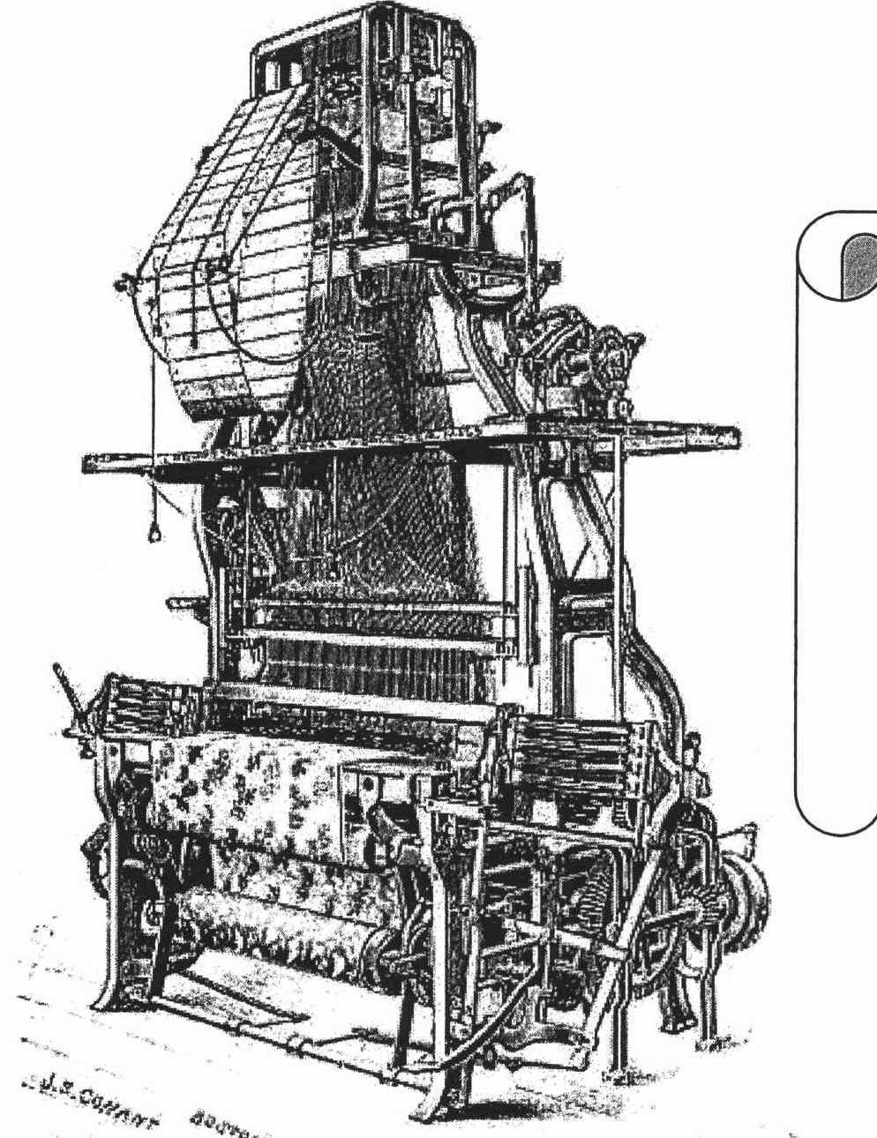
Figure 1: Machine X
QUESTION A5 (10 marks)
- Elaborate THREE (3) types of replacement algorithm.
- List TWO (2) types of mapping that require a replacement algorithm.
- Discuss the reason why the replacement algorithm needs to be implemented.
QUESTION A6 (10 marks)
- Provide one example for each classification of multiple processor organization.
- Draw a simplified computer architecture of the following:
Symmetric Multiprocessors
ii. Clusters
iii. Non Uniform Memory Access (NUMA)
QUESTION A7 (10 marks)
Question 9 is based on Figure 2.
- Identify addressing mode in Figure 2.
- Which register will be involved in Figure 2 addressing mode?
- If register in Figure 2 is replaced with memory, what is the new addressing mode?
- Addressing mode in (a) is using register and addressing mode in (c) is using memory.
Discuss which addressing mode will be executed faster with appropriate justification.
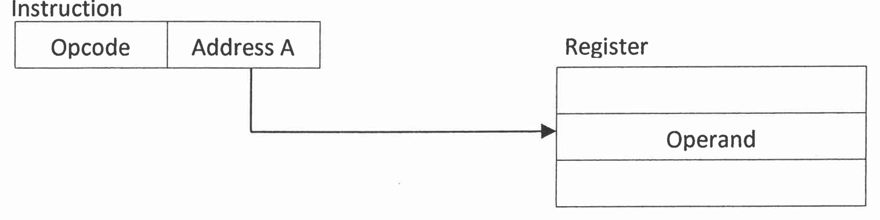
Figure 2: Addressing mode type x.
QUESTION A8 (10 marks)
- List the phases in the machine cycle,
- Discuss the function of the different CPU components in the machine cycle.
- What will happen in the machine cycle if access to the main memory is blocked?
QUESTION A9 (10 marks)
- Convert decimal numbers of 13 and 31 to binary number bases. Show your complete
workflow. Your answer must be in 6 bit.
- Solve the following equations using sign and magnitude representation. Show the
complete working flow.
- 13+31
- 13-31
- -13+31
- -13-31
QUESTION A10 (10 marks)
- Explain TWO (2) methods to handle multiple interrupts.
- Give ONE (1) example of a non-maskable interrupt.
- Why Direct Memory Access (DMA) is faster than interrupt-driven and programmed 1/0?
- USB is known as a 'hot' connection. What does it mean by "hot connection"?

PART B (20 MARKS)
Answer the question in this part.
QUESTION B1 (20 marks)
Question 1 is based on Figure 3 and Table 1.
Write an appropriate program using correct assembly language notations to compute the
equation shown in Figure 3 using instructions for one-address, two-address, and three-
address. The available instructions are provided in Table 1. The register labeled A, B, C, and
D are fixed, while registers x, y, and z can be used temporarily. The final answer must be
stored in register y.

Figure 3
Table 1 : Machine instruction
One-address | Two-address | Three-address
LOADp | MOV (p,q) | ADD (p.q.r)
STORp | ADD (p,q) | SUB (p,q,r)
ADDp | SUB (p,q) | MUL (p.q.r)
SUBp | MUL (p,q) | DIV(p,q,r)
MULp | DIV(p,q)
DIVp

