
CONFIDENTIAL CS/NOV 2026/CSC429

UNIVERSITI TEKNOLOGI MARA FINAL EXAMINATION

COURSE
COURSE CODE
EXAMINATION TIME
COMPUTER ORGANIZATION AND ARCHITECTURE

CSC429
NOVEMBER 2026
3 HOURS

INSTRUCTIONS TO CANDIDATES

- This question paper consists of two (2) parts: PART A (10 Questions) PART B (1 Question)

- Answer ALL questions in the Answer Booklet. Start each answer on a new page.

- Do not bring any material into the examination room unless permission is given by the invigilator .
- Please check to make sure that this examination pack consists of: i) the Question Paper
  - an Answer Booklet - provided by the Faculty

- Answer ALL questions in English.

DO NOT TURN THIS PAGE UNTIL YOU ARE TOLD TO DO SO

This examination paper consists of 5 printed pages.

PART A (80 MARKS)
Answer ALL questions in this part.
QUESTION 1 (5 marks)
Give ONE (1) appropriate example for each component in Von Neumann architecture.
QUESTION 2 (5 marks)
- Name the inventor of the integrated circuit.
- ln which computer generation was the integrated circuit first introduced?
- List THREE (3) main components of an integrated circuit.
QUESTION 3 (5 marks)
What is the decimal value of the sum of the binary numbers 1101 1100 and 0010 0111 if they
are represented in sign and magnitude? Assume that the basic unit is the byte. Show your
workflow.
QUESTION 4 (5 marks)
- Discuss the computer interface that is available during the third and fourth computer
generations.
- ln your opinion, what is the leading cause that changed the computer interface in the third
to the fourth computer generations?
QUESTION 5 (10 marks)
Question 7 is based on the following scenarios.
While cleaning his house, Ahmad found an old cassette tape of a popular 80's band. He
played the tape and listened to several songs according to the listed tracks.
Hafiz was tasked to research on the history of Malay culture by his professor. He went
to the National Archive to search for information and manage to access one the
resources which was stored in a floppy disk.
Sara is planning to buy a new computer. She aims to get one with good processing
speed. While researching for computer specifications, she found out that larger cache
space has a direct effect towards processing performance.
Hana loves playing role-playing games (RPG) and is planning to buy a newly released
game that requires a high-speed RAM. But, she is devastated when she found out that
her game console does not support the minimum RAM requirement of the game.
- Based on the above scenarios, identify the access method for each storage
devices/memory mentioned in (i), (ii), (iii) and (iv).
- Describe SRAM and DRAM.
- Which level of cache is the fastest in a three-level cache architecture? Which type of
RAM is used to implement the cache?
QUESTION 6 (10 marks)
Question 10 is based on Figure 1. Figure 1 depicts a Non-uniform Memory Access (NUMA)
architecture.
- Redraw a symmetric multiprocessor organization based on Figure 1.
- Give TWO (2) examples of tightly coupled Multiple Instruction, Multiple Data (MIMD)
parallel processor architectures.
- Discuss TWO (2) disadvantages of tightly coupled Multiple Instruction, Multiple Data
(MIMD) parallel processor architectures.
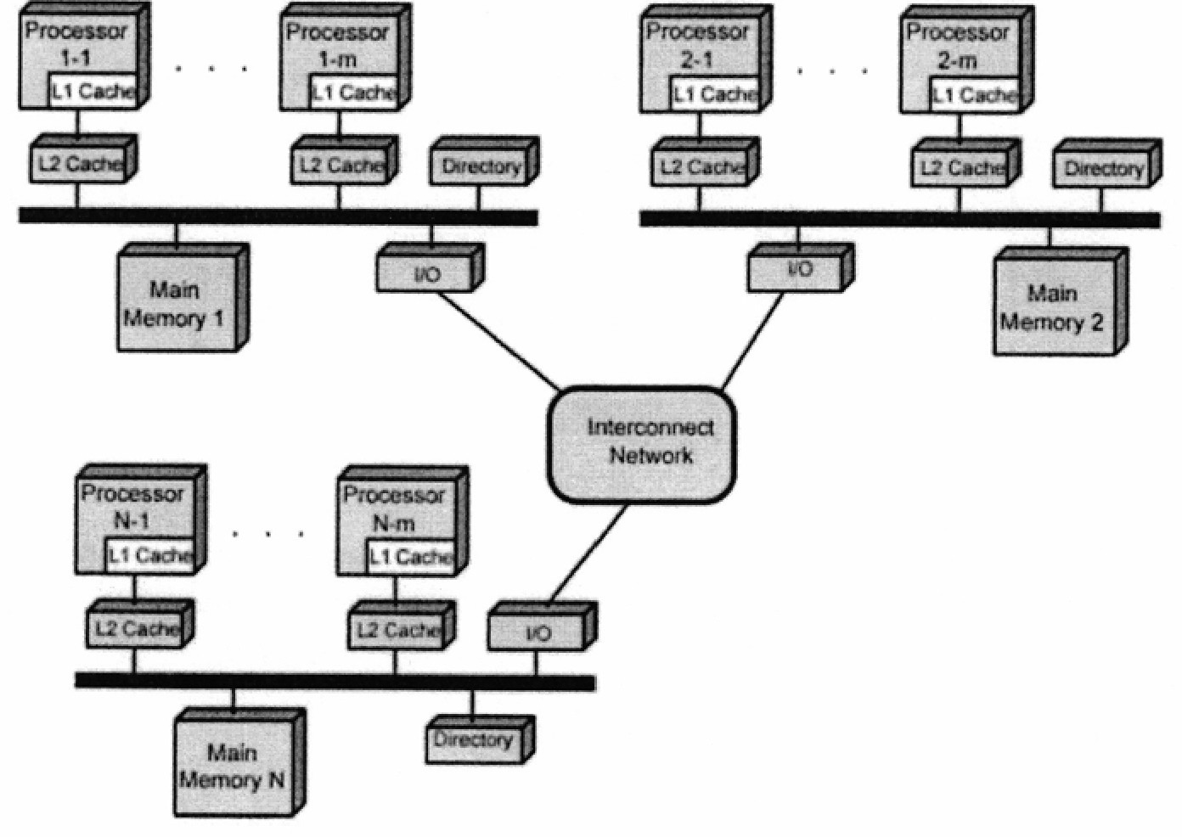
Figure 1: Non-uniform 'Memory Access (NUMA)
QUESTION 7 (10 marks)
- Discuss the TWO (2) processes in the machine cycle that are governed by the main
memory.
- List TWO (2) operations that are comprised in the Execute phase.
- Explain what happens in the Program Counter (PC) and Instruction Register (IR) during
the Fetch cycle.
QUESTION 8 (10 marks)
Describe the specific function of each registers in the CPU.
QUESTION 9 (10 marks)
Question 1 is based on the following statement.
In 1942, Mr. X and Mr. Y proposed an all-electronic calculating machine. The U.S. Army,
meanwhile, needed to calculate complex wartime ballistics tables. The result was Electronic
Numerical Integrator And Computer (ENIAC) that was built between 1943 and 1945. ENIAC
is the first large-scale computer to run at electronic speed without being slowed by any
mechanical parts. For a decade, until a 1955 lightning strike, ENIAC may have run more
calculations than all mankind had done up to that point.
- In which computer generation, ENIAC is developed?
- Who built the ENIAC machine?
- What is the main technology used in the ENIAC machine?
- Outline a possible solution for each of the following problems that are faced when ENIAC
is used.
Problem
Solution
Produced a lot of heat
Consume a lot of ener
Lar e in size
Slow rocessin
Limited ro rammin ca abilities
QUESTION 10 (10 marks)
- Convert -176.812510 to floating point number in IEEE single precision format in
hexadecimal value form.
- Convert 3FOOC00016 in IEEE single precision floating point number to decimal value
form.

PART B (20 MARKS)
Answer the question in this part.
QUESTION 11 (20 marks)
Question 1 is based on Figure 2 and Table 1.
Write the appropriate programs using correct assembly language notations and comments to
compute the equation represented in Figure 2 using zero-, one-, and three-address
instructions. The instructions available for use are provided in Table 1. Note that Register A,
B, C, and D cannot be modified, and Register x, y, and z can be used as temporary registers,
However, the final answer must be stored in Register y.
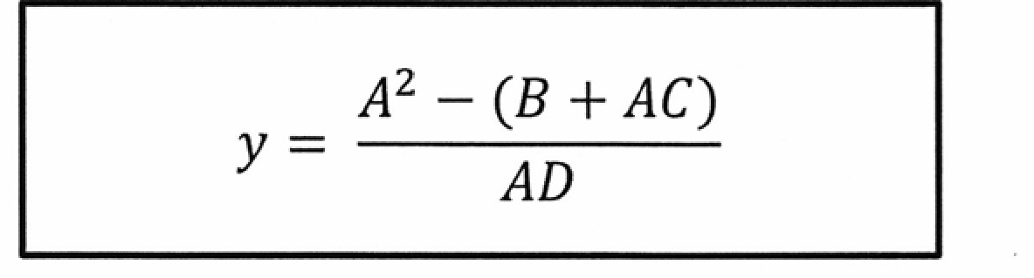
Figure 2
Table 1: Machine Instruction
Zero-address | One-address | Three-address
PUSH | LOAD | ADD
pop | STOR | SUB
ADD | ADD | MUL
SUB | SUB | DIV
MUL
DIV | DIV

