
CONFIDENTIAL CS/NOV 2026/CSC429

UNIVERSITI TEKNOLOGI MARA FINAL EXAMINATION

COURSE
COURSE CODE
EXAMINATION TIME
COMPUTER ORGANIZATION AND ARCHITECTURE

CSC429
NOVEMBER 2026
3 HOURS

INSTRUCTIONS TO CANDIDATES

- This question paper consists of two (2) parts: PART A (10 Questions) PART B (1 Question)

- Answer ALL questions in the Answer Booklet. Start each answer on a new page.

- Do not bring any material into the examination room unless permission is given by the invigilator .
- Please check to make sure that this examination pack consists of: i) the Question Paper
  - an Answer Booklet - provided by the Faculty

- Answer ALL questions in English.

DO NOT TURN THIS PAGE UNTIL YOU ARE TOLD TO DO SO

This examination paper consists of 6 printed pages.

PART A (80 MARKS)
Answer ALL questions in this part.
QUESTION 1 (5 marks)
Von Neumann architecture is the fundamental concept in developing the IAS Machine in
1947. Describe briefly the function of each Von Neumann component using the aid of an
appropriate diagram.
QUESTION 2 (5 marks)
Question 1 is based on the following image and statements in Figure 1.
Charles Babbage was an English
mathematician, a philosopher and also an
inventor. He was born on 1791 in London
England. He was known for his
contributions to invent machine X to solve
four basic arithmetic functions. The
machine X has improved its calculations
design from Stepped Reckoner machine
and early mechanical calculator. The
machine X has introduced a number of
computing concepts which are still in use
today. Although this machine was not
actually completed, it is the first machine
that deserved to be called as a computer.
- What is the machine X name?
- In which generation does the machine X introduced?
- What is the function of machine X?
- Name the machine that has been invented prior to machine X?
- What is the title given to Charles Babbage due to his success to invent machine X?
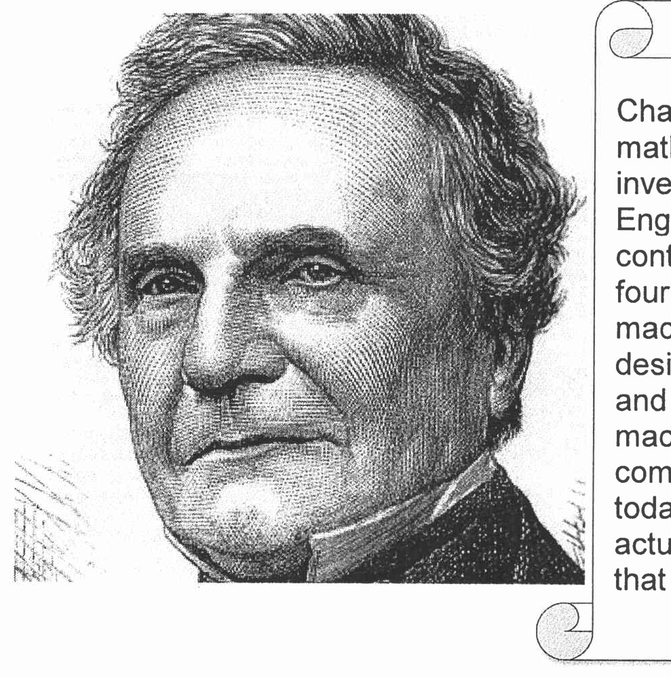
Figure 1 : A snippet from biography web page
QUESTION 3 (5 marks)
- Why is binary used instead of decimal in computer systems?
- Using the decimal representation, estimate the number of vacuum tubes needed to
represent the value of 139. Show your workflow.
- Estimate the number of vacuum tubes needed to represent the value of 139 using the
binary representation. Show your workflow.
QUESTION 4 (5 marks)
A touch screen is an essential device commonly used to ensure work can be conducted with
ease and convenience. It can act as input and output devices
- Describe how the touch screen can be an input and output device.
- Name ONE (1) another device that can be an input and output.
QUESTION 5 (10 marks)
- Explain how the bits are stored in the SRAM and DFiAM.
- Why is SRAM technology faster than DRAM technology?
- Compare SRAM and DRAM in terms of cost and power consumption.
QUESTION 6 (10 marks)
- Complete the taxonomy of parallel processor architecture illustrated in Figure 2.
- Discuss TWO (2) disadvantages of symmetric multiprocessor (SMP).
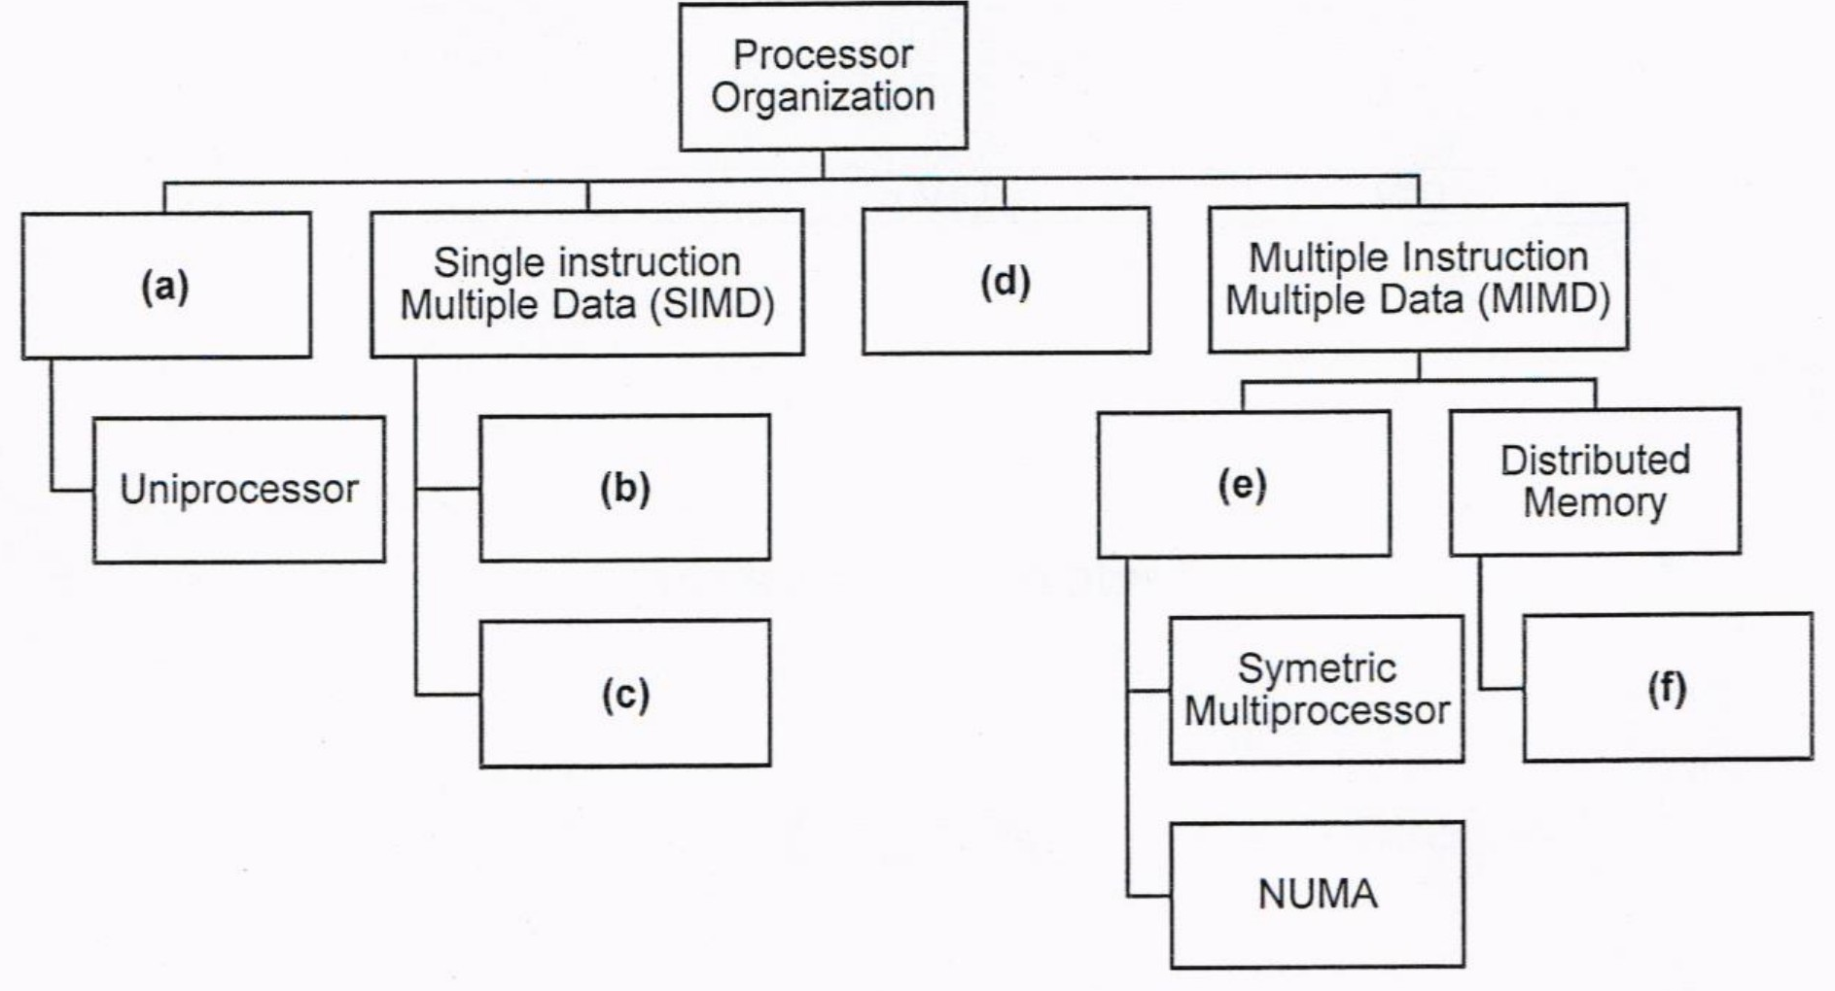
Figure 2: Taxonomy of Parallel Processor Architecture
QUESTION 7 (10 marks)
- List TWO (2) buses types that are available in the computer system.
- Differentiate TWO (2) characteristics of system interconnection
and CPU
interconnection.
- Explain the different types of data transfer timing.
QUESTION 8 (10 marks)
- Calculate -19 - 99 decimal using the following techniques in byte-addressable unit.
- Sign and magnitude.
- One's and two's complement
- Calculate -19 + 99 decimal using the following techniques in byte-addressable unit.
- Sign and magnitude.
- One's and two's complement
QUESTION 9 (10 marks)
Figure 3 illustrates the icon of one of the interfaces to the external devices.
- Identify the type of external device interface based on the icon in Figure 3.
- The external devices interface in (a) can have a "hot connection". Define hot connection.
- Discuss the THREE (3) input-output techniques available in a computer system and
elaborate on the Central Processing Unit's involvement in each technique.
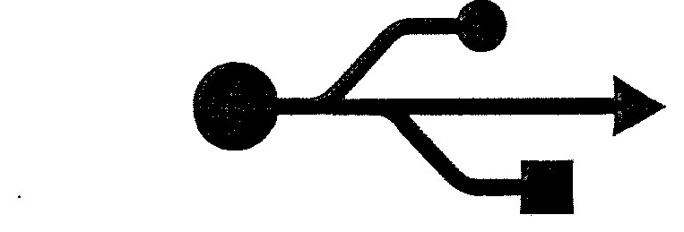
Figure 3: Interface to the external devices
QUESTION 10 (10 marks)
- ldentify the correct access method based on the following scenario
Access method
Scenario
Readi
I
files.
c file from a folder.
Accessi
a
Streami
files line
line.
Accessin
AS ecific file block usi
an index in a la
e file.
toas
cific frame or a timestam
in the video.
Jum
tn
- Rank the following memory types based on the most to the least storage capacity'
Main memory, Tape, Ll Cache, Hard drive, ReBister, L3 Cache
- Discuss the term volatile from the perspective of computer memory.

PART B (20 MARKS)
Answer the question in this part.
QUESTION 11 (20 marks)
Question 1 is based on Figure 4 and Table 1.
Write the appropriate programs using correct assembly language notations and comments to
compute the equation represented in Figure 4 using zero-, one-, and three-address
instructions. The instructions available for use are provided in Table 1. Note that Register A,
B, C, and D cannot be modified, and Register x, y, and z can be used as temporary registers,
However, the final answer must be stored in Register y.
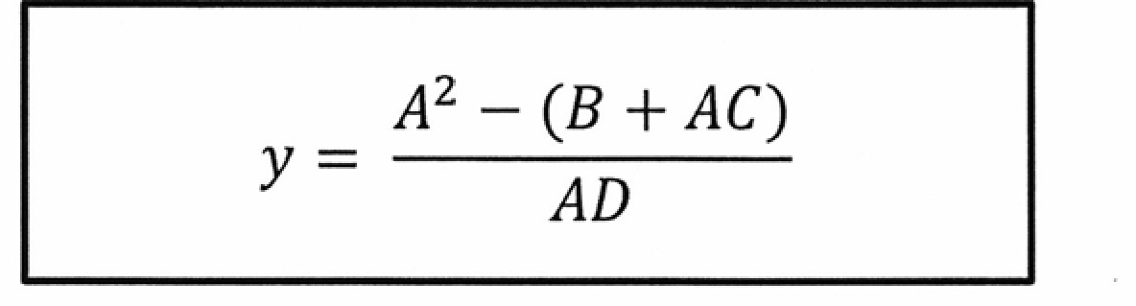
Figure 4
Table 1: Machine Instruction
Zero-address | One-address | Three-address
PUSH | LOAD | ADD
pop | STOR | SUB
ADD | ADD | MUL
SUB | SUB | DIV
MUL
DIV | DIV

