
CONFIDENTIAL CS/NOV 2026/CSC429

UNIVERSITI TEKNOLOGI MARA FINAL EXAMINATION

COURSE
COURSE CODE
EXAMINATION TIME
COMPUTER ORGANIZATION AND ARCHITECTURE

CSC429
NOVEMBER 2026
3 HOURS

INSTRUCTIONS TO CANDIDATES

- This question paper consists of two (2) parts: PART A (10 Questions) PART B (1 Question)

- Answer ALL questions in the Answer Booklet. Start each answer on a new page.

- Do not bring any material into the examination room unless permission is given by the invigilator .
- Please check to make sure that this examination pack consists of: i) the Question Paper
  - an Answer Booklet - provided by the Faculty

- Answer ALL questions in English.

DO NOT TURN THIS PAGE UNTIL YOU ARE TOLD TO DO SO

This examination paper consists of 6 printed pages.

PART A (80 MARKS)
Answer ALL questions in this part.
QUESTION 1 (5 marks)
Given the following Non Uniform Memory Access (NUMA) diagram.
- State ONE (1) advantage of Symmetric Mufti-Processor (SMP) that is applied in NUMA
architecture.
- Describe ONE (1) disadvantage of cluster architecture.
- Draw a possible architecture for cluster architecture based on Figure 1.
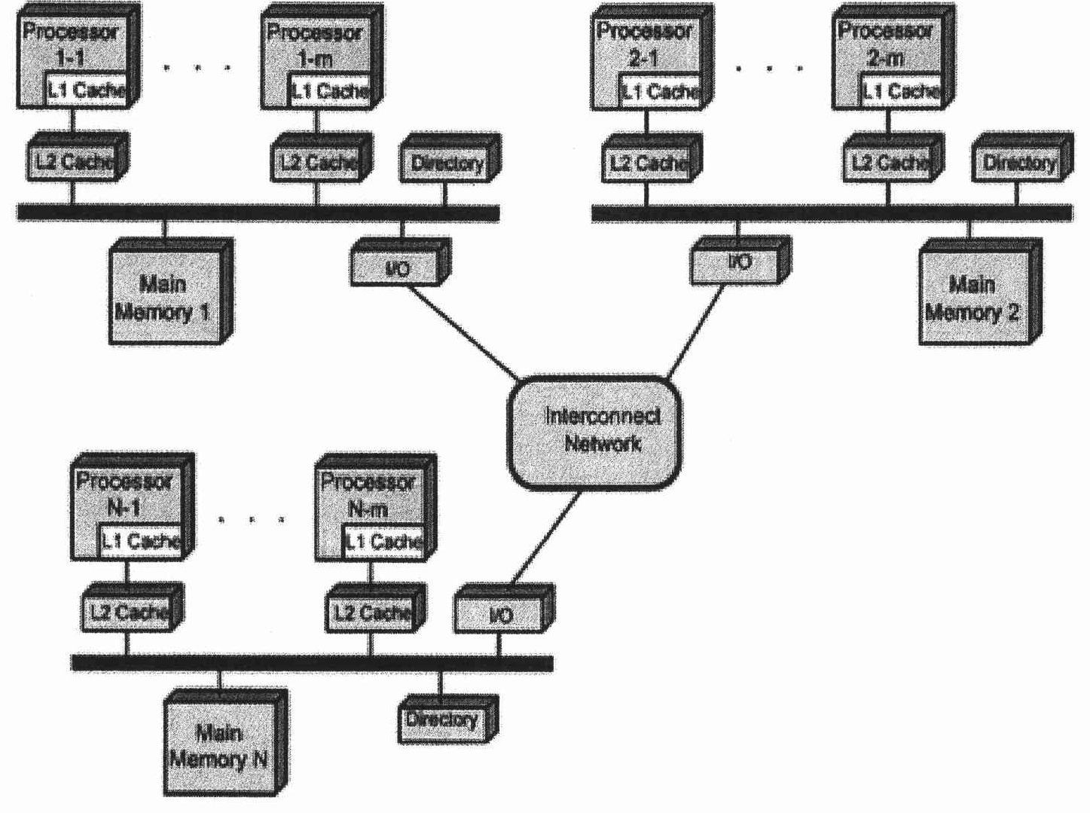
Figure 1: NUMA Architecture
QUESTION 2 (5 marks)
Question 1 is based on the following Figure 2.
Inventor 'Y' was France's most
celebrated
mathematician
and
physicist. In 1642, inventor 'Y'
invented
and
build
the
first
working calculating machine as a
means of helping his father to
perform tedious tax accounting.
- Who is inventor 'Y'?
- Name another calculating machine that was invented in the same generation as inventor
Y's calculating machine.
- Which programming language is named after inventor 'Y'?
- State TWO (2) mathematical operationsthat can be performed byinventor Y's calculating
machine.
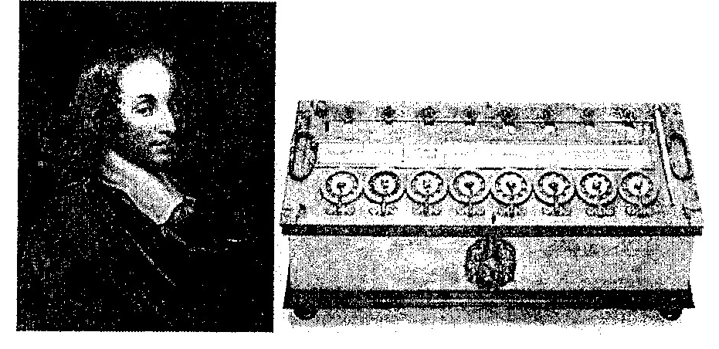
Figure 2: Inventor 'Y' and his calculating machine.
QUESTION 3 (5 marks)
Calculate -9Brr - 37a using 1's and 2's complement method. Show your complete workflow.
QUESTION 4 (5 marks)
- What is mapping function?
- Differentiate between direct and associative mapping in cache.
- If a 28-bit address is used with word size = 4 bit and line = 10 bit, calculate the tag size of
both direct and associative mapping.
QUESTION 5 (10 marks)
- Differentiate between interrupt-driven 1/0 and programmed 1/0.
- Discuss ONE (1) benefit of programmed 1/0.
- Discuss TWO (2) disadvantages of multiple interrupts.
QUESTION 6 (10 marks)
Question 10 is based on Figure 3. Figure 3 depicts a Non-uniform Memory Access (NUMA)
architecture.
- Redraw a symmetric multiprocessor organization based on Figure 3.
- Give TWO (2) examples of tightly coupled Multiple Instruction, Multiple Data (MIMD)
parallel processor architectures.
- Discuss TWO (2) disadvantages of tightly coupled Multiple Instruction, Multiple Data
(MIMD) parallel processor architectures.
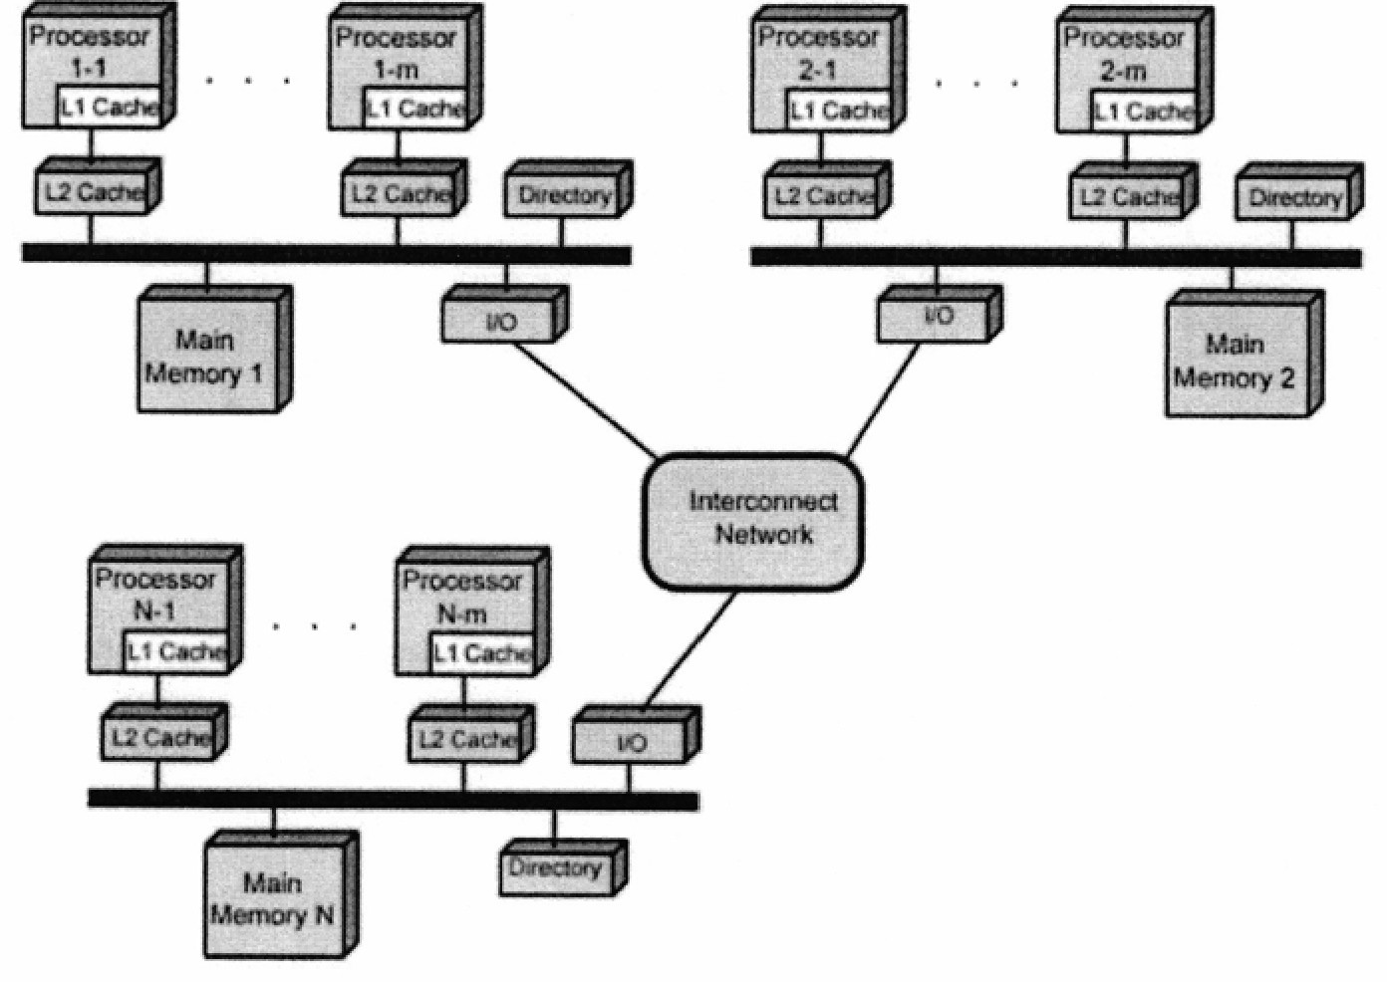
Figure 3: Non-uniform 'Memory Access (NUMA)
QUESTION 7 (10 marks)
- Draw Single Instruction, Single data (SISD) architecture with the following information:
- CU is the control unit
- PU is the processing unit
- MU is the memory unit
- IS is the instruction stream
- DS is the data stream
- Describe the parallel architecture.
- Explain ONE (1) benefit of parallel architecture.
- Differentiate between loosely-coupled and strongly-coupled Multiple Instruction, Multiple
Data stream (MIMD) architecture with example.
QUESTION 8 (10 marks)
- Given x = AA + CD; show the workflow to solve the equation in:
- Hexadecimal value
Decimal value
- Given y = IA - 3D; show the workflow to solve the equation in:
- Sign and magnitude representation
I's and 2's complement representation
QUESTION 9 (10 marks)
- Discuss THREE (3) types of interfaces to external devices.
- Classify the following input/output devices to their respective 1/0 module:
- Network interface card
Scanner
Touch Screen
- Register
QUESTION 10 (10 marks)
- Discuss the TWO (2) processes in the machine cycle that are governed by the main
memory.
- List TWO (2) operations that are comprised in the Execute phase.
- Explain what happens in the Program Counter (PC) and Instruction Register (IR) during
the Fetch cycle.

PART B (20 MARKS)
Answer the question in this part.
QUESTION 11 (20 marks)
Question 1 is based on Figure 4 and Table 1.
Write the appropriate programs using correct assembly language notations and comments to
compute the equation represented in Figure 4 using zero-, one-, and three-address
instructions. The instructions available for use are provided in Table 1. Note that Register A,
B, C, and D cannot be modified, and Register x, y, and z can be used as temporary registers,
However, the final answer must be stored in Register y.
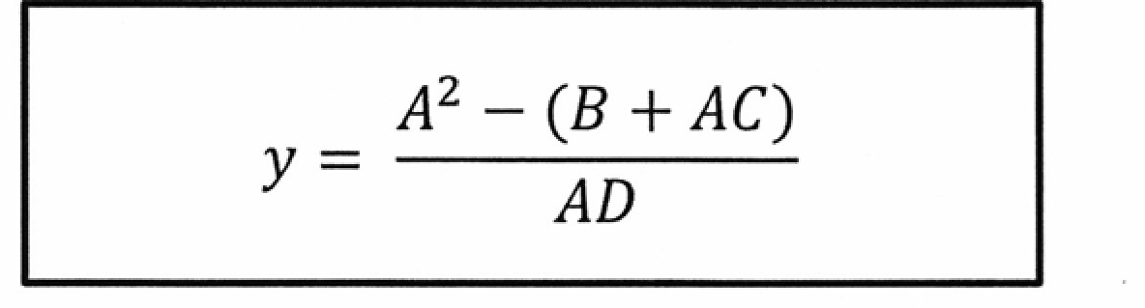
Figure 4
Table 1: Machine Instruction
Zero-address | One-address | Three-address
PUSH | LOAD | ADD
pop | STOR | SUB
ADD | ADD | MUL
SUB | SUB | DIV
MUL
DIV | DIV

