
CONFIDENTIAL CS/NOV 2026/CSC429

UNIVERSITI TEKNOLOGI MARA FINAL EXAMINATION

COURSE
COURSE CODE
EXAMINATION TIME
COMPUTER ORGANIZATION AND ARCHITECTURE

CSC429
NOVEMBER 2026
3 HOURS

INSTRUCTIONS TO CANDIDATES

- This question paper consists of two (2) parts: PART A (10 Questions) PART B (1 Question)

- Answer ALL questions in the Answer Booklet. Start each answer on a new page.

- Do not bring any material into the examination room unless permission is given by the invigilator .
- Please check to make sure that this examination pack consists of: i) the Question Paper
  - an Answer Booklet - provided by the Faculty

- Answer ALL questions in English.

DO NOT TURN THIS PAGE UNTIL YOU ARE TOLD TO DO SO

This examination paper consists of 4 printed pages.

PART A (80 MARKS)
Answer ALL questions in this part.
QUESTION 1 (5 marks)
Give suitable example for each processor organization.
QUESTION 2 (5 marks)
- List TWO (2) advantages of SMP organization.
- Define cluster organization.
- Give ONE (1) benefit of cluster organization.
QUESTION 3 (5 marks)
- Name the inventor of the integrated circuit.
- ln which computer generation was the integrated circuit first introduced?
- List THREE (3) main components of an integrated circuit.
QUESTION 4 (5 marks)
Differentiate between DRAM and SRAM in term of the following characteristics:
- Speed.
- Size per bit.
- Cost.
- Type of bits stored.
- Refreshing need when powered.
QUESTION 5 (10 marks)
- Compare TWO (2) system bus timing approach with appropriate examples.
- Discuss ONE (1) reason why an I/O module is needed.
- List TWO (2) interfaces to external devices
QUESTION 6 (10 marks)
- Explain how the bits are stored in the SRAM and DFiAM.
- Why is SRAM technology faster than DRAM technology?
- Compare SRAM and DRAM in terms of cost and power consumption.
QUESTION 7 (10 marks)
- Convert 273.7812510 to a floating-point number in IEEE single precision format in
hexadecimal value form.
- Convert C158 8000H in IEEE single precision floating point number to decimal value
form
QUESTION 8 (10 marks)
Keyboard is the most common input/output device to communicate between computer and
user.
- What is the input/output module category for keyboard?
- State TWO (2) other devices that are in the similar input/output module category?
- What is the basic unit of exchange for keyboard?
- Discuss TWO (2) types of characters.
QUESTION 9 (10 marks)
Describe FOUR (4) type of access methods based on hardware implementation of the
storage device. Provide ONE (1) appropriate example for each access type.
QUESTION 10 (10 marks)
- Differentiate SRAM and DRAM from the perspective of the following characteristics,
- The way the bits are stored.
- Speed.
- Location it is being used.
- Why does DRAM need refreshing?
- Comparing DRAM and SRAM, which memory would be placed higher in the memory
hierarchy? Give your justification to support your answer.

PART B (20 MARKS)
Answer the question in this part.
QUESTION 11 (20 marks)
Question 1 is based on Figure 1 and Table 1.
Write the appropriate programs using correct assembly language notations and comments to
compute the equation represented in Figure 1 using one-, two- and three-address
instructions. The instructions available for use are provided in Table 1. Note that Register A,
B, C, D, E and F cannot be modified and Register X, Y and Z can be used as temporary
register. Final answer must be stored in Register X.
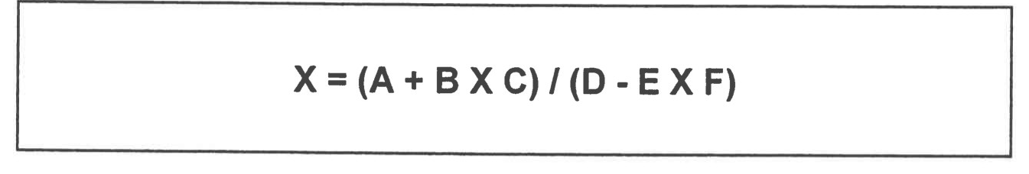
Figure 1
Table 1 : Machine Instruction
i Nia dress |  | address
LOAD M | MOVE (X e Y) | MOVE (X e Y)
STORE M | ADD (X k.. X + Y) | ADD (X e Y + Z)
ADD M | SUB (X e X - Y) | SUB (X e Y-Z)
SUB M | MUL (X e X x Y) | MUL (X e Y x Z)
MUL M | DIV (X e x / Y) | DIV (X e Y / Z)
DIV M

