CONFIDENTIAL  CS/NOV 2026/ICT450

UNIVERSITI TEKNOLOGI MARA
MARKING SCHEME

COURSE :
COURSE CODE :
EXAMINATION :
TIME :
DATABASE DESIGN AND DEVELOPMENT
ICT450
NOVEMBER 2026 (MOCK)
3 HOURS

MARKING SCHEME NOTES

- This marking scheme accompanies the ICT450 mock paper (November 2026).
Answers are unofficial model answers, not official UTM marking schemes.

- Marking points state the expected answer and the allocation of marks; every question retains its source paper and page reference.

- Five questions x 20 marks; total = 100 marks.
- Real-bank questions: 5. Placeholders: 0.
Questions and answers are for local study use only.

- Structure derived from 12 unique ICT450 past papers; every real question remains traceable to its source page.

FOR MARKERS' USE ONLY

This marking scheme consists of 7 printed pages.
MARKING GUIDE
QUESTION 1 (20 marks)
Source: ICT450-2023-JUL · page [2] · bank id ICT450-2023-JUL-Q1
Reference answer
(a) Two limitations of the file-based approach. [4 marks]
• Extensive programming and program-data dependence — every file needs its own management program, and changing a file structure requires the programs to be rewritten.
• Complex and difficult system administration — each file has its own format, access rules and storage, so administration does not scale well.
• Inadequate security and redundant data — access controls are weak, and independent files tend to store the same data more than once, causing inconsistency.
• Difficult structural change and limited sharing — separate files create islands of information that are hard to change or share safely.
(b) Two basic building blocks of a data model. [4 marks]
• Entity — a distinguishable object, person, place or event about which data is kept, such as STUDENT or COURSE.
• Relationship — an association between entities, such as a STUDENT enrolling in a COURSE.
• Attribute — a property that describes an entity, such as StudID or StudentName.
(c) The art and culture club table. [12 marks]
• i) Three characteristics of a relational table violated by Table 1:
• The table has two columns with the same name, “Name”; every column in a relation must have a unique name.
• The Skill column stores several values in one cell, such as “Modern Dance, Singing”; each cell must contain a single atomic value.
• The StudID column mixes numeric values with the text value 2023455abc; all entries in a column must use the same data type.
• There is no clearly declared primary key and the duplicate Name headings make the structure ambiguous.
• ii) Possible courses of action:
• Rename the two Name columns to FirstName and LastName.
• Move Skill into a separate SKILL table keyed by StudID and Skill, creating a one-to-many relationship with STUDENT.
• Standardise StudID as one data type, validate input and reject values such as 2023455abc.
• Declare StudID as the primary key and enforce entity integrity.
Marking guide
• a) 2 marks for each of two limitations named and explained (2 × 2 = 4).
• b) 2 marks for each of two building blocks named and explained (2 × 2 = 4).
• c)(i) 2 marks for each of three violations identified and explained (3 × 2 = 6).
• c)(ii) 2 marks for each of three suitable actions linked to the violations (3 × 2 = 6).
Provenance: model_unofficial · confidence high · Model-authored from the approved question text, the supplied source assets and the ICT200/ICT450 knowledge base; no official ICT450 marking scheme was supplied.
Knowledge base basis: TOPIC 1 DATABASE CONCEPT (1).pdf; TOPIC 2 DATA MODEL (1).pdf; TOPIC 3 RELATIONAL DATA MODELstu.pdf
Assumptions / notes
• Table 1 is treated as a single relation with the columns shown: StudID, Name, Name and Skill.
• A StudID is assumed to be a numeric identifier; the value 2023455abc is therefore an inconsistent data-type entry.

QUESTION 2 (20 marks)
Source: ICT450-2024-JUL · page [3] · bank id ICT450-2024-JUL-Q2
Reference answer
(a) Match the data models with their statements. [4 marks]
• Hierarchical — records are organised in a strict parent-child tree; each child has one parent.
• Network — records are linked through sets and pointers, allowing many-to-many relationships.
• Relational — data is represented as tables with rows, columns and keys, queried with SQL.
• Entity Relationship — a conceptual model of entities, attributes and relationships, usually drawn as an ERD.
(b) Two business rules from the pet-shop schema. [4 marks]
• A customer can make many purchases, but each purchase is made by exactly one customer.
• A purchase can contain many pets, and each pet belongs to one purchase through PurchaseID.
• A pet has one species, age and price recorded.
(c) Three reasons for protecting data. [6 marks]
• Privacy and legal compliance — personal and financial data must not be exposed.
• Data integrity and trust — unauthorised changes can corrupt records and decisions.
• Business continuity and competitive advantage — theft or tampering can cause financial and reputational loss.
(d) Three multimedia data challenges. [6 marks]
• Large storage size — images, audio and video consume much more space than structured records.
• Complex indexing and retrieval — content-based search needs metadata and specialised indexes.
• Format and metadata diversity — many codecs, dimensions and formats must be normalised and described.
Marking guide
• a) 1 mark for each correct data-model description (4).
• b) 2 marks for each business rule (4).
• c) 2 marks for each reason (6).
• d) 2 marks for each challenge (6).
Provenance: model_unofficial · confidence medium · Model-authored from the approved question text, the supplied source assets and the ICT200/ICT450 knowledge base; no official ICT450 marking scheme was supplied.
Knowledge base basis: TOPIC 2 DATA MODEL (1).pdf; TOPIC 6 DATABASE DESIGN (1).pdf
Assumptions / notes
• The matching statements for the data-model table were not present in the extracted asset; the answer describes each model's matching statement.

QUESTION 3 (20 marks)
Source: ICT450-2024-JAN · page [4, 5] · bank id ICT450-2024-JAN-Q3
Reference answer
Figure 2 is an employee evaluation report. One employee has several project rows, so the report is an unnormalised relation with a repeating group.
(a) Normal form of Figure 2 and reasons. [3 marks]
The report is in unnormalised form (UNF) because the project rows repeat for the same employee. If it is flattened to one row per project, it is in 1NF, but it still contains partial and transitive dependencies. It is not in 2NF or 3NF.
Unnormalised report relation.
REPORT (EmployeeID, EmployeeName, EmploymentYear, DepartmentID, DepartmentName, Phone, Address, ProjectCode, ProjectName, Location, Grade, SupervisorID, SupervisorName, SupervisorDepartment)
(b) Relational schema, primary keys and dependencies. [6 marks]
The repeated project code ST01 with two locations is a key trap: ProjectCode alone does not identify a project instance. The assignment key is (EmployeeID, ProjectCode, Location).
Relational schema before 3NF.
EMPLOYEE (EmployeeID, EmployeeName, EmploymentYear, DepartmentID, DepartmentName, Phone, Address)
PROJECT (ProjectCode, ProjectName)
PROJECT_LOCATION (ProjectCode, Location)
SUPERVISOR (SupervisorID, SupervisorName, SupervisorDepartment)
ASSIGNMENT (EmployeeID, ProjectCode, Location, Grade, SupervisorID)
Functional dependencies:
Functional dependencies in the report.
EmployeeID → EmployeeName, EmploymentYear, DepartmentID, DepartmentName, Phone, Address
ProjectCode → ProjectName
SupervisorID → SupervisorName, SupervisorDepartment
EmployeeID, ProjectCode, Location → Grade, SupervisorID
DepartmentID → DepartmentName
(c) Normalise to 3NF, showing all steps. [11 marks]
Step 1 — 1NF: one row per employee-project assignment; all cells atomic. Key: (EmployeeID, ProjectCode, Location).
Step 2 — 2NF: remove partial dependencies. Employee data depends on EmployeeID; project data depends on ProjectCode; supervisor data depends on SupervisorID.
2NF relations.
EMPLOYEE (EmployeeID, EmployeeName, EmploymentYear, DepartmentID, DepartmentName, Phone, Address)
PROJECT (ProjectCode, ProjectName)
PROJECT_LOCATION (ProjectCode, Location)
SUPERVISOR (SupervisorID, SupervisorName, SupervisorDepartment)
ASSIGNMENT (EmployeeID, ProjectCode, Location, Grade, SupervisorID)
Step 3 — 3NF: remove transitive dependencies. DepartmentName depends on DepartmentID, and the supervisor's department depends on SupervisorID.
3NF relations.
DEPARTMENT (DepartmentID, DepartmentName)
EMPLOYEE (EmployeeID, EmployeeName, EmploymentYear, DepartmentID, Phone, Address)
PROJECT (ProjectCode, ProjectName)
PROJECT_LOCATION (ProjectCode, Location)
SUPERVISOR (SupervisorID, SupervisorName, DepartmentID)
ASSIGNMENT (EmployeeID, ProjectCode, Location, Grade, SupervisorID)
3NF sample data: EMPLOYEE
EmployeeID | EmployeeName | EmploymentYear | DepartmentID | Phone | Address
303303 | Siti Nur Fadilah | 2000 | S1 | 017 | JC 1234, Bandar Jasin Bestari Seksyen 7, Melaka

3NF sample data: DEPARTMENT
DepartmentID | DepartmentName
S1 | Software Development

3NF sample data: PROJECT and PROJECT_LOCATION
ProjectCode | ProjectName | Location
MD01 | Mobile Apps Development | Kuala Terengganu
WD01 | Website Development | Machang
ST01 | Software Integration | Seremban
ST01 | Software Integration | Tapah

3NF sample data: SUPERVISOR
SupervisorID | SupervisorName | DepartmentID
123123 | Willy | S1
101101 | Mawar | S1

3NF sample data: ASSIGNMENT
EmployeeID | ProjectCode | Location | Grade | SupervisorID
303303 | MD01 | Kuala Terengganu | A | 123123
303303 | WD01 | Machang | A+ | 101101
303303 | ST01 | Seremban | A- | 101101
303303 | ST01 | Tapah | A | 101101

Marking guide
• a) 3 marks: UNF/1NF identified (1), repeating group explained (1), reason why not 2NF/3NF (1).
• b) 6 marks: relations (3), keys (2), dependencies (1).
• c) 11 marks: 1NF (2), 2NF with partial dependencies removed (4), 3NF with transitive dependencies removed and DEPARTMENT split (5).
Provenance: model_unofficial · confidence medium · Model-authored from the approved question text, the supplied source assets and the ICT200/ICT450 knowledge base; no official ICT450 marking scheme was supplied.
Knowledge base basis: TOPIC 5 NORMALIZATION (1).pdf
Assumptions / notes
• The report contains a repeating group of projects for one employee.
• Project code ST01 appears twice with different locations, so the project instance is identified by (ProjectCode, Location).
• Supervisor department names map to DepartmentID values; this supports the 3NF split into DEPARTMENT.

QUESTION 4 (20 marks)
Source: ICT450-2025-FEB · page [4] · bank id ICT450-2025-FEB-Q4
Reference answer
e-Travel schema.
CUSTOMERS (CustomerID, FirstName, LastName, PhoneNumber)
BOOKING (BookingID, BookingDate, NumberOfPax, TripDate, CustomerID*, GuideID*, PackageID*)
GUIDE (GuideID, GuideName, BasicSalary, HireDate)
PACKAGE (PackageID, PackageName, PricePerPax, PackageDetails)
(a) Total number of trips for each date. [4 marks]
SELECT TripDate, COUNT(*) AS total_trips
FROM BOOKING
GROUP BY TripDate;
(b) Customer with the highest number of bookings. [4 marks]
SELECT c.*
FROM CUSTOMERS c
JOIN BOOKING b ON b.CustomerID = c.CustomerID
GROUP BY c.CustomerID, c.FirstName, c.LastName, c.PhoneNumber
ORDER BY COUNT(*) DESC
FETCH FIRST 1 ROW ONLY;
(c) Increase 10% salary for guides on a February 2025 trip. [4 marks]
UPDATE GUIDE
SET BasicSalary = BasicSalary * 1.10
WHERE GuideID IN (
SELECT GuideID
FROM BOOKING
WHERE TripDate BETWEEN DATE '2025-02-01' AND DATE '2025-02-28'
);
(d) Packages booked more than 70 times. [4 marks]
SELECT p.PackageName
FROM PACKAGE p
JOIN BOOKING b ON b.PackageID = p.PackageID
GROUP BY p.PackageID, p.PackageName
HAVING COUNT(*) > 70;
(e) Customers who booked between February and March 2025. [4 marks]
SELECT COUNT(DISTINCT CustomerID) AS total_customers
FROM BOOKING
WHERE TripDate BETWEEN DATE '2025-02-01' AND DATE '2025-03-31';
Marking guide
• a) 4 marks: GROUP BY date and COUNT.
• b) 4 marks: join, GROUP BY customer, descending order/top-1.
• c) 4 marks: UPDATE, 10%, February subquery.
• d) 4 marks: join, GROUP BY package, HAVING > 70.
• e) 4 marks: COUNT DISTINCT and date range.
Provenance: model_unofficial · confidence high · Model-authored from the approved question text, the supplied source assets and the ICT200/ICT450 knowledge base; no official ICT450 marking scheme was supplied.
Knowledge base basis: TOPIC 7 SQL.pdf
Assumptions / notes
• TripDate is the date used for the February/March filters.

QUESTION 5 (20 marks)
Source: ICT450-2026-FEB · page [4, 5, 6] · bank id ICT450-2026-FEB-Q5
Reference answer
The ERD models customers, orders, products, order lines, invoices and delivery slots. ORDER_ITEM resolves the many-to-many order-product relationship.
(a) Construct the ERD with Crow's Foot notation. [16 marks]
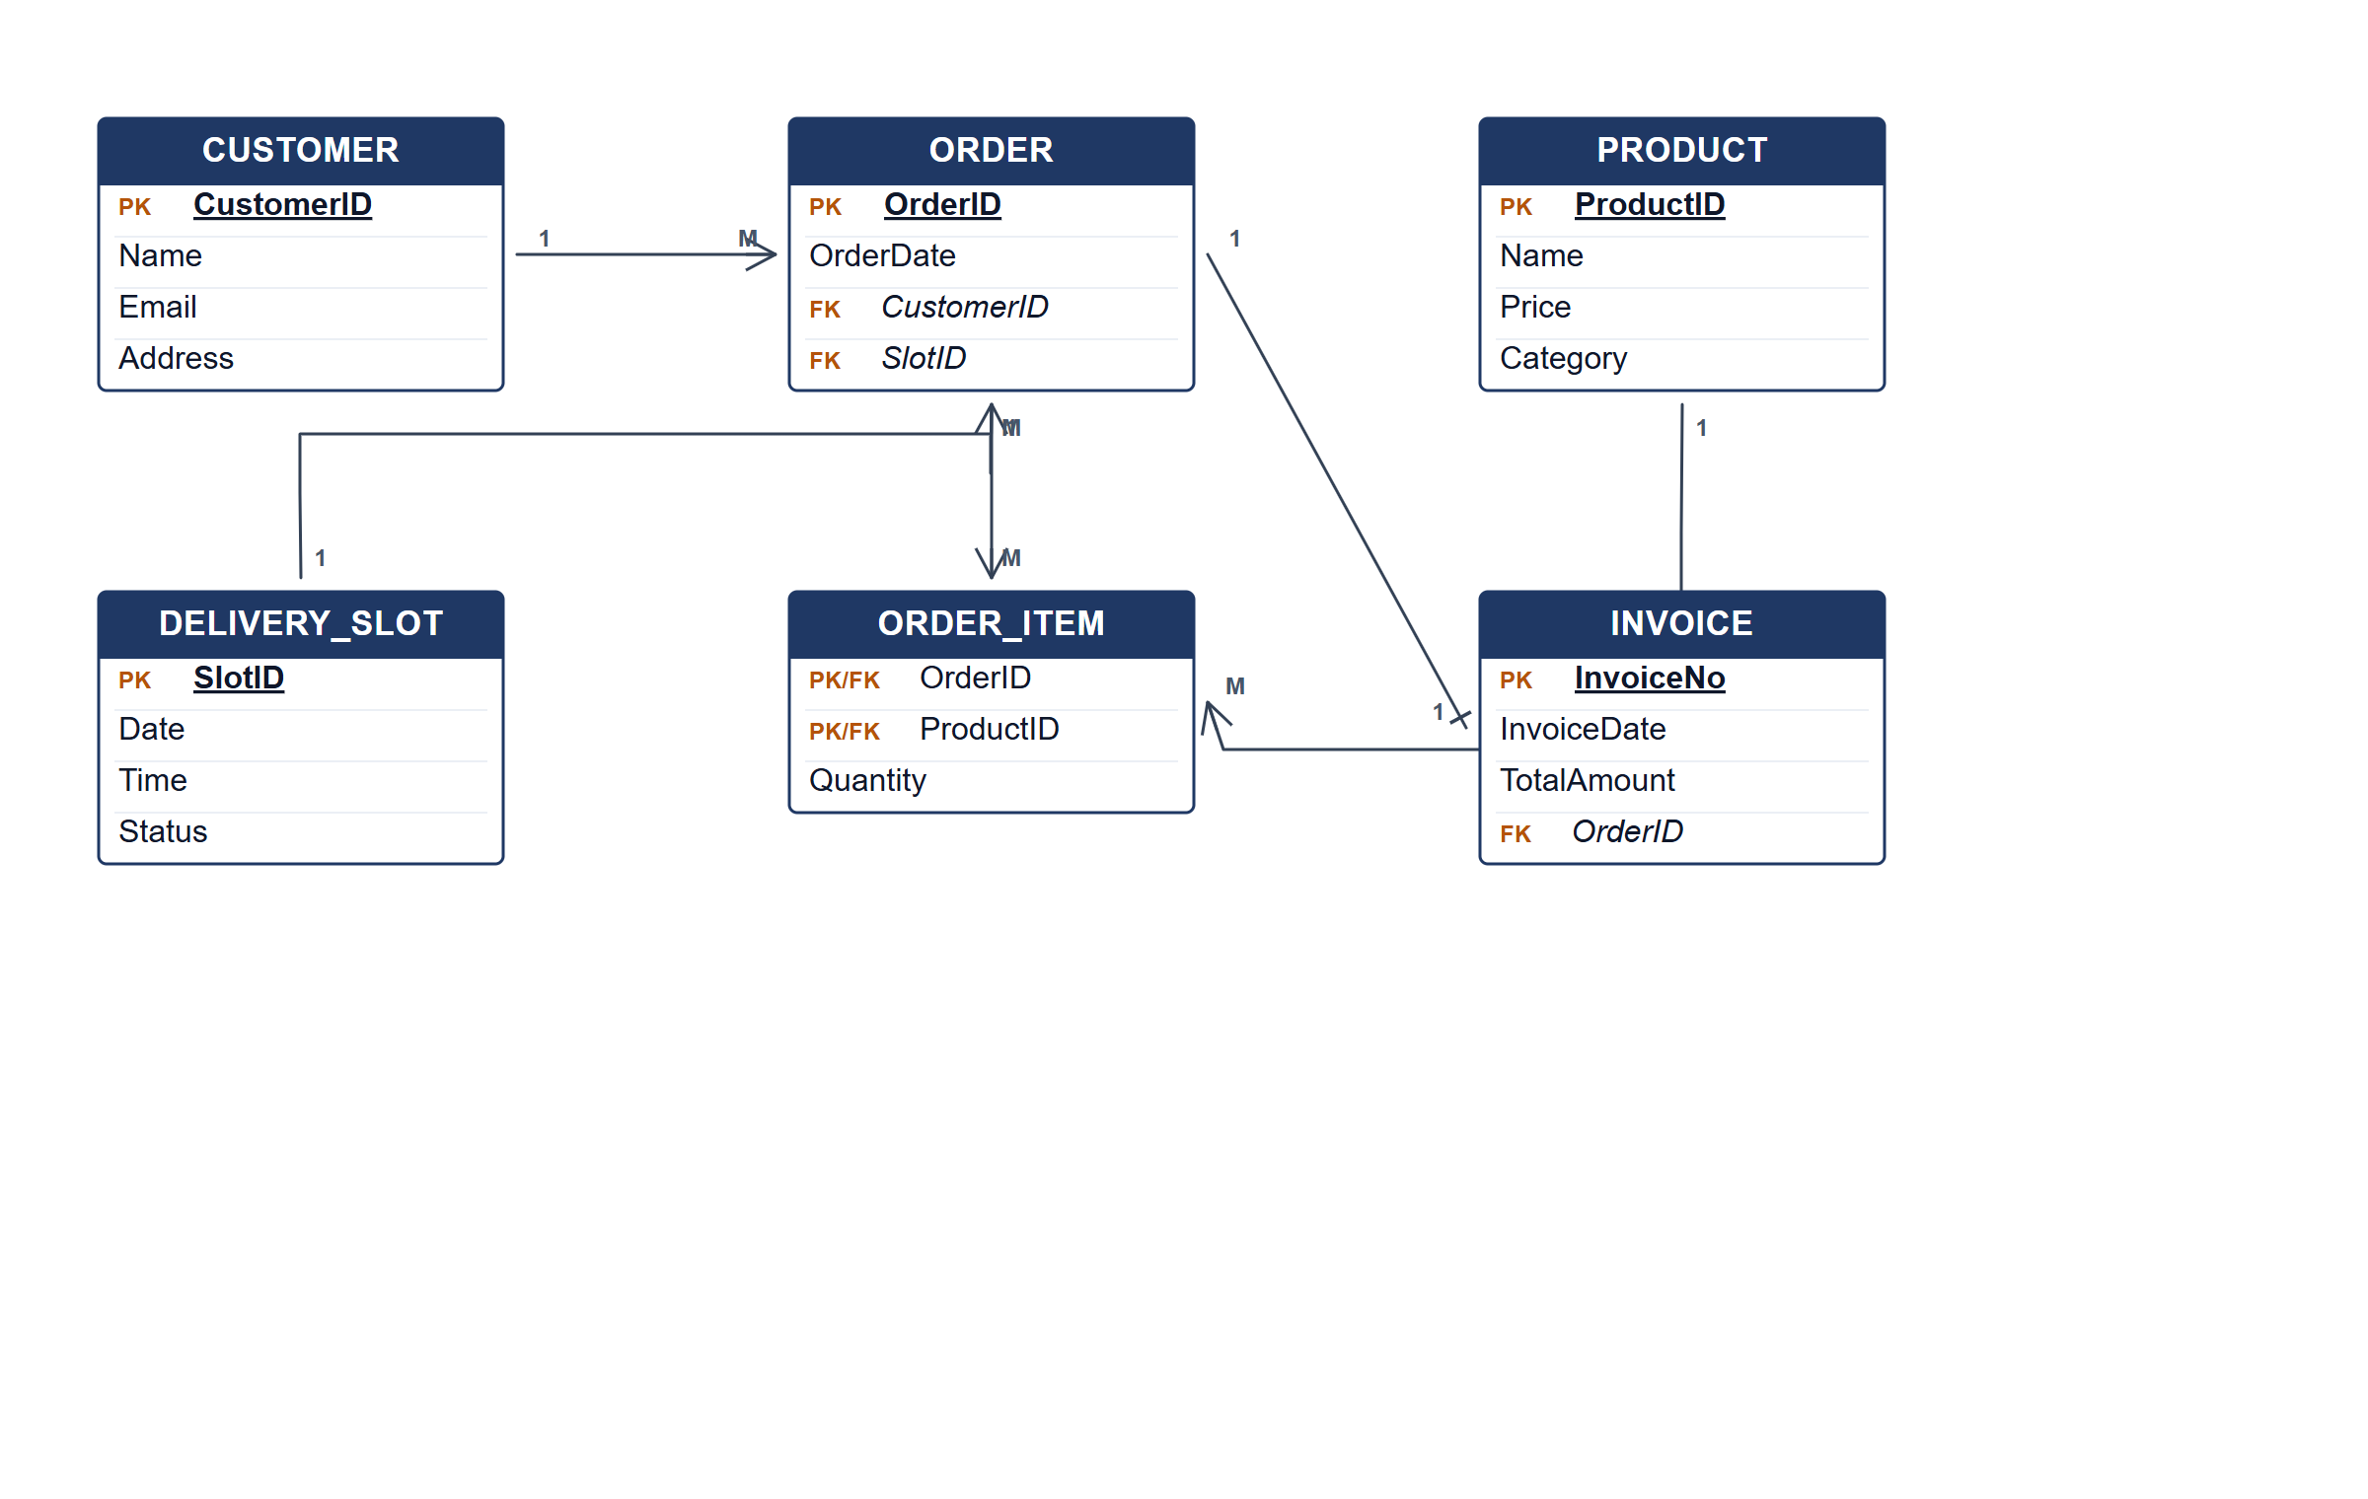
FreshBasket ERD.
(b) Two pieces of information from the ERD. [4 marks]
• The products and quantities in each customer order.
• The invoice total and delivery slot for each order.
Marking guide
• a) 16 marks: customer/order/product (5); order item, invoice and delivery slot (5); relationships and cardinalities (4); keys (2).
• b) 2 marks for each information item (4).
Provenance: model_unofficial · confidence high · Model-authored from the approved question text, the supplied source assets and the ICT200/ICT450 knowledge base; no official ICT450 marking scheme was supplied.
Knowledge base basis: TOPIC 4 ERD_stu (2).pdf; TOPIC 3 RELATIONAL DATA MODELstu.pdf
Assumptions / notes
• An order has exactly one invoice and one delivery slot; an order can contain many products.

