CONFIDENTIAL  CS/NOV 2026/ICT450

UNIVERSITI TEKNOLOGI MARA
MARKING SCHEME

COURSE :
COURSE CODE :
EXAMINATION :
TIME :
DATABASE DESIGN AND DEVELOPMENT
ICT450
NOVEMBER 2026 (MOCK)
3 HOURS

MARKING SCHEME NOTES

- This marking scheme accompanies the ICT450 mock paper (November 2026).
Answers are unofficial model answers, not official UTM marking schemes.

- Marking points state the expected answer and the allocation of marks; every question retains its source paper and page reference.

- Five questions x 20 marks; total = 100 marks.
- Real-bank questions: 5. Placeholders: 0.
Questions and answers are for local study use only.

- Structure derived from 12 unique ICT450 past papers; every real question remains traceable to its source page.

FOR MARKERS' USE ONLY

This marking scheme consists of 7 printed pages.
MARKING GUIDE
QUESTION 1 (20 marks)
Source: ICT450-2022-FEB · page [2, 3] · bank id ICT450-2022-FEB-Q1
Reference answer
(a) Four data items in online purchasing. [4 marks]
• Customer identity and contact data.
• Product ID, name, price and quantity.
• Order ID, order date and payment status.
• Delivery address and tracking information.
(b) Relational model features and importance. [4 marks]
• Data is represented as relations (tables) of rows and columns, with keys and integrity constraints.
• End users see a simple tabular view and can query it with SQL without knowing physical storage.
• Designers gain a logical, DBMS-independent structure that supports data independence and controlled redundancy.
(c) Keys and integrity for the academy tables. [12 marks]
• i) Superkeys include {STUDENT_IC}, {STUDENT_ID}, {EMAIL}, {STUDENT_IC, STUDENT_ID} and {STUDENT_ID, EMAIL}.
• Candidate keys: STUDENT_IC, STUDENT_ID and EMAIL, because each is unique and minimal.
• Primary key: STUDENT_ID — it is unique, stable and shorter than the IC.
• ii) STUDENT: entity integrity YES because STUDENT_ID is unique and non-null; referential integrity YES because every COURSE_ID exists in COURSE.
• COURSE: entity integrity YES because COURSE_ID is the unique primary key; referential integrity is not applicable because it has no foreign key.
Marking guide
• a) 1 mark for each of four data items (4).
• b) 2 marks for the features and 2 marks for importance (4).
• c)(i) 2 marks for superkeys, 2 for candidate keys and 2 for the primary key/reason (6).
• c)(ii) 3 marks for each table's integrity explanation (6).
Provenance: model_unofficial · confidence high · Model-authored from the approved question text, the supplied source assets and the ICT200/ICT450 knowledge base; no official ICT450 marking scheme was supplied.
Knowledge base basis: TOPIC 1 DATABASE CONCEPT (1).pdf; TOPIC 2 DATA MODEL (1).pdf; TOPIC 3 RELATIONAL DATA MODELstu.pdf
Assumptions / notes
• The STUDENT table has unique STUDENT_IC, STUDENT_ID and EMAIL values; the third table is the COURSE table shown.

QUESTION 2 (20 marks)
Source: ICT450-2023-JUL · page [2] · bank id ICT450-2023-JUL-Q2
Reference answer
(a) Four activities in the database design phase. [8 marks]
• Create the conceptual design — identify entities, attributes, relationships and business rules.
• Select the DBMS software — choose a platform that fits the data model, cost and hardware.
• Create the logical design — map the conceptual model to tables, keys, domains and constraints.
• Create the physical design — choose storage, indexes, file organisation and access paths.
(b) Mobile database suitability and three usage factors. [8 marks]
• Yes, a mobile database is suitable for a company with branches in Malaysia and Indonesia because staff need access away from the office.
• Factor 1: ubiquitous connectivity — field staff can reach the database from any branch or location.
• Factor 2: synchronization — local device data can be reconciled with the central database when connectivity returns.
• Factor 3: portability and location-aware services — mobile devices support on-site inventory and customer service.
(c) Structured versus unstructured data. [4 marks]
• Structured data has a predefined schema and is stored in rows and columns; example: a sales table.
• Unstructured data has no predefined relational schema; example: images, video, audio or free-text documents.
Marking guide
• a) 2 marks for each of four design activities (8).
• b) 2 marks for suitability and 2 marks for each of three factors (2 + 6 = 8).
• c) 2 marks for each data type with example (4).
Provenance: model_unofficial · confidence high · Model-authored from the approved question text, the supplied source assets and the ICT200/ICT450 knowledge base; no official ICT450 marking scheme was supplied.
Knowledge base basis: TOPIC 2 DATA MODEL (1).pdf; TOPIC 6 DATABASE DESIGN (1).pdf

QUESTION 3 (20 marks)
Source: ICT450-2023-FEB · page [4] · bank id ICT450-2023-FEB-Q3
Reference answer
The boarding schema contains a repeating group of flight and destination attributes for each customer booking.
(a) Define normalization and its importance. [3 marks]
• Normalization is the process of evaluating and correcting table structures to minimise redundancy and anomalies.
• It is important because it prevents insertion, update and deletion anomalies and keeps each fact in one place.
(b) Three requirements for good normalized tables. [6 marks]
• Each cell must be atomic and there must be no repeating groups; example: one row per boarding pass, not a list of flights in one cell.
• Every non-key attribute must depend on the whole primary key; example: customer name depends on CustIC, not on FlightID.
• There must be no transitive dependency; example: DestinationName must depend on DestinationID, not on FlightID through the destination.
(c) Normalise to 3NF. [11 marks]
1NF: expand the repeating group to one row per customer-flight-date; key (CustIC, FlightID, DateDepart).
2NF: remove customer, flight and destination partial dependencies.
2NF relations.
CUSTOMER (CustIC, CustFirstName, CustLastName)
FLIGHT (FlightID, PlaneType, Capacity, DestinationID)
DESTINATION (DestinationID, DestinationName)
BOARDING (CustIC, FlightID, DateDepart, DateArrive, TimeDepart, TimeArrive, Seat)
3NF: separate the flight schedule so date/time attributes depend on FlightID and DateDepart, not on the passenger.
3NF relations.
CUSTOMER (CustIC, CustFirstName, CustLastName)
DESTINATION (DestinationID, DestinationName)
FLIGHT (FlightID, PlaneType, Capacity, DestinationID)
FLIGHT_SCHEDULE (FlightID, DateDepart, DateArrive, TimeDepart, TimeArrive)
BOARDING (CustIC, FlightID, DateDepart, Seat)
Marking guide
• a) 3 marks: definition and importance.
• b) 6 marks: 2 marks for each requirement with example.
• c) 11 marks: 1NF (2), 2NF (4), 3NF (5).
Provenance: model_unofficial · confidence medium · Model-authored from the approved question text, the supplied source assets and the ICT200/ICT450 knowledge base; no official ICT450 marking scheme was supplied.
Knowledge base basis: TOPIC 5 NORMALIZATION (1).pdf
Assumptions / notes
• The curly braces in the printed schema denote a repeating group of flight/destination attributes.

QUESTION 4 (20 marks)
Source: ICT450-2024-JAN · page [5] · bank id ICT450-2024-JAN-Q4
Reference answer
Movie database schema.
MOVIE (MovieID, MovieName, Genre, DateRelease, NetProfit, DirectorID*)
DIRECTOR (DirectorID, DirectorName, Nationality)
REVIEW (ReviewID, Description, MovieID*, ReviewerID*)
REVIEWER (ReviewerID, ReviewerName)
(a) Movies released from 2021 until 2023. [4 marks]
SELECT *
FROM MOVIE
WHERE DateRelease BETWEEN DATE '2021-01-01' AND DATE '2023-12-31';
(b) Total movies directed by Malaysian directors. [4 marks]
SELECT COUNT(*) AS total_movies
FROM MOVIE m
JOIN DIRECTOR d ON d.DirectorID = m.DirectorID
WHERE d.Nationality = 'Malaysian';
(c) Average net profit for each genre. [4 marks]
SELECT Genre, AVG(NetProfit) AS "Average Net Profit"
FROM MOVIE
GROUP BY Genre;
(d) Reviewers with more than two reviews. [4 marks]
SELECT r.ReviewerName
FROM REVIEWER r
JOIN REVIEW v ON v.ReviewerID = r.ReviewerID
GROUP BY r.ReviewerID, r.ReviewerName
HAVING COUNT(*) > 2;
(e) Movie that received the most reviews. [4 marks]
SELECT m.MovieName
FROM MOVIE m
JOIN REVIEW v ON v.MovieID = m.MovieID
GROUP BY m.MovieID, m.MovieName
ORDER BY COUNT(*) DESC
FETCH FIRST 1 ROW ONLY;
MySQL: replace FETCH FIRST 1 ROW ONLY with LIMIT 1.
Marking guide
• a) 4 marks: date range and SELECT.
• b) 4 marks: movie-director join and Malaysian filter.
• c) 4 marks: AVG, GROUP BY genre and alias.
• d) 4 marks: join, GROUP BY reviewer, HAVING > 2.
• e) 4 marks: join, COUNT, descending order and top-1.
Provenance: model_unofficial · confidence high · Model-authored from the approved question text, the supplied source assets and the ICT200/ICT450 knowledge base; no official ICT450 marking scheme was supplied.
Knowledge base basis: TOPIC 7 SQL.pdf
Assumptions / notes
• DateRelease is stored as a date; 'most reviews' is answered with a top-1 ordered query.

QUESTION 5 (20 marks)
Source: ICT450-2025-FEB · page [5] · bank id ICT450-2025-FEB-Q5
Reference answer
The ERD separates studios, employees, programs, suppliers, materials and skills. The many-to-many relationships are drawn directly between entities. At implementation they become junction tables: STUDIO_SUPPLIER, SUPPLIER_MATERIAL and EMPLOYEE_SKILL. The PROGRAM subtype attributes are listed below the diagram.
(a) Construct the ERD with Crow's Foot notation. [16 marks]
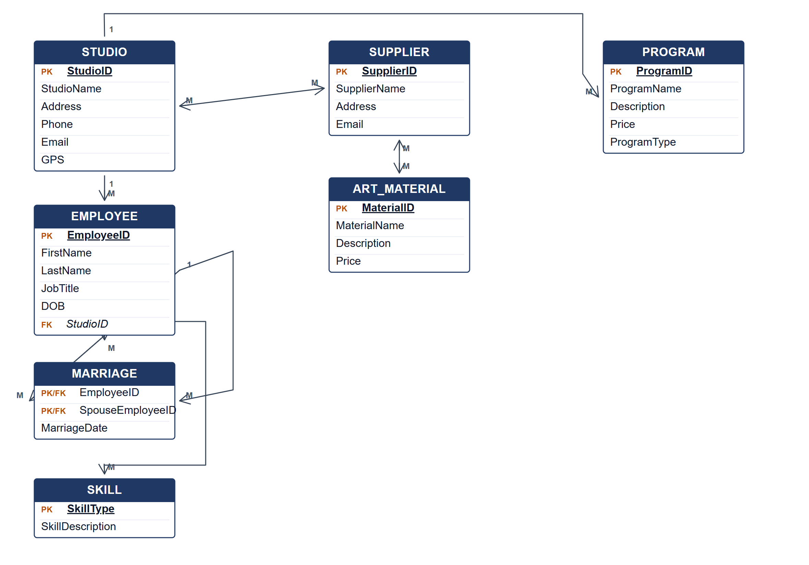
Crow's Foot ERD for the Excellent Art database.
PROGRAM subtype attributes
Program type | Subtype attribute
Visual Art | ClassType
Glass Painting | ProgramLevel (1–5)
Handicraft | CraftData

(b) Two reports from the ERD. [4 marks]
• Studio programme report — list each studio with its programmes, programme type and subtype-specific details such as class type, program level or craft data.
• Supplier and material report — show each studio's suppliers and the art materials each supplier provides, with prices.
• Employee skills report — list employees by studio with their acquired skills.
Marking guide
• a) 16 marks: STUDIO, EMPLOYEE, PROGRAM and SUPPLIER (4); ART_MATERIAL, SKILL and MARRIAGE (3); PROGRAM subtype attributes (2); direct many-to-many relationships and their junction tables (3); keys and Crow's Foot cardinalities (4).
• b) 2 marks for each of two relevant reports explained (2 × 2 = 4).
Provenance: model_unofficial · confidence medium · Model-authored from the approved question text, the supplied source assets and the ICT200/ICT450 knowledge base; no official ICT450 marking scheme was supplied.
Knowledge base basis: TOPIC 4 ERD_stu (2).pdf; TOPIC 3 RELATIONAL DATA MODELstu.pdf
Assumptions / notes
• PROGRAM subtypes share the ProgramID key. Their subtype attributes are listed below the diagram rather than drawn as separate boxes, keeping the ERD readable.
• A marriage is represented as an associative entity linking two EMPLOYEE rows, because it has a marriage date and involves two employees.
• STUDIO deals with many SUPPLIERs, and SUPPLIER supplies many ART_MATERIALs; both many-to-many relationships are drawn directly and become junction tables at implementation.

