CONFIDENTIAL  CS/NOV 2026/ICT450

UNIVERSITI TEKNOLOGI MARA
MARKING SCHEME

COURSE :
COURSE CODE :
EXAMINATION :
TIME :
DATABASE DESIGN AND DEVELOPMENT
ICT450
NOVEMBER 2026 (MOCK)
3 HOURS

MARKING SCHEME NOTES

- This marking scheme accompanies the ICT450 mock paper (November 2026).
Answers are unofficial model answers, not official UTM marking schemes.

- Marking points state the expected answer and the allocation of marks; every question retains its source paper and page reference.

- Five questions x 20 marks; total = 100 marks.
- Real-bank questions: 5. Placeholders: 0.
Questions and answers are for local study use only.

- Structure derived from 12 unique ICT450 past papers; every real question remains traceable to its source page.

FOR MARKERS' USE ONLY

This marking scheme consists of 7 printed pages.
MARKING GUIDE
QUESTION 1 (20 marks)
Source: ICT450-2018-JUN · page [2] · bank id ICT450-2018-JUN-Q1
Reference answer
(a) Two problems associated with a file system. [4 marks]
• Extensive programming and program-data dependence — each file needs its own management program, and changing a file structure breaks the programs.
• Data redundancy and inconsistency — the same data is stored in several files and updates are not coordinated.
• Complex administration and weak security — file access is decentralised and difficult to control.
(b) Basic structure of the ER model and two advantages. [4 marks]
• The ER model represents data as entities, attributes and relationships; entities are objects, attributes describe them and relationships connect them.
• Advantage: it is a clear communication tool between designers, programmers and users.
• Advantage: it is independent of the DBMS and provides a conceptual blueprint before implementation.
(c) TRUCK, BASE and TYPE tables. [12 marks]
• i) TRUCK to BASE is many-to-one: each truck has one Base_Code, while one base can have many trucks. TRUCK to TYPE is also many-to-one: each truck has one Type_Code.
• Entity integrity: TRUCK YES (Truck_Num is unique and non-null); BASE YES (Base_Code is unique and non-null); TYPE YES (Type_Code is unique and non-null).
• Referential integrity: every TRUCK.Base_Code exists in BASE and every TRUCK.Type_Code exists in TYPE.
• ii) ERD:
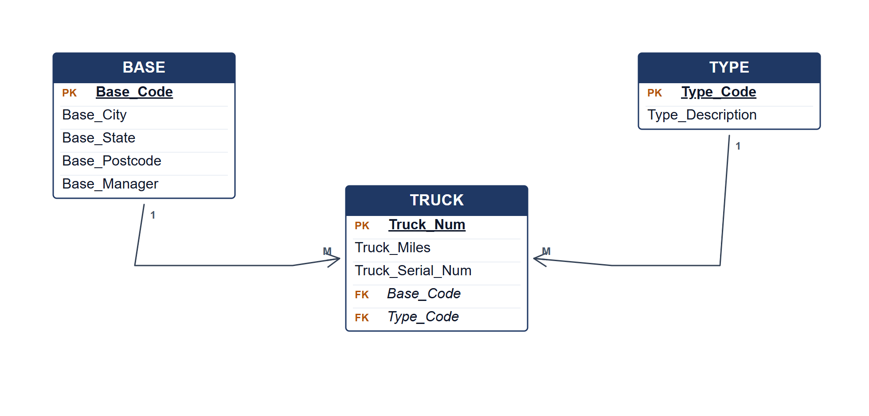
Crow's Foot ERD for TRUCK, BASE and TYPE.
Marking guide
• a) 2 marks for each of two file-system problems (2 × 2 = 4).
• b) 2 marks for the ER structure and 2 marks for each advantage (2 + 2 = 4).
• c)(i) 3 marks for the relationship types and 2 marks for the entity-integrity explanation (5).
• c)(ii) 7 marks for entities, keys, relationships, connectivity and cardinalities.
Provenance: model_unofficial · confidence high · Model-authored from the approved question text, the supplied source assets and the ICT200/ICT450 knowledge base; no official ICT450 marking scheme was supplied.
Knowledge base basis: TOPIC 1 DATABASE CONCEPT (1).pdf; TOPIC 2 DATA MODEL (1).pdf; TOPIC 3 RELATIONAL DATA MODELstu.pdf
Assumptions / notes
• The TRUCK table has a composite foreign key to BASE and TYPE; both are mandatory.

QUESTION 2 (20 marks)
Source: ICT450-2019-DEC · page [2, 3] · bank id ICT450-2019-DEC-Q2
Reference answer
(a) Entity and attribute concepts with examples. [8 marks]
• An entity is a distinguishable object, person, place or event about which the database stores data.
• An attribute is a property that describes an entity; it has a domain and may be a key.
• Example 1: entity STUDENT with attributes StudentID, StudentName, Programme and GPA.
• Example 2: entity COURSE with attributes CourseCode, CourseName, CreditHour and Department.
• The business rules determine which entities and attributes are needed and how they are related.
(b) Purpose of entity integrity. [2 marks]
• Entity integrity requires every primary key to be unique and non-null, so each row can be identified without ambiguity.
(c) Top-down versus bottom-up design. [4 marks]
• Top-down starts with the overall business model and decomposes it into entities and attributes.
• Bottom-up starts with individual attributes and data elements and combines them into entities and relationships.
• Top-down suits a new, well-understood enterprise model; bottom-up suits existing files being integrated.
(d) Three types of periodic maintenance. [6 marks]
• Corrective maintenance — fixing errors discovered in operation.
• Adaptive maintenance — adapting to new hardware, software or business requirements.
• Perfective maintenance — improving performance, usability or adding enhancements.
Marking guide
• a) 4 marks for entity/attribute definitions and 4 marks for two examples (8).
• b) 2 marks for the entity-integrity purpose.
• c) 2 marks for each approach and 2 marks for the comparison (4).
• d) 2 marks for each maintenance type (6).
Provenance: model_unofficial · confidence high · Model-authored from the approved question text, the supplied source assets and the ICT200/ICT450 knowledge base; no official ICT450 marking scheme was supplied.
Knowledge base basis: TOPIC 2 DATA MODEL (1).pdf; TOPIC 6 DATABASE DESIGN (1).pdf
Assumptions / notes
• Figure 2.0 is answered generically because the asset is a figure crop; the examples use standard entities.

QUESTION 3 (20 marks)
Source: ICT450-2019-JUN · page [5] · bank id ICT450-2019-JUN-Q4
Reference answer
The AB Bistro receipt contains one receipt header and a repeating list of menu items. It is flattened to one row per menu line.
(a) Normal form of the receipt. [3 marks]
• The flattened receipt is in 1NF because each cell is atomic and the key (ReceiptNo, MenuID) can be formed.
• It is not in 2NF: receipt date/time/server/table/total depend only on ReceiptNo, while MenuDescription and Price depend only on MenuID.
• It is not in 3NF because ServerName depends transitively on ServerID.
(b) Purpose of normalization. [3 marks]
• Normalization removes redundant data and update anomalies by placing each fact in one table and linking tables with keys.
(c) Normalise to 3NF. [14 marks]
1NF: one row per receipt-menu line; key (ReceiptNo, MenuID).
1NF relation.
RECEIPT_1NF (ReceiptNo, ReceiptDate, ReceiptTime, ServerID, ServerName, TableNo, MenuID, MenuDescription, Quantity, Price, Amount, Total, Payment, Balance)
2NF: remove partial dependencies.
2NF relations.
RECEIPT (ReceiptNo, ReceiptDate, ReceiptTime, ServerID, ServerName, TableNo, Total, Payment, Balance)
MENU (MenuID, MenuDescription, Price)
RECEIPT_ITEM (ReceiptNo, MenuID, Quantity, Amount)
3NF: remove ServerID → ServerName.
3NF relations.
SERVER (ServerID, ServerName)
RECEIPT (ReceiptNo, ReceiptDate, ReceiptTime, ServerID, TableNo, Total, Payment, Balance)
MENU (MenuID, MenuDescription, Price)
RECEIPT_ITEM (ReceiptNo, MenuID, Quantity, Amount)
Sample receipt data
ReceiptNo | Date | Server | Table | Total | Payment | Balance
101 | 17/01/2019 | Nurul Najwa | 30 | 34.00 | 50.00 | 16.00

Sample menu data
MenuID | Description | Price
M10 | Tomyam Thai | 10.00
M12 | Daging Masak Pedas | 7.00
D4 | Teh Ais | 2.50

Marking guide
• a) 3 marks: 1NF identified, with 2NF and 3NF reasons.
• b) 3 marks: redundancy/anomaly purpose.
• c) 14 marks: 1NF (3), 2NF partial dependencies (5), 3NF transitive dependency (6).
Provenance: model_unofficial · confidence high · Model-authored from the approved question text, the supplied source assets and the ICT200/ICT450 knowledge base; no official ICT450 marking scheme was supplied.
Knowledge base basis: TOPIC 5 NORMALIZATION (1).pdf
Assumptions / notes
• The receipt is treated as one header with repeating menu lines; Amount = Quantity × Price.

QUESTION 4 (20 marks)
Source: ICT450-2022-FEB · page [5, 6] · bank id ICT450-2022-FEB-Q4
Reference answer
Publishing schema.
PUBLISHER (PublisherName, City, State, Country, PhoneNum)
AUTHOR (AuthorNum, AuthorName)
BOOK (ISBN, BookName, PublicationYear, AuthorNum, PublisherName)
CUSTOMER (CustNum, CustName, Street, City, State, Country, Email)
ORDER (OrderID, ISBN, CustNum, Date, Quantity)
(a) Create the BOOK table. [4 marks]
CREATE TABLE BOOK (
ISBN VARCHAR(20) NOT NULL,
BookName VARCHAR(150) NOT NULL,
PublicationYear NUMBER(4),
AuthorNum NUMBER(10),
PublisherName VARCHAR(100),
PRIMARY KEY (ISBN),
FOREIGN KEY (AuthorNum) REFERENCES AUTHOR (AuthorNum),
FOREIGN KEY (PublisherName) REFERENCES PUBLISHER (PublisherName)
);
(b) Books by John Wiley & Sons Inc and Pustaka Berhad. [4 marks]
SELECT b.ISBN, b.BookName, a.AuthorName
FROM BOOK b
JOIN AUTHOR a ON a.AuthorNum = b.AuthorNum
WHERE b.PublisherName IN ('John Wiley & Sons Inc', 'Pustaka Berhad')
ORDER BY b.BookName DESC;
(c) Books published in 2021 by Pustaka Trading in Jasin, Melaka. [4 marks]
SELECT COUNT(*) AS total_books
FROM BOOK b
JOIN PUBLISHER p ON p.PublisherName = b.PublisherName
WHERE b.PublicationYear = 2021
AND p.PublisherName = 'Pustaka Trading'
AND p.City = 'Jasin'
AND p.State = 'Melaka';
(d) Publisher that published more than 50 books. [4 marks]
SELECT PublisherName, COUNT(*) AS total_books
FROM BOOK
GROUP BY PublisherName
HAVING COUNT(*) > 50;
(e) Book name with total orders more than 3. [4 marks]
SELECT b.BookName, SUM(o.Quantity) AS total_ordered
FROM BOOK b
JOIN "ORDER" o ON o.ISBN = b.ISBN
GROUP BY b.ISBN, b.BookName
HAVING SUM(o.Quantity) > 3;
Marking guide
• a) 4 marks: columns/types (2), primary key (1), foreign keys (1).
• b) 4 marks: joins (2), IN filter (1), descending order (1).
• c) 4 marks: joins (2), year/city/state filters (2).
• d) 4 marks: GROUP BY publisher and HAVING > 50.
• e) 4 marks: join (2), SUM/GROUP BY/HAVING (2).
Provenance: model_unofficial · confidence high · Model-authored from the approved question text, the supplied source assets and the ICT200/ICT450 knowledge base; no official ICT450 marking scheme was supplied.
Knowledge base basis: TOPIC 7 SQL.pdf
Assumptions / notes
• Publisher and author names are matched exactly as printed in the schema.

QUESTION 5 (20 marks)
Source: ICT450-2023-FEB · page [6] · bank id ICT450-2023-FEB-Q5
Reference answer
The ERD models products, SKUs, colours, retailers and stores. SKU is the product-colour variant, and RETAILER_PRODUCT records the distribution contract.
(a) Construct the ERD with Crow's Foot notation. [16 marks]
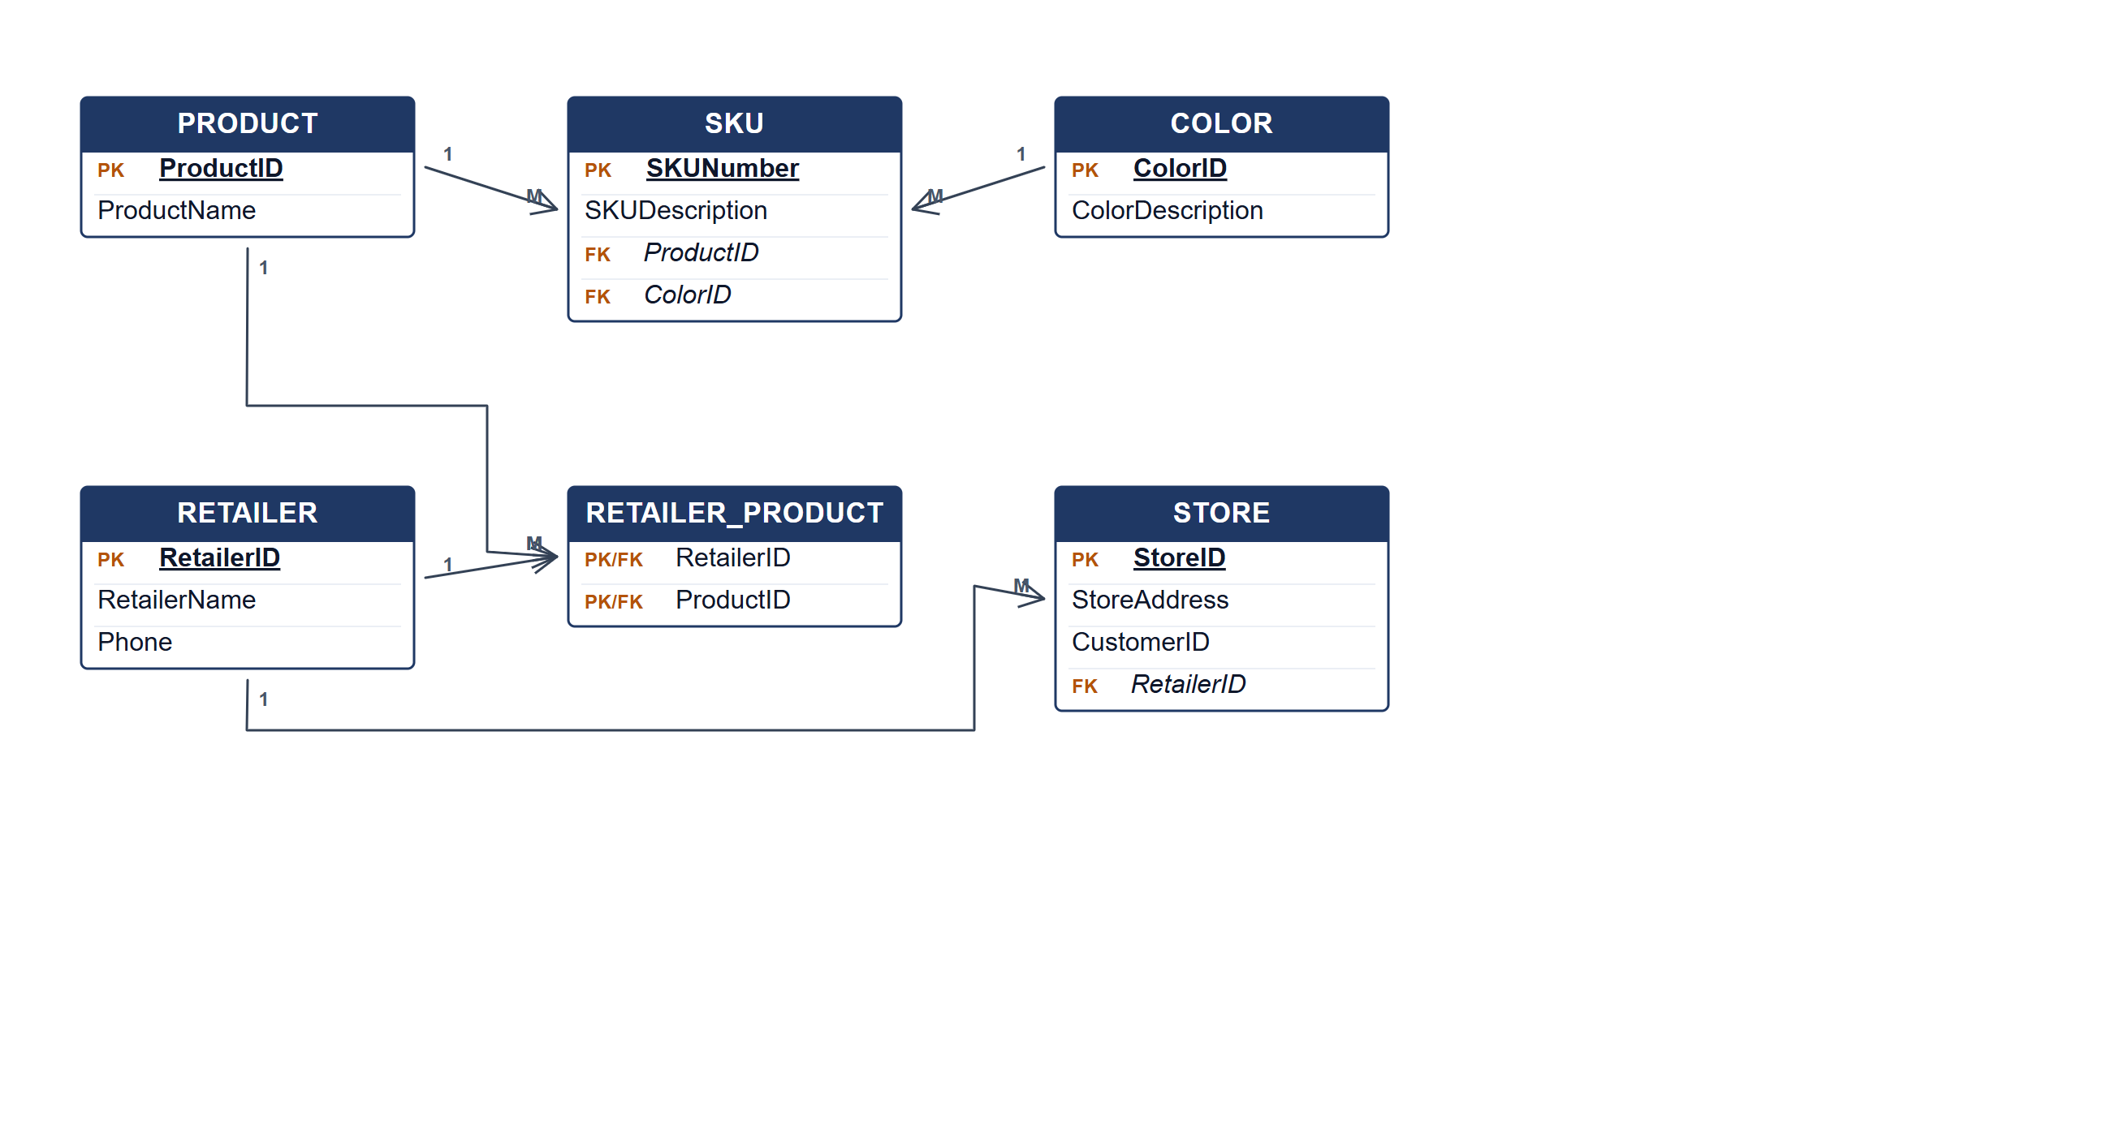
Chanteq Boutique ERD.
(b) Two reports from the ERD. [4 marks]
• Product distribution report — products and the retailers contracted to distribute them.
• SKU and colour catalogue — every SKU with its product, colour description and store availability.
Marking guide
• a) 16 marks: product/SKU/colour (5); retailer and contract (4); store and relationships (5); keys (2).
• b) 2 marks for each report (4).
Provenance: model_unofficial · confidence medium · Model-authored from the approved question text, the supplied source assets and the ICT200/ICT450 knowledge base; no official ICT450 marking scheme was supplied.
Knowledge base basis: TOPIC 4 ERD_stu (2).pdf; TOPIC 3 RELATIONAL DATA MODELstu.pdf
Assumptions / notes
• A store is identified by StoreID and carries a CustomerID for shipping confirmation; a retailer distributes many products through a contract.

