CONFIDENTIAL  CS/NOV 2026/ICT450

UNIVERSITI TEKNOLOGI MARA
MARKING SCHEME

COURSE :
COURSE CODE :
EXAMINATION :
TIME :
DATABASE DESIGN AND DEVELOPMENT
ICT450
NOVEMBER 2026 (MOCK)
3 HOURS

MARKING SCHEME NOTES

- This marking scheme accompanies the ICT450 mock paper (November 2026).
Answers are unofficial model answers, not official UTM marking schemes.

- Marking points state the expected answer and the allocation of marks; every question retains its source paper and page reference.

- Five questions x 20 marks; total = 100 marks.
- Real-bank questions: 5. Placeholders: 0.
Questions and answers are for local study use only.

- Structure derived from 12 unique ICT450 past papers; every real question remains traceable to its source page.

FOR MARKERS' USE ONLY

This marking scheme consists of 8 printed pages.
MARKING GUIDE
QUESTION 1 (20 marks)
Source: ICT450-2024-JAN · page [2] · bank id ICT450-2024-JAN-Q1
Reference answer
(a) Meaning of data and database. [4 marks]
• Data are raw facts, such as a customer name or an order amount, that have not yet been processed into meaning.
• A database is an organised collection of logically related data stored and managed as a single repository.
(b) Data inconsistency and an example. [4 marks]
• Data inconsistency exists when the same fact has different values in different places.
• Example: a customer's phone number is updated in the Customers table but the old number remains in an Orders table.
(c) Zinnirah's problem and the ERD solution. [6 marks]
• The three tables are not linked by keys, so joins become complex and the same customer/product data is duplicated.
• The solution is an ERD with CUSTOMER, ORDER, PRODUCT and ORDER_LINE, where ORDER_LINE resolves the many-to-many order-product relationship.
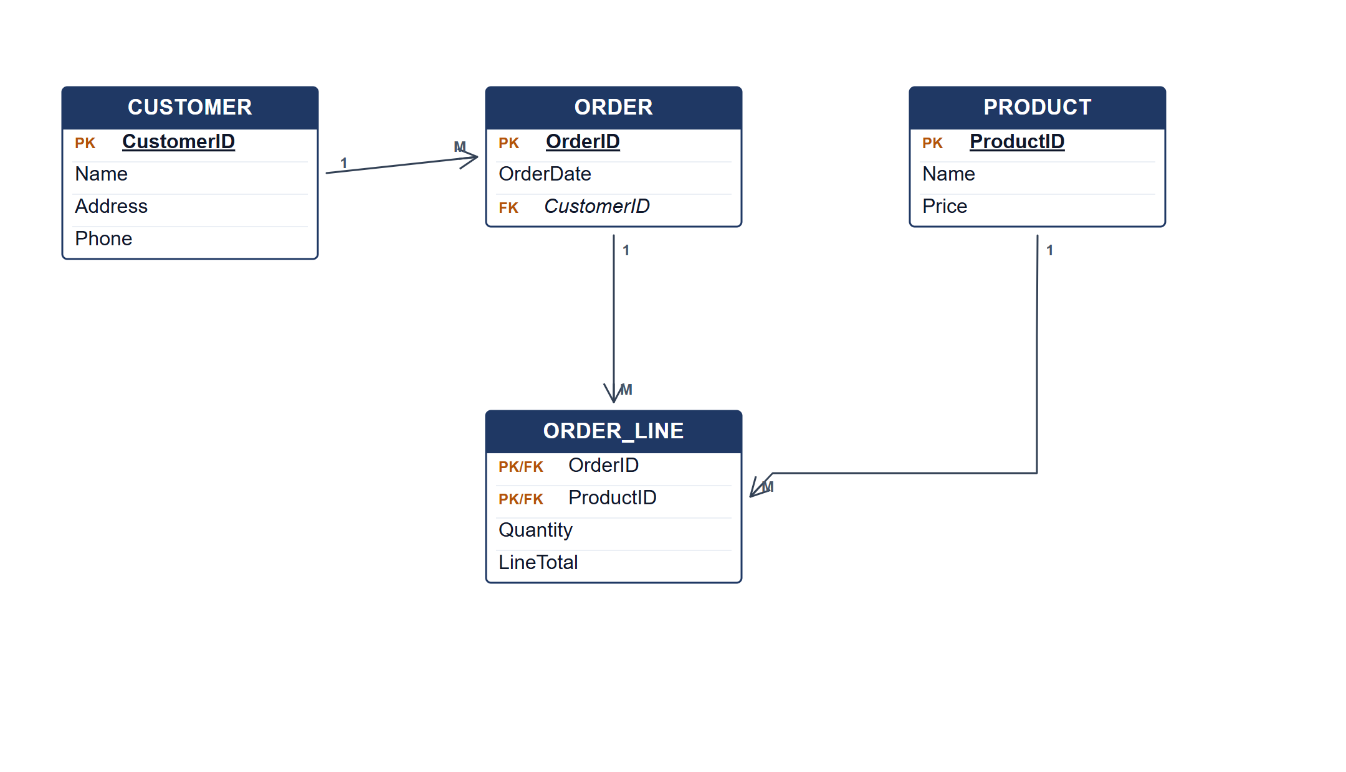
ERD for the ZY Stationary database.
(d) Three types of SDLC maintenance. [6 marks]
• Corrective maintenance — fixing errors found after delivery.
• Adaptive maintenance — changing the system for a new environment, platform or business rule.
• Perfective maintenance — improving performance or adding enhancements requested by users.
Marking guide
• a) 2 marks each for data and database (4).
• b) 2 marks for the definition and 2 for the example (4).
• c) 2 marks for the problem and 4 marks for the ERD (6).
• d) 2 marks for each maintenance type (6).
Provenance: model_unofficial · confidence high · Model-authored from the approved question text, the supplied source assets and the ICT200/ICT450 knowledge base; no official ICT450 marking scheme was supplied.
Knowledge base basis: TOPIC 1 DATABASE CONCEPT (1).pdf; TOPIC 2 DATA MODEL (1).pdf; TOPIC 3 RELATIONAL DATA MODELstu.pdf
Assumptions / notes
• The three tables are Customers, Orders and Products; an order can contain many products.

QUESTION 2 (20 marks)
Source: ICT450-2023-FEB · page [3] · bank id ICT450-2023-FEB-Q2
Reference answer
(a) Four activities in the database initial study. [8 marks]
• Analyse the company situation — study the organisation's structure, mission, operations, data handling and business environment.
• Define the problems and constraints — identify weaknesses, missing or redundant data, security issues and limits such as budget, time or existing systems.
• Define the objectives — state what the database must achieve and check that the objectives match the end users' needs.
• Define the scope and boundaries — decide which business areas, entities, data types and users are inside the database, and what external systems or limits bound it.
(b) Four limitations of mobile databases, with examples. [8 marks]
• Limited bandwidth and intermittent connectivity — a field worker may lose the network while updating a delivery record.
• Limited storage, memory and battery — a smartphone may not hold a full local copy of a large central database.
• Security and privacy risks — a lost or stolen mobile device may expose cached customer data unless it is encrypted.
• Synchronisation and consistency — offline edits from several devices must be merged without overwriting newer data.
• Heterogeneous devices and operating systems increase development and testing effort.
(c) Rows that will fail insertion into the STAFF table. [4 marks]
• Row 3033 (Siti Ziana) will fail because Salary = 11000 is outside the allowed range 3000–10000; this violates the domain or check constraint on Salary.
• Row 3034 (Ahmad Daniel) will fail because Salary = “150a” is not numeric; this violates the data type of the Salary column.
• Rows 3035 and 3036 satisfy the stated data types and range, and all StaffID values are unique.
Marking guide
• a) 2 marks for each of four initial-study activities explained (4 × 2 = 8).
• b) 2 marks for each of four mobile-database limitations with a relevant example (4 × 2 = 8).
• c) 2 marks for row 3033 with the range/domain reason; 2 marks for row 3034 with the data-type reason (2 + 2 = 4).
Provenance: model_unofficial · confidence high · Model-authored from the approved question text, the supplied source assets and the ICT200/ICT450 knowledge base; no official ICT450 marking scheme was supplied.
Knowledge base basis: TOPIC 2 DATA MODEL (1).pdf; TOPIC 6 DATABASE DESIGN (1).pdf
Assumptions / notes
• The staff table has StaffID as its primary key; Salary must be numeric and lie in the stated range 3000–10000; DepartmentID is numeric.

QUESTION 3 (20 marks)
Source: ICT450-2026-FEB · page [3] · bank id ICT450-2026-FEB-Q3
Reference answer
Table 1 repeats the registration and volunteer data for each skill, so the skill list is a repeating group.
(a) Two problems in Table 1. [3 marks]
• RegisterID, RegisterDate, VolunteerID and VolunteerName repeat for every skill, creating redundancy.
• Skill and YearsOfExperience are stored in a repeating group rather than in a separate registration-skill relation.
• The blank VolunteerName cells also show inconsistent data entry.
(b) Keys and dependencies. [6 marks]
Flattened relation.
REGISTRATION_SKILL (RegisterID, RegisterDate, VolunteerID, VolunteerName, SkillID, SkillName, YearsOfExperience)
Functional dependencies.
RegisterID → RegisterDate, VolunteerID
VolunteerID → VolunteerName
SkillID → SkillName
RegisterID, SkillID → YearsOfExperience
(c) Normalise to 3NF. [11 marks]
1NF: one row per registration-skill pair; key (RegisterID, SkillID).
2NF: remove volunteer, registration and skill partial dependencies.
2NF/3NF relations.
VOLUNTEER (VolunteerID, VolunteerName)
REGISTRATION (RegisterID, RegisterDate, VolunteerID)
SKILL (SkillID, SkillName)
REGISTRATION_SKILL (RegisterID, SkillID, YearsOfExperience)
3NF: VolunteerName depends on VolunteerID and SkillName on SkillID; no further transitive dependency remains.
Sample 3NF data: REGISTRATION
RegisterID | RegisterDate | VolunteerID
101 | 28/9/2025 | V15
102 | 5/10/2025 | V17
103 | 30/10/2025 | V20

Sample 3NF data: REGISTRATION_SKILL
RegisterID | SkillID | YearsOfExperience
101 | J1 | 5
101 | S2 | 2
102 | M1 | 25
103 | W1 | 10

Marking guide
• a) 3 marks: two problems with reasons.
• b) 6 marks: key and dependencies.
• c) 11 marks: 1NF (2), 2NF (4), 3NF (5).
Provenance: model_unofficial · confidence high · Model-authored from the approved question text, the supplied source assets and the ICT200/ICT450 knowledge base; no official ICT450 marking scheme was supplied.
Knowledge base basis: TOPIC 5 NORMALIZATION (1).pdf
Assumptions / notes
• RegisterID identifies one registration; each registration can list several skills. Years of experience belongs to the registration-skill pair.

QUESTION 4 (20 marks)
Source: ICT450-2024-JUL · page [5] · bank id ICT450-2024-JUL-Q4
Reference answer
Relational schema used by the question.
STUDENT (StudentID, FirstName, LastName, PhoneNumber, FacultyID*)
CANDIDATE (CandidateID, StudentID*)
VOTING (VotingID, VotingDate, StudID*)
VOTING_DETAILS (VotingID*, CandidateID*, VotingTime)
FACULTY (FacultyID, FacultyName)
(a) Total number of candidates for each faculty. [4 marks]
SELECT f.FacultyID, f.FacultyName,
COUNT(c.CandidateID) AS total_candidates
FROM FACULTY f
JOIN STUDENT s ON s.FacultyID = f.FacultyID
JOIN CANDIDATE c ON c.StudentID = s.StudentID
GROUP BY f.FacultyID, f.FacultyName;
(b) Students who do not vote for any candidate. [4 marks]
SELECT s.*
FROM STUDENT s
WHERE NOT EXISTS (
SELECT 1
FROM VOTING v
JOIN VOTING_DETAILS vd ON vd.VotingID = v.VotingID
WHERE v.StudID = s.StudentID
);
(c) Total number of voters for each faculty. [4 marks]
SELECT f.FacultyID, f.FacultyName,
COUNT(DISTINCT v.StudID) AS total_voters
FROM FACULTY f
JOIN STUDENT s ON s.FacultyID = f.FacultyID
JOIN VOTING v ON v.StudID = s.StudentID
GROUP BY f.FacultyID, f.FacultyName;
(d) Full name of candidates with more than 500 votes. [4 marks]
SELECT c.CandidateID,
CONCAT(s.FirstName, ' ', s.LastName) AS full_name,
COUNT(vd.VotingID) AS total_votes
FROM CANDIDATE c
JOIN STUDENT s ON s.StudentID = c.StudentID
JOIN VOTING_DETAILS vd ON vd.CandidateID = c.CandidateID
GROUP BY c.CandidateID, s.FirstName, s.LastName
HAVING COUNT(vd.VotingID) > 500;
In Oracle, replace CONCAT(...) with s.FirstName || ' ' || s.LastName.
(e) Total number of students who vote for only one candidate. [4 marks]
SELECT COUNT(*) AS students_voting_once
FROM (
SELECT v.StudID
FROM VOTING v
JOIN VOTING_DETAILS vd ON vd.VotingID = v.VotingID
GROUP BY v.StudID
HAVING COUNT(DISTINCT vd.CandidateID) = 1
) AS single_vote;
Marking guide
• a) 4 marks: candidate-student-faculty join (2), COUNT per faculty (2).
• b) 4 marks: anti-join/not-exists on voting details (3), correct student output (1).
• c) 4 marks: faculty-student-voting join (2), COUNT DISTINCT voters (2).
• d) 4 marks: candidate vote join (2), GROUP BY and HAVING > 500 (2).
• e) 4 marks: group votes by student (2), HAVING count = 1 and outer COUNT (2).
Provenance: model_unofficial · confidence high · Model-authored from the approved question text, the supplied source assets and the ICT200/ICT450 knowledge base; no official ICT450 marking scheme was supplied.
Knowledge base basis: TOPIC 7 SQL.pdf
Assumptions / notes
• A candidate's faculty is the faculty of the student who is the candidate.
• A vote is represented by a VOTING row plus its VOTING_DETAILS rows; a student who has no VOTING_DETAILS row has not voted for a candidate.

QUESTION 5 (20 marks)
Source: ICT450-2025-JUL · page [5, 6] · bank id ICT450-2025-JUL-Q5
Reference answer
The ERD models collectors, duties, localities, vehicles, houses and waste types. The supervisor relationship is recursive on COLLECTOR, and DUTY_WASTE records the weight collected for each waste type.
(a) Construct the ERD with Crow's Foot notation. [16 marks]
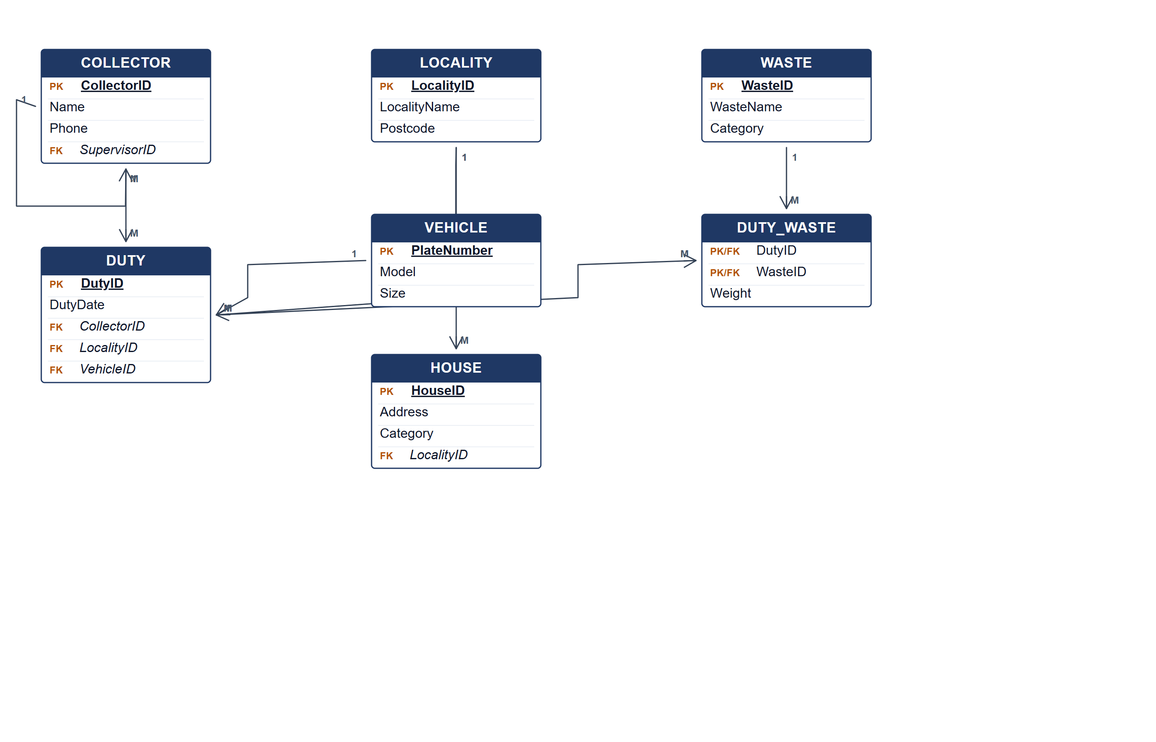
Clean Environment ERD.
(b) Two pieces of information from the ERD. [4 marks]
• The collection duties assigned to each collector, with date, locality and vehicle.
• The total weight collected for each waste type and locality.
Marking guide
• a) 16 marks: collector/duty/locality/vehicle (6); house and waste (4); recursive supervisor and DUTY_WASTE relationships (4); keys (2).
• b) 2 marks for each information item (4).
Provenance: model_unofficial · confidence medium · Model-authored from the approved question text, the supplied source assets and the ICT200/ICT450 knowledge base; no official ICT450 marking scheme was supplied.
Knowledge base basis: TOPIC 4 ERD_stu (2).pdf; TOPIC 3 RELATIONAL DATA MODELstu.pdf
Assumptions / notes
• Supervisor is a recursive role on COLLECTOR; a duty collects many waste types with a weight per waste type.

