CONFIDENTIAL  CS/NOV 2026/ICT450

UNIVERSITI TEKNOLOGI MARA
MARKING SCHEME

COURSE :
COURSE CODE :
EXAMINATION :
TIME :
DATABASE DESIGN AND DEVELOPMENT
ICT450
NOVEMBER 2026 (MOCK)
3 HOURS

MARKING SCHEME NOTES

- This marking scheme accompanies the ICT450 mock paper (November 2026).
Answers are unofficial model answers, not official UTM marking schemes.

- Marking points state the expected answer and the allocation of marks; every question retains its source paper and page reference.

- Five questions x 20 marks; total = 100 marks.
- Real-bank questions: 5. Placeholders: 0.
Questions and answers are for local study use only.

- Structure derived from 12 unique ICT450 past papers; every real question remains traceable to its source page.

FOR MARKERS' USE ONLY

This marking scheme consists of 8 printed pages.
MARKING GUIDE
QUESTION 1 (20 marks)
Source: ICT450-2026-FEB · page [2] · bank id ICT450-2026-FEB-Q1
Reference answer
(a) Four examples of data in a student registration database system. [4 marks]
• Student identification data — student number, name, date of birth, gender and contact details.
• Programme data — programme code, programme name, faculty and study level.
• Course registration data — course code, course name, semester, section and registration date.
• Academic record data — coursework marks, final examination marks and grades.
• Other valid examples: address, telephone number, scholarship status or adviser details.
(b) Four limitations of the traditional computerized file system. [4 marks]
• It requires extensive programming, and file layouts are embedded in programs, creating program-data dependence.
• System administration is complex and difficult because each file has its own format, access rules and storage.
• Changing existing file structures is difficult and can require rewriting the application programs.
• Security features are likely inadequate, with little central control over who can read or change each file.
• Independent files tend to contain redundant data, causing inconsistency and structural dependency.
(c) Three important features of a data dictionary. [6 marks]
• It gives a detailed description of all tables in the database, including every attribute name, characteristic, data type, size and constraint.
• It stores metadata — data about data — and is sometimes called the database designer's database because it records the design decisions about tables and their structures.
• It provides a central, consistent reference for designers, programmers and users, so definitions do not diverge and changes can be controlled.
(d) Six phases of the Database Life Cycle (DBLC). [6 marks]
• Database initial study.
• Database design.
• Implementation and loading.
• Testing and evaluation.
• Operation.
• Maintenance and evolution.
Marking guide
• a) 1 mark for each of four valid examples (4 × 1 = 4).
• b) 1 mark for each of four limitations stated correctly (4 × 1 = 4).
• c) 2 marks for each of three data-dictionary features explained (3 × 2 = 6).
• d) 1 mark for each of the six DBLC phases in the correct order (6 × 1 = 6).
Provenance: model_unofficial · confidence high · Model-authored from the approved question text, the supplied source assets and the ICT200/ICT450 knowledge base; no official ICT450 marking scheme was supplied.
Knowledge base basis: TOPIC 1 DATABASE CONCEPT (1).pdf; TOPIC 2 DATA MODEL (1).pdf; TOPIC 3 RELATIONAL DATA MODELstu.pdf

QUESTION 2 (20 marks)
Source: ICT450-2025-JUL · page [2, 3] · bank id ICT450-2025-JUL-Q2
Reference answer
(a) Two disadvantages of the network model. [4 marks]
• It is cumbersome — the set and pointer structures make the database difficult to design, understand and use.
• It lacks ad hoc query capability, so programmers must write code for every report instead of issuing a query.
• A structural change in the database can produce havoc in all application programs, showing poor data independence.
(b) Two reasons the books table violates relational-table characteristics. [4 marks]
• The ISBN 978-981-4824-24-7 appears in two rows, so the declared primary key is not unique and entity integrity is violated.
• The Authors column stores several authors in one cell, such as “Ahmad Rostam, Rozaniza, Alizi Alias”; a relational table requires each cell to be atomic.
• Publisher Name is repeated for the same Publisher ID, which also creates redundancy, although that is a normalization issue rather than a table-characteristic violation.
(c) Three views of data for the designer. [6 marks]
• Data structure view — how the data is organised: entities, attributes, relationships and the resulting tables.
• Data access view — how users and programs retrieve and update the data: queries, access paths, indexes and security.
• Activities view — the business processes, transactions and reports that transform the stored data into information.
• The business view, by contrast, sees data as an information source rather than as structures and processes.
(d) Three benefits of big data to companies. [6 marks]
• Better decision-making — large and varied datasets reveal patterns, trends and customer behaviour that small samples cannot show.
• More personalised products and marketing — companies can tailor offers, recommendations and service levels to individual customers.
• Operational efficiency and cost reduction — analysing transactions, logs and supply-chain data can expose waste, bottlenecks and fraud.
• New revenue and innovation — data can support new services, predictive maintenance and data-driven business models.
Marking guide
• a) 2 marks for each of two disadvantages explained (2 × 2 = 4).
• b) 2 marks for each of two violations correctly linked to the table data (2 × 2 = 4).
• c) 2 marks for each of three designer views explained (3 × 2 = 6).
• d) 2 marks for each of three benefits explained (3 × 2 = 6).
Provenance: model_unofficial · confidence high · Model-authored from the approved question text, the supplied source assets and the ICT200/ICT450 knowledge base; no official ICT450 marking scheme was supplied.
Knowledge base basis: TOPIC 2 DATA MODEL (1).pdf; TOPIC 6 DATABASE DESIGN (1).pdf
Assumptions / notes
• The publishing table is read as ISBN, BookTitle, Authors, Publisher ID and Publisher Name.

QUESTION 3 (20 marks)
Source: ICT450-2018-DEC · page [3, 4] · bank id ICT450-2018-DEC-Q4
Reference answer
The order form contains order, customer, product and staff data, with a repeating group of product lines.
(a) Relational schema for the order form. [2 marks]
Order-form relation in 1NF (one row per product line).
ORDER_FORM (OrderNo, OrderDate, CustomerNo, CustomerName, CustomerAddress, City, State, ProductNo, Description, Quantity, UnitPrice, StaffID, StaffName)
Order header data
OrderNo | OrderDate | CustomerNo | Customer | Address | City | State
1234 | 11-Apr-2018 | 9876 | Sufian Ghani | 456, Gemersik Street | Kuala Krai | Kelantan

Person in charge: S101 – Marina.
Item lines
OrderNo | ProductNo | Description | Qty | UnitPrice
1234 | A123 | Pencil | 100 | 3.00
1234 | B234 | Eraser | 200 | 1.50
1234 | C345 | Sharpener | 5 | 8.00
1234 | A333 | Ruler | 50 | 0.50

(b) Primary key of the relation. [2 marks]
The primary key is (OrderNo, ProductNo). One order has many products, and a product can appear on many orders, so neither attribute alone is unique.
(c) Normalise the order form to 3NF. [16 marks]
Step 1 — 1NF: one row per order-product line; all values atomic. Key: (OrderNo, ProductNo).
Step 2 — 2NF: remove partial dependencies. Order data depends on OrderNo; product data depends on ProductNo; staff data depends on StaffID.
2NF relations.
ORDER (OrderNo, OrderDate, CustomerNo, CustomerName, CustomerAddress, City, State, StaffID, StaffName)
PRODUCT (ProductNo, Description, UnitPrice)
ORDER_ITEM (OrderNo, ProductNo, Quantity)
Step 3 — 3NF: remove transitive dependencies. CustomerNo determines customer details; City determines State; StaffID determines StaffName.
3NF relations.
CUSTOMER (CustomerNo, CustomerName, Address, City)
CITY (City, State)
STAFF (StaffID, StaffName)
ORDER (OrderNo, OrderDate, CustomerNo, StaffID)
PRODUCT (ProductNo, Description, UnitPrice)
ORDER_ITEM (OrderNo, ProductNo, Quantity)
3NF sample data: CUSTOMER
CustomerNo | CustomerName | Address | City
9876 | Sufian Ghani | 456, Gemersik Street | Kuala Krai

3NF sample data: CITY
City | State
Kuala Krai | Kelantan

3NF sample data: ORDER
OrderNo | OrderDate | CustomerNo | StaffID
1234 | 11-Apr-2018 | 9876 | S101

3NF sample data: STAFF
StaffID | StaffName
S101 | Marina

3NF sample data: PRODUCT
ProductNo | Description | UnitPrice
A123 | Pencil | 3.00
B234 | Eraser | 1.50
C345 | Sharpener | 8.00
A333 | Ruler | 0.50

3NF sample data: ORDER_ITEM
OrderNo | ProductNo | Quantity
1234 | A123 | 100
1234 | B234 | 200
1234 | C345 | 5
1234 | A333 | 50

Marking guide
• a) 2 marks: relation containing the order, customer, product and staff data.
• b) 2 marks: composite key (OrderNo, ProductNo) with a reason.
• c) 16 marks: 1NF order relation stated with atomic rows (4), 2NF partial dependencies removed into ORDER, PRODUCT and ORDER_ITEM (6), 3NF transitive dependencies removed into CUSTOMER, CITY and STAFF (6).
Provenance: model_unofficial · confidence high · Model-authored from the approved question text, the supplied source assets and the ICT200/ICT450 knowledge base; no official ICT450 marking scheme was supplied.
Knowledge base basis: TOPIC 5 NORMALIZATION (1).pdf
Assumptions / notes
• One order can contain many products; the same product appears once per order.
• City determines State for this data, so CITY is separated in 3NF.

QUESTION 4 (20 marks)
Source: ICT450-2019-DEC · page [3, 4] · bank id ICT450-2019-DEC-Q3
Reference answer
Relational schema used by the question.
BANK (bankCode, bankName, bankAddress)
ACCOUNT (accNo, balance, accType, branchCode)
LOAN (loanNo, amount, loanType, branchCode)
CUSTOMER (custIC, custName, custAddress, branchCode)
BRANCH (branchCode, branchAddress, bankCode)
Schema note: the printed ACCOUNT and LOAN relations do not show a customer identifier. The answers below assume ACCOUNT.custIC and LOAN.custIC as foreign keys to CUSTOMER (custIC), which is required to link a customer to an account or loan.
(a) Create the ACCOUNT table. [3 marks]
CREATE TABLE ACCOUNT (
accNo VARCHAR(20) NOT NULL,
balance DECIMAL(12,2),
accType VARCHAR(20),
branchCode VARCHAR(10),
custIC VARCHAR(20),
PRIMARY KEY (accNo),
FOREIGN KEY (branchCode) REFERENCES BRANCH (branchCode),
FOREIGN KEY (custIC) REFERENCES CUSTOMER (custIC)
);
(b) Add the customer phone number attribute. [2 marks]
ALTER TABLE CUSTOMER
ADD custPhone VARCHAR(20);
(c) Total number of customers who opened an account at Aprilbank. [2 marks]
SELECT COUNT(DISTINCT c.custIC) AS "
"total_customers
FROM CUSTOMER c
JOIN ACCOUNT a ON a.custIC = c.custIC
JOIN BRANCH b ON b.branchCode = a.branchCode
JOIN BANK bk ON bk.bankCode = b.bankCode
WHERE bk.bankName = 'Aprilbank';
(d) Customers with more than RM 30,000 in an account at the Melaka branch. [3 marks]
SELECT DISTINCT c.custIC, c.custName
FROM CUSTOMER c
JOIN ACCOUNT a ON a.custIC = c.custIC
JOIN BRANCH b ON b.branchCode = a.branchCode
WHERE a.balance > 30000
AND b.branchAddress LIKE '%Melaka%';
(e) Customers with Personal or Housing loans, sorted by account type. [3 marks]
SELECT DISTINCT c.custIC, c.custName, a.accType
FROM CUSTOMER c
JOIN LOAN l ON l.custIC = c.custIC
JOIN ACCOUNT a ON a.custIC = c.custIC
WHERE l.loanType IN ('Personal', 'Housing')
ORDER BY a.accType ASC;
(f) Customers with an account whose names are neither Intan nor Ahmad. [3 marks]
SELECT DISTINCT c.custName
FROM CUSTOMER c
JOIN ACCOUNT a ON a.custIC = c.custIC
WHERE c.custName NOT IN ('Intan', 'Ahmad');
(g) Total amount of personal loan for each branch. [4 marks]
SELECT branchCode,
SUM(amount) AS total_personal_loan
FROM LOAN
WHERE loanType = 'Personal'
GROUP BY branchCode;
Marking guide
• a) 3 marks: CREATE TABLE (1), primary key (1), branch foreign key (1); the assumed customer foreign key is acceptable.
• b) 2 marks: ALTER TABLE (1) and custPhone attribute (1).
• c) 2 marks: COUNT with the Aprilbank join/filter.
• d) 3 marks: balance > 30000 (1), Melaka branch (1), correct customer output (1).
• e) 3 marks: loan-type predicate (1), customer join (1), ORDER BY account type (1).
• f) 3 marks: account join (1), NOT IN both names (2).
• g) 4 marks: Personal filter (1), SUM(amount) (1), GROUP BY branch (1), correct output (1).
Provenance: model_unofficial · confidence medium · Model-authored from the approved question text, the supplied source assets and the ICT200/ICT450 knowledge base; no official ICT450 marking scheme was supplied.
Knowledge base basis: TOPIC 7 SQL.pdf
Assumptions / notes
• The printed schema has no customer identifier in ACCOUNT or LOAN. The answer assumes ACCOUNT.custIC and LOAN.custIC are the foreign keys to CUSTOMER; without such a link the customer-level questions cannot be answered.
• “Melaka branch” is matched from BRANCH.branchAddress.
• The loan branch is the branch recorded in LOAN.branchCode.

QUESTION 5 (20 marks)
Source: ICT450-2018-JUN · page [5] · bank id ICT450-2018-JUN-Q5
Reference answer
The ERD models dentists, patients, treatments and appointments. The many-to-many treatment history is resolved by PATIENT_TREATMENT, which carries the tooth number and diagnosis. TREATMENT is specialised into disease and orthodontic subtypes.
(a) Construct the ERD with Crow's Foot notation. [16 marks]
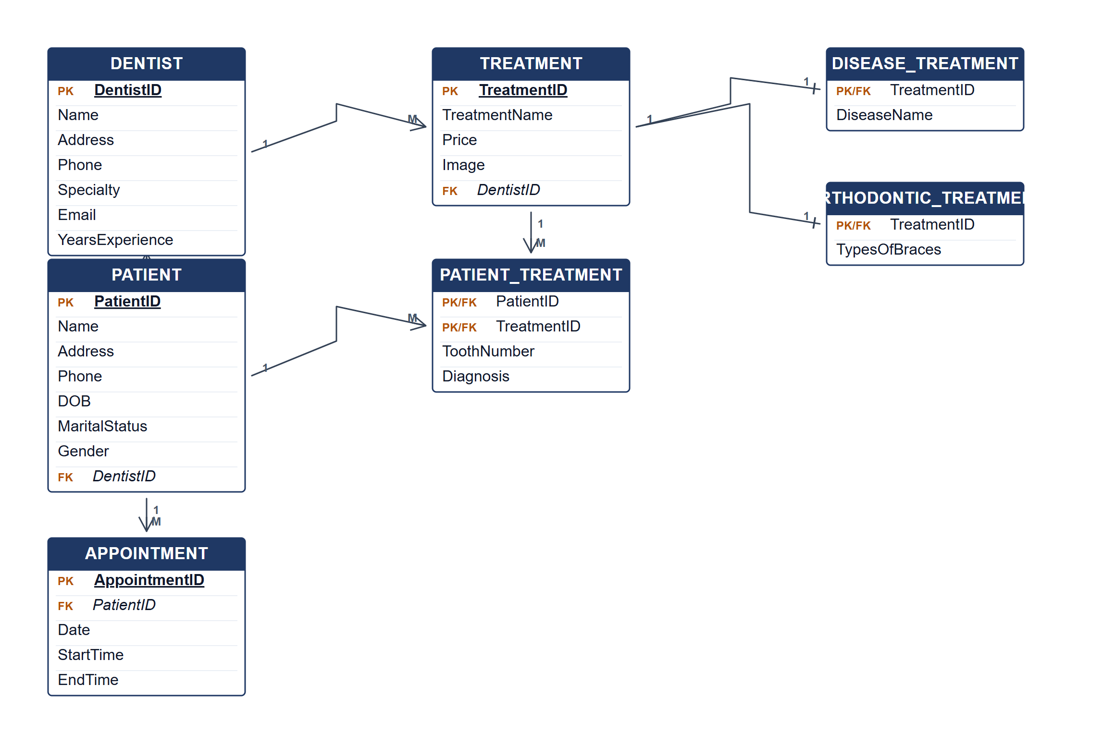
Crow's Foot ERD for the dental clinic.
(b) Two reports from the ERD. [4 marks]
• Patient treatment history — list each patient's treatments, tooth numbers, diagnoses and treating dentist.
• Dentist workload report — count patients, appointments and treatments performed by each dentist.
• Orthodontic case report — list orthodontic treatments with the type of braces and the patients concerned.
Marking guide
• a) 16 marks: DENTIST and PATIENT with attributes and the 1:N relationship (4); TREATMENT and PATIENT_TREATMENT with tooth number and diagnosis (4); APPOINTMENT (2); disease and orthodontic subtypes (3); keys and Crow's Foot cardinalities (3).
• b) 2 marks for each of two relevant reports explained (2 × 2 = 4).
Provenance: model_unofficial · confidence medium · Model-authored from the approved question text, the supplied source assets and the ICT200/ICT450 knowledge base; no official ICT450 marking scheme was supplied.
Knowledge base basis: TOPIC 4 ERD_stu (2).pdf; TOPIC 3 RELATIONAL DATA MODELstu.pdf
Assumptions / notes
• A treatment is a treatment type performed by one dentist; the patient-treatment relationship stores the tooth number and diagnosis for each patient.
• APPOINTMENT belongs to a patient; the requirements do not list a dentist attribute for an appointment, so none is invented.
• DISEASE_TREATMENT and ORTHODONTIC_TREATMENT are subtypes of TREATMENT.

