CONFIDENTIAL CS/OCT 2026/MAT133

UNIVERSITI TEKNOLOGI MARA FINAL EXAMINATION

COURSE
COURSE CODE
EXAMINATION TIME
PRE CALCULUS
MAT133 OCTOBER 2026
2 HOURS

INSTRUCTIONS TO CANDIDATES

- This question paper consists of 5 questions.

- Answer ALL questions in the Answer Booklet. Start each answer on a new page.

- Do not bring any material into the examination room unless permission is given by the invigilator .
- Please check to make sure that this examination pack consists of: i) the Question Paper
  - a one - page Append ix 1
  - an Answer Booklet - provided by the Faculty
  - a graph paper - provided by the Faculty

- Answer ALL questions in English.

/

DO NOT TURN THIS PAGE UNTIL YOU ARE TOLD TO DO SO

This examination paper consists of 9 printed pages

QUESTION 1
a) Solve the compound inequality -8 < 1 - x < 1. Express the answer in interval notation.
(4 marks)
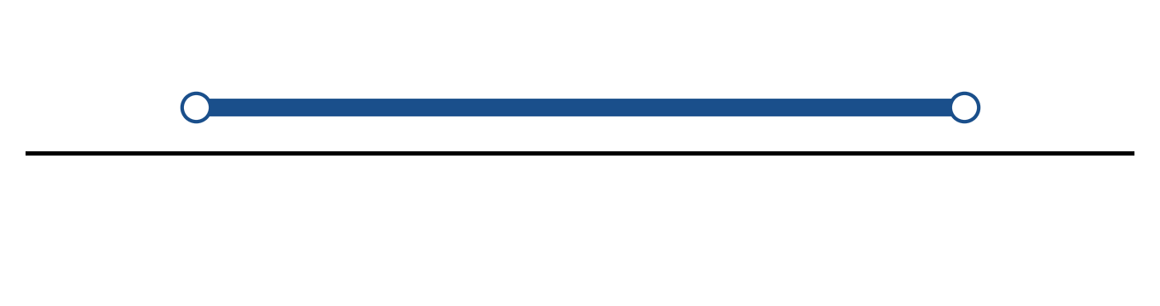
Figure: solution on a number line.
b) Solve the inequality |2x - 4| > 3. Express the answer in interval notation and on a number line.
(5 marks)
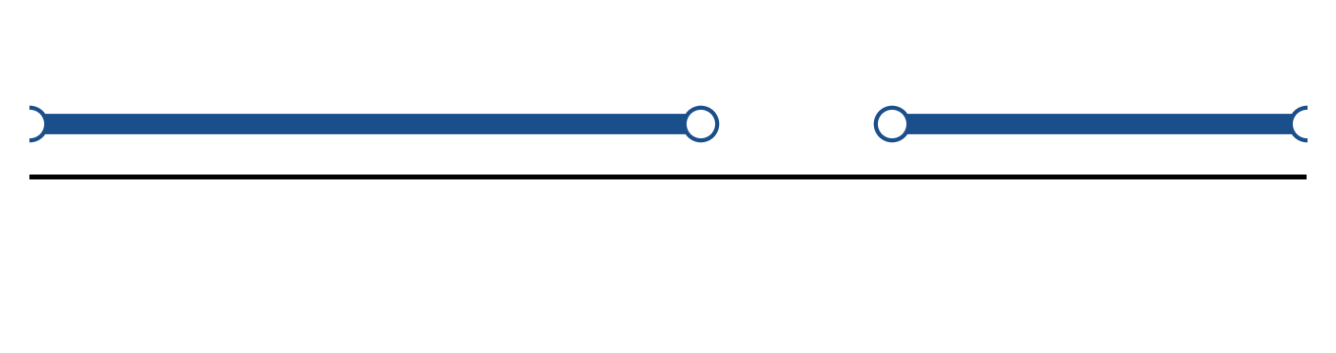
Figure: solution on a number line.
c) Sketch y = -2|x - 3| - 5. State the vertex, the y-intercept and any x-intercepts.
(5 marks)
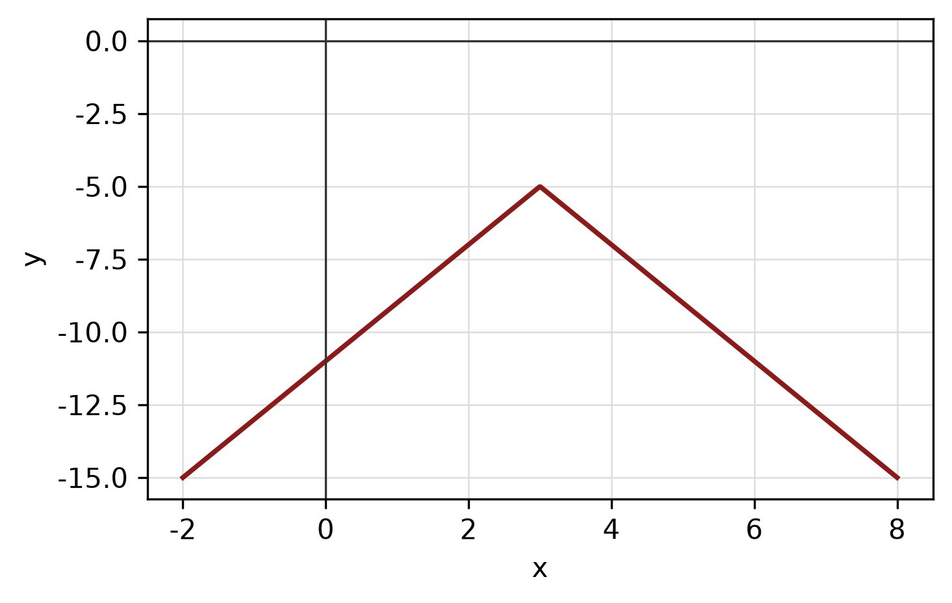
Figure: absolute-value graph.
QUESTION 2
a) Sketch y = |x - 2| + 1 for -2 ≤ x ≤ 6. State the domain and range.
(4 marks)
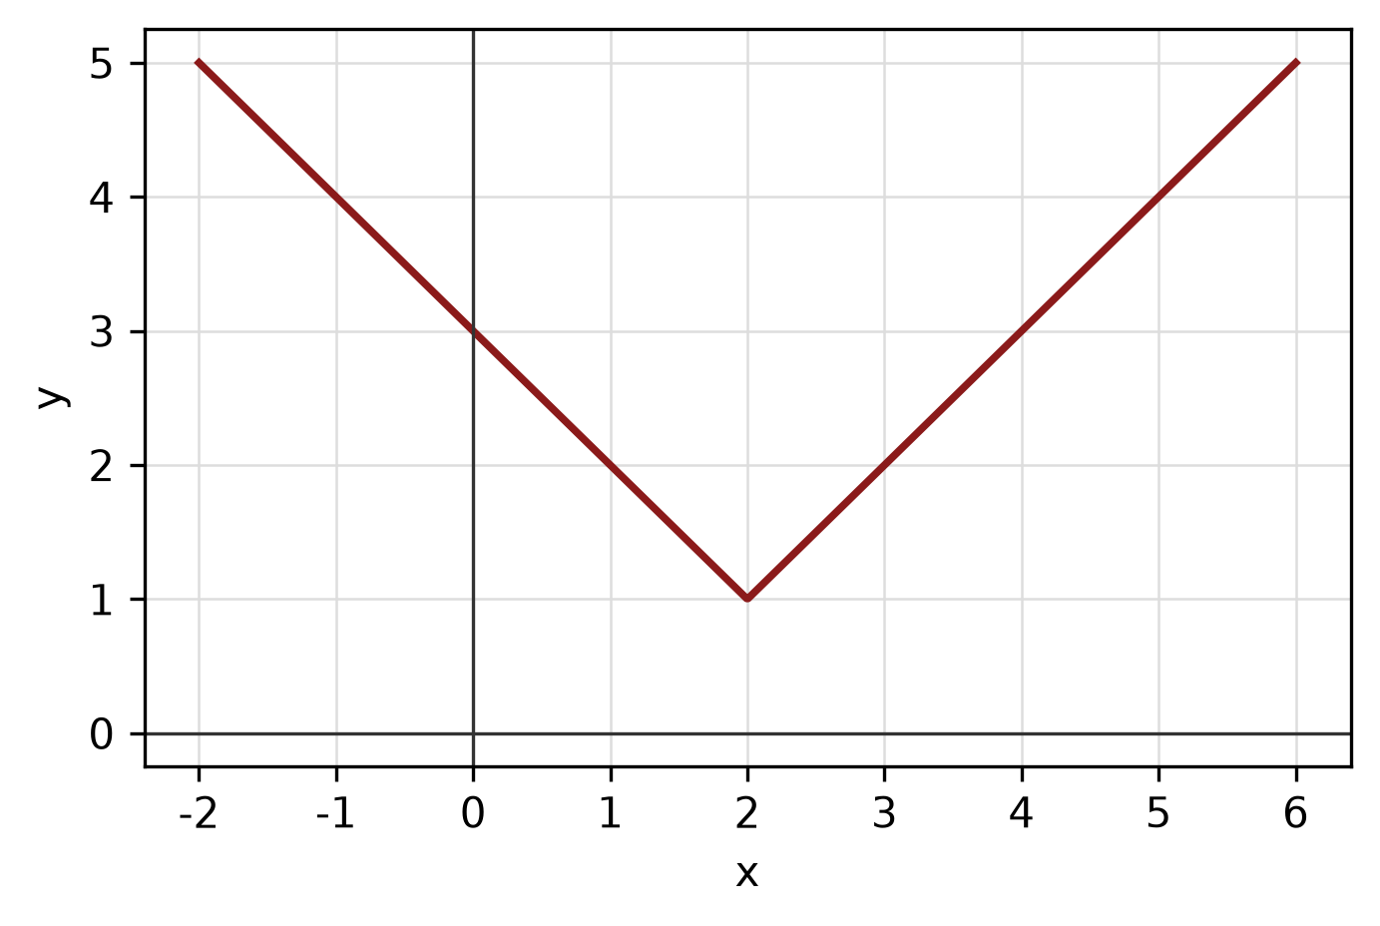
Figure: function graph.
b) Given f(x) = 5 - 2x and g(x) = -2x - 1, find (f + g)(x), (f - g)(x) and (f g)(x). State the domain of each.
(4 marks)
c) Find the equation of the line with x-intercept 2 and y-intercept -5.
(4 marks)
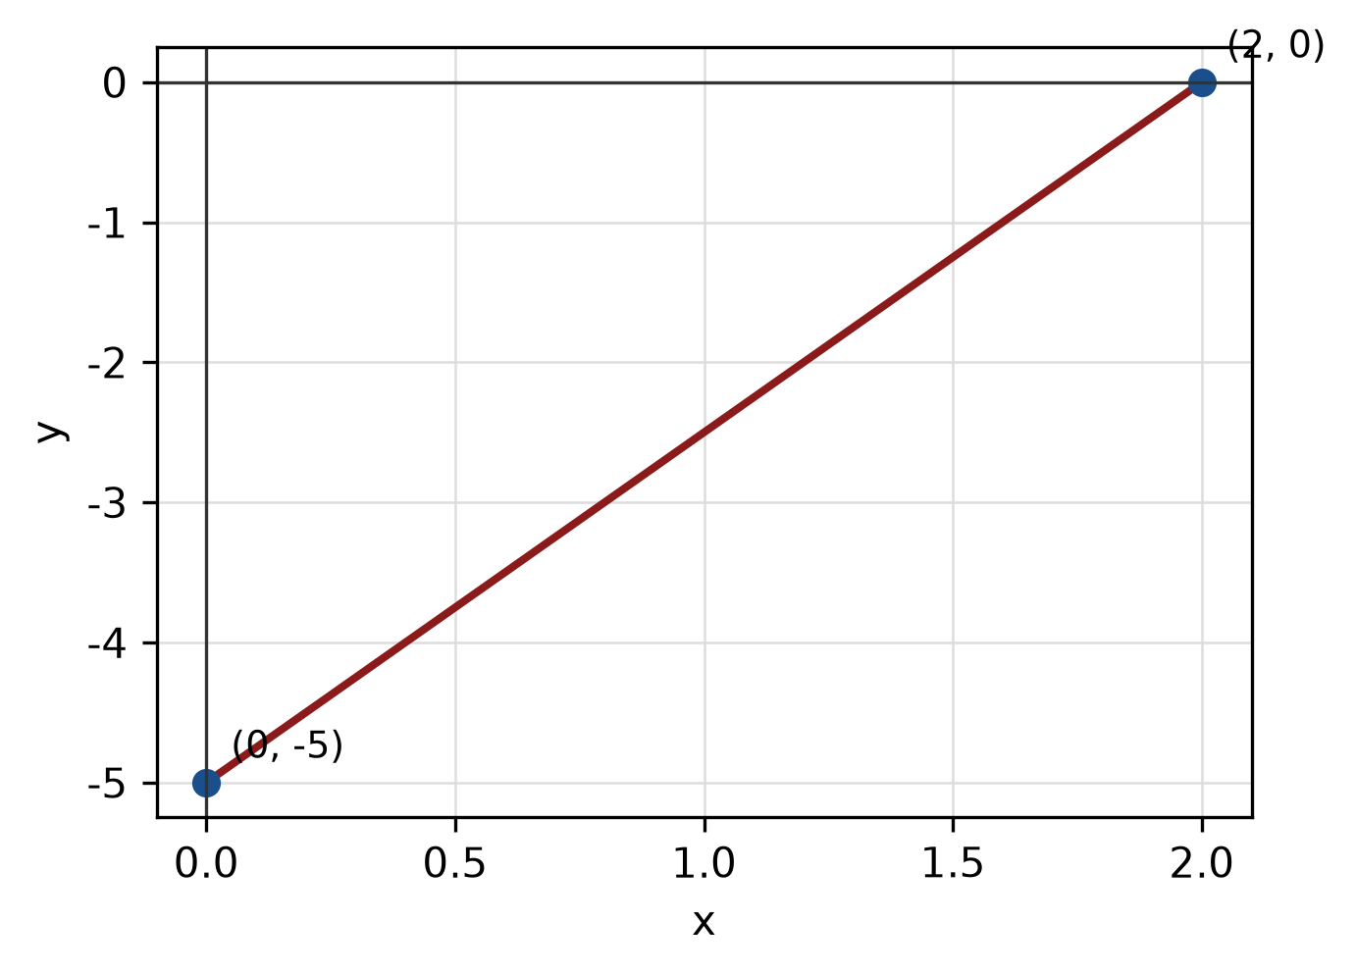
Figure: line and intercepts.
QUESTION 3
a) Given z₁ = -3 - 4i and z₂ = 3 - 2i, express z₁/z₂ in the form a + bi.
(5 marks)
b) Find the modulus and argument of z = 7 + 24i. Give the argument in degrees correct to one decimal place.
(5 marks)
c) Express log_2(2) + log_2(4) as a single logarithm and evaluate it.
(3 marks)
QUESTION 4
a) Graph the system of inequalities below and shade the feasible region. State the vertices of the region.
x ≥ 0, y ≥ 0, 1x + 3y ≤ 5.
(5 marks)
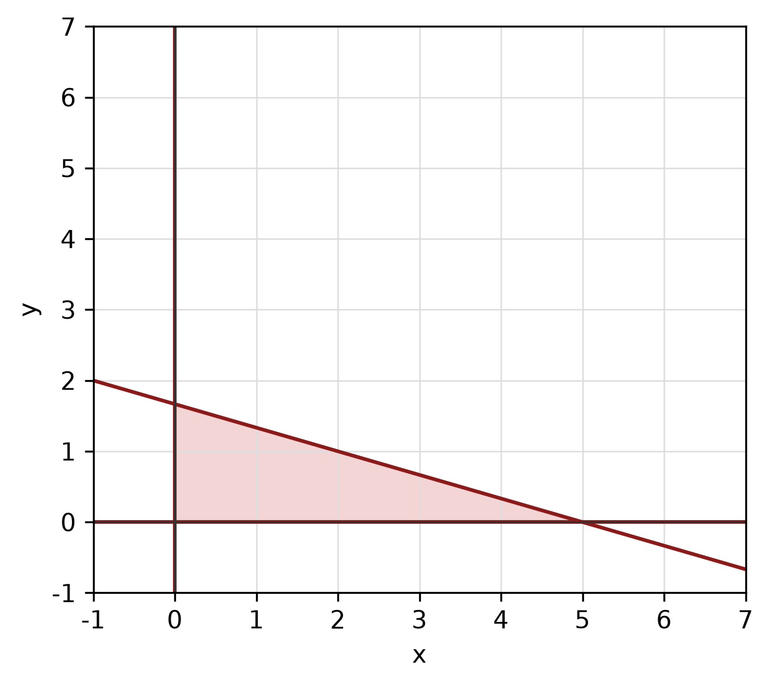
Figure: feasible region.
b) Write a system of inequalities that describes the shaded triangular region with vertices (0, 0), (8, 0) and (0, 7).
(5 marks)
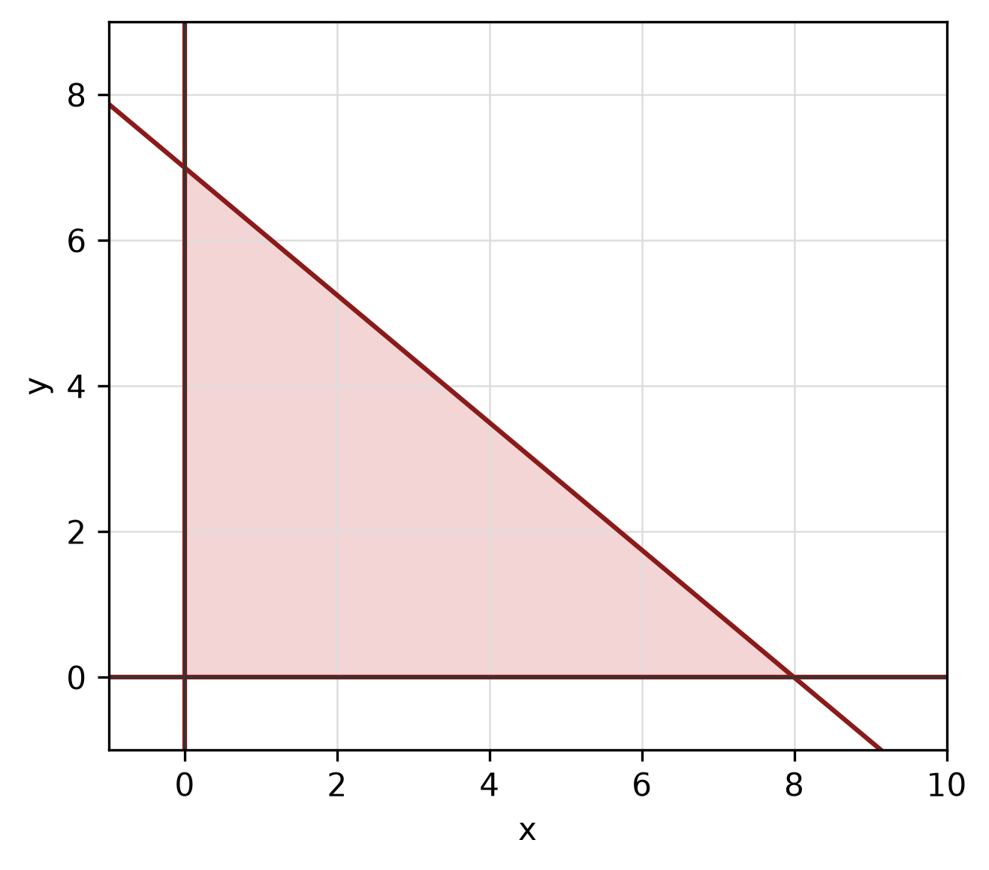
Figure: shaded triangular region.
c) Write x² - 6x + y² + 6y - 7 = 0 in standard form. Hence state the centre and radius and sketch the circle.
(5 marks)
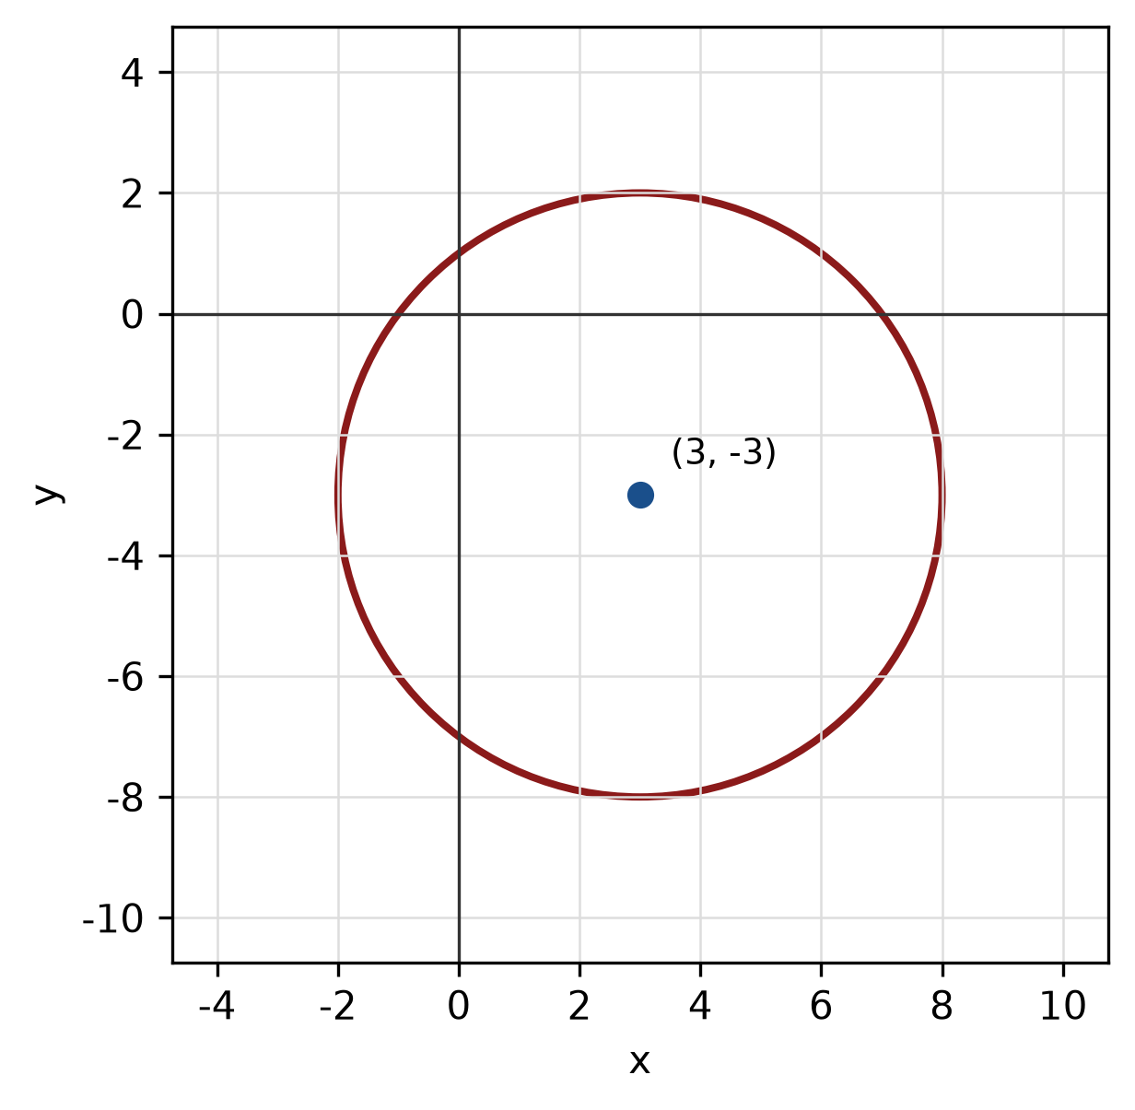
Figure: circle.
QUESTION 5
a) Given sin A = 5/13 where A is in quadrant II and cos B = 12/13 where B is in quadrant IV, find sin 2A and cos(A + B).
(5 marks)
b) Find the perimeter of the sector with radius 9 cm and central angle 180°.
(4 marks)
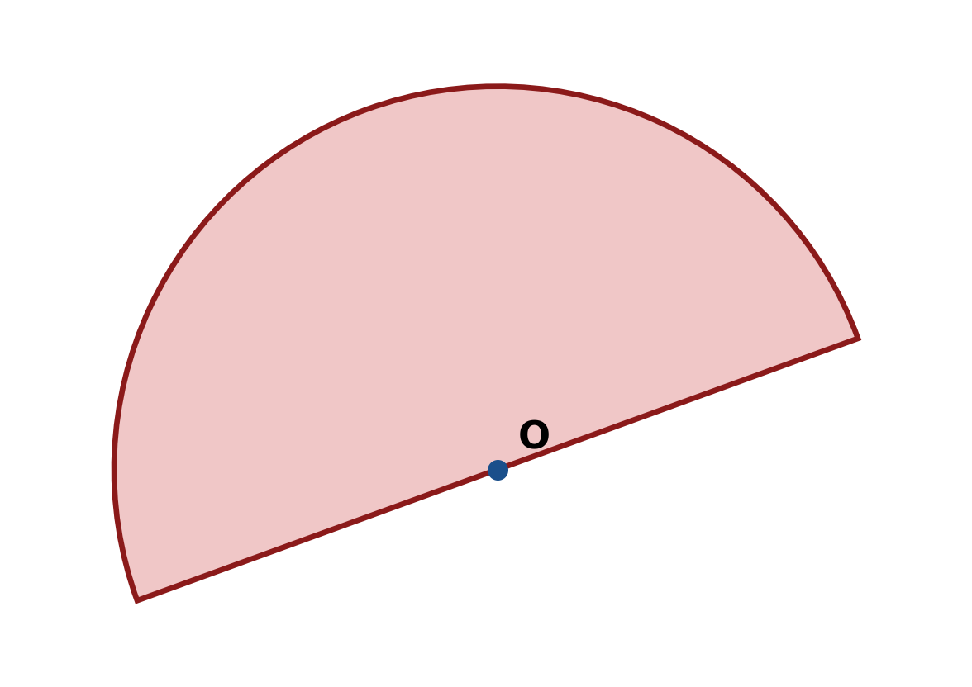
Figure: sector.
c) Solve the triangle with sides a = 7 cm, b = 24 cm and c = 25 cm. Find all three angles.
(5 marks)
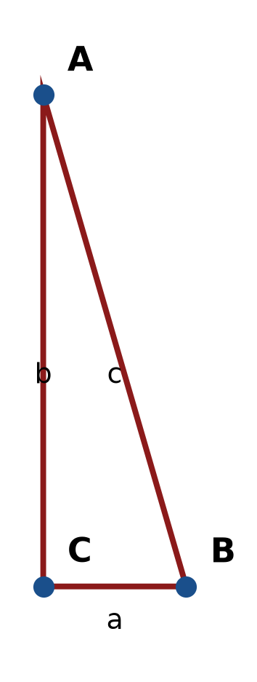
Figure: right triangle.
END OF QUESTION PAPER

APPENDIX 1
Formula sheet (as supplied with the paper).
sin² A + cos² A = 1 | tan² A + 1 = sec² A
sin(A + B) = sin A cos B + cos A sin B | tan 2A = 2 tan A / (1 − tan² A)
cos(A + B) = cos A cos B − sin A sin B | Arc length, s = rθ
tan(A − B) = (tan A − tan B) / (1 + tan A tan B) | Area of sector = ½r²θ
cos 2A = cos² A − sin² A | a / sin A = b / sin B = c / sin C
cos 2A = 1 − 2sin² A = 2cos² A − 1 | a² = b² + c² − 2bc cos A
sin 2A = 2 sin A cos A | Area of triangle = ½ab sin C

