CONFIDENTIAL CS/OCT 2026/MAT133

UNIVERSITI TEKNOLOGI MARA FINAL EXAMINATION

COURSE
COURSE CODE
EXAMINATION TIME
PRE CALCULUS
MAT133 OCTOBER 2026
2 HOURS

INSTRUCTIONS TO CANDIDATES

- This question paper consists of 5 questions.

- Answer ALL questions in the Answer Booklet. Start each answer on a new page.

- Do not bring any material into the examination room unless permission is given by the invigilator .
- Please check to make sure that this examination pack consists of: i) the Question Paper
  - a one - page Append ix 1
  - an Answer Booklet - provided by the Faculty
  - a graph paper - provided by the Faculty

- Answer ALL questions in English.

/

DO NOT TURN THIS PAGE UNTIL YOU ARE TOLD TO DO SO

This examination paper consists of 6 printed pages

QUESTION 1
a) Solve the compound inequality -6 < -3x - 2 < 0. Express the answer in interval notation.
(4 marks)
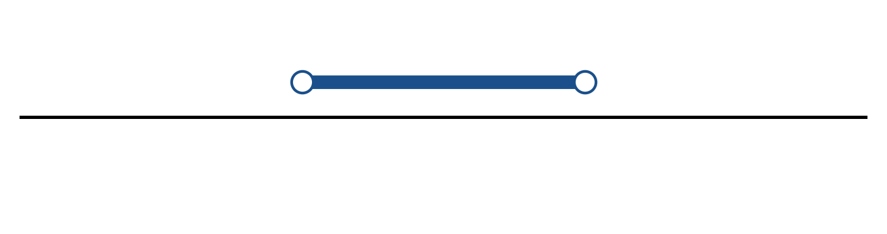
Figure: solution on a number line.
b) Solve the inequality |5x + 5| ≤ 7. Express the answer in interval notation and on a number line.
(5 marks)
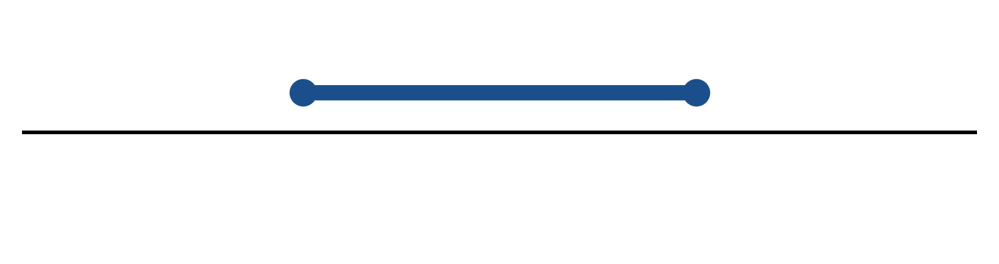
Figure: solution on a number line.
c) Sketch y = 2|x - 2| + 5. State the vertex, the y-intercept and any x-intercepts.
(5 marks)
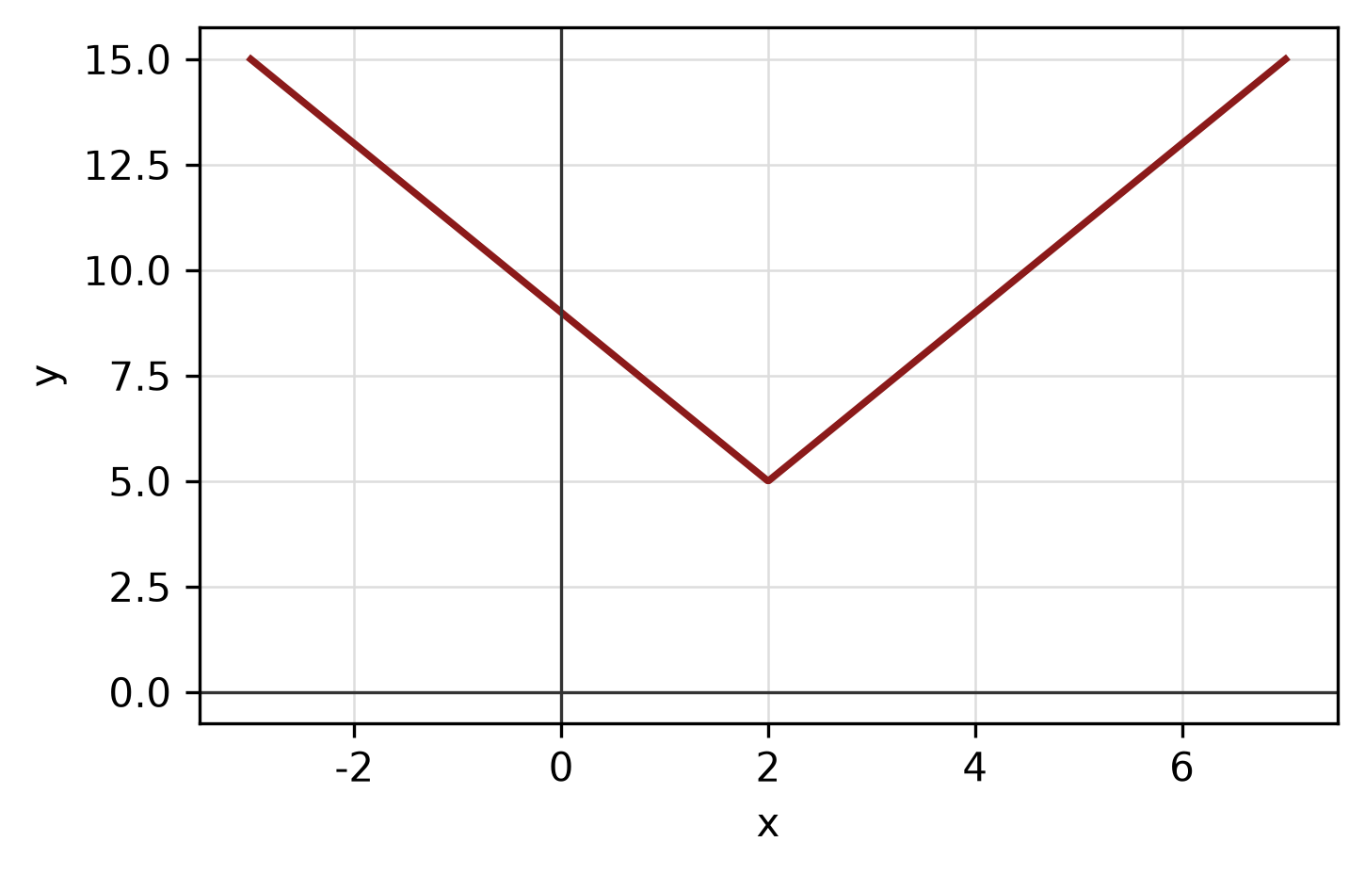
Figure: absolute-value graph.
QUESTION 2
a) Determine algebraically whether f(x) = 3x^4 + 2x^3 + 6 is even, odd or neither. State the symmetry of its graph.
(4 marks)
b) The piecewise function is defined by
f(x) = 2 - 3x, if x < -1;
f(x) = -2, if -1 ≤ x ≤ 2;
f(x) = x² - 3, if x > 2.
Sketch the graph and find f(-2), f(0) and f(3).
(5 marks)
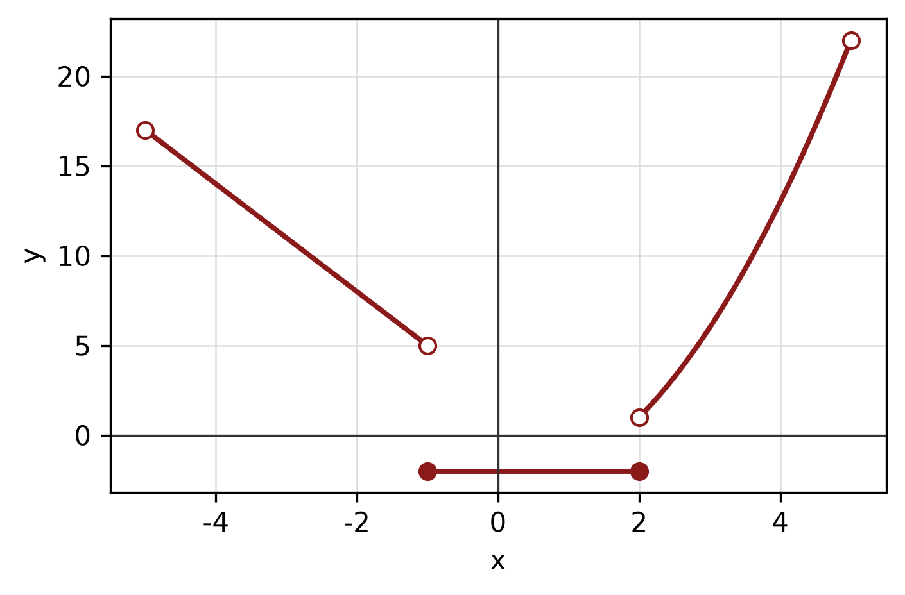
Figure: piecewise graph.
c) Sketch the circle x² + 8x + y² - 2y - 19 = 0. State its centre and radius.
(4 marks)
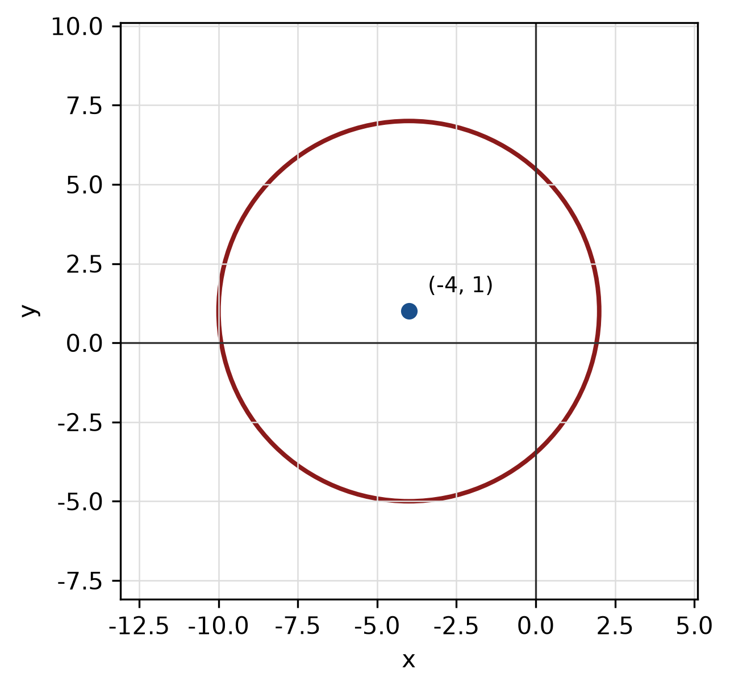
Figure: circle.
QUESTION 3
a) Given z₁ = -4 + 2i and z₂ = -5 + 2i, express z₁/z₂ in the form a + bi.
(5 marks)
b) Find the modulus and argument of z = -3 + 4i. Give the argument in degrees correct to one decimal place.
(5 marks)
c) Use synthetic division to divide f(x) = -2x^3 - 3x² - x + 2 by x. State the quotient and remainder.
(5 marks)
QUESTION 4
a) Solve the simultaneous equations
-3x - y = 15
-x - 5y = 5.
(4 marks)
b) Graph the system of inequalities below and shade the feasible region. State the vertices of the region.
x ≥ 0, y ≥ 0, 2x + 3y ≤ 8.
(5 marks)
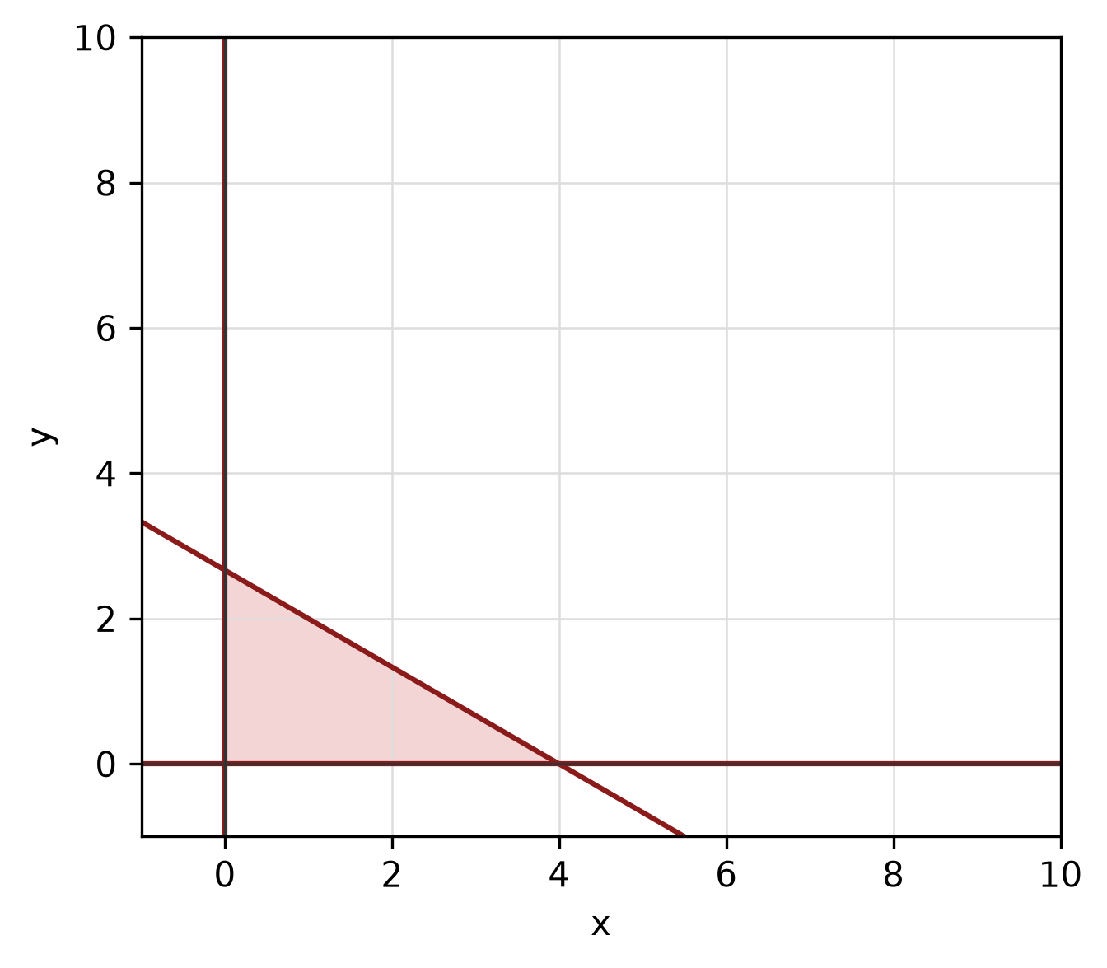
Figure: feasible region.
c) Write the equation of the circle with centre (4, -5) and radius 5. Hence write its general equation and sketch the circle.
(5 marks)
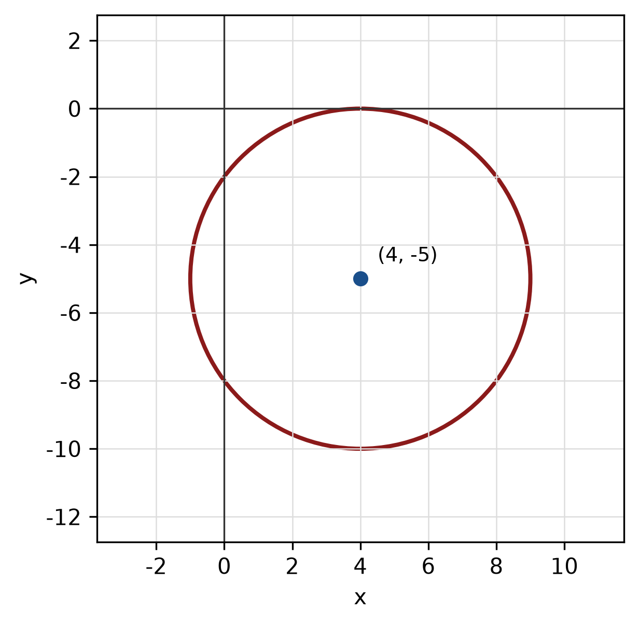
Figure: circle.
QUESTION 5
a) Prove the identity (1 - cos² x)/(sin x cos x) = tan x.
(5 marks)
b) Convert 30° to radians, and convert π radians to degrees.
(3 marks)
c) In triangle ABC, A = 30°, B = 45° and a = 6 cm. Use the sine rule to find b.
(4 marks)
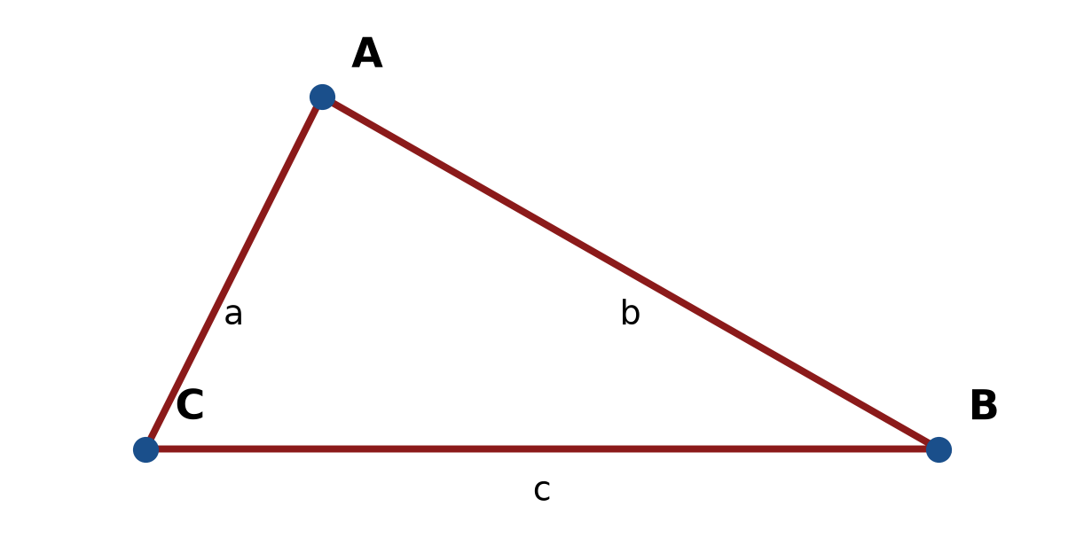
Figure: triangle ABC.
END OF QUESTION PAPER

APPENDIX 1
Formula sheet (as supplied with the paper).
sin² A + cos² A = 1 | tan² A + 1 = sec² A
sin(A + B) = sin A cos B + cos A sin B | tan 2A = 2 tan A / (1 − tan² A)
cos(A + B) = cos A cos B − sin A sin B | Arc length, s = rθ
tan(A − B) = (tan A − tan B) / (1 + tan A tan B) | Area of sector = ½r²θ
cos 2A = cos² A − sin² A | a / sin A = b / sin B = c / sin C
cos 2A = 1 − 2sin² A = 2cos² A − 1 | a² = b² + c² − 2bc cos A
sin 2A = 2 sin A cos A | Area of triangle = ½ab sin C

