CONFIDENTIAL CS/OCT 2026/MAT133

UNIVERSITI TEKNOLOGI MARA FINAL EXAMINATION

COURSE
COURSE CODE
EXAMINATION TIME
PRE CALCULUS
MAT133 OCTOBER 2026
2 HOURS

INSTRUCTIONS TO CANDIDATES

- This question paper consists of 5 questions.

- Answer ALL questions in the Answer Booklet. Start each answer on a new page.

- Do not bring any material into the examination room unless permission is given by the invigilator .
- Please check to make sure that this examination pack consists of: i) the Question Paper
  - a one - page Append ix 1
  - an Answer Booklet - provided by the Faculty
  - a graph paper - provided by the Faculty

- Answer ALL questions in English.

/

DO NOT TURN THIS PAGE UNTIL YOU ARE TOLD TO DO SO

This examination paper consists of 9 printed pages

QUESTION 1
a) Solve the inequality 6x - 7 > 4. Express the answer in interval notation.
(4 marks)
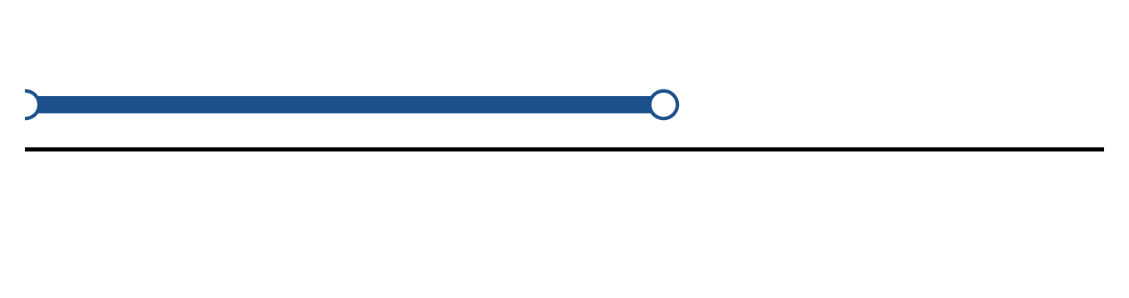
Figure: solution on a number line.
b) Solve the inequality |1 - 2x| > 3. Express the answer in interval notation and on a number line.
(5 marks)
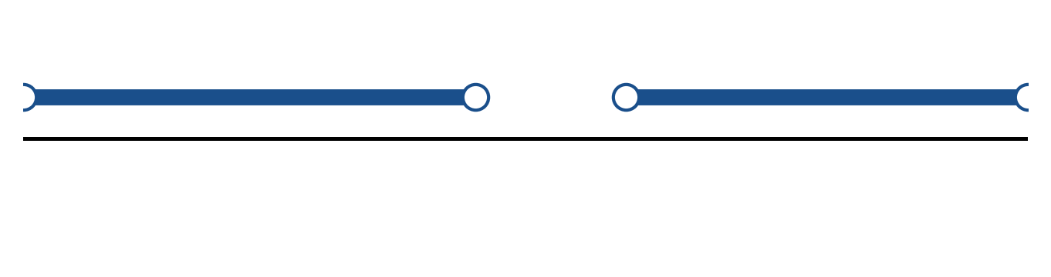
Figure: solution on a number line.
c) Solve the equation |5x + 4| = 3.
(4 marks)
QUESTION 2
a) Sketch y = (x - 1)² - 3 for -2 ≤ x ≤ 4. State the domain and range.
(4 marks)
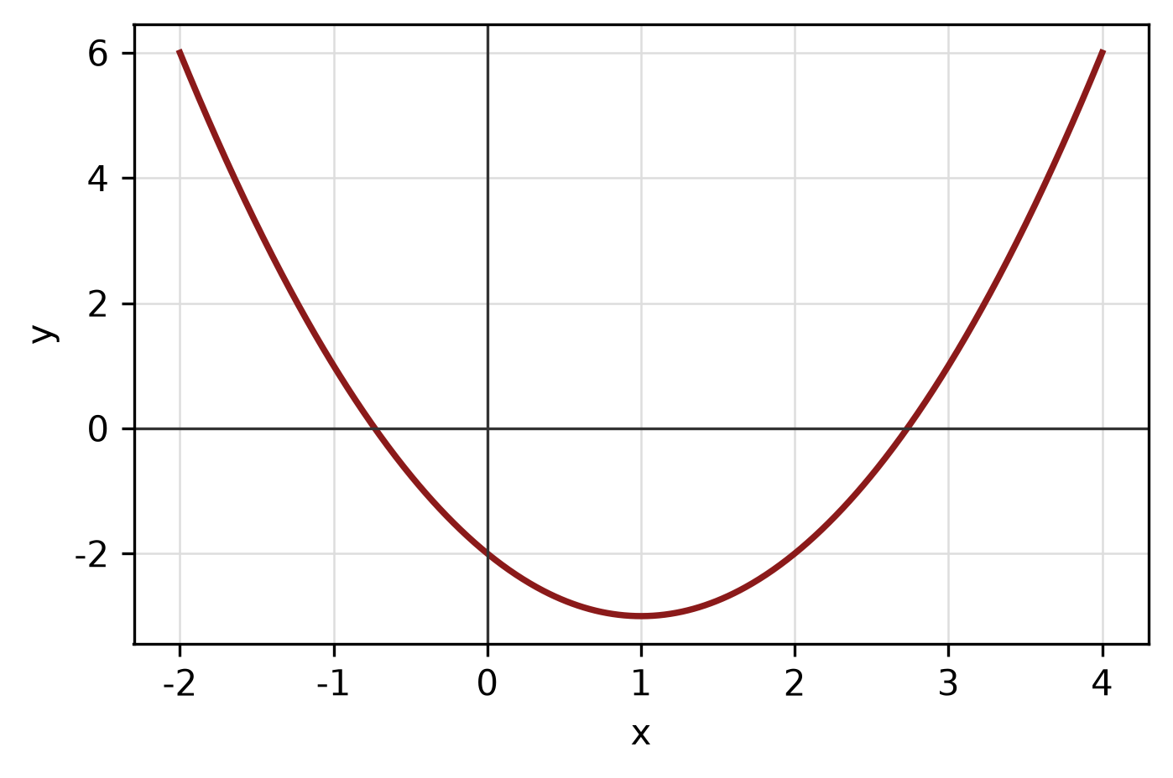
Figure: function graph.
b) Given f(x) = 4x + 3 and g(x) = 3x + 1, find (f + g)(x), (f - g)(x) and (f g)(x). State the domain of each.
(4 marks)
c) The endpoints of a diameter of a circle are (6, 5) and (-1, 4). Find the centre, radius and equation of the circle.
(5 marks)
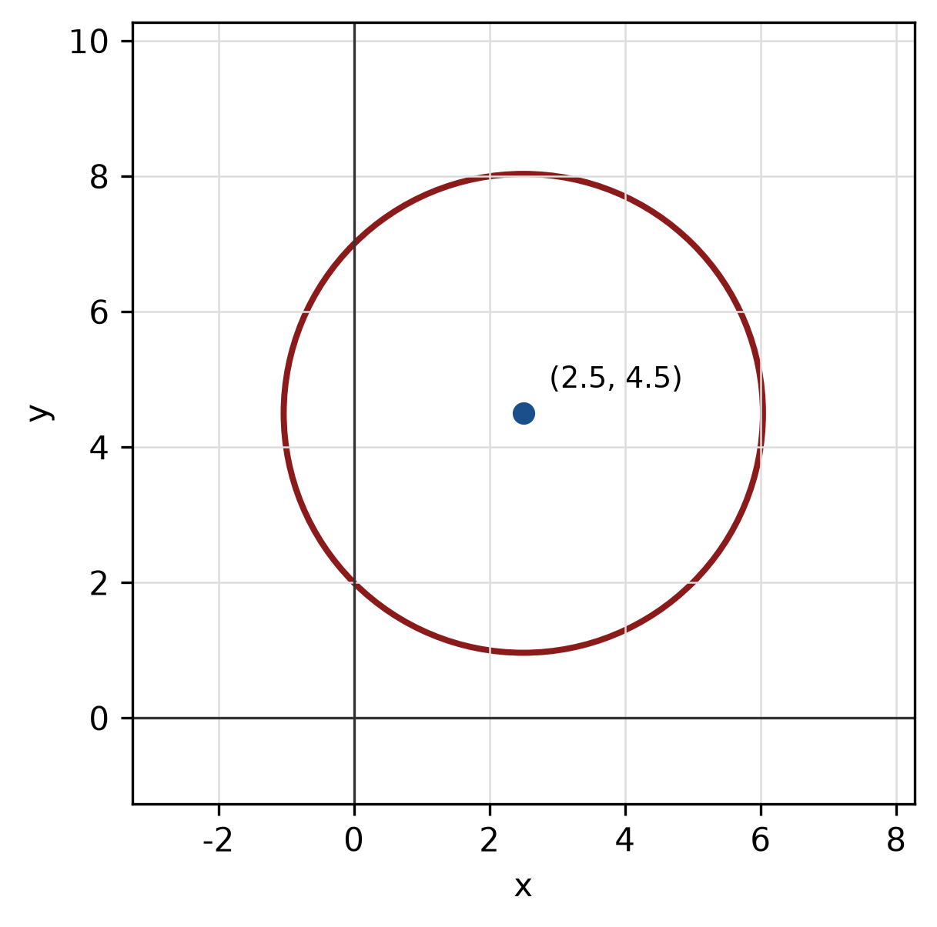
Figure: circle from diameter.
QUESTION 3
a) Given z₁ = -4 + 4i and z₂ = 2 - 3i, express z₁/z₂ in the form a + bi.
(5 marks)
b) Find the modulus and argument of z = 8 + 15i. Give the argument in degrees correct to one decimal place.
(5 marks)
c) Use long division to find the quotient and remainder when f(x) = x^3 + 5x² + 6x + 1 is divided by x - 1.
(5 marks)
QUESTION 4
a) Solve the simultaneous equations
x - y = 5
-3x + 2y = -12.
(4 marks)
b) Graph the system of inequalities below and shade the feasible region. State the vertices of the region.
x ≥ 0, y ≥ 0, 1x + 1y ≤ 8.
(5 marks)
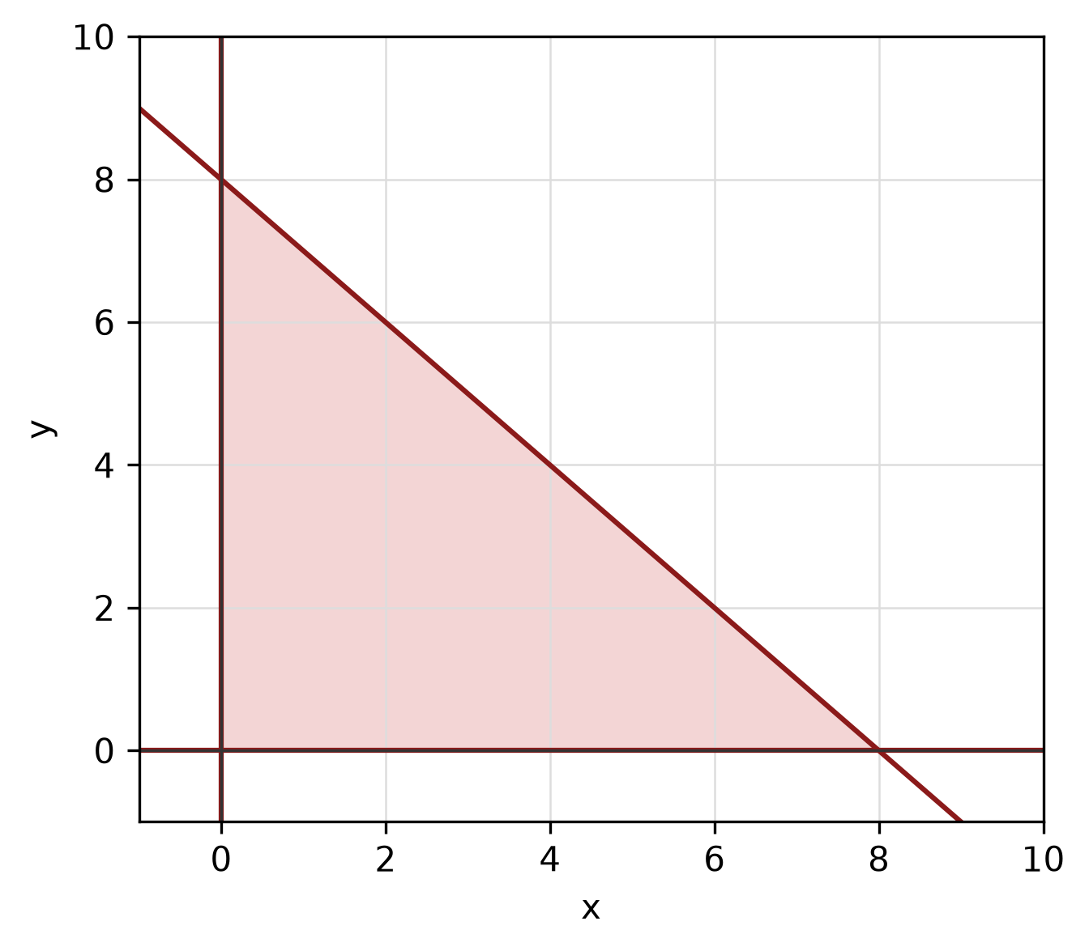
Figure: feasible region.
c) Sketch the circle x² + 8x + y² + 10y + 37 = 0. State its centre and radius.
(4 marks)
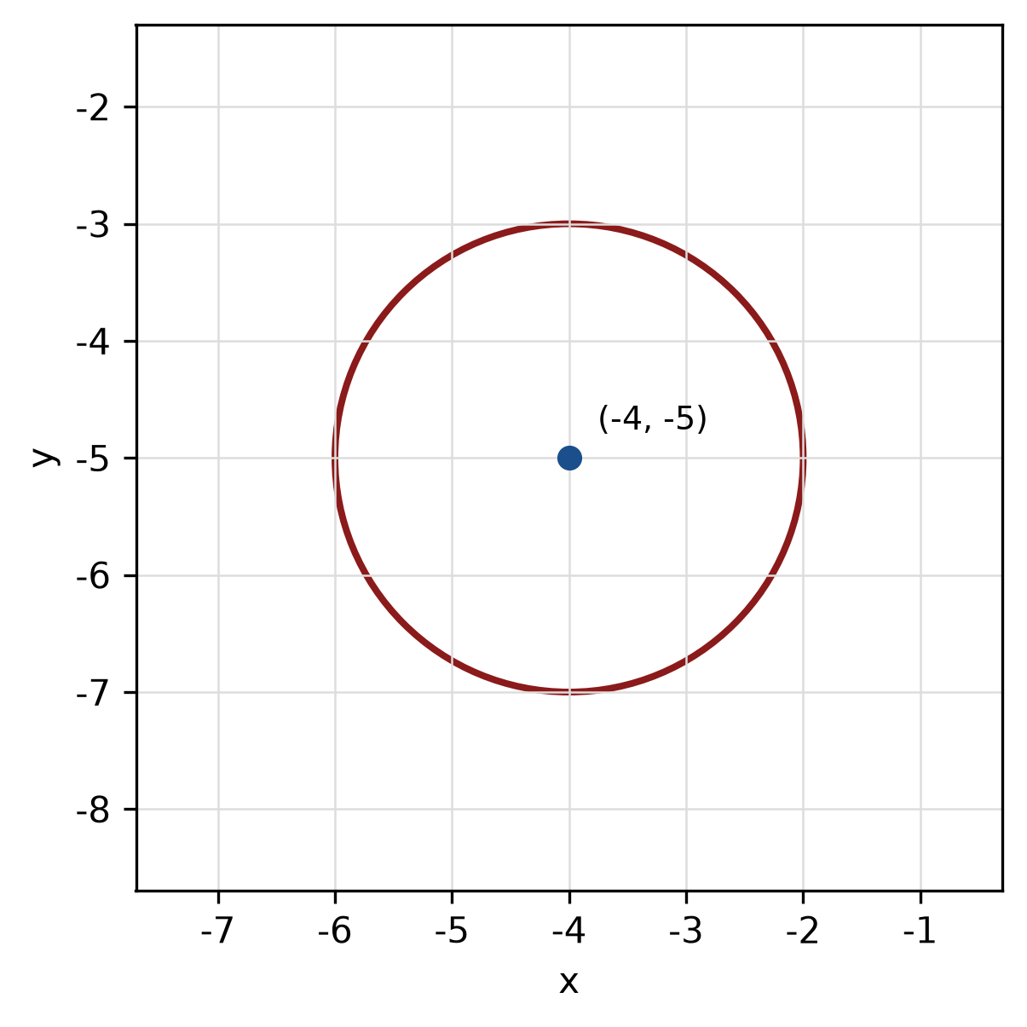
Figure: circle.
QUESTION 5
a) For y = -3 sin(2x + 0) + 2, state the amplitude, period and phase shift, then sketch the graph for -180° ≤ x ≤ 180°.
(5 marks)
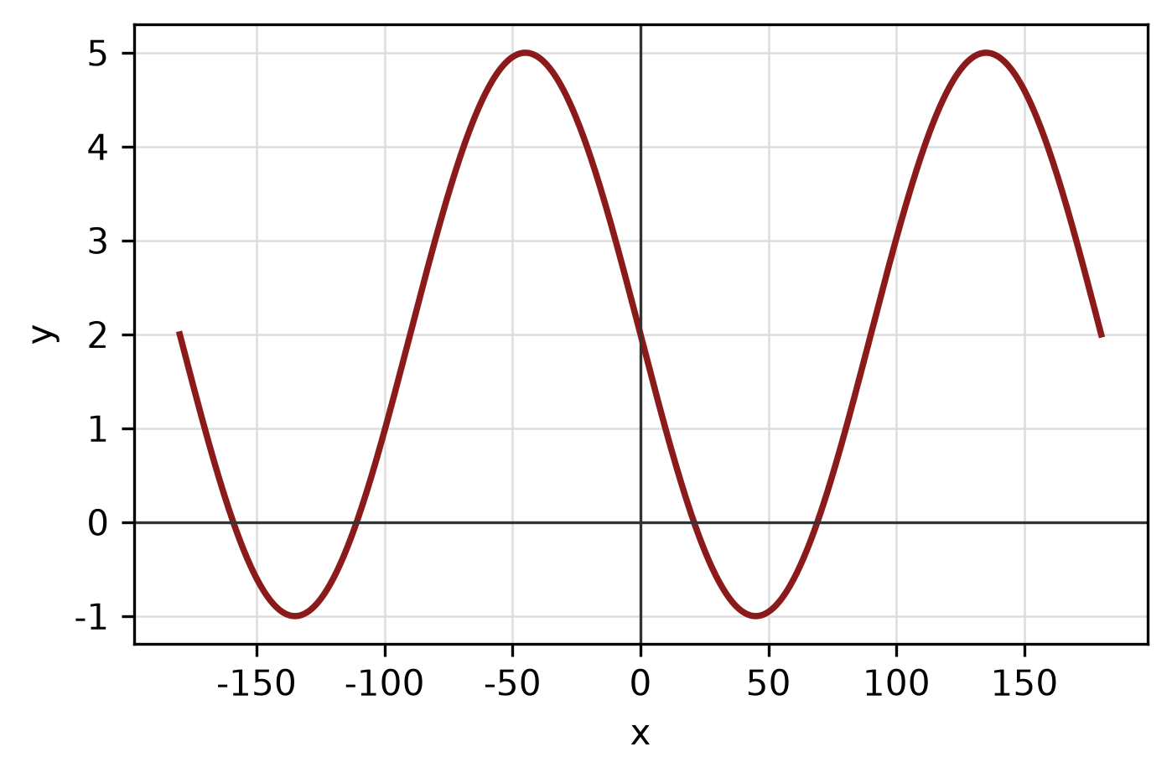
Figure: trigonometric graph.
b) Find the area of the sector of a circle with radius 8 cm and central angle 135°.
(4 marks)
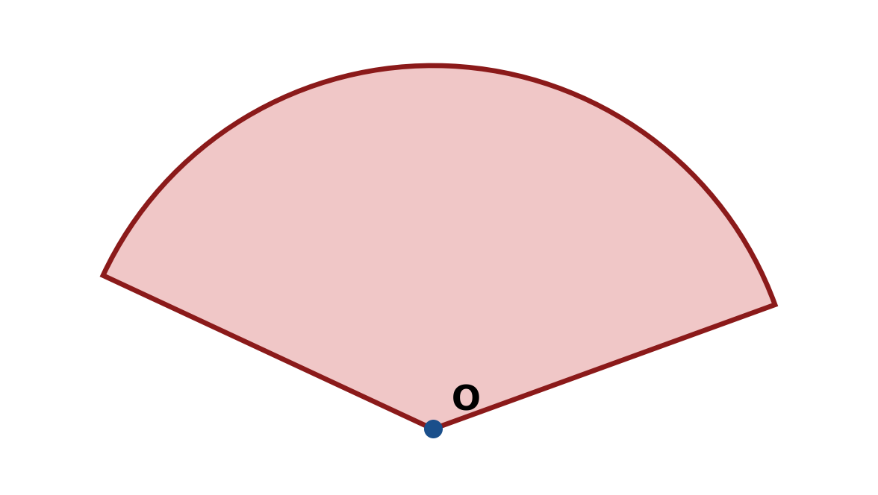
Figure: sector.
c) Solve the triangle with sides a = 14 cm, b = 48 cm and c = 50 cm. Find all three angles.
(5 marks)
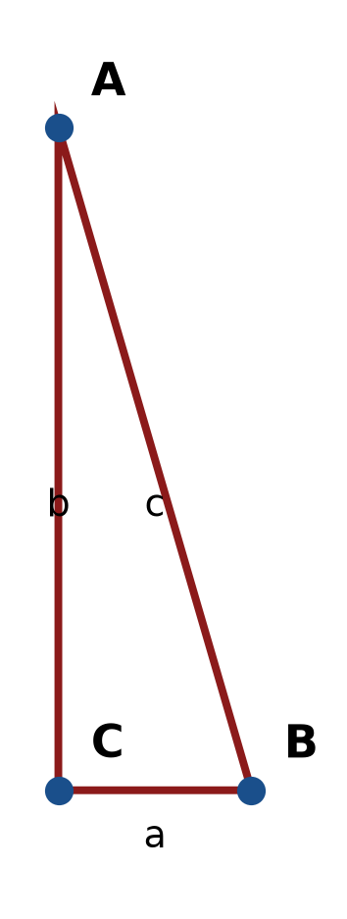
Figure: right triangle.
END OF QUESTION PAPER

APPENDIX 1
Formula sheet (as supplied with the paper).
sin² A + cos² A = 1 | tan² A + 1 = sec² A
sin(A + B) = sin A cos B + cos A sin B | tan 2A = 2 tan A / (1 − tan² A)
cos(A + B) = cos A cos B − sin A sin B | Arc length, s = rθ
tan(A − B) = (tan A − tan B) / (1 + tan A tan B) | Area of sector = ½r²θ
cos 2A = cos² A − sin² A | a / sin A = b / sin B = c / sin C
cos 2A = 1 − 2sin² A = 2cos² A − 1 | a² = b² + c² − 2bc cos A
sin 2A = 2 sin A cos A | Area of triangle = ½ab sin C

