CONFIDENTIAL CS/OCT 2026/MAT133

UNIVERSITI TEKNOLOGI MARA FINAL EXAMINATION

COURSE
COURSE CODE
EXAMINATION TIME
PRE CALCULUS
MAT133 OCTOBER 2026
2 HOURS

INSTRUCTIONS TO CANDIDATES

- This question paper consists of 5 questions.

- Answer ALL questions in the Answer Booklet. Start each answer on a new page.

- Do not bring any material into the examination room unless permission is given by the invigilator .
- Please check to make sure that this examination pack consists of: i) the Question Paper
  - a one - page Append ix 1
  - an Answer Booklet - provided by the Faculty
  - a graph paper - provided by the Faculty

- Answer ALL questions in English.

/

DO NOT TURN THIS PAGE UNTIL YOU ARE TOLD TO DO SO

This examination paper consists of 5 printed pages

QUESTION 1
a) Write the solution of 3x - 1 ≥ -1 in interval notation and on a number line.
(3 marks)
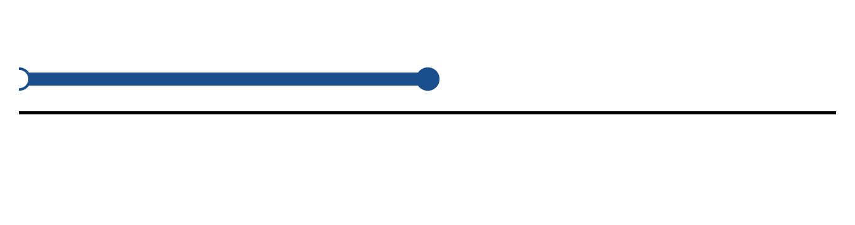
Figure: solution set.
b) Solve the inequality |-2x - 1| ≤ 5. Express the answer in interval notation and on a number line.
(5 marks)
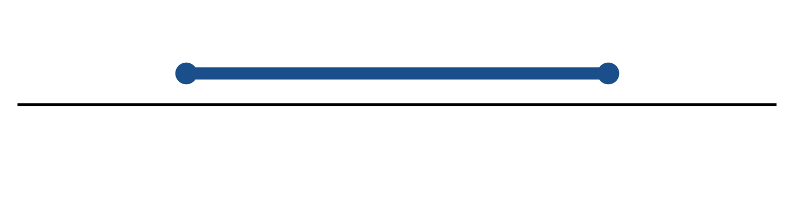
Figure: solution on a number line.
c) Solve the equation |4x - 4| = 3.
(4 marks)
QUESTION 2
a) Given f(x) = 2x + 2 and g(x) = -1/(x - 6), find (g ∘ f)(x) and state its domain.
(5 marks)
b) Given f(x) = 3x - 6 and g(x) = x - 1, find (f + g)(x), (f - g)(x) and (f g)(x). State the domain of each.
(4 marks)
c) The endpoints of a diameter of a circle are (2, -6) and (-4, 3). Find the centre, radius and equation of the circle.
(5 marks)
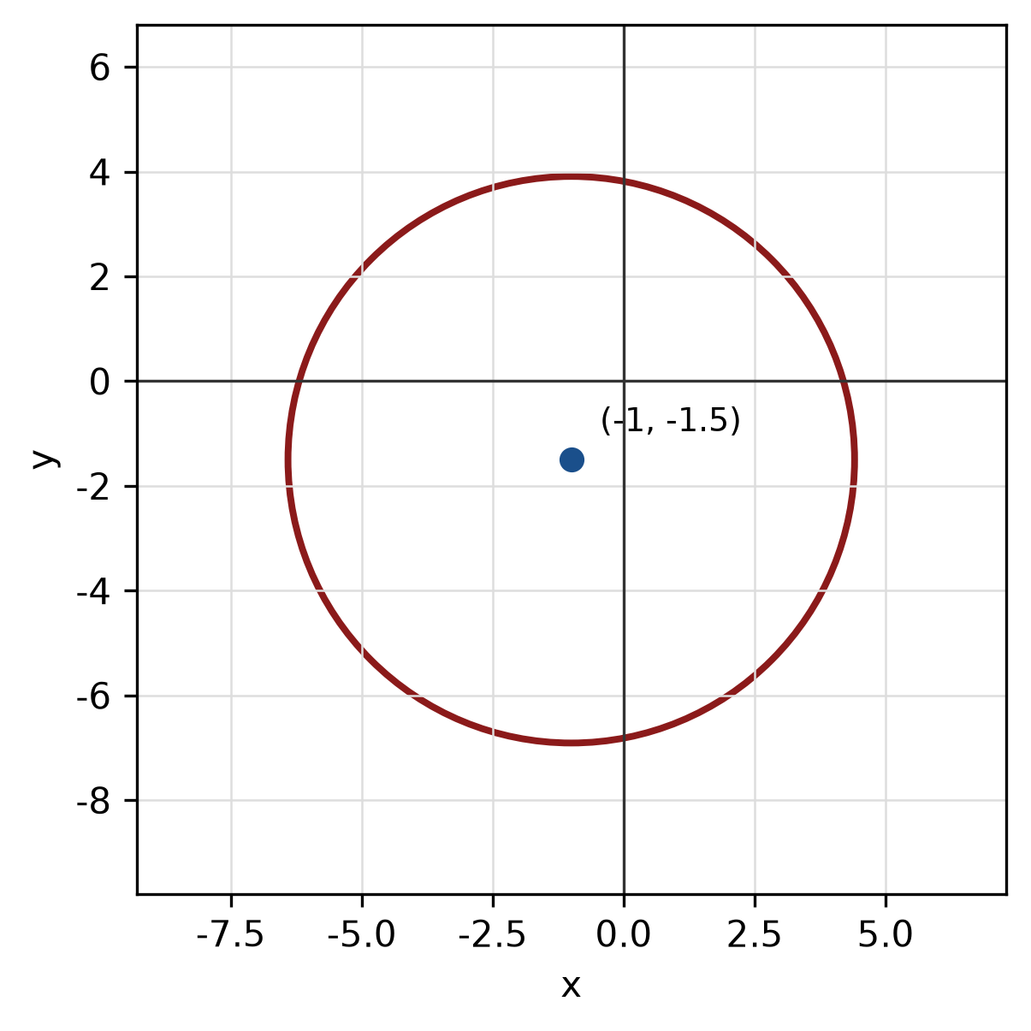
Figure: circle from diameter.
QUESTION 3
a) Given z₁ = 4 - i and z₂ = -5 - 5i, express z₁/z₂ in the form a + bi.
(5 marks)
b) Evaluate i^27 and simplify completely.
(3 marks)
c) Use the remainder theorem to find the remainder when f(x) = 2x^3 + 5x² - 2x + 4 is divided by x - 3.
(3 marks)
QUESTION 4
a) Solve the simultaneous equations
-4x + 2y = -18
4x - 4y = 16.
(4 marks)
b) Solve the simultaneous equations
y = x² - 1
y = 7x - 13.
(5 marks)
c) Write the equation of the circle with centre (2, -3) and radius 2. Hence write its general equation and sketch the circle.
(5 marks)
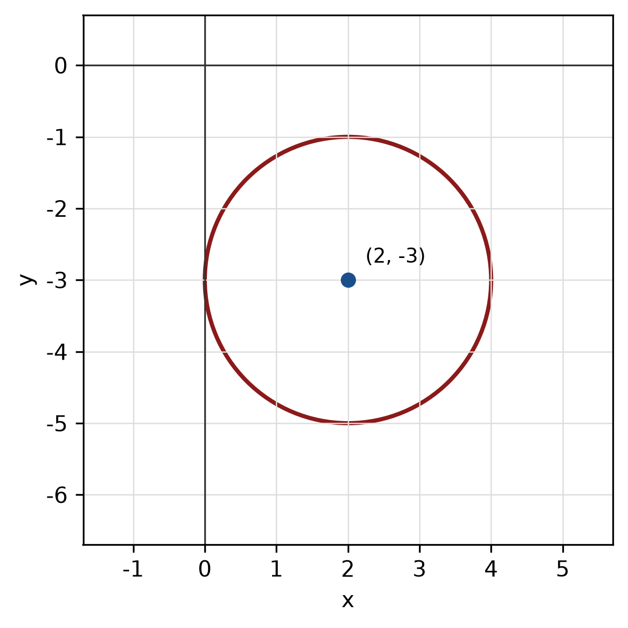
Figure: circle.
QUESTION 5
a) Given sin A = 8/17 and A is in quadrant 1, find the exact values of cos A, tan A and sec A.
(4 marks)
b) Find the perimeter of the sector with radius 12 cm and central angle 90°.
(4 marks)
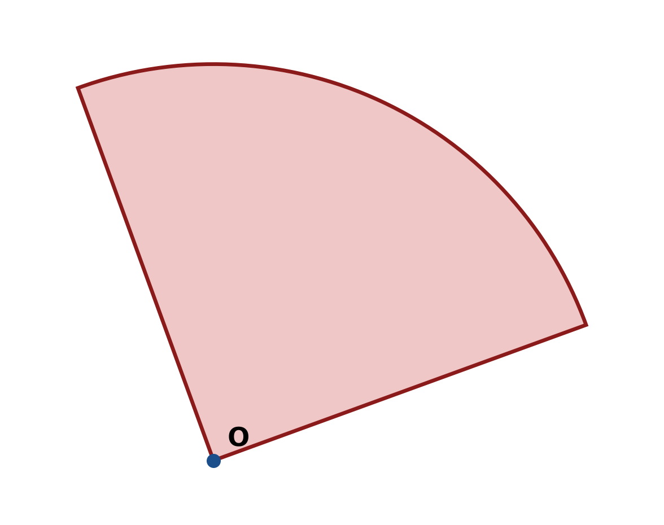
Figure: sector.
c) Find the area of triangle ABC with a = 14 cm, b = 9 cm and included angle C = 45°.
(4 marks)
END OF QUESTION PAPER

APPENDIX 1
Formula sheet (as supplied with the paper).
sin² A + cos² A = 1 | tan² A + 1 = sec² A
sin(A + B) = sin A cos B + cos A sin B | tan 2A = 2 tan A / (1 − tan² A)
cos(A + B) = cos A cos B − sin A sin B | Arc length, s = rθ
tan(A − B) = (tan A − tan B) / (1 + tan A tan B) | Area of sector = ½r²θ
cos 2A = cos² A − sin² A | a / sin A = b / sin B = c / sin C
cos 2A = 1 − 2sin² A = 2cos² A − 1 | a² = b² + c² − 2bc cos A
sin 2A = 2 sin A cos A | Area of triangle = ½ab sin C

