
CONFIDENTIAL CS/NOV 2026/CSC429

UNIVERSITI TEKNOLOGI MARA FINAL EXAMINATION

COURSE
COURSE CODE
EXAMINATION TIME
COMPUTER ORGANIZATION AND ARCHITECTURE

CSC429
NOVEMBER 2026
3 HOURS

INSTRUCTIONS TO CANDIDATES

- This question paper consists of two (2) parts: PART A (10 Questions) PART B (1 Question)

- Answer ALL questions in the Answer Booklet. Start each answer on a new page.

- Do not bring any material into the examination room unless permission is given by the invigilator .
- Please check to make sure that this examination pack consists of: i) the Question Paper
  - an Answer Booklet - provided by the Faculty

- Answer ALL questions in English.

DO NOT TURN THIS PAGE UNTIL YOU ARE TOLD TO DO SO

This examination paper consists of 6 printed pages.

PART A (80 MARKS)
Answer ALL questions in this part.

QUESTION A1 (5 marks)
Question 1 is based on the following snippet garnered from a computer science web page.
Henry Edward "Ed" Roberts
(September 13, 1941 -April 1, 2010)
was an American engineer, entrepreneur and
medical doctor who invented the first
commercially successful personal computer in
1975. He is most often known as "the father of
the personal computer". The computer was
available as a kit for $439 or assembled for
$621 and had several additional add-ons such
as a memory board and interface boards. By
August 1975, over 5,000 Altair 8800 personal
computers were sold; starting the personal
computer revolution.

- In which computer generation that a personal computer is introduced?
- Discuss ONE (1) other major discovery that is found in this generation.
- Advances in laptop and hand-held devices are accelerating during this computer generation. How such technology is feasible as compared to previous computer generation?

QUESTION A2 (5 marks)
Question 1 is based on the following Figure 1.
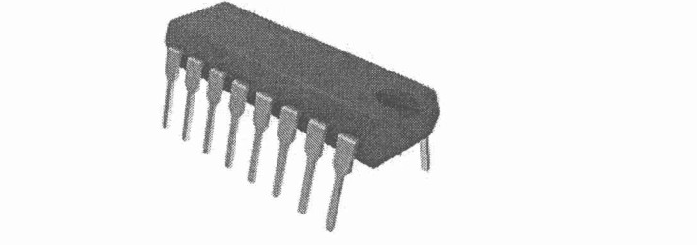
The development of component X led to a drastic increase in speed and efficiency of computers. Component X is a single, complete electronic semiconductor circuits contained on pieces of silicon, and sometimes called as chips.
- What is the name of component X?
- In which computer generation was component X introduced?
- Who is the inventor of component X?
- State ONE (1) input device and ONE (1) output device that was introduced in the same generation as component X.

QUESTION A3 (5 marks)
- Define cache.
- Differentiate between cache and main memory in term of the following characteristics:
- Price
- Memory size
- Access time
- Distance from Central Processing Unit (CPU)

QUESTION A4 (5 marks)
- List THREE (3) interfaces to external device.
- Discuss 'hot connection' of device.

QUESTION A5 (10 marks)
Computer consists of four main components as illustrated in Figure 1. Each component has its own function in ensuring that the computer system works well. Question 4 is based on
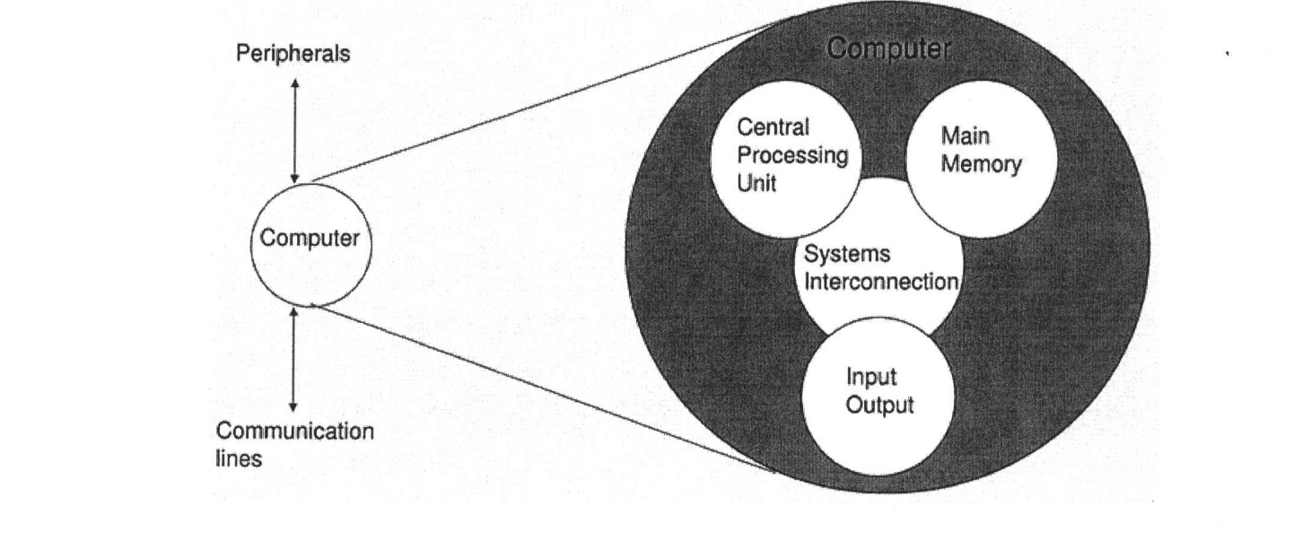
a) Explain THREE (3) types of system interconnection.
b) State TWO (2) sub-components of central processing unit and its function.

QUESTION A6 (10 marks)
Illustration in Figure 1 shows an interrupt that happen during the execution of a program. Question 4 is based on Figure 1.
Update status
The program can't check for definition updates. Error found: Ox80072ee7. The server name or address
could not be resolved
Go online to view troubleshpoting tips
Start time
Time elapse& 00:00:01

a) Define interrupt.
b) Why interrupt is important?
c) Explain TWO (2) types of interrupt.
d) Discuss ONE (1) option to handle multiple interrupts that happen simultaneously.

QUESTION A7 (10 marks)
a) List the FOUR (4) classifications of parallel processors and provide examples for each.
b) Discuss ONE (1) advantage of using cluster computer architecture.

QUESTION A8 (10 marks)
a) Explain the problem in polling 1/0 method.
b) Explain how buffering can help to improve the device overall performance?
c) Discuss how DMA technique can help the 1/0 transfer performance instead of using polling method and interrupt 1/0 method?

QUESTION A9 (10 marks)
Keyboard is the most common means for computer interaction.
a) Explain TWO (2) types of keyboard characters.
b) Describe THREE (3) categories of input and output module. Give an appropriate example for each category.

QUESTION A10 (10 marks)
a) Why input/output problem occurs?
b) Describe THREE (3) categories for input/output module and provide an appropriate example each.

PART B (20 MARKS)
Answer the question in this part.

QUESTION B1 (20 marks)
Question 1 is based on Figure 2 and Table 1.
Write an appropriate program using correct assembly language notations to compute the equation shown in Figure 2 using instructions for one-address, two-address, and three- address. The available instructions are provided in Table 1. The register labeled A, B, C, and D are fixed, while registers x, y, and z can be used temporarily. The final answer must be stored in register y.
One-address | Two-address | Three-address
LOADp | MOV (p,q) | ADD (p.q.r)
STORp | ADD (p,q) | SUB (p,q,r)
ADDp | SUB (p,q) | MUL (p.q.r)
SUBp | MUL (p,q) | DIV(p,q,r)
MULp | DIV(p,q)
DIVp

