
CONFIDENTIAL CS/NOV 2026/CSC429

UNIVERSITI TEKNOLOGI MARA FINAL EXAMINATION

COURSE
COURSE CODE
EXAMINATION TIME
COMPUTER ORGANIZATION AND ARCHITECTURE

CSC429
NOVEMBER 2026
3 HOURS

INSTRUCTIONS TO CANDIDATES

- This question paper consists of two (2) parts: PART A (10 Questions) PART B (1 Question)

- Answer ALL questions in the Answer Booklet. Start each answer on a new page.

- Do not bring any material into the examination room unless permission is given by the invigilator .
- Please check to make sure that this examination pack consists of: i) the Question Paper
  - an Answer Booklet - provided by the Faculty

- Answer ALL questions in English.

DO NOT TURN THIS PAGE UNTIL YOU ARE TOLD TO DO SO

This examination paper consists of 8 printed pages.

PART A (80 MARKS)
Answer ALL questions in this part.
QUESTION A1 (5 marks)
Question 1 is based on the following Figure 1.
Inventor 'Y' was France's most celebrated mathematician and physicist. In 1642, inventor 'Y' invented and built the first working calculating machine as a means of helping his father to perform tedious tax accounting.
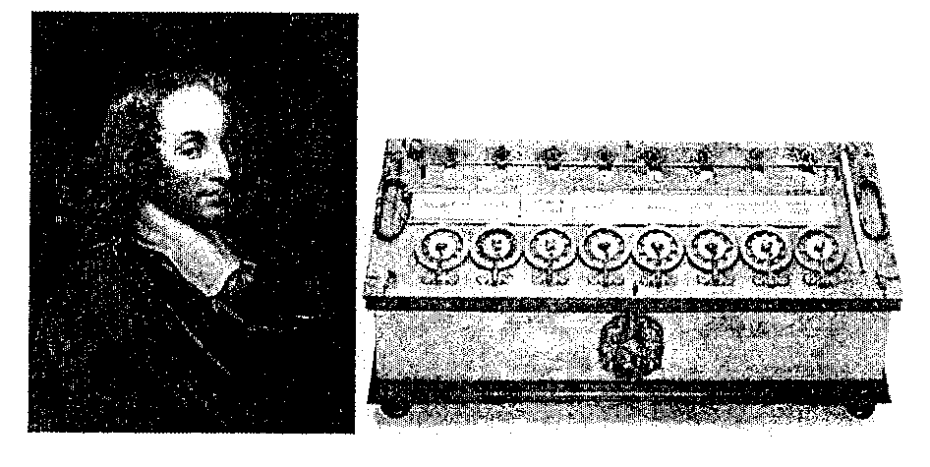
Figure 1: Inventor 'Y' and his calculating machine.
a) Who is inventor 'Y'?
b) Name another calculating machine that was invented in the same generation as inventor Y's calculating machine.
c) Which programming language is named after inventor 'Y'?
d) State TWO (2) mathematical operations that can be performed by inventor Y's calculating machine.

QUESTION A2 (5 marks)
Question 1 is based on the following Figure 1.
The development of component X led to a drastic increase in speed and efficiency of computers. Component X is a single, complete electronic semiconductor circuit contained on pieces of silicon, and sometimes called as chips.
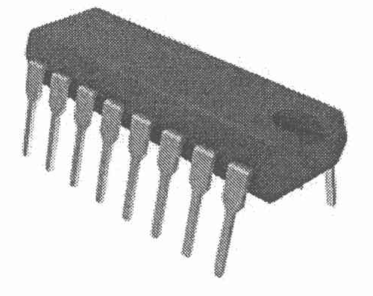
Figure 1: Component X
a) What is the name of component X?
b) In which computer generation was component X introduced?
c) Who is the inventor of component X?
d) State ONE (1) input device and ONE (1) output device that was introduced in the same generation as component X.
QUESTION A3 (5 marks)
0101011100111000111100101100111000011001
Figure 1
a) Calculate the byte content shown in Figure 1.
b) Calculate 2D.5h + ED.2h in binary. Show your complete workflow.
QUESTION A4 (5 marks)
a) Solve -48₁₀ + 68₁₀ using the sign and magnitude method. Show the complete workflow.
b) Calculate -96₁₀ - 15₁₀ using the 1's and 2's complement method. Show the complete workflow.
QUESTION A5 (10 marks)
Question 7 is based on Figure 2.
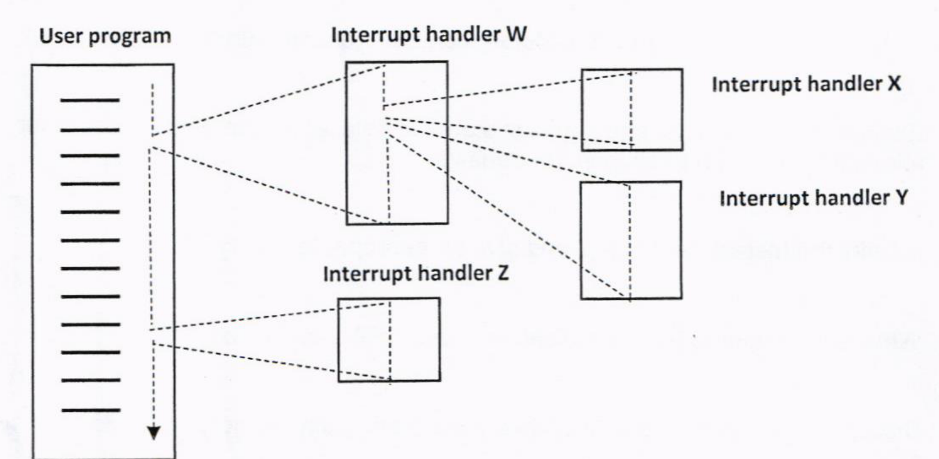
Figure 2: Nested interrupts
a) Define interrupt.
b) Identify the interrupt that has the highest priority with relevant justification.
c) Identify the interrupt that has the lowest priority with relevant justification.
d) Rank the sequence of the interrupt process completed if the computer system applies the defined priority concept to handle multiple interrupts.
e) Rank the sequence of the interrupt process completed if the computer system applies the disable nested interrupt concept to handle multiple interrupts.
QUESTION A6 (10 marks)
Given that the size of the data bus is 32 bits, the size of the address bus is 8 bits, and the size of the control bus is 4 bits.
a) Determine the size of the word and provide relevant justification.
b) Determine the size of the register and provide relevant justification.
c) Discuss what will happen if system interconnection is blocked from the perspective of the machine cycle.
d) Elaborate the role of CPU interconnection.
QUESTION A7 (10 marks)
Given the architecture of Single Instruction, Single Data Stream (SISD) in Figure 3, with CU representing Control Unit, PU representing the Processing Unit, and MU representing the Memory Unit.
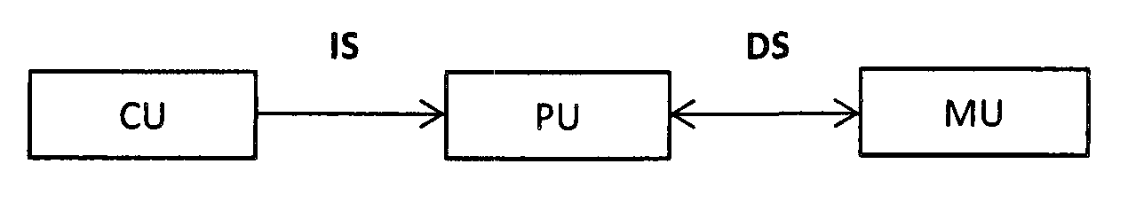
Figure 3: Single Instruction, Single Data Stream (SISD)
a) Draw the following multiple processor organization with appropriate labels. Clearly show the Instruction Stream (IS) and Data Stream (DS). i) MIMD with shared memory. ii) MIMD with distributed memory.
b) Give ONE (1) example for each multiple-processor organization in (a).
c) Discuss ONE (1) advantage of using MIMD with distributed memory.

QUESTION A8 (10 marks)
Question 10 is based on Figure 2. Figure 2 depicts a Non-uniform Memory Access (NUMA) architecture.
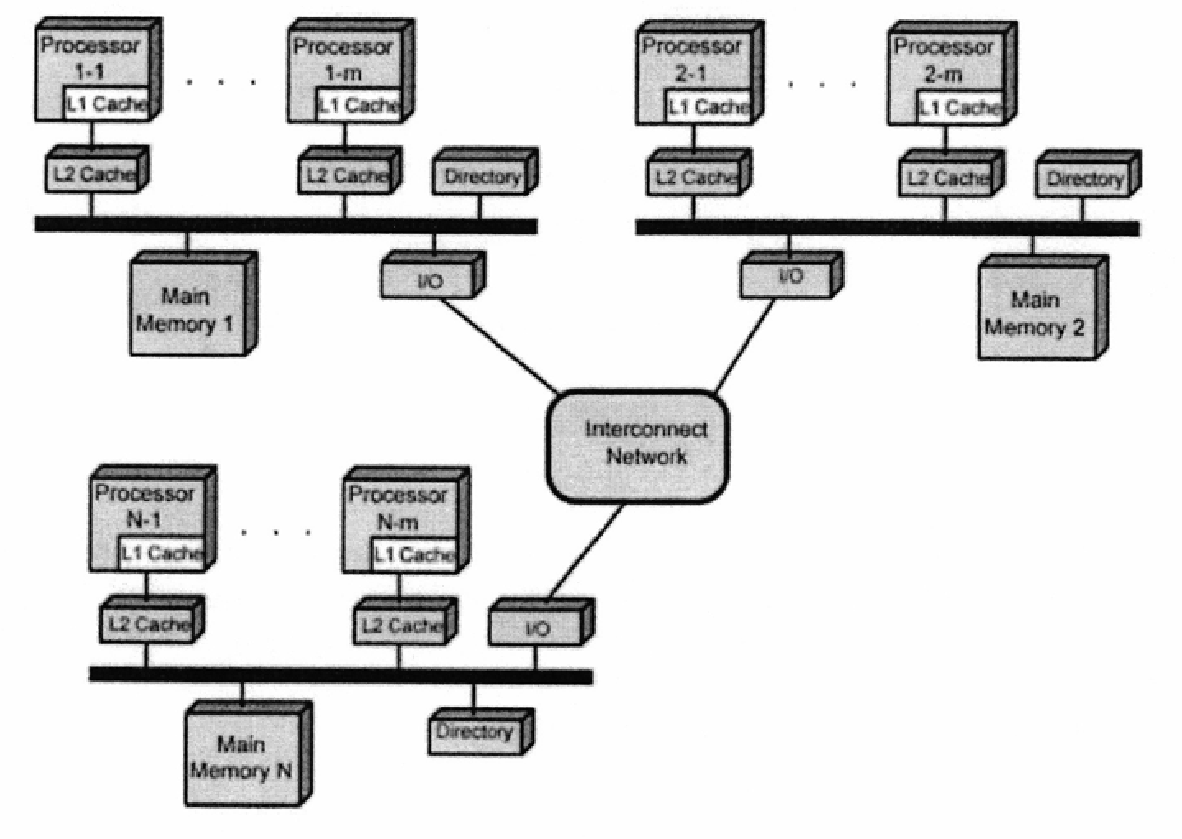
Figure 2: Non-uniform Memory Access (NUMA)
a) Redraw a symmetric multiprocessor organization based on Figure 2.
b) Give TWO (2) examples of tightly coupled Multiple Instruction, Multiple Data (MIMD) parallel processor architectures.
c) Discuss TWO (2) disadvantages of tightly coupled Multiple Instruction, Multiple Data (MIMD) parallel processor architectures.
QUESTION A9 (10 marks)
a) Differentiate the involvement of CPU in the interrupt-driven I/O technique and Direct Memory Access (DMA).
b) Define interrupt.
c) Discuss what happens during a context switch.
d) Elaborate on the benefit of a context switch.
QUESTION A10 (10 marks)
Figure 1 illustrates the icon of one of the interfaces to the external devices.
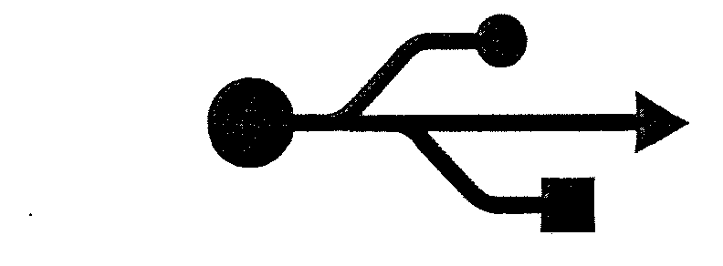
Figure 1: Interface to the external devices
a) Identify the type of external device interface based on the icon in Figure 1.
b) The external devices interface in (a) can have a "hot connection". Define hot connection.
c) Discuss the THREE (3) input-output techniques available in a computer system and elaborate on the Central Processing Unit's involvement in each technique.

PART B (20 MARKS)
Answer the question in this part.
QUESTION B1 (20 marks)
Question 1 is based on Figure 5 and Table 1. Write an appropriate program using correct assembly language notations to compute the equation shown in Figure 5 using instructions for zero-address, one-address, and three-address. The available instructions are provided in Table 1. The registers labeled A, B, C, and D are fixed, while registers x, y, and z can be used temporarily. The final answer must be stored in register z.
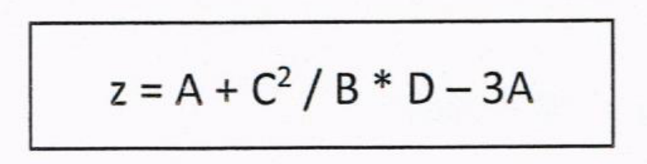
Figure 5
Table 1: Machine instruction
Zero-address | One-address | Three-address
PUSH p | LOAD p | ADD (p,q,r)
POP p | STOR p | SUB (p,q,r)
ADD | ADD p | MUL (p,q,r)
SUB | SUB p | DIV (p,q,r)
MUL | MUL p
DIV | DIV p

