
CONFIDENTIAL CS/NOV 2026/CSC429

UNIVERSITI TEKNOLOGI MARA FINAL EXAMINATION

COURSE
COURSE CODE
EXAMINATION TIME
COMPUTER ORGANIZATION AND ARCHITECTURE

CSC429
NOVEMBER 2026
3 HOURS

INSTRUCTIONS TO CANDIDATES

- This question paper consists of two (2) parts: PART A (10 Questions) PART B (1 Question)

- Answer ALL questions in the Answer Booklet. Start each answer on a new page.

- Do not bring any material into the examination room unless permission is given by the invigilator .
- Please check to make sure that this examination pack consists of: i) the Question Paper
  - an Answer Booklet - provided by the Faculty

- Answer ALL questions in English.

DO NOT TURN THIS PAGE UNTIL YOU ARE TOLD TO DO SO

This examination paper consists of 6 printed pages.

PART A (80 MARKS)
Answer ALL questions in this part.

QUESTION A1 (5 marks)
Question 1 is based on the following snippet garnered from a computer science web page.
Henry Edward "Ed" Roberts
(September 13, 1941 -April 1, 2010)
was an American engineer, entrepreneur and
medical doctor who invented the first
commercially successful personal computer in
1975. He is most often known as "the father of
the personal computer". The computer was
available as a kit for $439 or assembled for
$621 and had several additional add-ons such
as a memory board and interface boards. By
August 1975, over 5,000 Altair 8800 personal
computers were sold; starting the personal
computer revolution.

- In which computer generation that a personal computer is introduced?
- Discuss ONE (1) other major discovery that is found in this generation.
- Advances in laptop and hand-held devices are accelerating during this computer generation. How such technology is feasible as compared to previous computer generation?

QUESTION A2 (5 marks)
Question 1 is based on the following Figure 1.
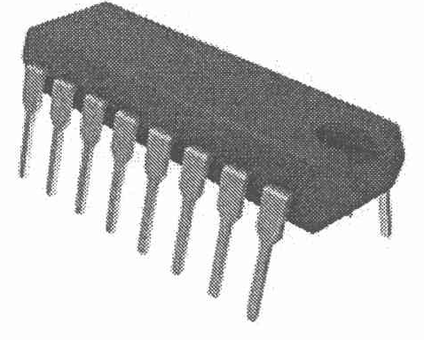
The development of component X led to a drastic increase in speed and efficiency of computers. Component X is a single, complete electronic semiconductor circuits contained on pieces of silicon, and sometimes called as chips.
- What is the name of component X?
- In which computer generation was component X introduced?
- Who is the inventor of component X?
- State ONE (1) input device and ONE (1) output device that was introduced in the same generation as component X.

QUESTION A3 (5 marks)
- List TWO (2) advantages of SMP organization.
- Define cluster organization.
- Give ONE (1) benefit of cluster organization.

QUESTION A4 (5 marks)
Give suitable example for each processor organization.

QUESTION A5 (10 marks)
Computer consists of four main components as illustrated in Figure 1. Each component has its own function in ensuring that the computer system works well. Question 4 is based on
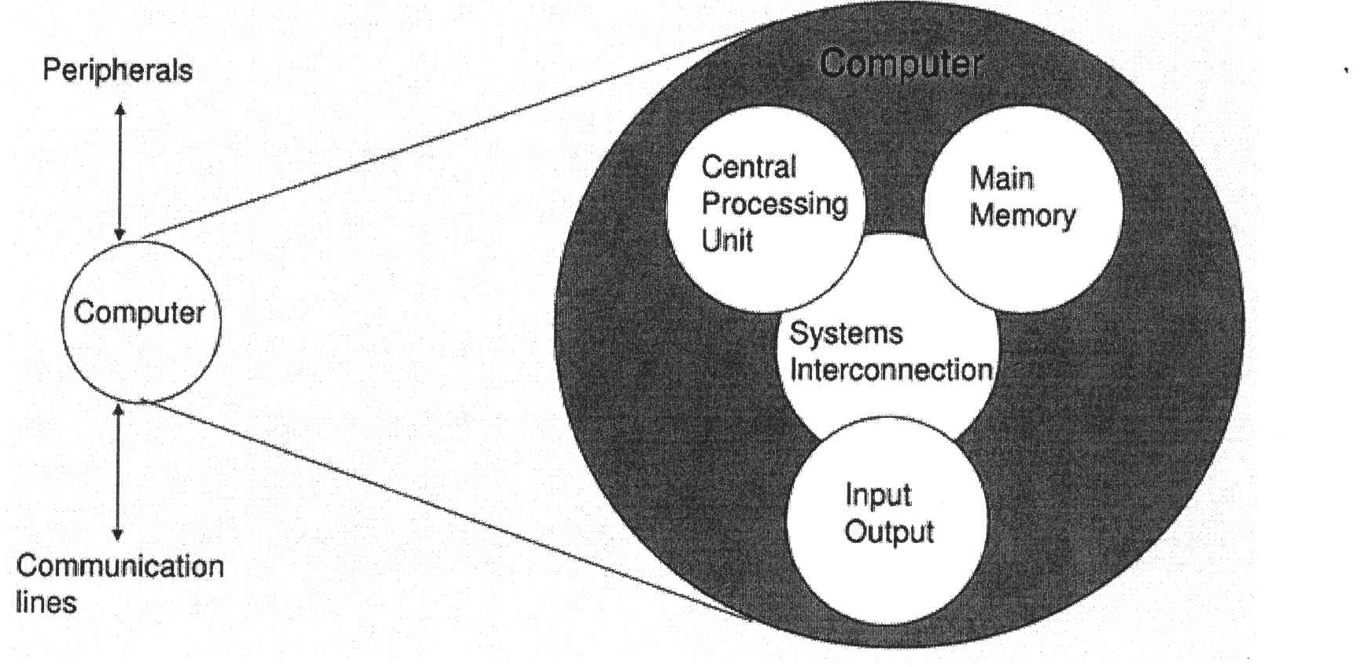
- Explain THREE (3) types of system interconnection.
- State TWO (2) sub-components of central processing unit and its function.

QUESTION A6 (10 marks)
Illustration in Figure 1 shows an interrupt that happen during the execution of a program. Question 4 is based on Figure 1.
Update status
The program can't check for definition updates. Error found: 0)C0072ee7. The server name or address
could not be resolved
Go online to view troubleshooting tips
Start time
Time elapsed:

- Define interrupt.
- Why interrupt is important?
- Explain TWO (2) types of interrupt.
- Discuss ONE (1) option to handle multiple interrupts that happen simultaneously.

QUESTION A7 (10 marks)
- List the FOUR (4) classifications of parallel processors and provide examples for each.
- Discuss ONE (1) advantage of using cluster computer architecture.

QUESTION A8 (10 marks)
- Calculate FIFAie - 664i6 using the following techniques. Showthe complete workflow.
- Sign and magnitude
- 2's complement

QUESTION A9 (10 marks)
- Discuss THREE (3) main key factors for memory selection.
- List TWO (2) examples for internal cabling memory and TWO (2) examples of system memory.

QUESTION A10 (10 marks)
- Describe THREE (3) types of interfaces to external devices.
- Explain TWO (2) types of interrupt.

PART B (20 MARKS)
Answer the question in this part.

QUESTION B1 (20 marks)
Question 1 is based on Figure 2 and Table 1.

Write an appropriate program using correct assembly language notations to compute the equation shown in Figure 2 using instructions for one-address, two-address, and three- address. The available instructions are provided in Table 1. The register labeled A, B, C, and D are fixed, while registers x, y, and z can be used temporarily. The final answer must be stored in register y.
One-address | Two-address | Three-address
LOADp | MOV (p,q) | ADD (p.q.r)
STORp | ADD (p,q) | SUB (p,q,r)
ADDp | SUB (p,q) | MUL (p.q.r)
SUBp | MUL (p,q) | DIV(p,q,r)
MULp | DIV(p,q)
DIVp

