
CONFIDENTIAL CS/NOV 2026/ICT450

UNIVERSITI TEKNOLOGI MARA FINAL EXAMINATION

COURSE
COURSE CODE
EXAMINATION TIME
DATABASE DESIGN AND DEVELOPMENT

ICT450
NOVEMBER 2026
3 HOURS

INSTRUCTIONS TO CANDIDATES

- This question paper consists of five (5) questions.

- Answer ALL questions in the Answer Booklet. Start each answer on a new page.

- Do not bring any material into the examination room unless permission is given by the invigilator .
- Please check to make sure that this examination pack consists of: i) the Question Paper
  - an Answer Booklet - provided by the Faculty

- Answer ALL questions in English.

DO NOT TURN THIS PAGE UNTIL YOU ARE TOLD TO DO SO

This examination paper consists of 4 printed pages.

QUESTION 1 (20 marks)
Smile Dental and Orthodontic Clinic has decided to build their own dental database system. The clinic has wisely chosen to hire you as a database designer and has offered to give you a free lifetime dental treatment if you design its database. You are given the following requirements:
- Dentists are identified by Dentist_ID. For each dentist, the name, address, telephone number, specialty, email address and years of experience must be recorded.
- Patients are identified by Patient_ID, and their names, addresses, phone number, date of birth, marital status and gender must be recorded.
• Every patient belongs to only one dentist. Every dentist has at least one patient.
- Each patient can have more than treatment for more than one teeth. On the other hand, one treatment can be done for more than one patient. Number of tooth and diagnosis are recorded.
- The input of treatment is Treatment_ID, treatment name, price, image for each treatment and tooth number.
- The dentist can do more than one treatment and one treatment is done by one dentist.
- Patient can have many appointments with several dates, start time and end time. Each appointment also will have an Appointment_ID.
- There are two types of treatments available in this dental system; disease treatment and orthodontic treatment. Disease treatment will allow dentist to check whether that patient has some specific disease. Attribute for orthodontic treatment is types of braces.
Based on the given information:
a) Construct an Entity Relationship Diagram (ERD) complete with all the required tables, attributes, relationships as well as the cardinalities using the Crow's Foot notation that reflects all of the given business rules.
(16 marks)
b) Briefly explain TWO (2) examples of reports that can be generated from ERD in above.
(4 marks)
QUESTION 2 (20 marks)
a) The evolution of data models has been driven by the increasing complexity of data storage, management, and analysis needs over time. Match the suitable data models with their correct statements.
(4 marks)
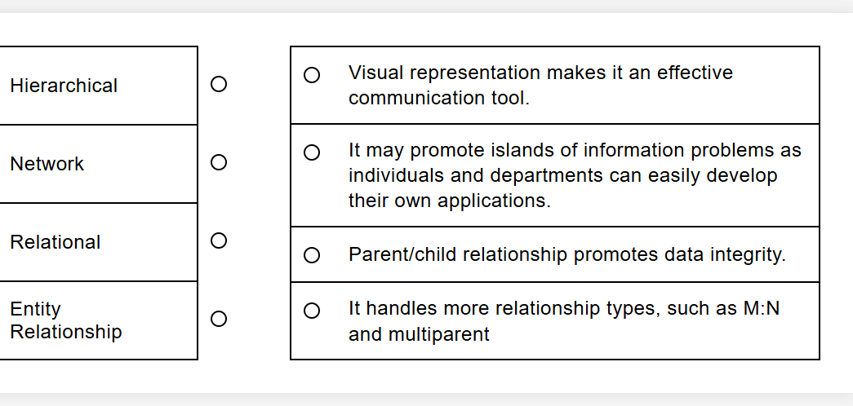
b) The following relational schema provides a basic structure for managing pet sales in a pet shop system. It includes customer information, pet information and purchase transactions.
PETS (PetID, Name, Species, Age, Price, PurchaseID*)
CUSTOMERS (CustomerID, Name, Address, Phone, Email)
PURCHASES (PurchaseID, CustomerID*, PurchaseDate)
Based on the relational schema above, describe TWO (2) related business rules.
(4 marks)
c) Security is a crucial aspect of DBMS. Describe THREE (3) reasons for protecting data from unauthorized users.
(6 marks)
d) Briefly explain THREE (3) challenges in handling multimedia data compared to traditional structured data.
(6 marks)
QUESTION 3 (20 marks)
Auto Servis Sdn Bhd launched their first ever automotive company. Auto Servis Sdn Bhd plan to hire a database designer to build their own Car Dealership System (CDS). These requirements are required to model the database of CDS :
Each salesperson is managed by one manager and each manager needs to manage many salespersons. Manager has manager ID, first name and last name. A salesperson has their ID, first name and last name. A salesperson is assigned to more than one customer. Each customer has their customer ID, first name, last name, phone number, address, city, state and country. Each customer can buy more than one vehicle. Every vehicle has its own, unique Vehicle Identification Number (VIN) which also referred to as the body number. Each vehicle can be categorized as Car, Truck and SUV. Car has engine size, truck has tonnage and SUV has number of seats as their attribute respectively. An invoice is issued to customers. It includes a unique invoice number, a salesperson's ID, VIN as well as the date of invoice.
Based on the given information :
a) Construct a complete Entity Relationship Diagram (ERD) with all required entities, attributes, relationships as well as the cardinalities using the Crow's Foot notation and include relevant attributes when necessary.
(16 marks)
b) Briefly describe TWO (2) examples of reports that can be generated from ERD in (a).
(4 marks)
QUESTION 4 (20 marks)
a) Within a larger information system, the database is subject to a life cycle as well. It is known as Database Life Cycle (DBLC). A properly designed database provides you with access to up-to-date and accurate information. It consists of six phases which are database initial study, database design, implementation & loading, testing & evaluation, operation and maintenance & evolution. Briefly explain FOUR (4) activities in the database initial study.
(8 marks)
b) Describe FOUR (4) limitations of mobile database. Give an example for each limitations.
(8 marks)
c) Table 2 consists of data about staff in Qish Boutique. Data type for StaffID, Salary and DepartmentID is a number. Data type for StaffName is a text. Salary is ranged from 3000-10000. Consider the following data.
Based on the data, there are certain rows will certainly fail to be inserted into database. Identify the rows and give a reason according to table property, why the data cannot be inserted.
(4 marks)
Table 2: STAFF
StaffID | StaffName | Salary | DepartmentID
3033 | Siti Ziana | 11000 | 10
3035 | Fazurah | 3000 | 20
3036 | Haqim Ahmad | 6000 | 20
3034 | Ahmad Daniel | 150a | 10
QUESTION 5 (20 marks)
Company IT Creative Solution makes an initiative to record its employees' skills. Table 3 shows a sample record for some of its employees. The company will request up to 2 important skills from each employee. However, this record is still in poor design. Some employees have not passed a certification test in any skill, while others have been certified in several skills. Some certified skills are shared by several employees, while other skills have no employees that hold those certifications.
Table 3 : Employee Skills Records of IT Creative Solution in 2025
Item | Staff ID | Staff Name | Position | Department ID & Name | Skill ID & Skill Name | Completion Date
1. | 304 | Intan Syafinaz | Analyst | D1 - Data Analytic | AD - Advanced Database | 1/1/2025
2. | 304 | Intan Syafinaz | Analyst | D1 - Data Analytic | BM - Basic DB Manipulation | 3/1/2025
3. | 301 | Robert James | UI/UX Designer | D2 - Software development | AD - Advanced Database | 1/1/2025
4. | 302 | Mohd Fikri Mohd Ali | Developer | D2 - Software development | - | -
5. | 307 | Zinnirah | Developer | D2 - Software development | AD - Advanced Database | 1/1/2025
6. | 307 | Zinnirah | Developer | D2 - Software development | FF - Frontend Frameworks | Not complete yet
7. | 305 | Linda Clark | System Admin | D3 - Network and Systems Administration | BM - Basic DB Manipulation | 3/1/2025
a) State the normal form of Table 3. Explain your answer with reasons.
(3 marks)
b) Identify the primary key(s) and partial dependencies and/or transitive dependencies.
(6 marks)
c) Normalize Table 1 from first normal form (1NF) until third normal form (3NF). Show all the steps involved.
(11 marks)

