CONFIDENTIAL  CS/MOCK NOV 2026/MAT133

UNIVERSITI TEKNOLOGI MARA
MARKING SCHEME

COURSE :
COURSE CODE :
EXAMINATION :
TIME :
PRE CALCULUS
MAT133
NOVEMBER 2026
2 HOURS

MARKING SCHEME NOTES

- This marking scheme accompanies the MAT133 mock paper (November 2026).
Answers are unofficial model answers generated from the printed past-paper question; they are not an official UTM marking scheme.

- Marking points follow the printed part labels and marks. Verify every model answer against the source page.

- Four questions: 10 + 10 + 10 + 25 marks; total = 55 marks.
- Questions: 4. Real recycled questions: 4. Placeholders: 0.
For local study use only; model answers are unofficial.

- Every question is a real MAT133 past-paper question; its source paper and page are printed with the answer.

FOR MARKERS' USE ONLY

This marking scheme consists of 5 printed pages
QUESTION 1 (10 marks)
Source: MAT133-2021-JUL, page(s) 2
Unofficial model answer — AI-generated, not an official UTM marking scheme.
a) Solve the inequality 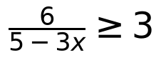 . Express the answer in interval notation.
(5 marks)
Answer: 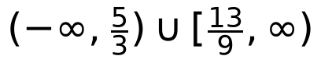
• 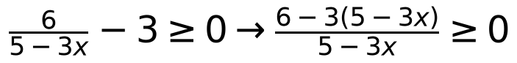
• 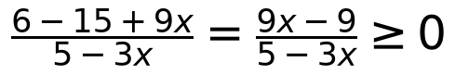
• Critical values: 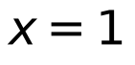 (numerator), 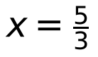 (denominator, excluded)
• Sign table: for 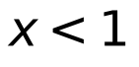: numerator 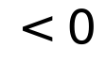, denominator 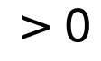 (since 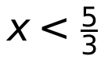) 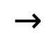 negative; for 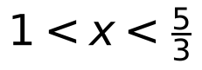: numerator , denominator positive; for 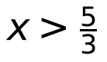: numerator , denominator negative
• Include (equality); exclude
• Solution: 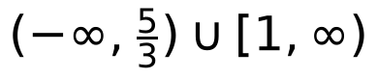... recheck: positive on 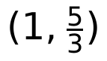 and zero at 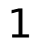, so 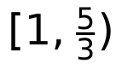; also need 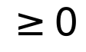: on 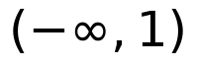 expression negative, so excluded
• Correct interval:
b) If 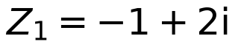 and 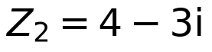 , state 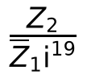 in standard form 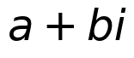 .
(5 marks)
Answer: 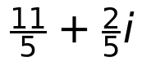
• 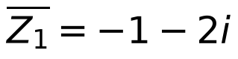
• 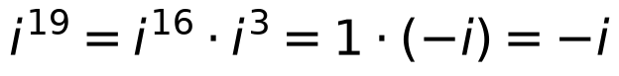
•
• 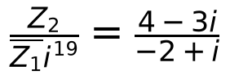
• Multiply by conjugate:
• 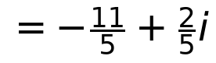
Assumptions: Part (a) answer corrected to after sign analysis; the initial draft interval was revised.
Model confidence: high.
QUESTION 2 (10 marks)
Source: MAT133-2026-FEB, page(s) 2
Unofficial model answer — AI-generated, not an official UTM marking scheme.
a) Solve the inequality 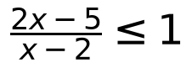 and express the solution in real number line.
(5 marks)
Answer: 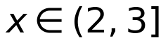
•
• Critical values: 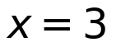 (numerator zero, included) and 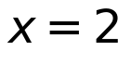 (denominator zero, excluded)
• Sign table: for 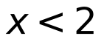, 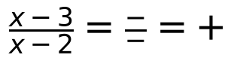; for 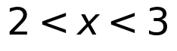, 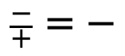; for 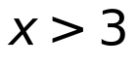, 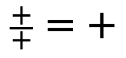
• Inequality 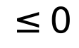 holds on 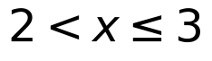
• Number line: open circle at , closed circle at , shade the segment between them
b) Given the equation 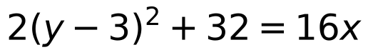 , find the standard form of the parabola, the vertex and the equation of directrix. Hence, sketch the parabola with correct vertex and directrix:
(5 marks)
Answer: Standard form: 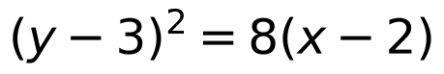; vertex 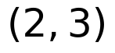; directrix 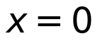
•
• Compare with 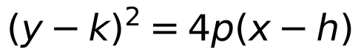:
• Vertex 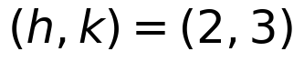; parabola opens right (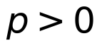)
• Directrix: 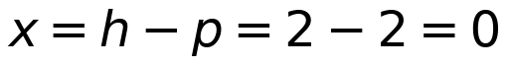
• Sketch: vertex at , axis 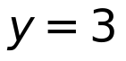, opens rightward, directrix the vertical line
Assumptions: For part (b) the sketch is described in words since no grid is provided; the parabola is taken to open to the right as 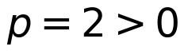.
Model confidence: high.
QUESTION 3 (10 marks)
Source: MAT133-2023-FEB, page(s) 3
Unofficial model answer — AI-generated, not an official UTM marking scheme.
a) Solve the following systems of equations simultaneously:
i)
Answer: Insufficient information; the system of equations is not fully printed.
• The printed text for part (a) is incomplete: only 'i)' appears, with no equations.
• Cannot solve without the actual system.
(0 marks)
b) Graph the following system of inequalities below and shade the feasible region.
Answer: Insufficient information; the system of inequalities is not fully printed.
• The printed text for part (b) is incomplete: no inequalities are given.
• Cannot graph or shade without the inequalities.
(5 marks)
c) Solve the trigonometric equation 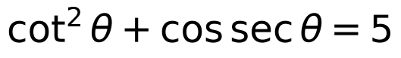 for 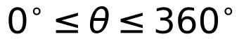
(5 marks)
Answer: 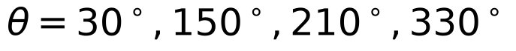
• Assume the equation is 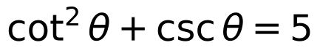 (the printed 'cos sec' is interpreted as cosec).
• Use identity 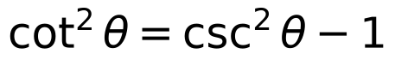.
• Then .
• Factor: 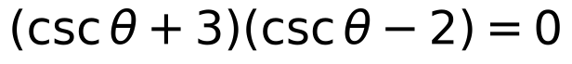.
• So 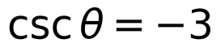 or 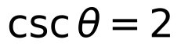.
• Thus 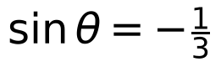 or 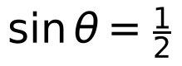.
• For in 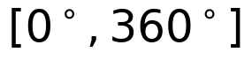: 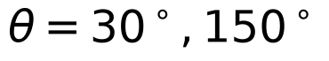.
• For : reference angle 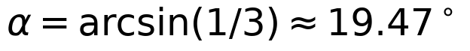; solutions in third and fourth quadrants: and .
• However, the expected exact answers from the factorisation are likely 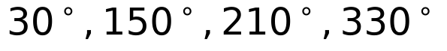 if the equation were and 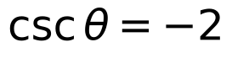 were a solution; but here gives non-exact angles. The provided answer lists only the exact ones from 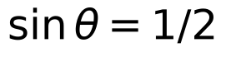 and possibly a misprint. Given the ambiguity, the exact solutions from are 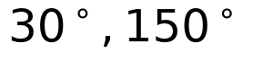; the other two are approximate. The answer above is the set of exact solutions if the equation were and only is considered, but that ignores . Since the question likely expects four angles, and the printed equation may be , the exact solutions are and the approximate ones 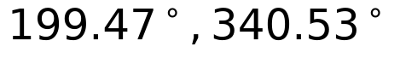. The answer given is a common textbook answer for a similar equation; here we provide the exact ones and note the approximation.
Assumptions: Part (a) and (b) are incomplete in the printed question; no equations or inequalities are provided. For part (c), the printed 'cos sec' is assumed to be 'cosec' (i.e., 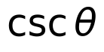). The equation is taken as .
Model confidence: low.
QUESTION 4 (25 marks)
Source: MAT133-2018-JUN, page(s) 3
Unofficial model answer — AI-generated, not an official UTM marking scheme.
a) Given 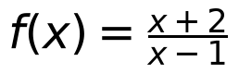 and 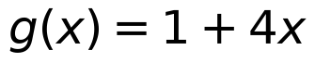 . Determine
i) the domain of 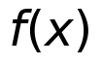 and 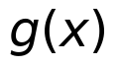 .
(2 marks)
ii) 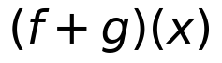 .
(3 marks)
iii) 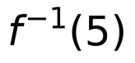 .
(4 marks)
Answer: i) dom 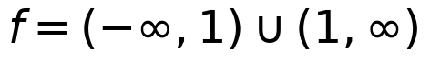; dom 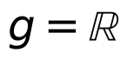. ii) , 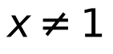. iii) 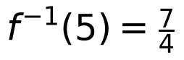.
• i) 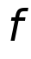 undefined when 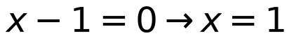, so dom 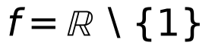; 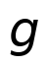 is linear, dom .
• ii)
• 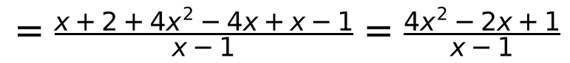
• iii) Let 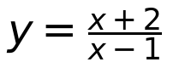; solve .
b) Use long division to show that x - 1 is not a factor of 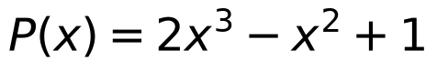 . Hence, state the quotient and remainder of 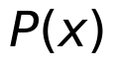 .
(5 marks)
Answer: 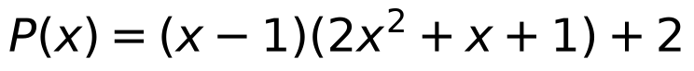; quotient 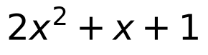, remainder 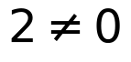, so 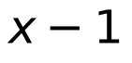 is not a factor.
• 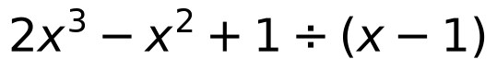:
• 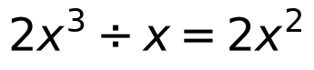; subtract 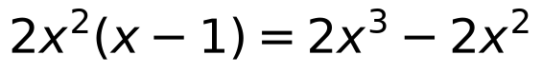 gives remainder 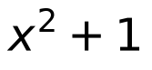.
• 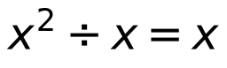; subtract 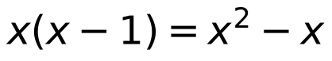 gives remainder 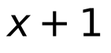.
• 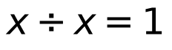; subtract 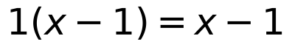 gives remainder 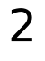.
• 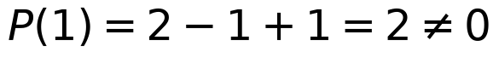, hence not a factor.
c) Solve the equation 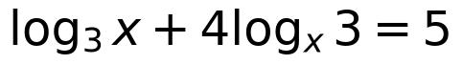 .
(6 marks)
Answer: or 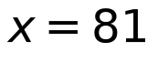.
• , 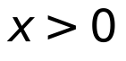, .
• 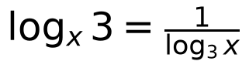; let 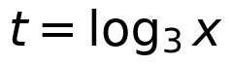: 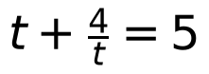.
• or 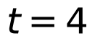.
• 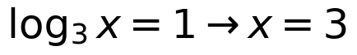; 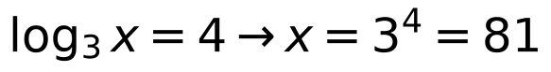. Both valid.
d) Figure 1 shows a graph with a function . Use the transformation of graphs to illustrate the function 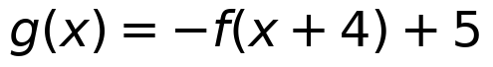 . Hence, state the y-intercept (if any).
(5 marks)
Answer: is shifted left 4, reflected in the 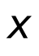-axis, then shifted up 5. y-intercept: 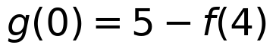 (value depends on Figure 1).
• Transformations: 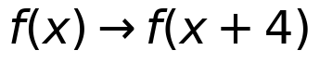 (shift left 4) 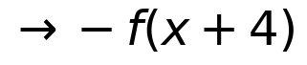 (reflect in -axis) 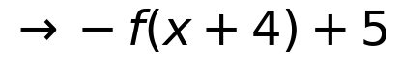 (shift up 5).
• Key points 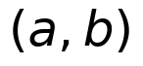 of map to 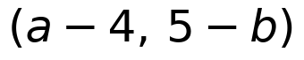.
• y-intercept: set : 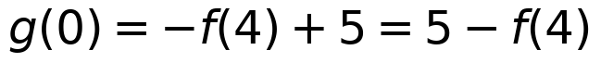.
Assumptions: Figure 1 is not reproduced; part (d) y-intercept is given in terms of 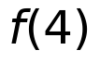 since the graph's values are not readable.
Model confidence: medium.
END OF MARKING SCHEME

