SOC + IT Helpdesk Ticketing Lab
Incident Investigation Evidence & Portfolio Documentation

1. Project Objective
Demonstrate a realistic SOC L1 workflow by using Wazuh to investigate Windows authentication failures and GLPI to document, assign, investigate, and resolve the incident.

2. Incident Summary
The lab generated Windows Event ID 4625 authentication failures. Threat Hunting identified five relevant events during the investigation window. Events were observed on the Windows endpoint and the lab Domain Controller. The Domain Controller events were validated against the test account. The analyst documented the activity as suspicious repeated authentication failures, while avoiding an unsupported conclusion that the activity was confirmed brute force.

3. Investigation Workflow
- Wazuh alert review
- Event ID 4625 validation
- Threat Hunting and event correlation
- Target account validation
- Severity/priority assessment
- GLPI incident ticket creation
- SOC L1 assignment
- Evidence and analyst notes
- Resolution and ticket closure/solve

4. Evidence Screenshots

01-threat-hunting-5-events.png
Threat Hunting showing five failed-authentication hits.
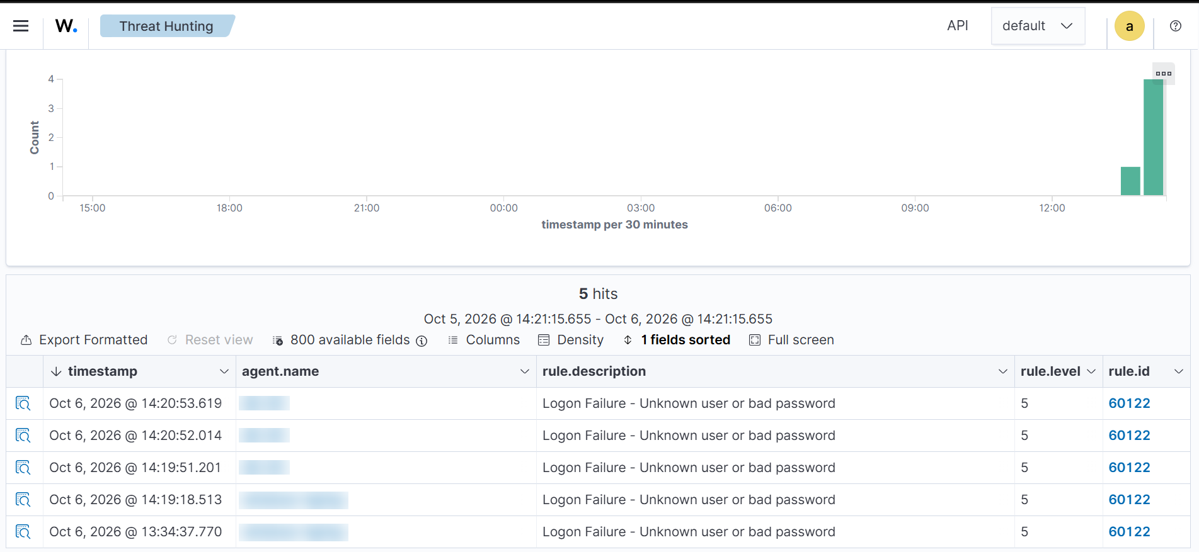

02-wazuh-4625-event.png
Wazuh Event ID 4625 event details.
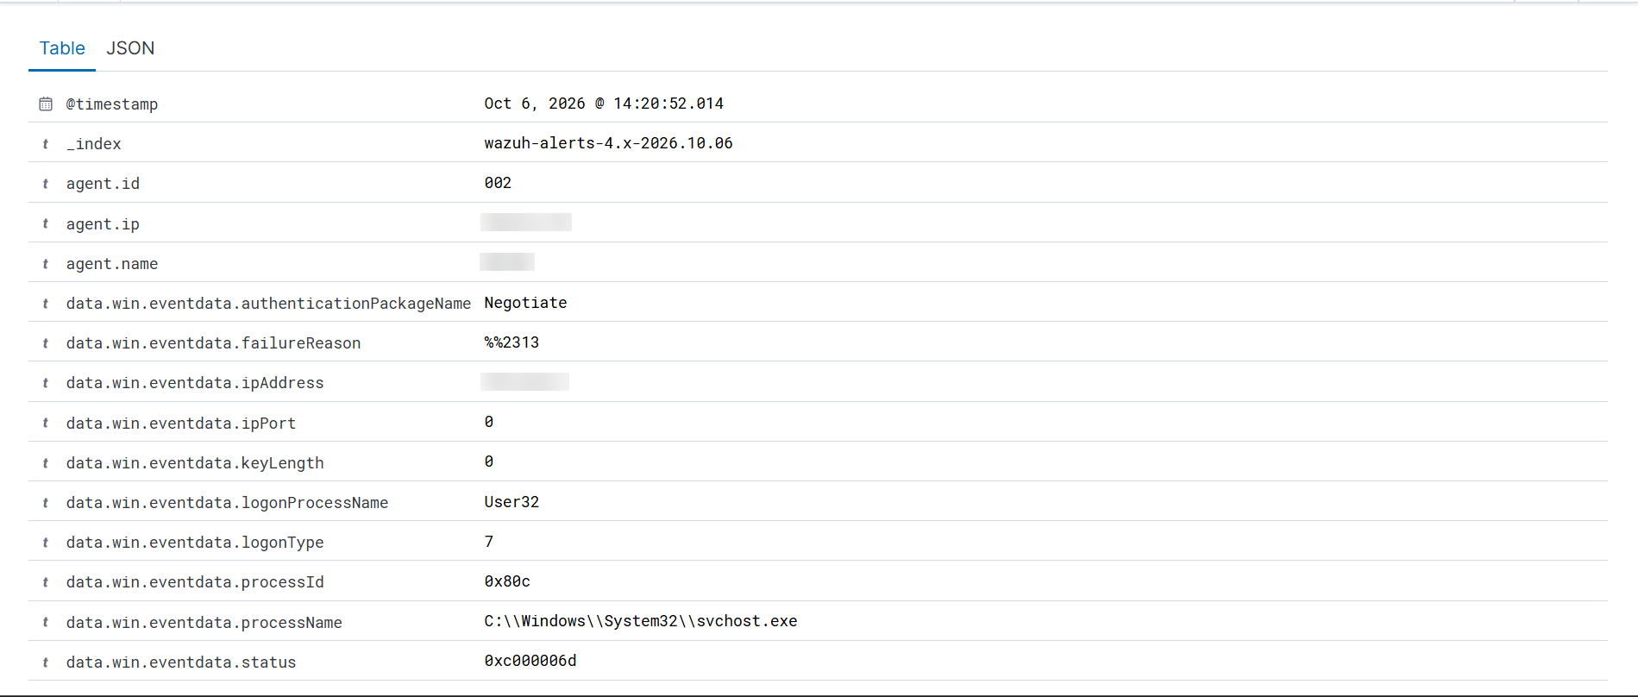

03-event-target-user.png
Event details confirming the target test account.
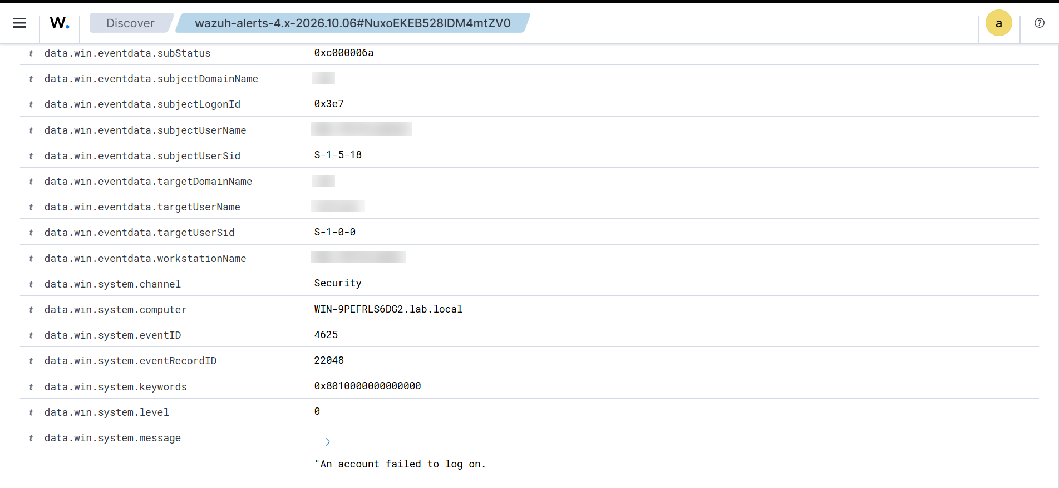

04-wazuh-rule-60122.png
Wazuh rule details for the failed-authentication alert.
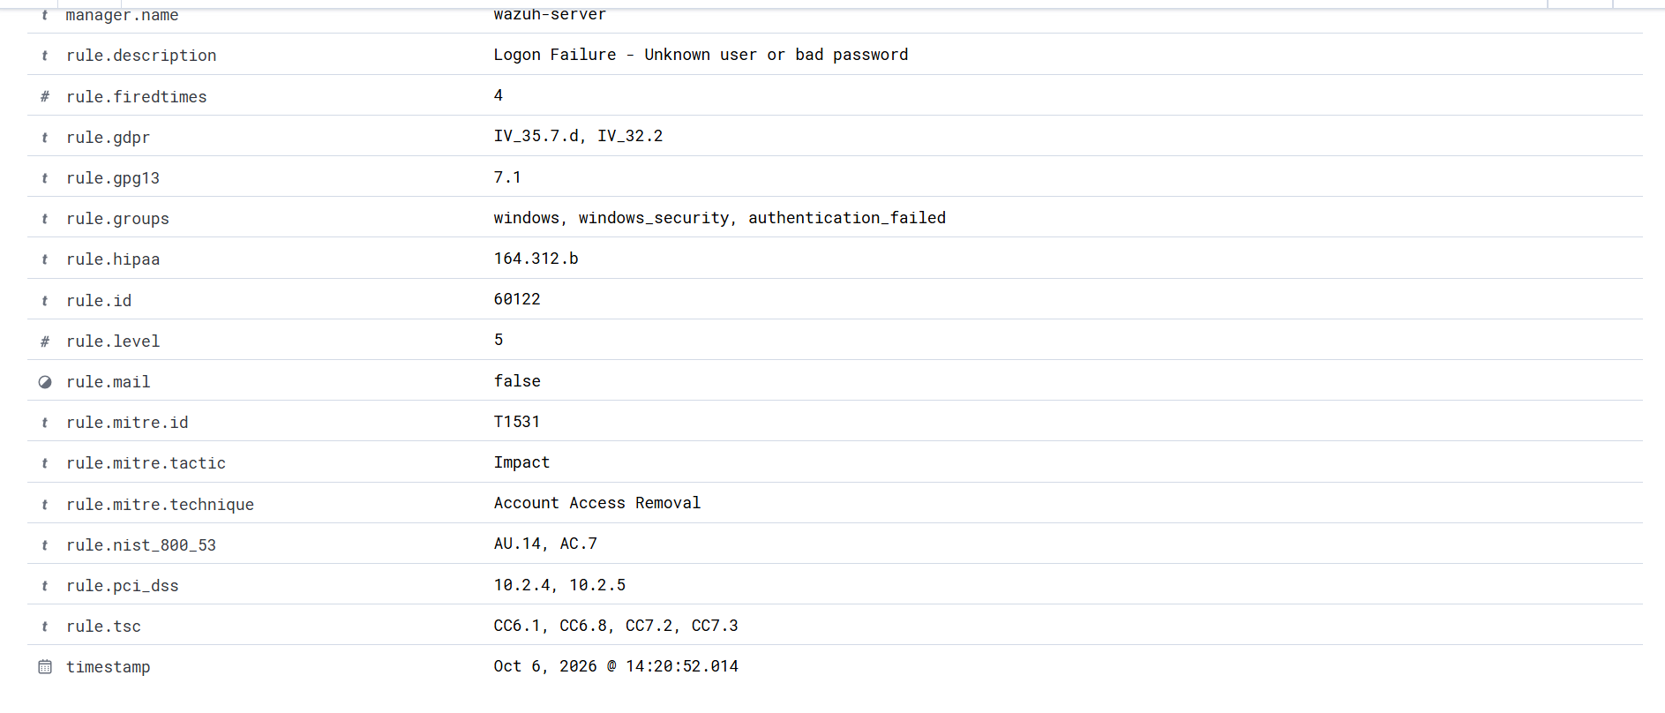

05-glpi-ticket-initial.png
GLPI incident ticket and initial description.
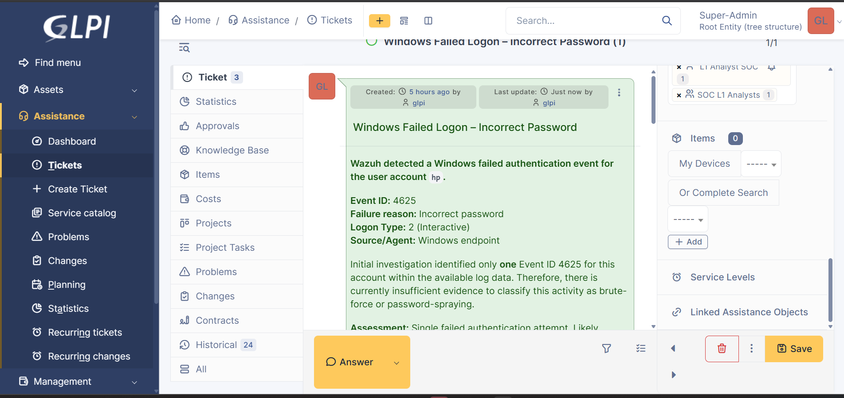

06-glpi-initial-triage.png
GLPI initial triage / analyst assessment.
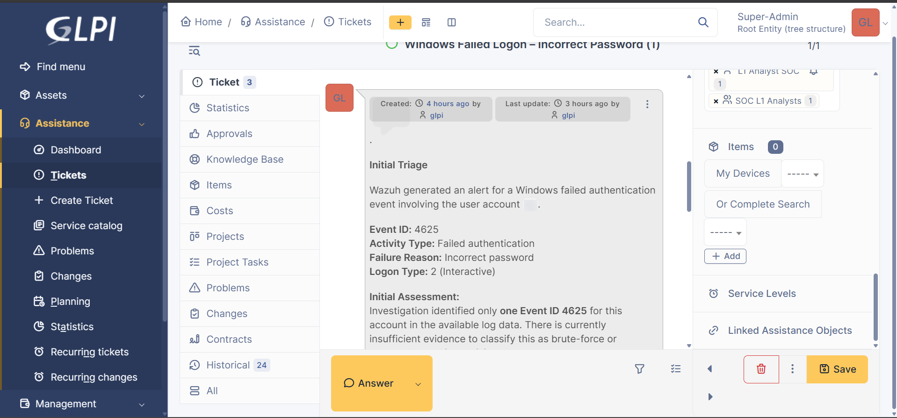

07-glpi-investigation-update.png
GLPI investigation update with correlated evidence.
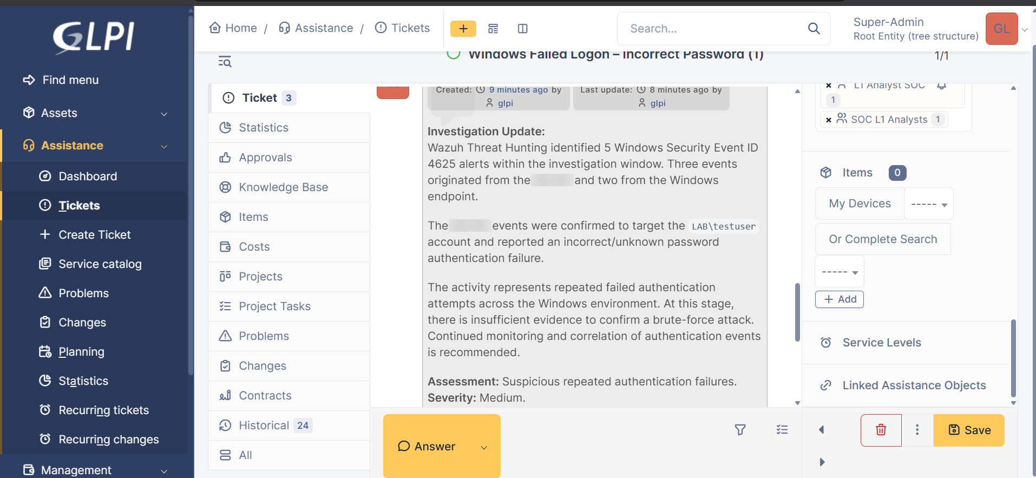

08-glpi-resolution.png
GLPI resolution statement.
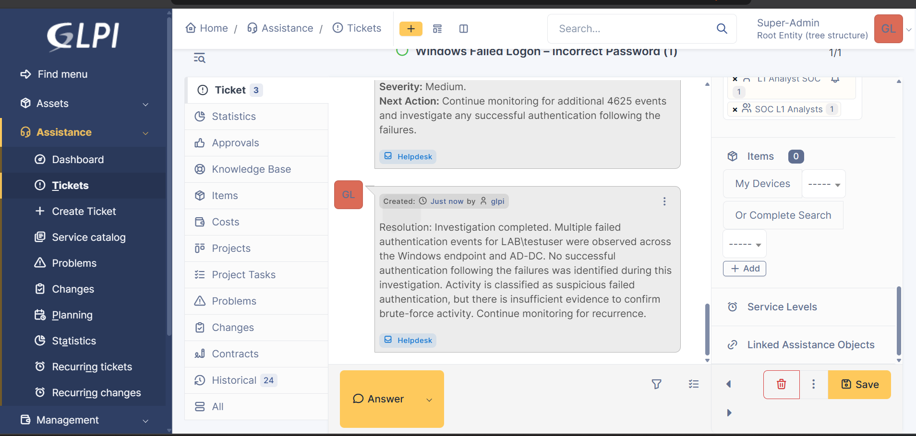

09-glpi-final-ticket-list.png
GLPI final ticket list / workflow state.
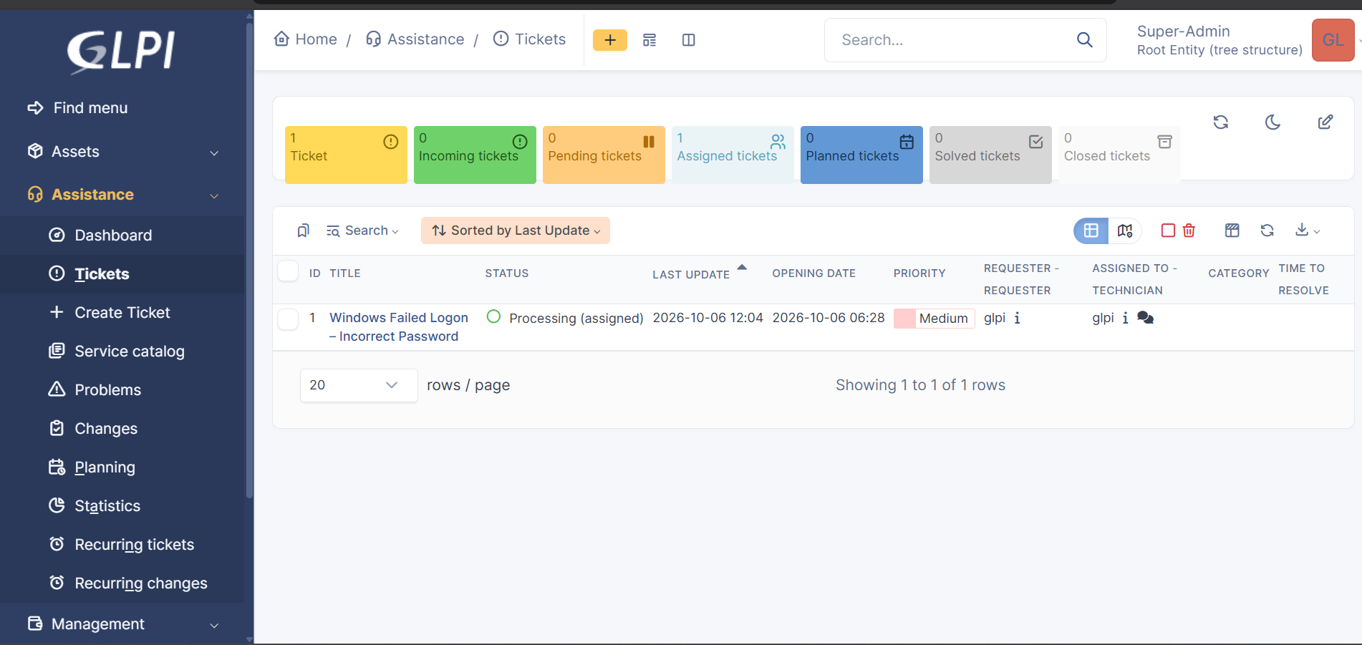

5. Analyst Conclusion
The evidence supports repeated failed authentication activity, but it does not by itself prove a brute-force or password-spraying attack. The incident was therefore documented as suspicious failed authentication and retained at a moderate severity/priority, with continued monitoring recommended.

6. Portfolio Notes
All screenshots in this package have been processed for public sharing. IP addresses, hostnames, and lab account/domain identifiers were blurred where detected. Review the images once more before publishing if you add any new screenshots.

