Project Iteration 1
Activity 4
User-Centric Computing II
COMP4600
Spring 2025 IA, ID document Project Name: YourAverageGamer
Team Name: Breaking Code
Trello board URL: https://trello.com/b/Pi71qEQG/youraveragegamer
GitHub repo URL: https://github.com/jermainejuwg/Comp-4600-project.git
Member information
# | Name
1 | Jermaine Jackson
2 | Robert Hicks Jr
3
4

All the works of all the team members
Content inventory

Member 1 name here
- Reviews
- Game reviews and Hardware & Gear reviews
- News
- Up to date gaming info through written articles
- Guides
- Easter eggs/hidden content and Gameplay walkthroughs
- Multimedia
- GIFS, Pictures, Game trailers, Gameplay breakdowns

Member 2 name here
- Walk-Throughs
- Gameplay to aid users in completing games and getting achievements.
- Creator Updates
- The latest updates on content creators and professional gamers.
- Discussion Boards
- Information on public boards for users to communicate with others about all gaming-related things.

Final list of content inventory
- Walkthroughs/Reviews
- News & Creator Updates
- Guides
- Multimedia
- Discussion Boards
The final sitemap created by the whole team based on the final content inventory

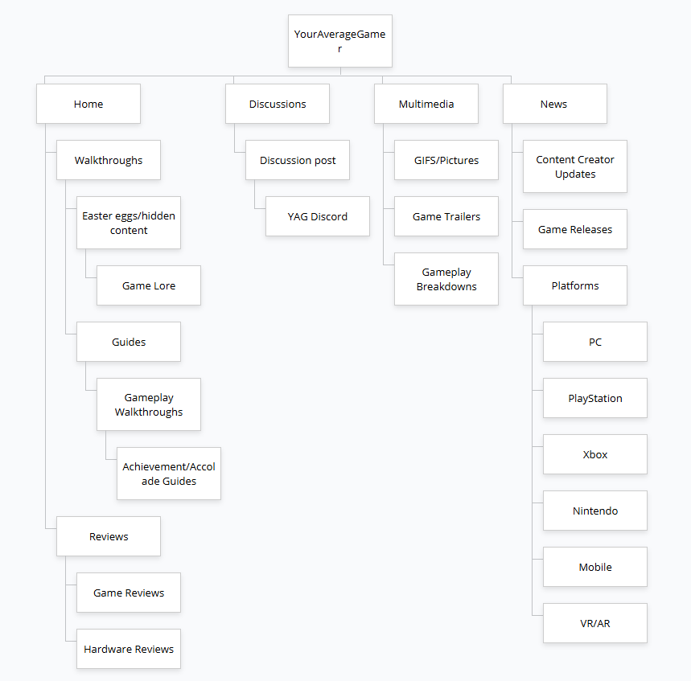
Tree test tasks decided by the team
- You are interested in the character breakdown of the Mario Bros…find where this information would be located.
- You want to see community or general feedback on a recent game…where would you go?
- You want to find the latest specs on controllers and headsets…what page provides that information?
- You want to find more information on Xbox games to play with your friend…where would you go?
- If you want to find PlayStation trophies for God of War, what page would you explore?

Tree Test results
Member 1 name
Insert the time taken for each of the 5 tasks here
Robert Hicks Jr
- 1min 38secs (Reviews/Guides/Hidden Content)
- 39secs (Game Reviews)
- 14secs (Hardware Reviews)
- 35secs (Xbox)
- 1min 11secs (Achievement Guides)
Tree test interview questions and answers
Member 1 name here
List the answers you received from the user after Tree test below -
- Did you find the pages where you thought they should? If not, which pages were not where you expected them to be in the menu hierarchy? ANS:
- Did it take more time than you thought it would take? If so, why do you think it took longer? ANS:
- Were menu items labeled properly to indicate relevant resources? If not, what was mislabeled and how would you correct it? ANS:
- Do you have any suggestions to make the site navigation easier? ANS:
Robert Hicks Jr
List the answers you received from the user after Tree test below -
- Did you find the pages where you thought they should? If not, which pages were not where you expected them to be in the menu hierarchy?

ANS: I found the majority of the pages that I needed to find; however, some tabs could be changed to be easier to locate the information. For example, the game lore page could be changed to character information or game backgrounds.

- Did it take more time than you thought it would take? If so, why do you think it took longer?

ANS: Not really, the majority of the titling was straightforward and easy to navigate.

- Were menu items labeled properly to indicate relevant resources? If not, what was mislabeled and how would you correct it?

ANS: The game lore label could have been different. I was a little confused on what lore meant.
Do you have any suggestions to make the site navigation easier?

ANS: Change the page to make it user-friendly for first-time users or people who aren’t too familiar with game pages. You want to be able to cater to your target audience but also friendly enough to invite other audiences to your page as well.

Team’s assessment of the sitemap
Insert the team’s assessment of the sitemap generated based on the Tree Testing. Include any weaknesses, strengths, and any possible modifications here.

Strengths:

Weaknesses:

Modifications:

Labels/titles
List the labels

