Project Iteration 1
Activity 3
User-Centric Computing II
COMP4600
Spring 2025
Project Name: YourAverageGamer
Team Name: Breaking Code
Trello board URL: https://trello.com/b/Pi71qEQG/youraveragegamer
GitHub repo URL: https://github.com/jermainej-uwg/Comp-4600-project.git

Member information
# | Name
1 | Jermaine Jackson
2 | Robert Hicks Jr
3
4

All the project iteration 1, activity 2 items from all members
Jermaine Jackson
Interview users
Age of the individual | 30+ and 16
Gender of the individual | Both male
Interview questions and answers
What genre of games do you prefer to play? | RPG and Singleplayer
How many games do you play in a year? | 5-10
Do you mainly play older games(5 or more years old) or newly released games? | Older
How often do you play video games? | Interview 1: Daily
What types of content do you find most desirable on a gaming website? Select all that apply… | Interview 1: Gameplay and side-quests
What type of hardware do you use for gaming? | Interview 1: PlayStation
How do you identify yourself? | Interview 1: Male
What type of features make a gaming site more trustworthy? | Interview 1: Professional Gamers (Creditable)
Do certain creators draw you to gaming? If yes, who are they? | Interview 1: Faze Clan
How old are you | Interview 1: 16
How important is it for a gaming website to be up to date in the latest game releases? | Interview 1: Very important
User Need Statements (list 5 statements)
A completionist needs easy to find step by step achievements and trophy guides in order to 100 percent the video game and collect all the trophies.
A hesitant gamer needs game reviews in order to know what games match their personal taste and won’t be a waste of money.
A social gamer needs the latest news on the video game industry in order to stay updated on the latest trends in gaming and participate in online discussions.
A curious gamer needs gameplay breakdowns because they want to see the games mechanics and how they work.
Jermaine, a lore explorer, needs easter egg/hidden content guides in order to find every easter egg/hidden secret to understand the true story of the game.

Robert Hicks Jr
Survey Monkey Survey
Generate a survey consisting of 5-7 questions about usability, demographics, content interests, and devices used to play. The context of the survey is to garner information on users who play video games in order to develop a webpage similar to IGN. Use these points to develop the questions. Close-Ended:
Self-Identification (To get a demographic for our target audience), Type of desirable content (Gameplay, side-quests, easter eggs, Boss reviews, collectibles, etc.), Frequency of Gaming (How long or how often), Type of hardware used to play (PlayStation, Xbox, PC, Nintendo, etc.). Open-Ended: What type of features make a gaming site more trustworthy? Do certain creators draw you to gaming?
https://www.surveymonkey.com/r/BCMXBJG
Interview users
Age of the individual | 32
Gender of the individual | Male
Interview questions and answers
How often do you play video games? | Interview 2: Rarely
What types of content do you find most desirable on a gaming website? Select all that apply… | Interview 2: Gameplay and side-quests
What type of hardware do you use for gaming? | Interview 2: Xbox
How do you identify yourself? | Interview 2: Male
What type of features makes a gaming site more trustworthy? | Interview 2: No ads
Do certain creators draw you to gaming? If yes, who are they? | Interview 2: No
What would make you prefer our gaming website over others like IGN? | Interview 2: Not familiar. But, fun, no ads, and ease of site. Able to win items
How old are you? | Interview2: 30+
How important is it for a gaming website to be up to date with the latest game releases? | Interview 2: Not very important
User Need Statements (list 5 statements)
Gamers need a way to easily find gameplay tips and side-quests because they want to help progress and discover more content in their games.
Gamers need a way to access game catalogs and breakdowns to fulfill their thirst for game background context.
Gamers need a way to get character details for cosplaying purposes.
Gamers need an incentive system to ensure they come back to the site later for more content.
Gamers need a clean format to access the material at hand.

Final List of User Need Statements
User Need Statements – final list
A completionist needs easy to find step by step achievements and trophy guides to 100 percent the video game and collect all the trophies.
Gamers need a way to access game catalogs and breakdowns to fulfill their thirst for game background context.
A social gamer needs the latest news on the video game industry to stay updated on the latest trends in gaming and participate in online discussions.
A curious gamer needs gameplay breakdowns because they want to see the game's mechanics and how they work.
Gamers need a way to easily find gameplay tips and side-quests because they want to help progress and discover more content in their games. Better format.

Summary of discussion on the effectiveness of the survey and interview questions
The questions are very effective because they identify user demographics and reveal exactly which types of games they play and what types of gamers they are. We chose the questions to break down if our audience is people who seek to complete games, unwind, or just play with others. The responses reveal exactly what the users need/want in a blogging webpage.

User Personas
Robert Hicks Jr - User Persona
https://www.canva.com/design/DAHA107R9Og/MVUncoyxD9swDtL3pWVyvQ/edit
Dakari Parker
Jermaine Jackson - User Persona
https://www.canva.com/design/DAHBfubbY4I/31egROiMmviWKubWA9iJDA/edit?utm_content=DAHBfubbY4I&utm_campaign=designshare&utm_medium=link2&utm_source=sharebutton
Combined User Persona
https://www.canva.com/design/DAHBxnkKzI8/KI2zNr6-d-fw-r1pDn8PFg/edit

User Flows
Robert Hicks Jr - User Flow
Site Navigation (Formatting)
https://app.creately.com/d/MkGPAJKy9hX/edit
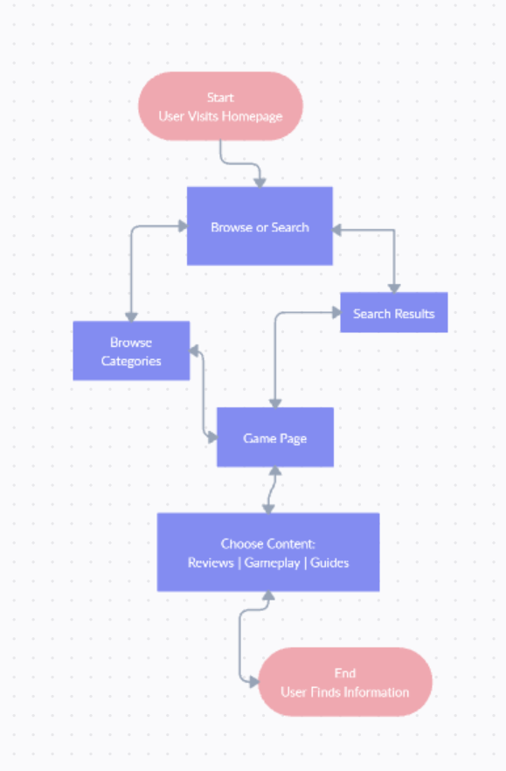
Jermaine Jackson - User Flow
A curious gamer needs gameplay breakdowns because they want to see the game's mechanics and how they work.
