Project Iteration 2
Activity 2
User-Centric Computing II
COMP4600
Spring 2025
Usability Test 2
Project Name: YourAverageGamer
Team Name: Breaking Code
Team’s Project Trello board URL: https://trello.com/b/Pi71qEQG/youraveragegamer
Team’s Project Github repo URL: https://github.com/jermainej-uwg/P1A6_UCC2.git
Website URL: https://black-minta-52.tiiny.site
Team members
# | Name
1 | Jermaine Jackson
2 | Robert Hicks Jr
3
4

Usability tests ran by all members
Member Name | Jermaine Jackson
Participant age | 30
Participant gender | Male
Test Date | May 4, 2026
Test Time | 9:30am
Total time taken | 2 minutes and 41 seconds
Test Introduction script
Hi, my name is Jermaine Jackson, and I’m a student in User‑Centric Computing II. Today I’ll be running a short usability test for my class project.
This isn’t a test of you more so it’s a test of the website. I just want to see how people naturally use it and what parts feel easy or confusing. The site is called YourAverageGamer, and it focuses on gaming content like reviews and community posts. I won’t give too many details because I’d like you to explore it freely. By participating, you’re helping me understand how real users interact with the site so I can improve its design and usability. Please think aloud as you go and tell me what you notice or expect.

The 10 Tasks users must complete and your observations
Here you will ask the user to be at ease and complete the tasks listed below You must observe and collect/note necessary information on the left
Task 1 (Find a guide for a game) | Completed successfully: yes Time taken: 18s  Facial expressions: thinking face  Any noises made: no  Any other gestures made: no
Task 2 (Navigate to hardware reviews) | Completed successfully: yes Time taken: 15s  Facial expressions: surprised face  Any noises made: no  Any other gestures made: no
Task 3 (Post a discussion post) | Completed successfully: yes Time taken: 25s  Facial expressions: curious face  Any noises made: no  Any other gestures made: no
Task 4 (Locate the latest game releases) | Completed successfully: yes Time taken: 22s  Facial expressions: confused face  Any noises made: no  Any other gestures made: no
Task 5 (Find the discord link) | Completed successfully: yes Time taken: 15s  Facial expressions: unsure face  Any noises made: no  Any other gestures made: no
Task 6 (Navigate to PlayStation news) | Completed successfully: yes Time taken: 12s  Facial expressions: happy face  Any noises made: no  Any other gestures made: no
Task 7 (Navigate to a GIF or picture) | Completed successfully: yes Time taken: 18s  Facial expressions: curious face  Any noises made: no  Any other gestures made: no
Task 8 (Read a discussion post) | Completed successfully: yes Time taken: 10s  Facial-expressions: neutral/blank face  Any noises made: no  Any other gestures made: no
Task 9 (Navigate from a subpage back to home page) | Completed successfully: yes Time taken: 6s  Facial expressions: relieved face  Any noises made: no  Any other gestures made: no
Task 10 (Find easter egg content for a game) | Completed successfully: yes Time taken: 20s  Facial expressions: thinking face  Any noises made: no  Any other gestures made: no
User’s opinions/comments/suggestions about the site
- What they liked
- Clear top level navigation labels
- Short descriptions for each section is simple and helpful to understanding the page
- Page navigation is simple and straightforward

- What they didn’t like
- Most of text is the same size so sections blend together instead of guiding the page
- Home page felt a little flat and not as engaging
- Certain pages the font is too dark for the page
- Wanted more clickable content on pages
The “Thank You” note to conclude the test
That’s the end of the usability test. Thank you so much for taking the time to participate. Your feedback really helps me understand how users interact with the YourAverageGamer website and what parts work well or might need improvement. Your honest reactions and thoughts will help me make the design clearer and more user‑friendly.
Your experience, assessment of the Usability Test
The assessment went smoothly. I wouldn’t do anything differently next time I felt like I got the process of the assessment down.

Member Name | Robert Hicks Jr
Participant age | 32
Participant gender | Male
Test Date | May 7th, 2026
Test Time | 3:56
Total time taken | 5mins
Test Introduction script
Hello, my name is Robert Hicks Jr and I am a developer for the webpage YourAverageGamer. Today, I would like to invite you to undergo a short test to determine the usability and overall quality of the webpage I am building. You can go completely at your own pace. I only ask that you try your best to complete the tasks. Each task will require you to locate certain information on the page in an attempt to understand the difficulty of exploring the page. Our page is designed to showcase gameplay, gaming products, and forum discussion pages for the gaming community! Use this site to navigate, please. https://black-minta-52.tiiny.site

The 10 Tasks users must complete and your observations
Here you will ask the user to be at ease and complete the tasks listed below You must observe and collect/note necessary information on the left
Homepage Navigation | Completed successfully: yes  Time taken: 10secs  Facial expressions: Confident  Any noises made: N/A  Any other gestures made: N/A
Find a Specific Game (God of War) | Completed successfully: no  Time taken: 90secs  Facial expressions: Confused  Any noises made: N/A  Any other gestures made: N/A

 | Navigate Through Pages | Completed successfully: yes  Time taken: 30secs  Facial expressions: Confident  Any noises made: N/A  Any other gestures made: N/A
 | Identify Game Details | Completed successfully: yes  Time taken: 23secs  Facial expressions: Content  Any noises made: N/A  Any other gestures made: N/A
 | Xbox News Navigation | Completed successfully: yes  Time taken: 10secs  Facial expressions: Confident/Excited  Any noises made: N/A  Any other gestures made: N/A
 | Gaming Pictures | Completed successfully: yes  Time taken: 6secs  Facial expressions: Confident  Any noises made: N/A  Any other gestures made: N/A:
 | PS5 News | Completed successfully: yes  Time taken: 28secs  Facial expressions: Confident  Any noises made: N/A  Any other gestures made: N/A
 | Find About/Contact Info | Completed successfully: no  Time taken: 86secs  Facial expressions: Confused  Any noises made: N/A  Any other gestures made: N/A
 | Navigate to the xbox news then find the xbox hardware page. | Completed successfully: yes  Time taken: 49secs  Facial expressions: Puzzled  Any noises made: N/A  Any other gestures made: N/A
 | Find live feed on Apex Patch Notes | Completed successfully: yes  Time taken: 57secs  Facial expressions: Neutral  Any noises made: N/A  Any other gestures made: N/A
 | User’s opinions/comments/suggestions about the site
- User liked the way the site was set up and how clean it was to use
- User liked the images and links
- User liked the layout/map
- User did not like how there was not a search bar
- User did not like how there wasn’t any clarification for finding information
 | The “Thank You” note to conclude the test
 | Thank you for taking the time to go through my site and give me an accurate examination of it for future developments.
Your experience, assessment of the Usability Test
I found that it was easy to navigate and find general information; however, that was only because of the fact that I knew the site map and how to navigate it. A search bar would prove to be very helpful for pinpointing specific information. When searching for broad information, our pages and drop boxes proved to work well. Other than that, some overall clearer headers to create distinction might help users who are not tech savvy to find our information better.
Accessibility tests and Markup validation
Jermaine Jackson
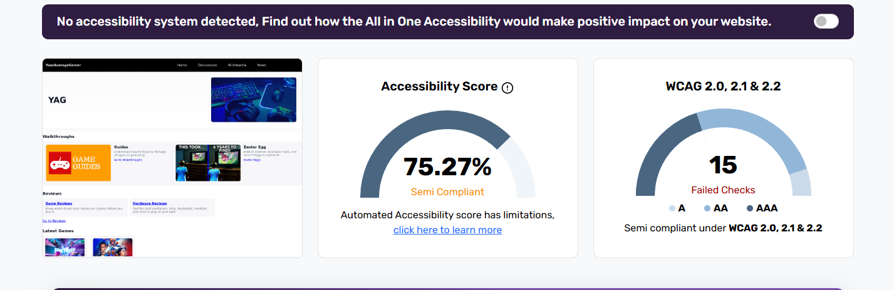
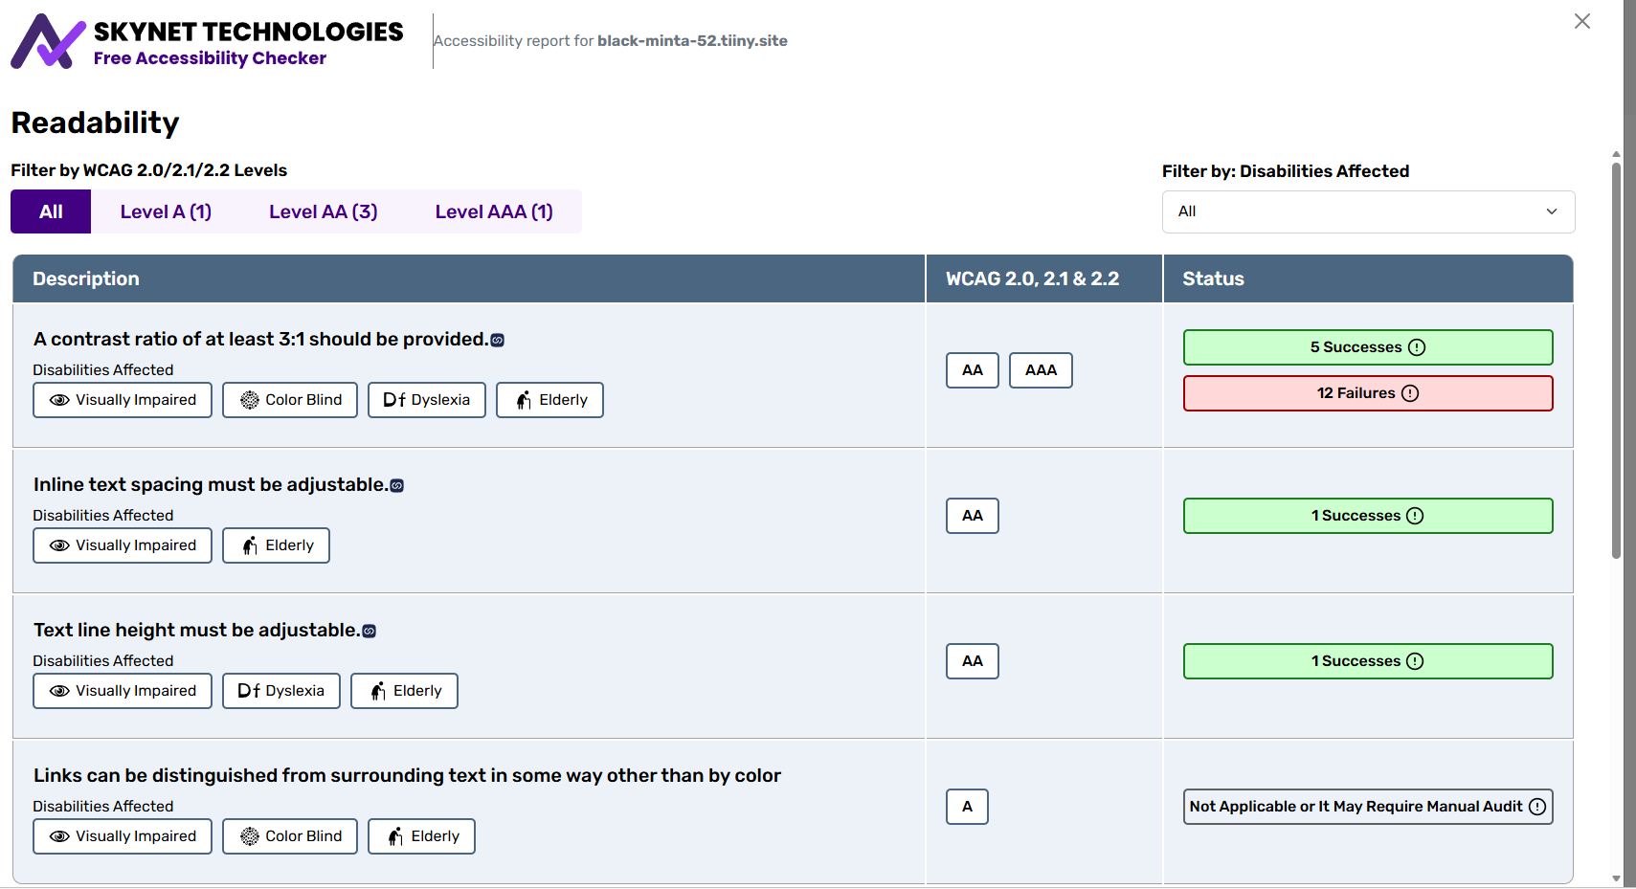
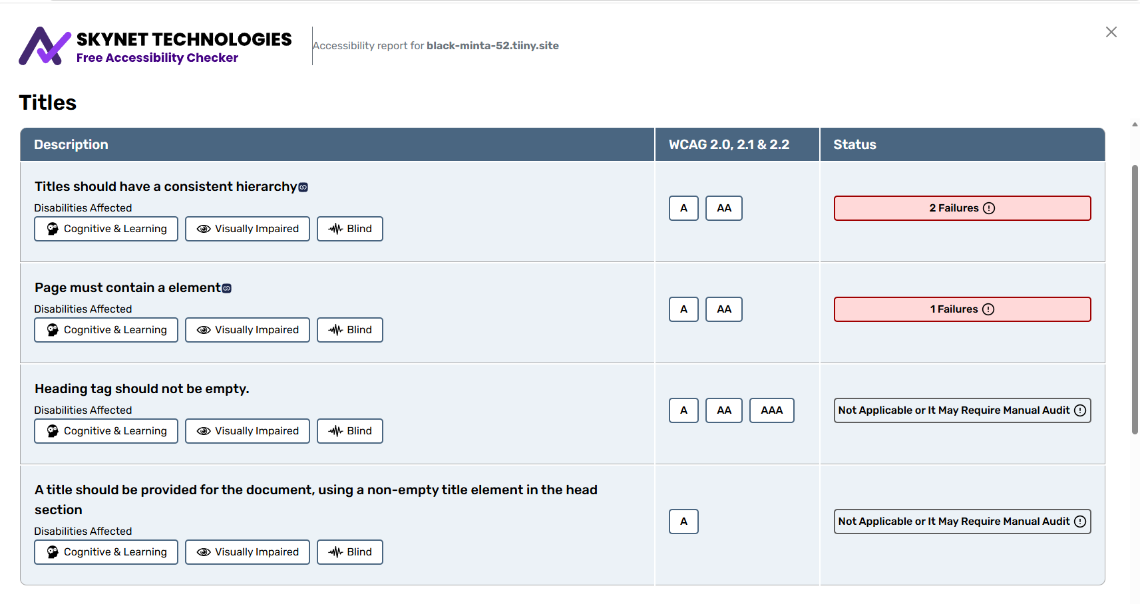
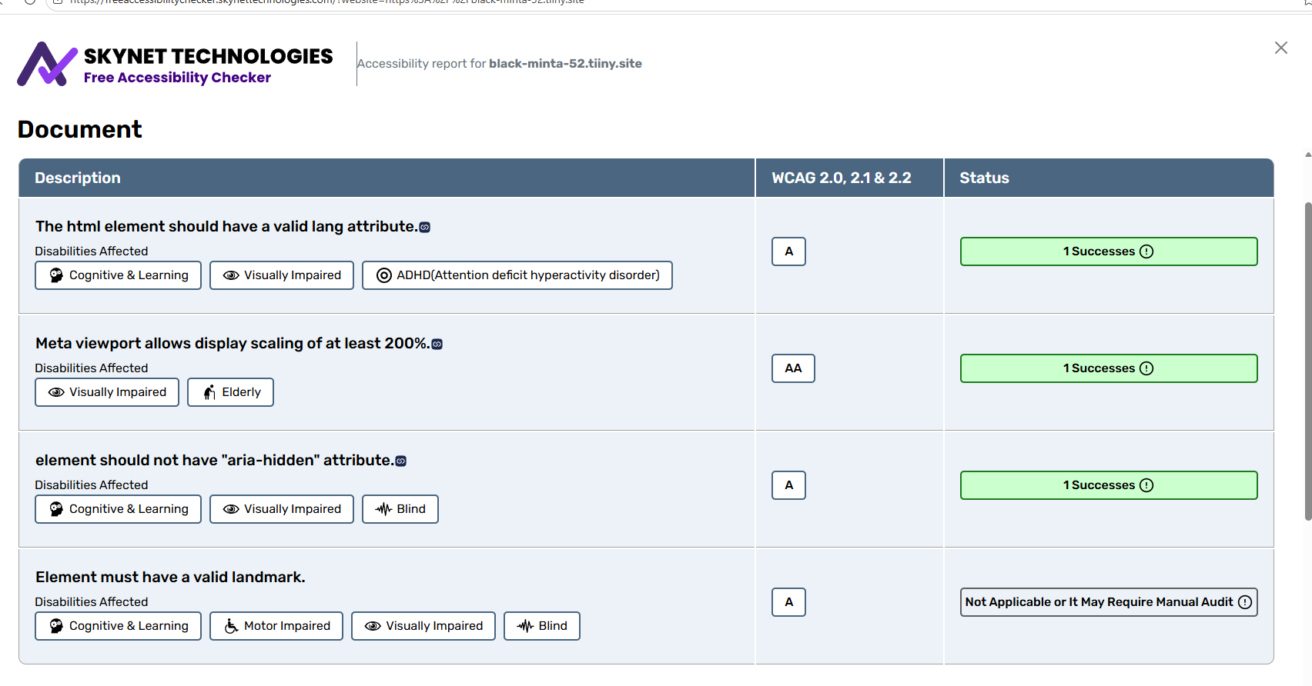
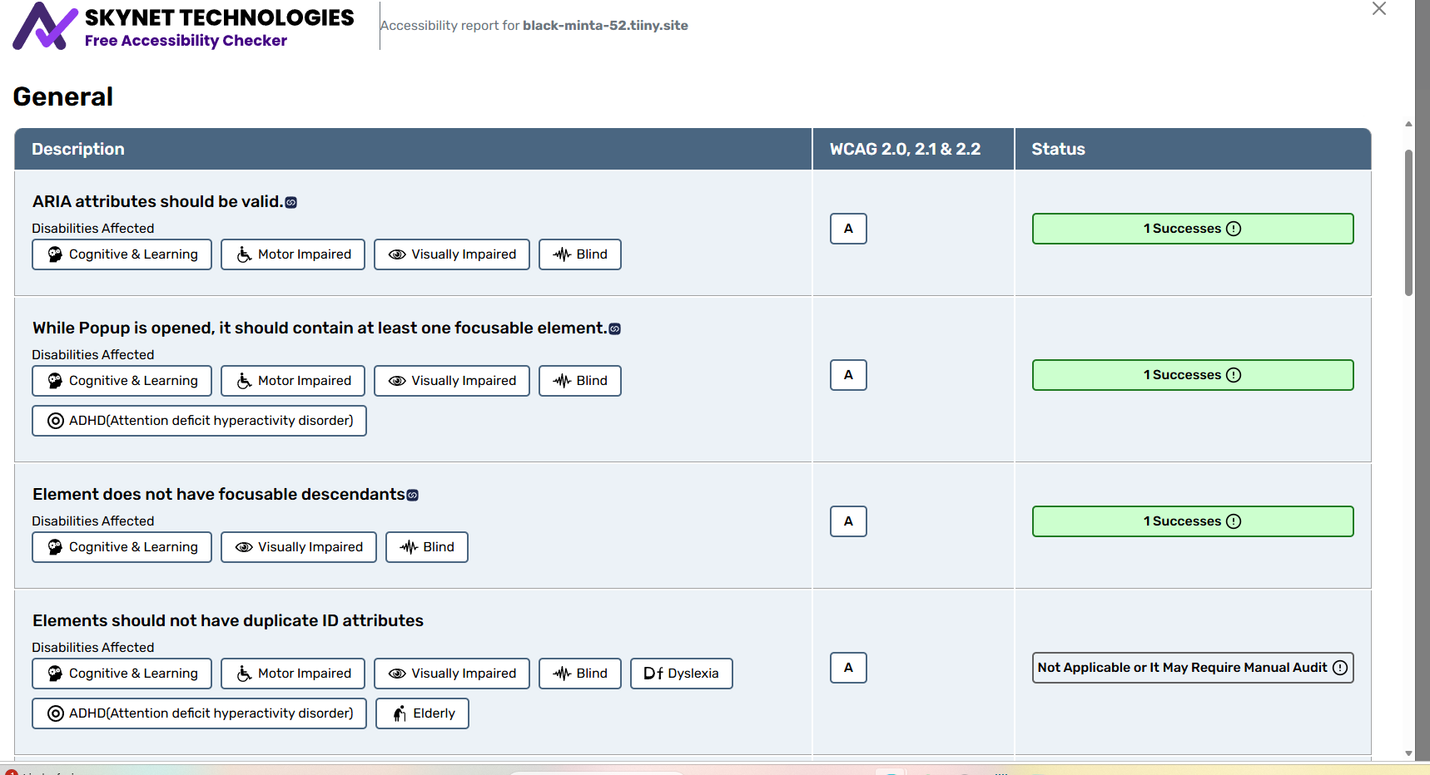
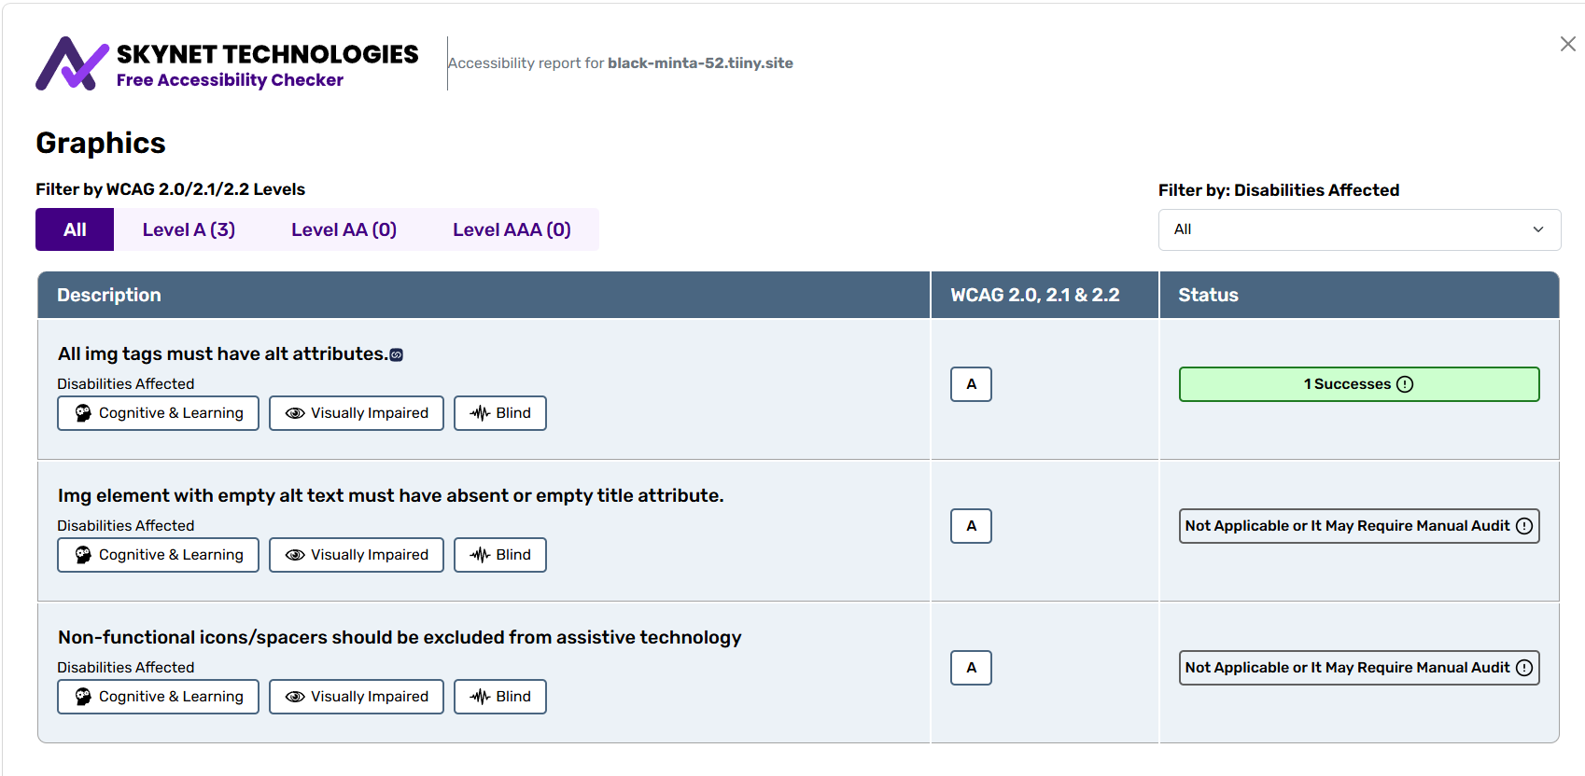
No contrast ratio that is of a least 3:1 was not provided, Titles don’t have consistent hierarchy, a page doesn’t contain an h1 element
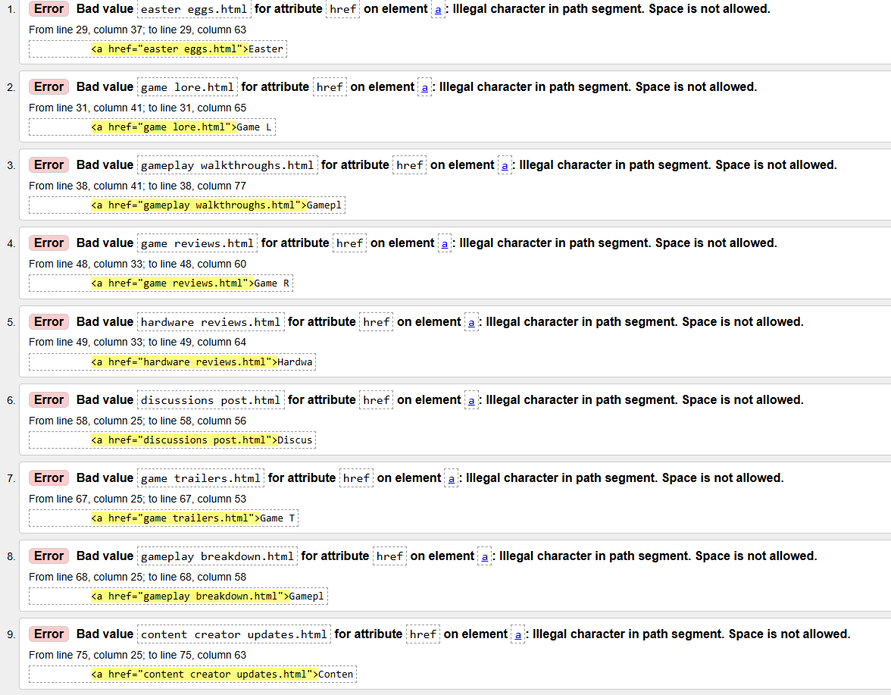
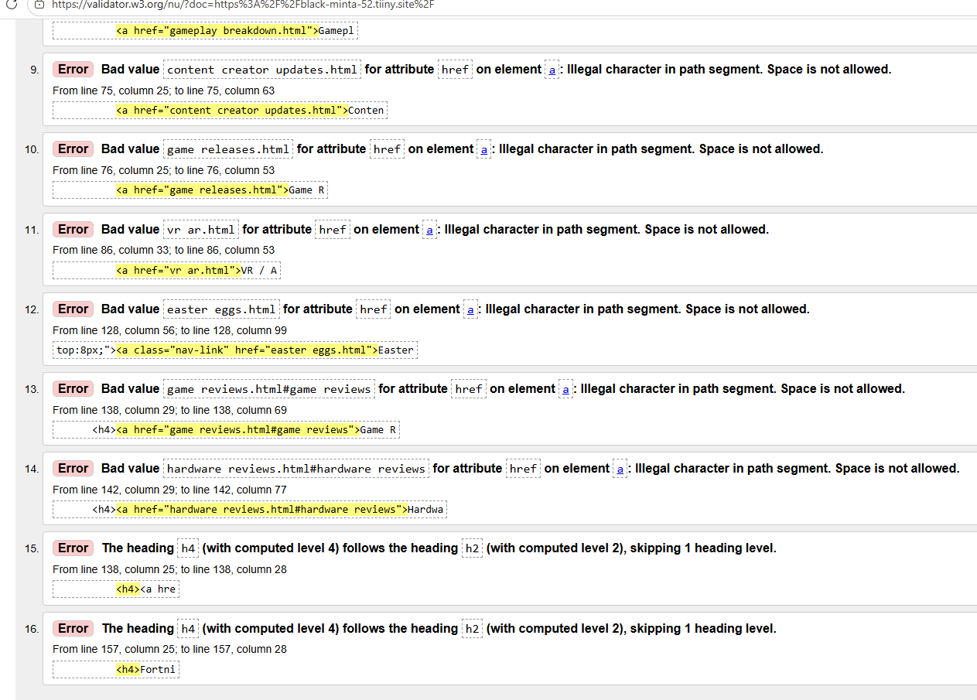
Had 14 space not allowed errors and 2 skipping 1 heading level errors
Member 2 Name
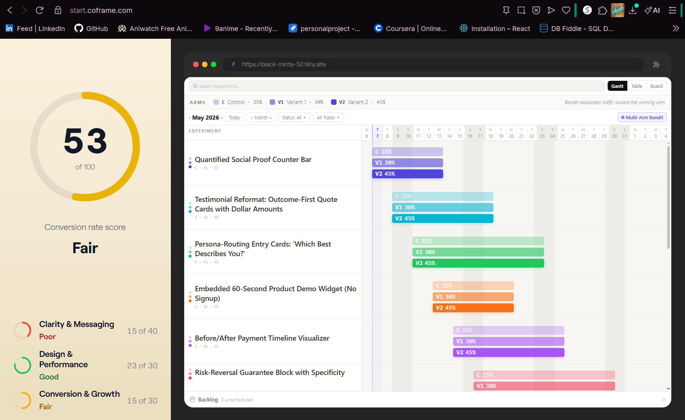
Poor clarity and overall clear delivery. However, the structure of the site and performance produced a satisfactory score.
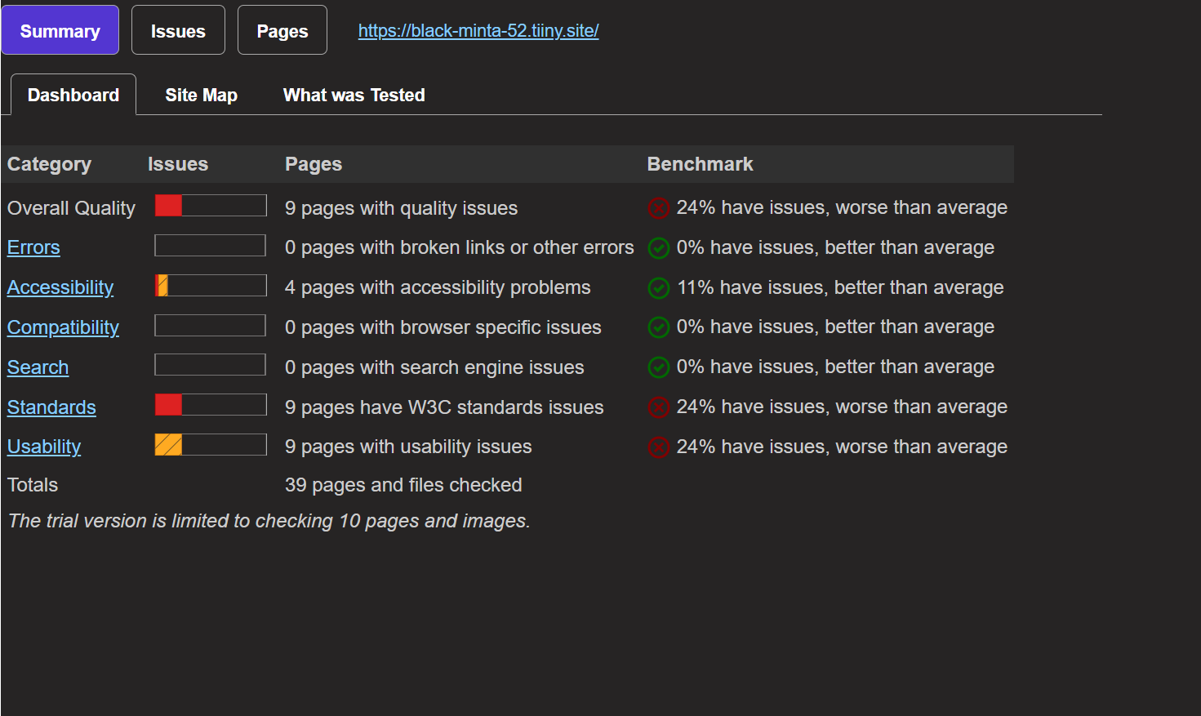
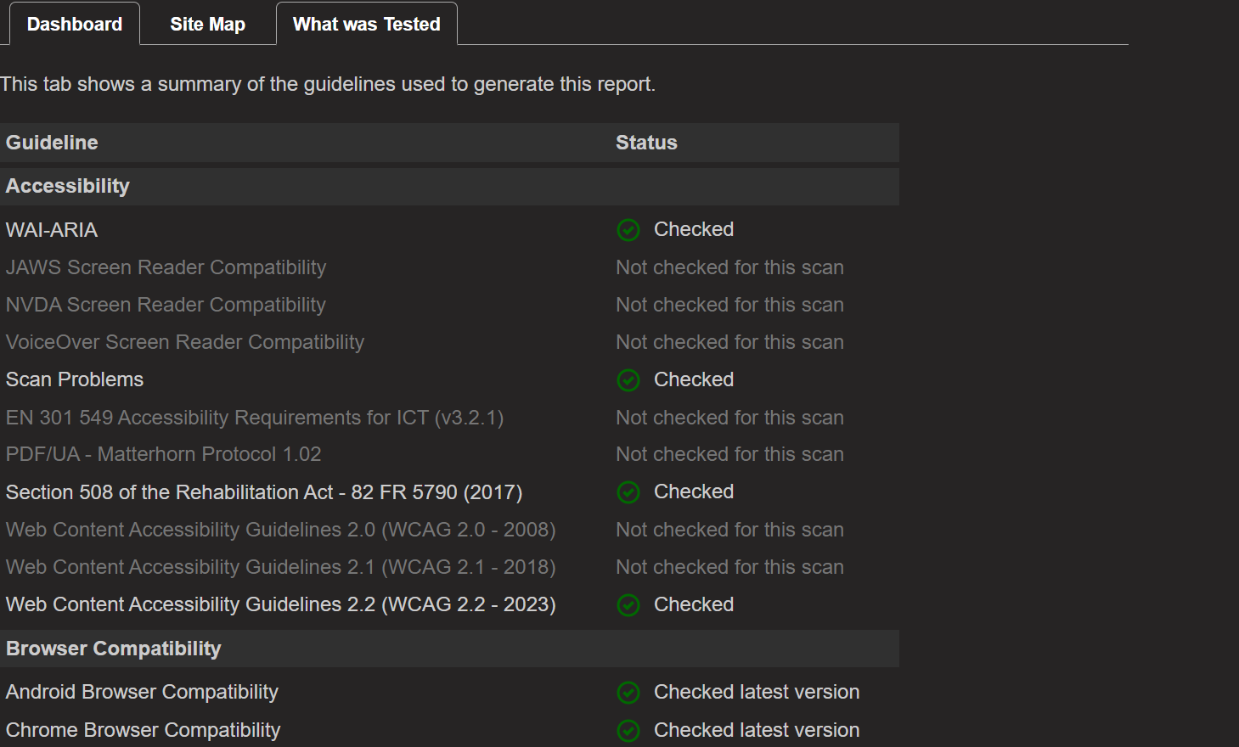
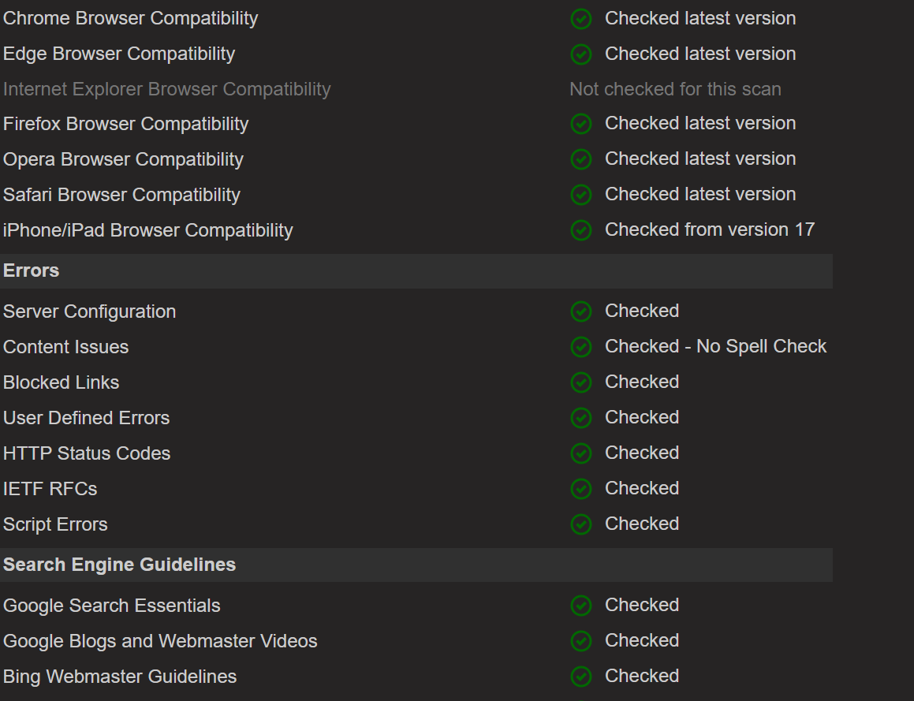
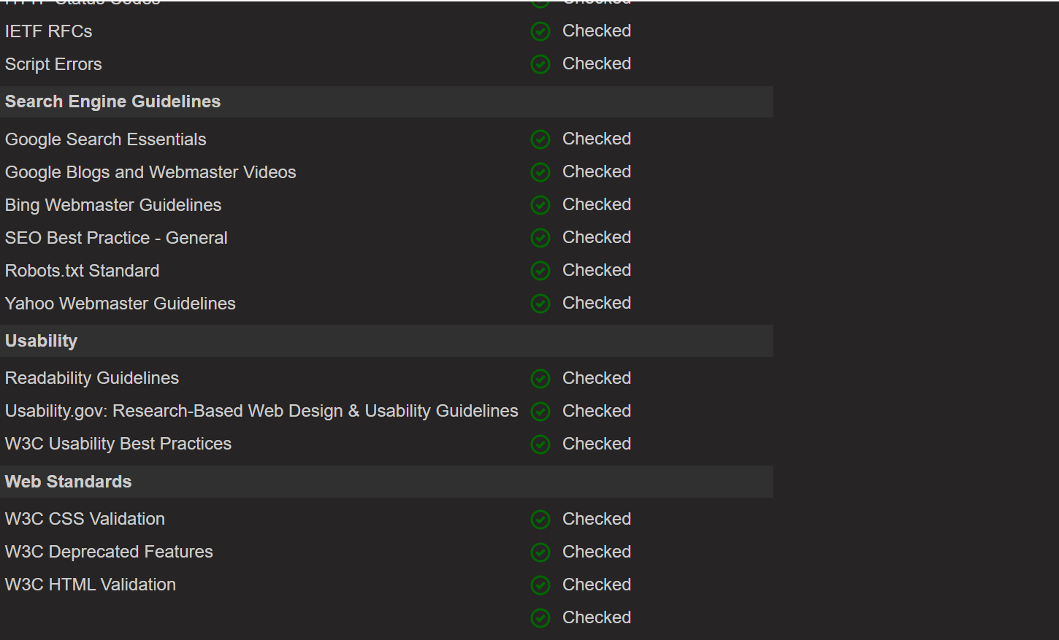
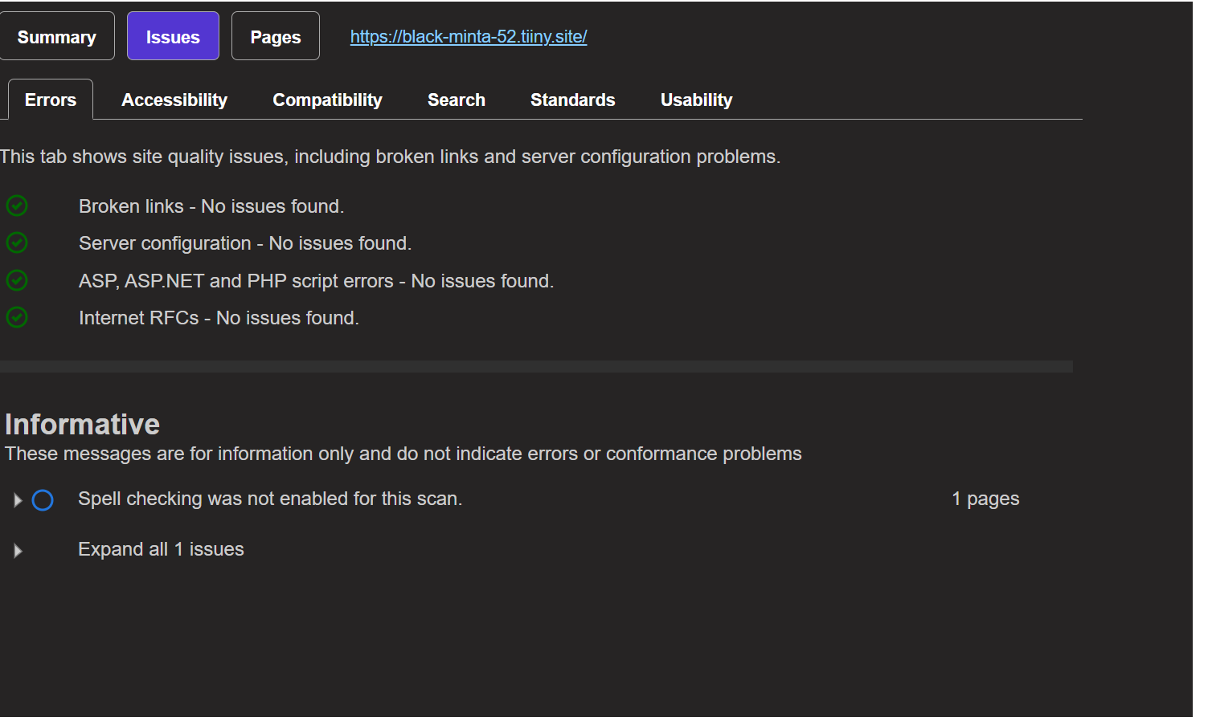
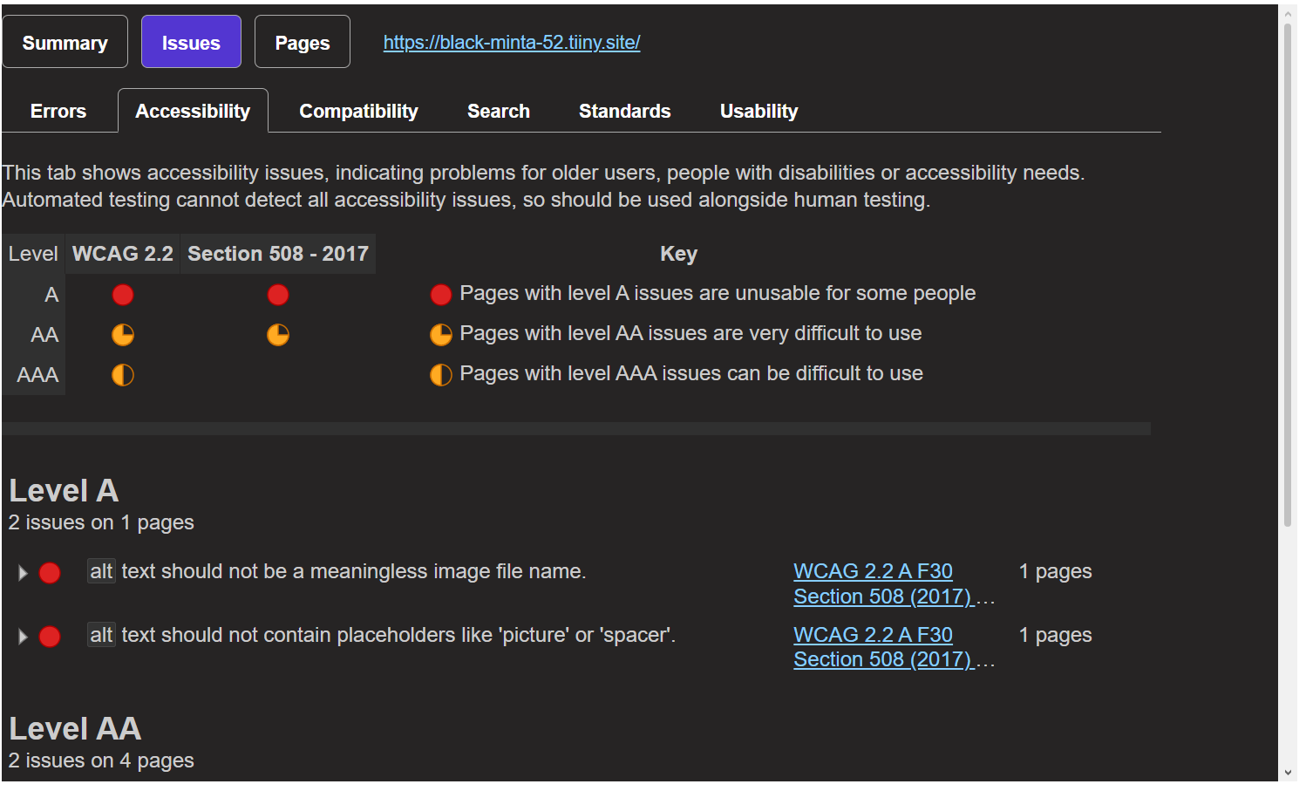
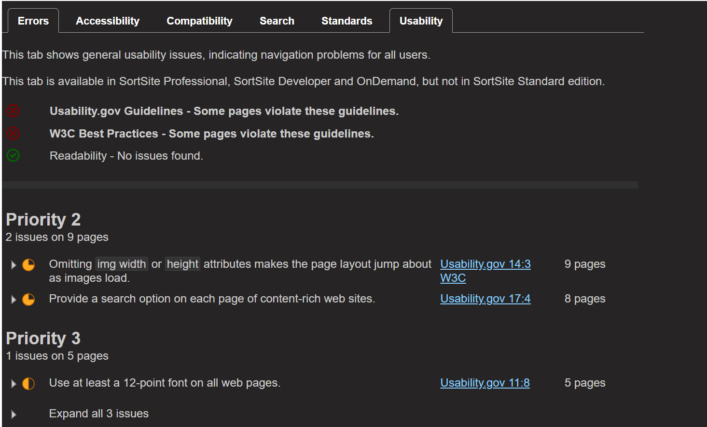
Formatting issues were a major part of the usability and HTML validation process. Several pages were checked off, but a few issues were found due to font, sizing, and layering of the pages. An attempt to create an uniform site would make the site more accessible and easier to view as well.
Team’s assessments
Usability test results, discussions, analysis
- Implementations can be the addition of a search bar and minor formatting corrections.
- Overall, the site was easy to use.

Accessibility issues
Accessibility issues mainly concerned not having a search bar for quick searches. A lot of info was nested which as well led to users being slightly confused on information.
HTML Markup issues
- Font
- Sizing (width/height)
- Overall Formatting
- Headers

