**Technologies available**

After having agreed with the client that we want to target **Android** platform due to number of devices on the market, we had to decide which technology to use. We considered the following two possibilities: **Android Studio** (native Android SDK – Software Development Kit) and **3rd party SDKs** (such as **Cordova** or **Xamarin**).

**Android Studio** is the IDE which provides access to Android SDK - a modified version of Java including Android features and Google APIs - used to develop native Android applications.

**Xamarin** is a cross-platform mobile development tool used to develop applications both for Android and iOS (in C#). Xamarin apps consist of two layers:

1. **iOS / Android** – containing the UI and application layers (written in C#)
2. **Core Library** – containing shared code such as business logic

**Cordova** is a mobile cross-platform application development framework for **Android**, **iOS**, **Windows** **Phone** and more. Development is done in HTML5, CSS3 and Javascript instead of platform specific APIs (such as the Android SDK), however it allows using native device APIs providing access to device’s camera, file system and more.

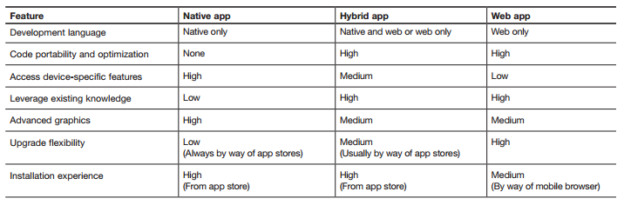

***Figure X:***description of main features of native vs hybrid development (<ftp://public.dhe.ibm.com/software/pdf/mobile-enterprise/WSW14182USEN.pdf>)

We decided to utilise the native **Android SDK**. The reasons were the following:

1. Using native APIs guarantees the look-and-feel will be the same on every device for the given platform.
2. Since the application is meant to be used for a longer amount of time (for meditation), the web application could run out of the memory, possibly resulting in bad user feedback. (http://venturebeat.com/2013/04/17/linkedin-mobile-web-breakup/)
3. Going native guarantees future compatibility, as Android Studio always adapts to the newest **Android SDK**, however when a new version of Android is released, cross-platform development tools might support it in a while.
4. Making use of all features available on the market – for Android especially Google AdSense or Play Store integration (purchases). Our client mentioned possible future in-app purchases integration, therefore native development ensures they will not have to refactor / rewrite the application once again when integrating it.