

**Team 52: Jaromir Latal & Lambros Zannettos**

**Client: The Mind Manifesto**

**(Imran Ahmad, Terry Hall)**

**Supervisor: Dr. Yun Fu**



**Table of Contents**

**1.** **Table of Contents** 3

**2. Abstract** 4

**3. Context** 4

**3. 1. Background to project and clients** 4

**3. 2. Problem being solved** 4

**4. Team Roles and Skills** 5

**4.1. Jaromir Latal** 5

**4.2. Lambros Zannettos** 5

**5. Requirements** 6

**5.1. Initial questions** 6

**5.2. List of requirements** 6

**5.3. Design** 7

**6. Work Distribution** 8

**6.1. Jaromir Latal** 8

**6.2. Lambros Zannettos** 8

**7. Technical Design** 9

**7.1. Technology chosen** 9

**7.2. Structure of the Application** 10

**7.3. User Interface** 10

**7.4. Design Patterns** 10

**7.4.1. Singleton** 10

**7.4.2. Template** 10

**7.4.3. Command** 10

# **2. Abstract**

The application we were asked to develop is meant to provide people escape from every day’s routine by providing them with multiple guided and unguided meditation courses (or “interventions”, as defined by client). The target user of this application is a busy person, who is likely to be overwhelmed and stressed; thus this application will allow him to slow down and relax. The application should be simple to use, including the UI and the user should be able to see how much time he has left and be able to jump to any place he wants. Another possible functionality is to provide user reminders / notifications that he has broken his meditation streak and should start over.

# **3. Context**

## **3. 1. Background to project and clients**

The Mind Manifesto (MM) is a set of toolboxes to help people improve their well-being and counter the negative effects of anxiety and stress in today’s hectic environment. The toolboxes are meditation tracks focused on certain areas of our lives, such as work, health or relationships – areas which have the greatest influence upon us.

Our clients, Imran Ahmad and Terry Hall, have asked us to create the mobile version of The Mind Manifesto, so that the interventions are available offline and on-the-go. This is meant to accompany the main version of The Mind Manifesto, which is currently available as a web application.

## **3. 2. Problem being solved**

Maybe add this here / expand 3.1.?

# **4. Team Roles and Skills**

## **4.1. Jaromir Latal**

* **Team Role:** Team Leader / Project Manager, Lead Interviewer for Requirements, Lead Tester
* **Key Skills:** I am proficient in Python, as it is the first programming language I have taught myself and have used it during multiple projects and programming competitions. I have also familiarity with C++ and Java due to taking International Baccalaureate Computer Science course.
* **Prior Project Experience:**
  + Machine Learning project in Python (scikit-learn) to predict stock prices
  + Patients Database in Java & MySQL for a child doctor
  + Educational Math Game written in Java using Swing GUI library
* **Communication & Teamwork:** Debating for 3 years have given me the opportunity to respect others’ opinions and approach them neutrally, finding the best possible solutions for multiple parties. Working as a Software Engineer in the largest agricultural software company in Slovakia provided me a plenty of opportunities to improve my teamwork and communication skills.

## **4.2. Lambros Zannettos**

* **Team Role:** Lead Software Engineer & UI Designer
* **Key Skills:**
* **Prior Project Experience:**
* **Communication & Teamwork:**

# **5. Requirements**

After being introduced to the project & client by Dr. Yun Fu, we discussed with my team partner possible scopes of the application. For this we researched current applications on the market (for Android and iOS) in order to prepare ourselves better for the upcoming meeting with the client. Our client sent us specifically three to have a closer look at – *Calm, Headspace and Insight Timer*.

## **5.1. Initial questions**

During the first meeting with the client we asked following questions to know the size and the scope of the project, as well as any preferences client has for the platform / technologies and design.

* What is exactly the project about?
* What platform would you like to target? Are there any preferences?
* Are there any technologies / languages / frameworks we are expected / asked to use?
* Details about the application and its functionality:
  + Do you have any specific UI design in mind?
  + What features are required for the core functionality?
  + What are the additional features we might implement?
  + Should it be on-line / off-line application? (e.g. tracks stored remotely)
  + Should the application feature in-app purchases as well?
  + Should the user have some settings available?
  + How many songs do you plan the app to hold? (relevant for off-line version)

## **5.2. List of requirements**

Based on the client’s answers to the questions, we drafted a list of requirements in MoSCoW (Must-Should-Could-Would) style, splitting the requirements into 4 categories based on their importance for the success of the project. After meeting with HCI Teaching Assistant Aisling O’Kane we finalised it and have it approved by our client.

**Must have -** **What must be delivered, i.e. it is essential for this phase?**

* Capability to play mp3 files stored locally on the device, including common media functions like play/stop/pause.
  + Complete: Media player and all its functions work as intended.
* Ability to detect connected headphones as the content is to be listened to via headphones only.
  + Complete: Media player displays a message to the user that for best experience headphones should be plugged in.
* Minimal, simple and intuitive UI design.
  + Complete: The design was rated well by both client and users.

**Should have - What should be delivered as a high priority but not essential?**

* A reminder function by which the app reminds the user to take some time to meditate. This could be either at random times or at specific times each day.
* Skip forward/backward buttons that skip a set number of seconds.
  + Complete: The skip time in seconds can be set in settings.
* Remembering last place left off in a session (if it was closed before completion).
* A big countdown timer signifying the time left in a session.
  + Complete: The users is being shown the time left on the music player screen.

**Could have - What could be delivered if there was available time / budget / resource?**

* A store part of the app, where the users can buy and download new content.
  + Incomplete: Pushed back into next version after discussion with client
* Translatable (this is easy to implement so could also belong in the Must list above).
  + Complete: Application is localised into user’s system language

**Would have - What would be delivered if time / budget / resource was unlimited?**

* Intelligent reminder that detects habits and breaks them.
  + Incomplete: Not possible in the time-frame given.
* Payment integration for new interventions in the application
  + Incomplete: Not enough time and issues present with testing in Google Play Store.

## **5.3. Design**

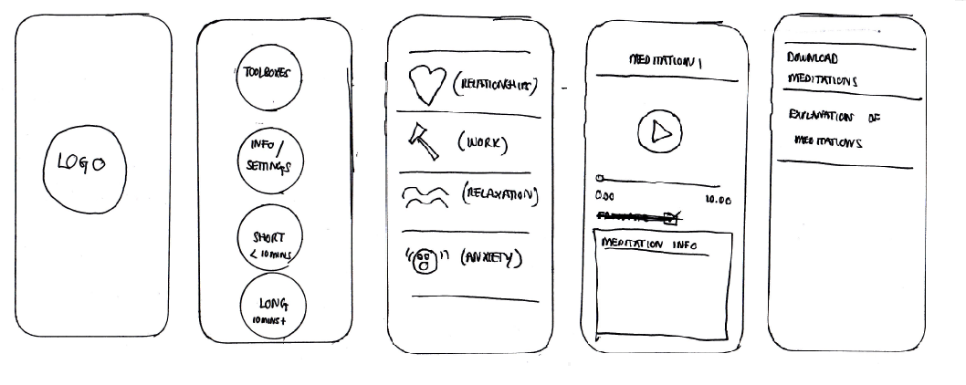The client has asked us to deliver a minimal, simple and clean UI, so that the application will not be cluttered and every first-time user will immediately know where to click. We created a paper-prototype independently and compared it to the client’s sketches.

**Figure 1: UI sketches provided by client**

**(from left: splash screen, main menu, toolboxes, media player, settings)**

INSERT OUR MOCKUPS HERE!

# **6. Work Distribution**

## **6.1. Jaromir Latal**

* Add error handing
* Add usage logging
* Fix bugs and issues found during the development
  + Complete: All reported issues on GitHub have been closed after being successfully solved.
* Refactor code
  + Complete: During the development we strictly adhered to OOP principles and made use of multiple design patterns
* Test the application
  + Complete: The application has been subjected to multiple types of testing, including the issues and bugs found during development.

## **6.2. Lambros Zannettos**

* Develop music player functionality
  + Complete: Implemented media player from scratch with cueing by desired time in seconds.
* Add more here 1
* Add more here 2

## **6.3. Shared**

* Produce bi-weekly reports
  + Complete: Bi-weekly reports have been filled in and submitted on time.
* What else did we share? Otherwise we can include it in both (unless we had a lot of things done together, e.g. UI mockups)

# **7. Technical Design**

## **7.1. Technology chosen**

After having agreed with the client that we want to target **Android** platform due to number of devices on the market, we had to decide which technology to use. We considered the following two possibilities: **Android Studio** (native Android SDK – Software Development Kit) and **3rd party SDKs** (such as **Cordova** or **Xamarin**).

**Android Studio** is the IDE which provides access to Android SDK - a modified version of Java including Android features and Google APIs - used to develop native Android applications.

**Xamarin** is a cross-platform mobile development tool used to develop applications both for Android and iOS (in C#). Xamarin apps consist of two layers:

1. **iOS / Android** – containing the UI and application layers (written in C#)
2. **Core Library** – containing shared code such as business logic

**Cordova** is a mobile cross-platform application development framework for **Android**, **iOS**, **Windows** **Phone** and more. Development is done in HTML5, CSS3 and Javascript instead of platform specific APIs (such as the Android SDK), however it allows using native device APIs providing access to device’s camera, file system and more.

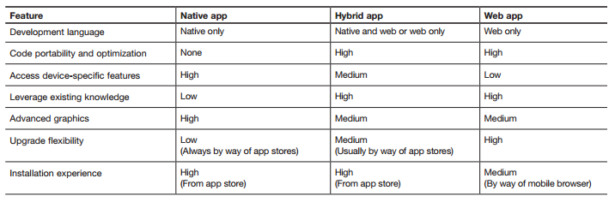

***Figure X:*** *description of main features of native vs hybrid development* (<ftp://public.dhe.ibm.com/software/pdf/mobile-enterprise/WSW14182USEN.pdf>)

We decided to utilise the native **Android SDK**. The reasons were the following:

1. Using native APIs guarantees the look-and-feel will be the same on every device for the given platform.
2. Since the application is meant to be used for a longer amount of time (for meditation), the web application could run out of the memory, possibly resulting in bad user feedback. (http://venturebeat.com/2013/04/17/linkedin-mobile-web-breakup/)
3. Going native guarantees future compatibility, as Android Studio always adapts to the newest **Android SDK**, however when a new version of Android is released, cross-platform development tools do not support it until an update is released.

## **7.2. Structure of the Application**

flowchart

## **7.3. User Interface**

Insert some screenshots here and describe the reasoning behind choosing / doing things the way they are

## **7.4. Design Patterns**

### **7.4.1. Singleton**

The Singleton pattern restricts the instantiation of the class to only one object, meaning only one instance of a class can be created, often being accessed globally.

Singleton has been implemented in our application in the MediaPlayerSingleton class. We decided to use so-called eager initialisation of Singleton, because our application will always need an instance (so that the MediaPlayer can play interventions in the applications). Moreover, the cost of creating one instance is not too expensive, which further affirmed our decision.

Using this design pattern ensured that the MediaPlayer instance always exists and that after changing screens the reference to the instance still exists, which is better rather than creating a completely new instance of MediaPlayer when a different meditation track is chosen.

### **7.4.2. Template**

Template pattern is a behavioural pattern design, which defines the skeleton of the algorithm and defers some steps to the subclasses – they can re-define certain steps as needed without changing the algorithm’s structure (which is common for all of them).

We made use of this pattern when creating items belonging to each category. While each category should have different items (some of them can be the same, e.g. a meditation track will be both in its own category and in all categories), the behaviour should be the same – when clicked the music player screen should be shown and the song played.

Usage of this design pattern allowed us to remove duplicate code which would have been otherwise needed for every item in the menu.

### **7.4.3. Command**