YuvaIntern
Virtual Data Science with Python Apprentice Internship

WEEK 3 REPORT
Statistical Analysis and Hypothesis Testing in Python
Four Hypotheses About Titanic Survival — Tested with Rigor

Submitted by | Jermy Biju
Role | Virtual Data Science with Python Apprentice Intern
Organization | YuvaIntern
Internship Duration | August 24, 2026 – September 28, 2026
Week 3 Duration | 30 – 35 hours
Dataset | Titanic (cleaned in Week 1, 889 rows × 14 columns)
Tools | Python 3.14, Pandas, NumPy, SciPy, Matplotlib, Seaborn

1. Executive Summary
This report presents Week 3 of the YuvaIntern Virtual Data Science with Python Apprenticeship. The task was to perform rigorous statistical analysis and hypothesis testing in Python. Four hypotheses about survival on the Titanic were formulated and tested using the appropriate statistical methods — chi-square, Welch's t-test, one-way ANOVA, and the Mann-Whitney U test.
Summary of findings:
- Sex and survival: strongly associated (chi-square = 258.43, p = 3.78e-58, Cramer's V = 0.54). Reject H0.
- Fare and survival: significant difference in mean fare (t = 6.76, p = 4.48e-11). Reject H0.
- Age across classes: significant difference in mean age (F = 91.40, p = 8.19e-37, eta-squared = 0.17). Reject H0.
- Age and survival: no significant difference in age distribution (U = 88,631, p = 0.21). Fail to reject H0.
Three of the four hypotheses were supported by the data; one was not. The strongest association is between sex and survival, followed by fare and survival, and age across passenger classes. The weakest is age itself, which does not differ significantly between survivors and non-survivors. All findings are reported as statistical associations, not causal claims.

2. Introduction — Why Hypothesis Testing?
Exploratory data analysis can reveal patterns, but it cannot tell us whether a pattern is real or simply the result of random variation in the sample. Hypothesis testing provides a formal, quantitative framework for that decision. It forces the analyst to state a claim in advance (the null hypothesis), choose a test statistic appropriate to the data, and decide whether the observed data are compatible with that null hypothesis.
For Week 3, four hypotheses were formulated about the Titanic dataset and tested using standard statistical methods. Each test is accompanied by a p-value, an effect size measure, and — where appropriate — a confidence interval. The result is a rigorous and reproducible assessment of which factors were and were not associated with survival.

3. Dataset
The dataset is the cleaned Titanic dataset from Week 1: 889 passengers, 14 columns, with zero missing values. Cleaning steps included dropping the deck column (approx 77% missing), imputing age using the median within (pclass, sex) subgroups, and removing two rows with missing embarkation information.
Variables used in this report:
Variable | Type | Role in tests
survived | Binary (0/1) | Outcome variable in all hypotheses
sex | Categorical | Grouping variable (Hypothesis 1)
fare | Continuous | Numerical outcome (Hypothesis 2)
pclass | Categorical (1/2/3) | Grouping variable (Hypothesis 3)
age | Continuous | Numerical variable (Hypotheses 3 and 4)

4. Methodology
Each hypothesis was paired with the statistical test most appropriate to the types of variables involved. Effect sizes were calculated alongside p-values, because a statistically significant result can still have a negligible practical impact.
# | Hypothesis (H0) | Test | Why this test
1 | Survival and sex are independent | Chi-square test of independence | Both variables are categorical
2 | Mean fare is the same for survivors and non-survivors | Welch's independent t-test | Continuous outcome across two groups with unequal variances
3 | Mean age is the same across all three classes | One-way ANOVA | Continuous outcome across three groups
4 | Age distribution is the same for survivors and non-survivors | Mann-Whitney U test | Non-parametric alternative to t-test (age is not normally distributed)

Significance level: alpha = 0.05 (two-sided tests).
Effect sizes reported: Cramer's V (chi-square), mean difference with 95% CI (t-test), Eta-squared (ANOVA), rank-biserial correlation (Mann-Whitney).

5. Results

5.1 Hypothesis 1 — Survival and Sex (Chi-Square)
H0: Survival and sex are independent.
H1: Survival and sex are associated.
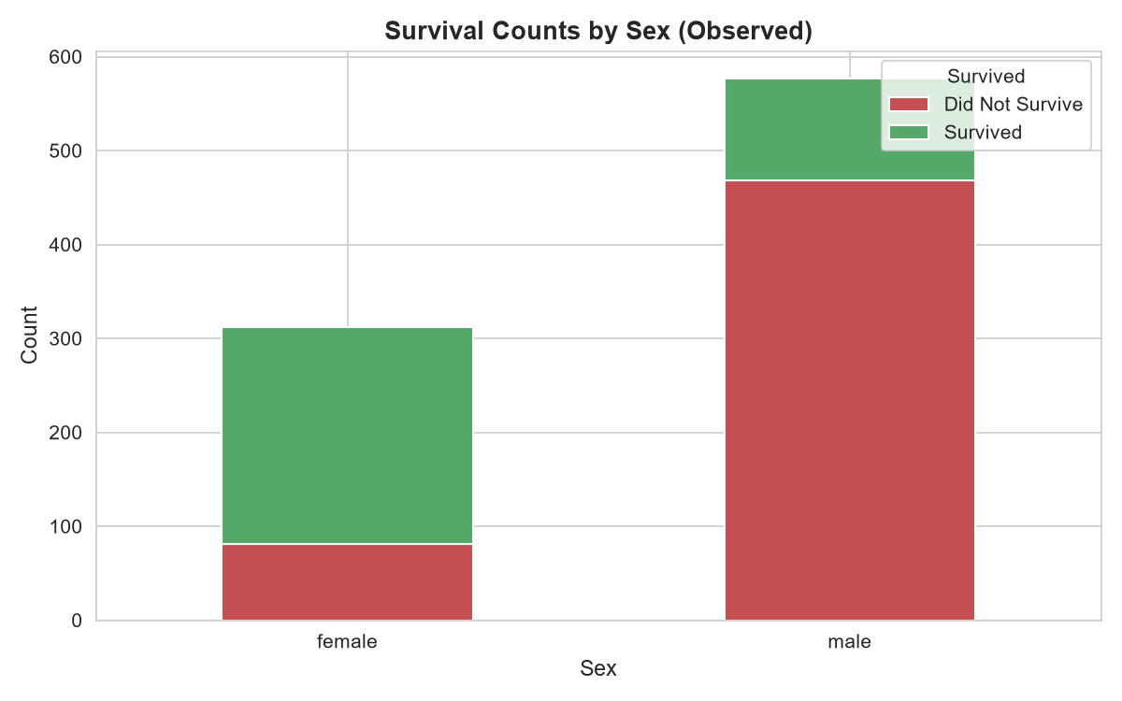
Figure 1: Observed survival counts by sex. Female passengers mostly survived; male passengers mostly did not.
Contingency table (observed counts):
Sex | Did Not Survive | Survived | Total
Female | 81 | 231 | 312
Male | 468 | 109 | 577

Test results:
Statistic | Value
Chi-square | 258.43
Degrees of freedom | 1
p-value | 3.78 x 10^-58
Cramer's V | 0.5392 (strong)

Decision: Reject H0 at alpha = 0.05. There is an extremely strong statistical association between sex and survival. The effect size (Cramer's V = 0.54) is large, meaning this is not only statistically significant but also practically important.

5.2 Hypothesis 2 — Mean Fare by Survival (Welch's t-test)
H0: Mean fare is the same for survivors and non-survivors.
H1: Mean fare differs between the two groups.
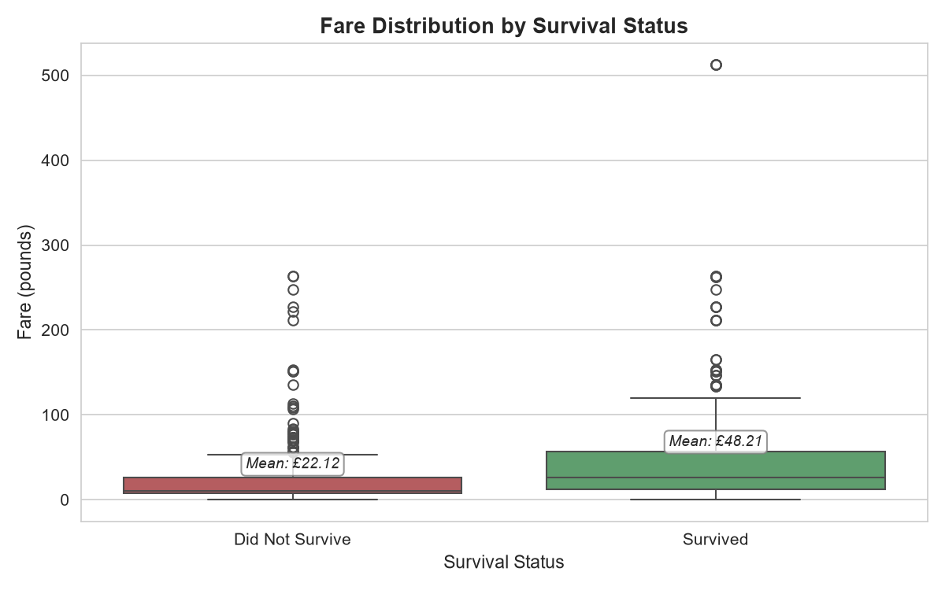
Figure 2: Fare distributions for survivors (green) and non-survivors (red). Survivors paid higher fares on average.
Descriptive statistics:
Group | n | Mean | Median | Std Dev
Survived | 340 | 48.21 | 26.00 | 66.75
Did Not Survive | 549 | 22.12 | 10.50 | 31.39

Test results:
Statistic | Value
t-statistic | 6.7597
p-value | 4.48 x 10^-11
Difference in means | 26.09
95% CI for difference | [18.51, 33.68]

Decision: Reject H0 at alpha = 0.05. Survivors paid on average 26 more than non-survivors, and the 95% confidence interval excludes zero by a wide margin. However, note that fare is strongly correlated with class, so this effect likely reflects the class difference documented in Hypothesis 3.

5.3 Hypothesis 3 — Mean Age Across Passenger Classes (ANOVA)
H0: Mean age is the same across all three passenger classes.
H1: At least one class has a different mean age.
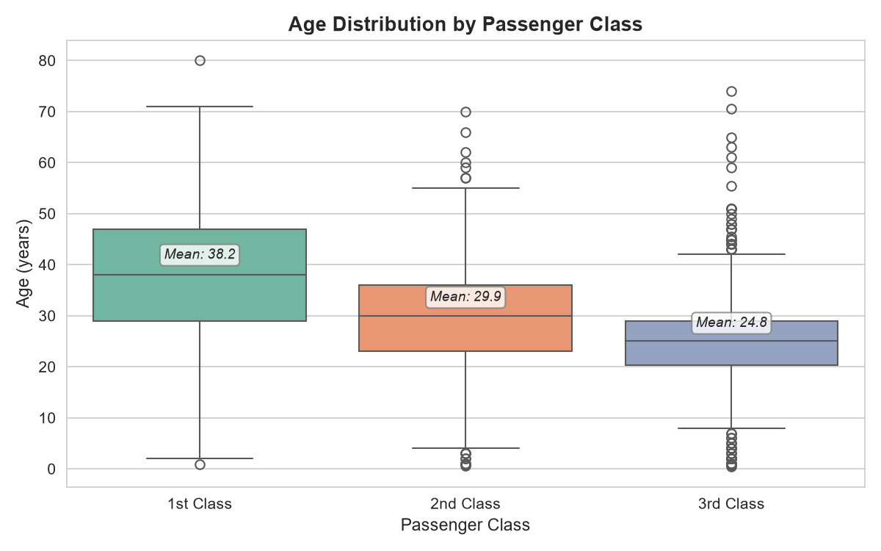
Figure 3: Age distributions by passenger class. Median age decreases from 1st to 3rd class.
Descriptive statistics:
Class | n | Mean Age | Median Age | Std Dev
1st Class | 214 | 38.16 | 38.00 | 13.73
2nd Class | 184 | 29.86 | 30.00 | 13.58
3rd Class | 491 | 24.80 | 25.00 | 10.67

Test results:
Statistic | Value
F-statistic | 91.3962
p-value | 8.19 x 10^-37
Eta-squared | 0.1710 (large)

Decision: Reject H0 at alpha = 0.05. Mean age differs significantly across classes, and the effect size (eta-squared = 0.17) is large. The pattern is monotonic: mean age decreases from 1st to 3rd class. This means that class is a proxy for age, which may partially explain why higher-class passengers survived at higher rates.

5.4 Hypothesis 4 — Age Distribution by Survival (Mann-Whitney U)
H0: Age distribution is the same for survivors and non-survivors.
H1: Age distributions differ between the two groups.
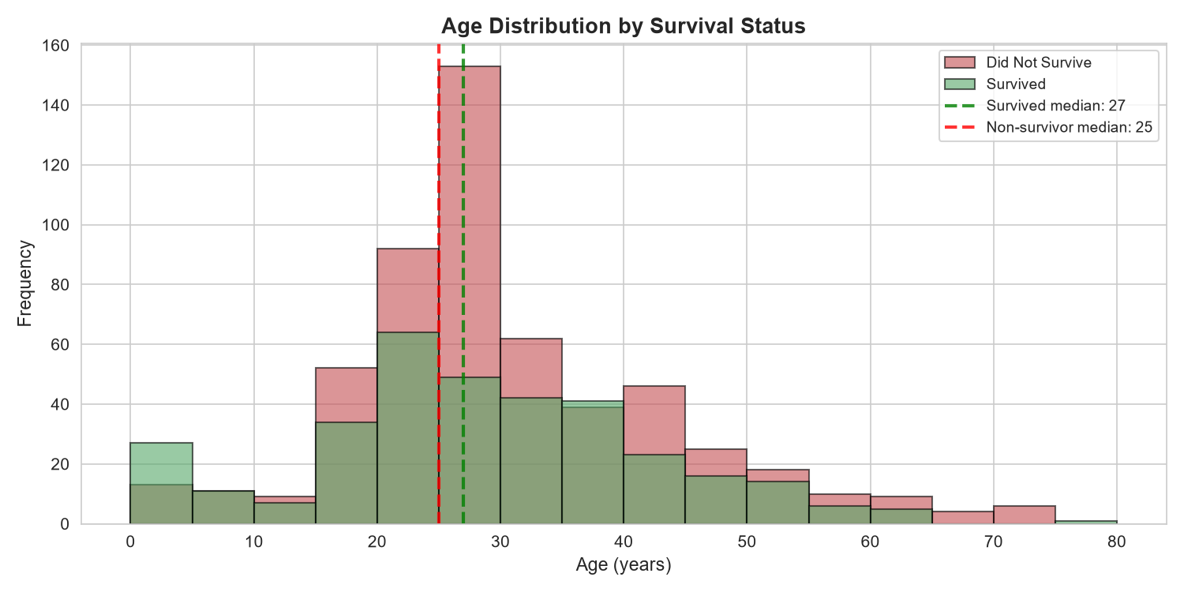
Figure 4: Overlaid age histograms for survivors and non-survivors. The distributions overlap heavily.
Descriptive statistics:
Group | n | Mean Age | Median Age | Std Dev
Survived | 340 | 27.98 | 27.00 | 13.92
Did Not Survive | 549 | 29.74 | 25.00 | 12.82

Test results:
Statistic | Value
U-statistic | 88,631.50
p-value | 0.206
Rank-biserial correlation | 0.0503 (negligible)

Decision: Fail to reject H0 at alpha = 0.05. There is no statistically significant difference in age distributions between survivors and non-survivors, and the effect size is negligible. Age, on its own, does not meaningfully separate survivors from non-survivors — a result that contrasts sharply with the associations found for sex, fare, and class.

5.5 Bonus — 95% Confidence Intervals for Survival Rate
To illustrate uncertainty around each group's survival estimate, Wilson 95% confidence intervals were computed for the six sex-by-class groups.
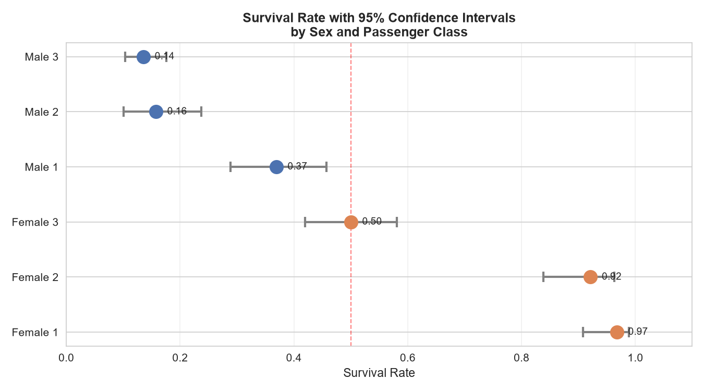
Figure 5: Survival rate with 95% confidence intervals by sex and passenger class. Female 1st class is the highest; male 3rd class is the lowest.
Survival rate and 95% CI:
Group | n | Survival Rate | 95% CI
Female 1st | 92 | 0.967 | [0.908, 0.989]
Female 2nd | 76 | 0.921 | [0.838, 0.963]
Female 3rd | 144 | 0.500 | [0.419, 0.581]
Male 1st | 122 | 0.369 | [0.288, 0.457]
Male 2nd | 108 | 0.157 | [0.101, 0.238]
Male 3rd | 347 | 0.135 | [0.103, 0.175]

Female 1st class survival is near-certain (96.7%, CI [90.8%, 98.9%]). Male 3rd class survival is near-certain in the opposite direction (13.5%, CI [10.3%, 17.5%]). Female 3rd class is the only group whose confidence interval crosses 50%, reflecting genuine uncertainty about whether more than half of that group survived.

6. Discussion

6.1 Statistical significance vs practical significance
A small p-value tells us that an effect is unlikely to have arisen by chance. It does not tell us how large the effect is. This distinction matters. For example:
- Sex and survival: p = 3.78e-58 AND Cramer's V = 0.54 -> both significant and large. A clear, practical effect.
- Fare and survival: p = 4.48e-11 AND mean difference = 26 -> significant with a sizable effect, though partly driven by class.
- Age across classes: p = 8.19e-37 AND eta-squared = 0.17 -> significant and large. Class is genuinely age-stratified.
- Age and survival: p = 0.206 -> not significant. Fails the primary test.

6.2 Correct test choice matters
Each hypothesis was matched to the appropriate test. Chi-square was used for two categorical variables, Welch's t-test for a continuous variable across two groups with unequal variances, ANOVA for a continuous variable across three groups, and the Mann-Whitney U test as a non-parametric alternative when normality could not be assumed. Choosing the wrong test — for example, using a t-test on heavily skewed fare data — could produce misleading results.

6.3 What this analysis does not claim
All findings are statistical associations in an observational dataset. No causal claims are made. For example, the fact that survivors paid higher fares on average does not mean paying a higher fare caused survival. Class, sex, age, and fare are interrelated, and this analysis documents the patterns rather than explaining the underlying mechanisms.

7. Conclusion
Week 3 demonstrated how formal hypothesis testing can confirm, qualify, or reject patterns observed during exploratory analysis. Three of the four hypotheses were supported by the data: survival was associated with sex (extremely strong), mean fare differed between survivors and non-survivors (strong, but entangled with class), and mean age differed across passenger classes (large effect). The fourth hypothesis — that age distribution differs by survival — was not supported.
The statistical workflow followed here is directly relevant to real-world analytics: state a hypothesis, choose a test that matches the data, report both p-values and effect sizes, interpret confidence intervals, and acknowledge the limits of what the data can and cannot establish. The result is an analysis that is honest about what it found and honest about what it did not.

8. Appendix — Key Code Snippets

8.1 Chi-square test (Hypothesis 1)
from scipy import stats
contingency = pd.crosstab(df['sex'], df['survived'])
chi2, p, dof, expected = stats.chi2_contingency(contingency)

8.2 Welch's t-test with 95% CI (Hypothesis 2)
t, p = stats.ttest_ind(fare_survived, fare_not_survived,
equal_var=False)
mean_diff = fare_survived.mean() - fare_not_survived.mean()
# 95% CI computed using Welch-Satterthwaite degrees of freedom

8.3 One-way ANOVA (Hypothesis 3)
f, p = stats.f_oneway(age_1st, age_2nd, age_3rd)
# Effect size: eta-squared
eta_sq = ss_between / ss_total

8.4 Mann-Whitney U test (Hypothesis 4)
u, p = stats.mannwhitneyu(age_survived, age_not_survived,
alternative='two-sided')
rank_biserial = 1 - (2 * u) / (n1 * n2)

8.5 Wilson 95% CI for a proportion (Bonus)
def wilson_ci(k, n, confidence=0.95):
p = k / n
z = stats.norm.ppf(1 - (1 - confidence) / 2)
denom = 1 + z**2 / n
centre = (p + z**2 / (2*n)) / denom
margin = z * ((p*(1-p)/n + z**2/(4*n**2))**0.5) / denom
return (centre - margin, centre + margin)

