YuvaIntern
Virtual Data Science with Python Apprentice Internship

WEEK 4 REPORT
Machine Learning Model Development and Evaluation
Predicting Titanic Survival with Three Classification Models

Submitted by | Jermy Biju
Role | Virtual Data Science with Python Apprentice Intern
Organization | YuvaIntern
Internship Duration | August 24, 2026 – September 28, 2026
Week 4 Duration | 30 – 35 hours
Dataset | Titanic (cleaned in Week 1, 889 rows x 14 columns)
Tools | Python 3.14, Pandas, NumPy, Scikit-learn, Matplotlib, Seaborn

1. Executive Summary
This report presents Week 4 of the YuvaIntern Virtual Data Science with Python Apprenticeship. The task was to build and evaluate a basic machine learning model on a publicly available dataset. Three classification models were trained and evaluated to predict passenger survival on the Titanic: Logistic Regression, Decision Tree, and Random Forest.
Summary of results:
- Logistic Regression: 82.6% accuracy, ROC AUC 0.860 (best overall).
- Random Forest: 81.5% accuracy, ROC AUC 0.850 (best precision at 0.83).
- Decision Tree: 77.0% accuracy, ROC AUC 0.837 (weakest).
The simplest model, Logistic Regression, performed best by accuracy and AUC, suggesting that the underlying relationships in this dataset are largely linear. Feature importance analysis from the Random Forest identified sex, fare, age, and passenger class as the four most predictive features, confirming the statistical associations found in Week 3. A learning curve analysis showed no severe overfitting, with training and cross-validation scores staying within reasonable bounds.

2. Introduction — Why Machine Learning?
Weeks 1 through 3 built up to this point. In Week 1 the dataset was cleaned and prepared. In Week 2 the survival patterns were visualized. In Week 3 those patterns were tested statistically. Week 4 completes the cycle by asking a predictive question: given what we know about a passenger, can we predict whether they survived?
Machine learning models learn patterns from historical data and apply those patterns to new, unseen observations. This report builds three such models and evaluates them using standard classification metrics. The goal is not simply to achieve the highest accuracy, but to understand the trade-offs between different models and to be honest about each model's limitations.

3. Dataset and Preprocessing
The dataset is the cleaned Titanic dataset from Week 1: 889 passengers, 14 columns, with zero missing values. The target variable is survived (0 or 1).

3.1 Feature selection
Seven features were selected for the model:
Feature | Type | Handling
pclass | Ordinal (1/2/3) | Used directly
sex | Categorical | Mapped to 0 (male) / 1 (female)
age | Continuous | Standardized (mean=0, std=1)
sibsp | Integer | Standardized
parch | Integer | Standardized
fare | Continuous | Standardized
embarked | Categorical | One-hot encoded (drop_first=True)

Redundant columns dropped: alive (identical to survived), class (same as pclass), who, adult_male, embark_town, alone.

3.2 Train/test split
Split | Samples | Survival Rate
Training set | 711 | 0.383
Test set | 178 | 0.382

An 80/20 stratified split was used (random_state=42). Stratification ensured that the survival rate was nearly identical in both subsets (0.383 vs 0.382), preventing sampling bias.

4. Methodology — Model Selection
Three classification algorithms were chosen to compare different model families:
Model | Family | Why chosen
Logistic Regression | Linear | Simple, interpretable baseline. Well suited when relationships are approximately linear.
Decision Tree | Tree-based | Interpretable, non-linear. Shows decision rules explicitly.
Random Forest | Ensemble | Combines many trees to reduce overfitting. Often strong on tabular data.

Hyperparameters (chosen to prevent overfitting on a small dataset):
- Logistic Regression: max_iter=1000.
- Decision Tree: max_depth=5, min_samples_leaf=5.
- Random Forest: n_estimators=200, max_depth=6, min_samples_leaf=3.
Evaluation metrics:
- Accuracy — overall proportion of correct predictions.
- Precision — proportion of positive predictions that were correct.
- Recall — proportion of actual positives correctly identified.
- F1 Score — harmonic mean of precision and recall.
- ROC AUC — area under the ROC curve; measures ranking quality across thresholds.

5. Results

5.1 Confusion Matrices — Three Models Side by Side
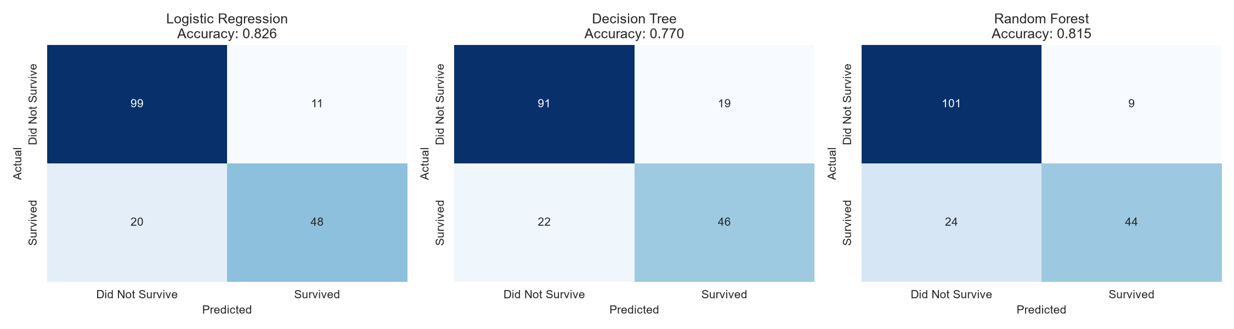
Figure 1: Confusion matrices for the three models on the test set (n = 178).
Logistic Regression has the most balanced confusion matrix: it correctly identifies 99 non-survivors and 48 survivors, with 11 false positives and 20 false negatives. Random Forest is the most conservative — it makes the fewest false positives (9) but misses more survivors (24 false negatives). Decision Tree is weakest overall, with 19 false positives and 22 false negatives.

5.2 ROC Curves
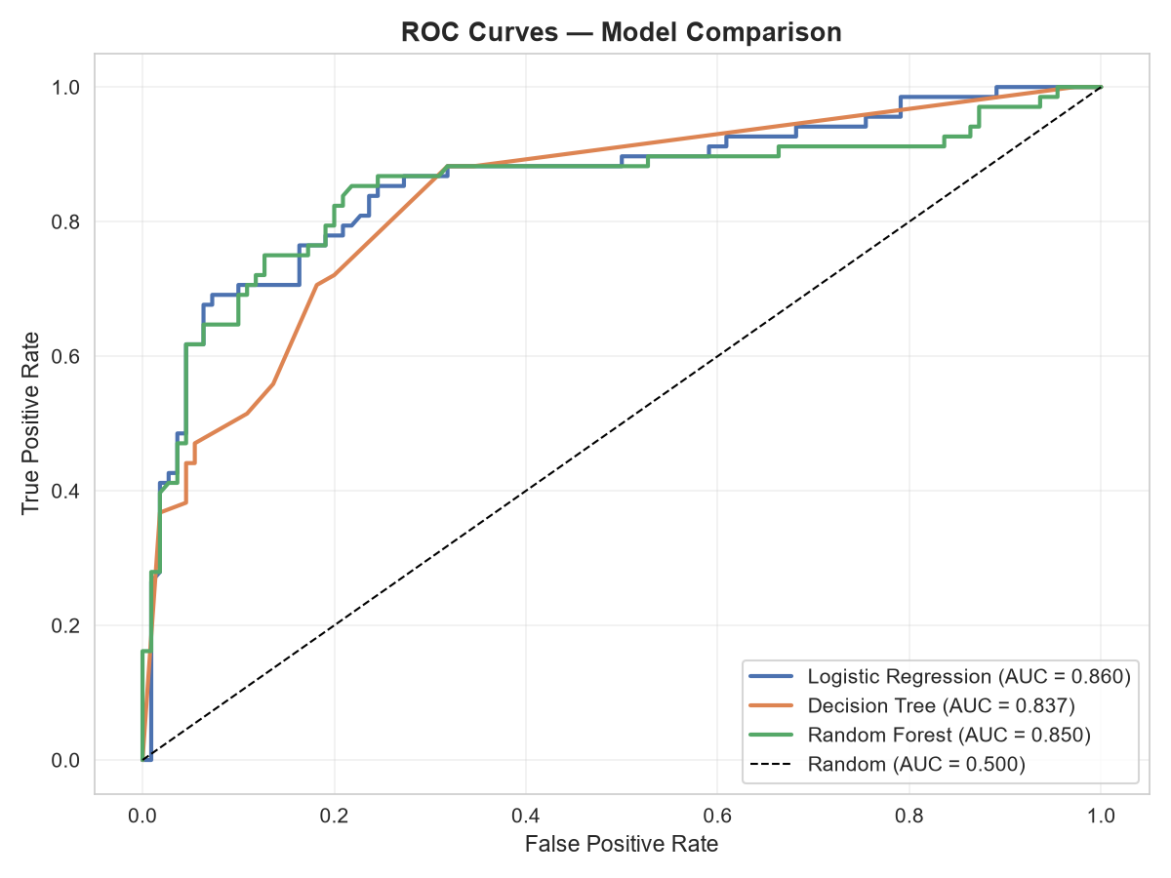
Figure 2: ROC curves for the three models. The dashed diagonal represents a random classifier.

ROC AUC values:
Model | ROC AUC
Logistic Regression | 0.860
Random Forest | 0.850
Decision Tree | 0.837
Random baseline | 0.500

All three models are far above the random baseline. Logistic Regression has the highest AUC, meaning that across all possible classification thresholds it ranks survivors above non-survivors more reliably than the other models.

5.3 Metrics Comparison
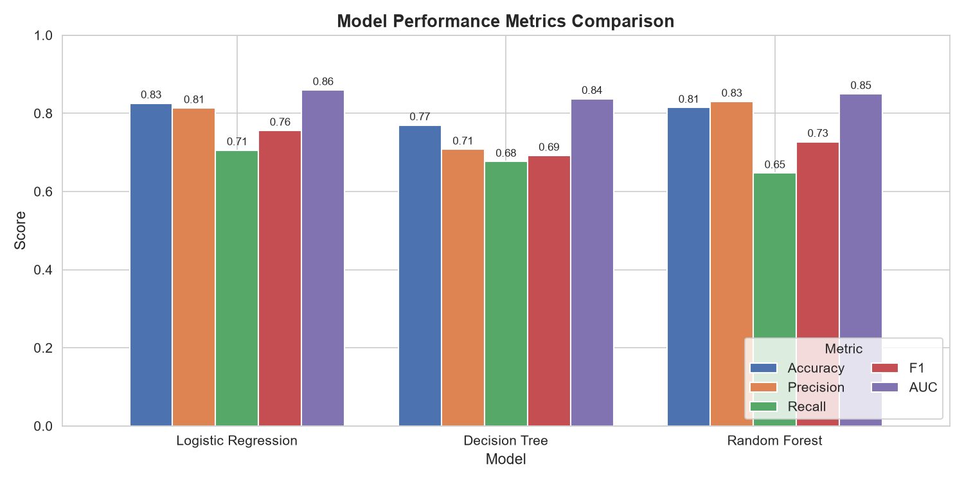
Figure 3: Accuracy, precision, recall, F1, and AUC for each model.
Full metrics table:
Model | Accuracy | Precision | Recall | F1 | AUC
Logistic Regression | 0.826 | 0.814 | 0.706 | 0.756 | 0.860
Decision Tree | 0.770 | 0.708 | 0.677 | 0.692 | 0.837
Random Forest | 0.815 | 0.830 | 0.647 | 0.727 | 0.850

Observations: Logistic Regression leads on accuracy, F1, and AUC. Random Forest has the highest precision (0.83), meaning when it predicts survival it is more often right, but its recall is lower (0.65), meaning it misses more real survivors. This is the classic precision-recall trade-off, and the right choice depends on the business cost of each type of error.

5.4 Feature Importance (Random Forest)
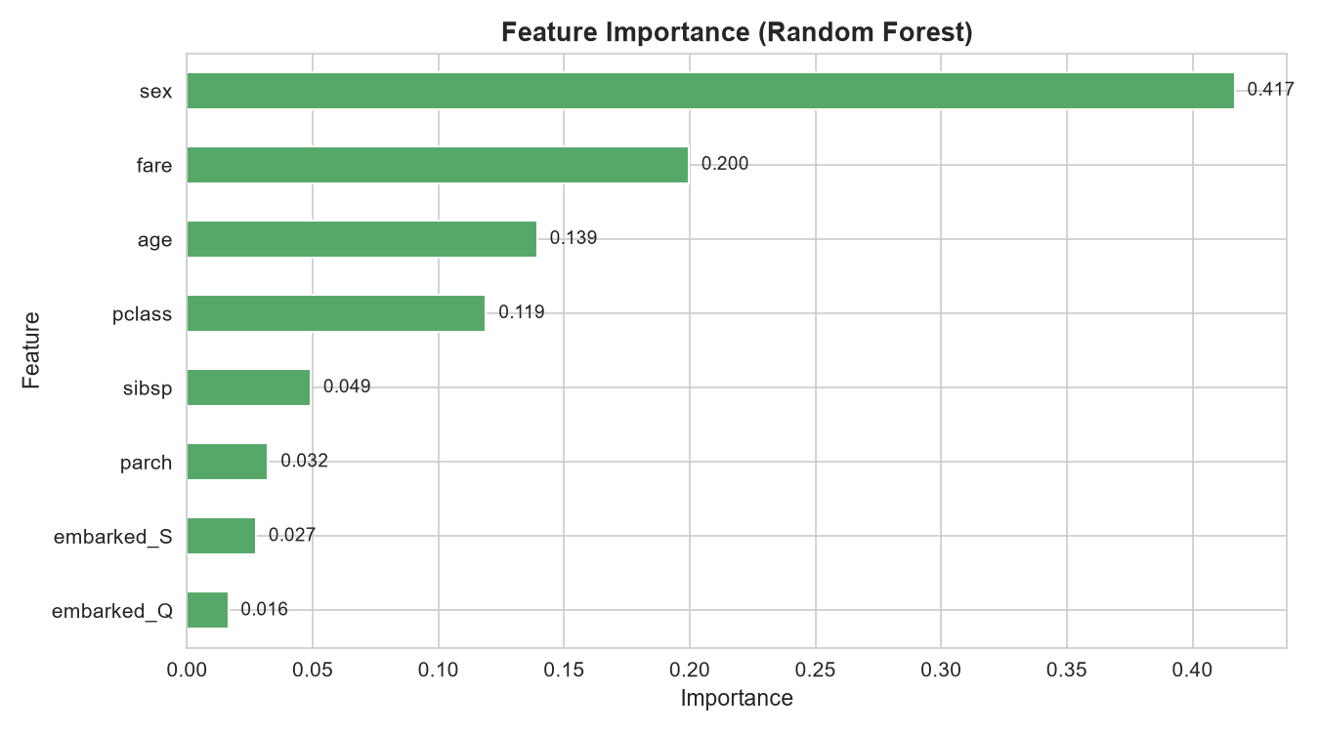
Figure 4: Relative importance of each feature in the Random Forest model.
Feature | Importance
sex | 0.417
fare | 0.200
age | 0.139
pclass | 0.119
sibsp | 0.049
parch | 0.032
embarked_S | 0.027
embarked_Q | 0.016

Four features account for roughly 87% of the model's decision power: sex, fare, age, and pclass. This is a strong cross-check on the statistical analysis from Week 3, which independently identified sex and pclass as the strongest predictors of survival. The remaining features (sibsp, parch, embarked) contribute very little.

5.5 Learning Curve — Overfitting Check
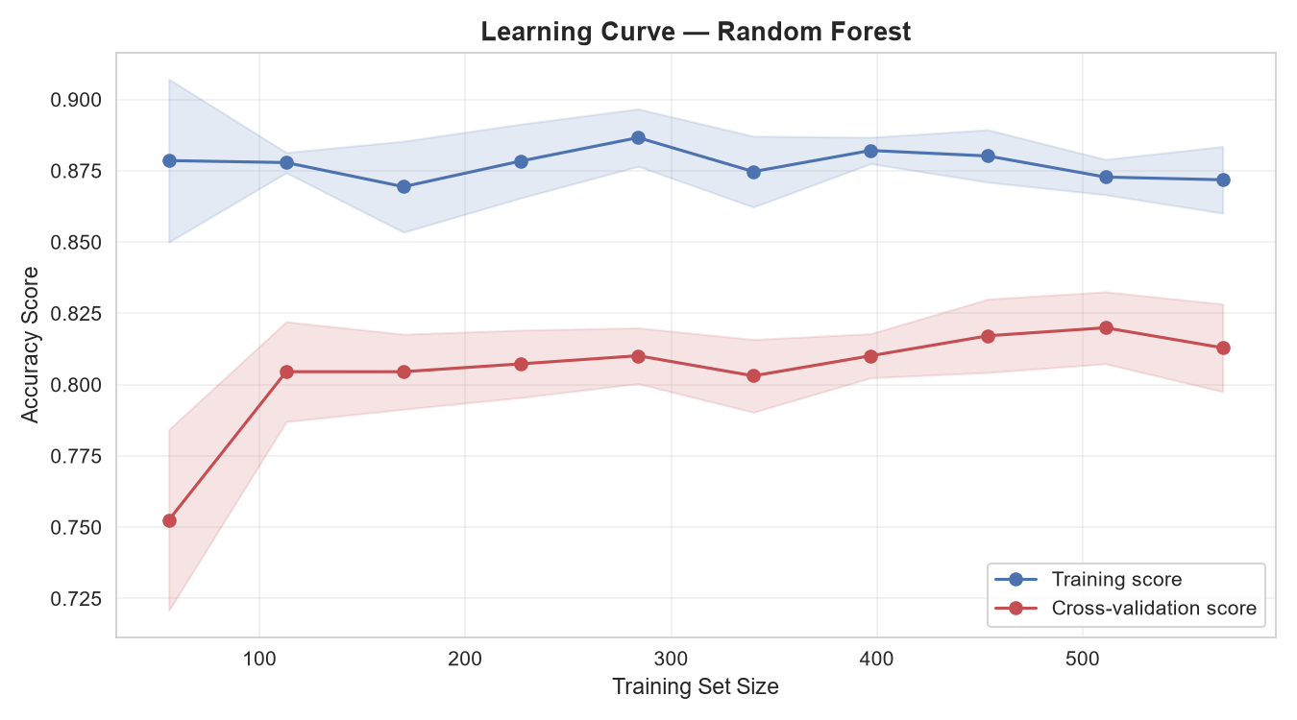
Figure 5: Learning curve for the Random Forest model. Training and cross-validation scores track each other closely.
The learning curve shows that training accuracy (around 0.88) and cross-validation accuracy (around 0.81) stay within about 0.07 of each other across all training set sizes. This small gap indicates that the model is not severely overfitting. The cross-validation score plateaus around 400 training samples, suggesting that additional data would not meaningfully improve performance — the model has extracted most of the signal available in these features.

6. Critical Discussion

6.1 Why Logistic Regression won
The simplest model won on this dataset. This is not unusual. The Titanic features are mostly linearly separable — sex, class, and fare together create a clear decision boundary. Tree-based models can overfit on small samples (889 rows), and even with hyperparameter limits, they struggled to beat the baseline. This is a useful lesson: more complex models are not always better.

6.2 Sources of error
- Small dataset. With only 178 test samples, a difference of 2-3 correct predictions can change accuracy by over 1%.
- Missing cabin information. The deck column was dropped in Week 1 due to 77% missing values. Cabin location was likely very predictive of survival.
- Imputed ages. Age was imputed by subgroup median in Week 1. This is a reasonable but imperfect substitute for real age.
- Unmeasured variables. Variables like "whether the passenger had a lifeboat seat" are not in the data but would be strongly predictive.
- Precision-recall trade-off. Even the best model misses 30% of actual survivors — a substantial error rate.

6.3 Suggestions for improvement
- Engineer more features. Titles extracted from names (Mr, Mrs, Miss, Master) strongly correlate with class and survival. Family size buckets (small/large) may also help.
- Try gradient boosting. XGBoost and LightGBM often outperform Random Forest on tabular data.
- Cross-validation tuning. Use grid search with 5-fold CV to tune hyperparameters more rigorously.
- Handle class imbalance. 62% of passengers did not survive. Class weights or SMOTE could improve recall for the survivor class.
- Collect more data. The learning curve suggests 400+ samples is the plateau, but more passengers (if available) could still help rare subgroups.

6.4 What this analysis does not claim
The model predicts survival based on associations in this dataset. It does not explain why survival differed. The relationships are observational. A model that predicts survival does not demonstrate causation, and the predictions should not be interpreted as causal statements about what would have saved individual passengers.

7. Conclusion
Week 4 completed the data science cycle that began in Week 1. The cleaned dataset was used to train three classification models — Logistic Regression, Decision Tree, and Random Forest — to predict passenger survival. Logistic Regression achieved the highest accuracy (82.6%) and ROC AUC (0.860), followed closely by Random Forest (81.5% / 0.850). Decision Tree was the weakest at 77.0%.
Feature importance analysis independently confirmed the findings of Week 3: sex, fare, age, and pclass account for roughly 87% of the model's predictive power. The learning curve showed no severe overfitting, and the study concluded with a candid discussion of error sources and improvement paths. The exercise demonstrates that model development is as much about honest evaluation and clear documentation as it is about achieving a high score.

8. Appendix — Key Code Snippets

8.1 Data preparation
df_ml = df[features + [target]].copy()
df_ml['sex'] = df_ml['sex'].map({'male': 0, 'female': 1})
df_ml = pd.get_dummies(df_ml, columns=['embarked'],
prefix='embarked', drop_first=True)
X_train, X_test, y_train, y_test = train_test_split(
X, y, test_size=0.20, random_state=42, stratify=y
)

8.2 Logistic Regression
from sklearn.linear_model import LogisticRegression
log_reg = LogisticRegression(random_state=42, max_iter=1000)
log_reg.fit(X_train_scaled, y_train)
y_pred = log_reg.predict(X_test_scaled)
y_proba = log_reg.predict_proba(X_test_scaled)[:, 1]

8.3 Decision Tree and Random Forest
from sklearn.tree import DecisionTreeClassifier
from sklearn.ensemble import RandomForestClassifier
dt = DecisionTreeClassifier(max_depth=5, min_samples_leaf=5, random_state=42)
rf = RandomForestClassifier(n_estimators=200, max_depth=6,
min_samples_leaf=3, random_state=42)

8.4 Evaluation metrics
from sklearn.metrics import (accuracy_score, precision_score,
recall_score, f1_score, roc_auc_score)
acc = accuracy_score(y_test, y_pred)
auc = roc_auc_score(y_test, y_proba)

8.5 Learning curve
from sklearn.model_selection import learning_curve
train_sizes, train_scores, test_scores = learning_curve(
RandomForestClassifier(n_estimators=200, max_depth=6),
X_train_scaled, y_train, cv=5,
train_sizes=np.linspace(0.1, 1.0, 10), scoring='accuracy'
)

