SHORT SUMMARY

PREPROCESSING

I set up links to the files according to mother&infant pairs. Based on the information in the ids file I only worked with the subjects where all three measurements(mother, infant torso, infant ankle) were present, which resulted in 27 pairs, where one mother had twins, so I counted that as another pair, so I ended up with 28 mother&infant pairs.
I took only 48 hours of measurements and aligned all three so they started on the exact same time-stamp.
I removed no-wear time based on the local(15 minutes windows):
-std (all three axis below 0.002 g)
-span from min to max(all three axis below 0.015 g)
-slope of a fitted line(all three axis below 10⁻⁷ (no wear time should in theory have no slope, with noise and spikes there is always some))

There are many papers about no-wear time removal, stating different cut points for std. In one of your papers there is a mention about noise 0.0026 g std of GENEAs when still on surface and 0.01g span from breathing and 0.08 from heart beat, but later papers used lower cut points and indeed when examining the results I noticed that in no-wear the noise is much smaller, maybe GENEAs got better :)
I designed the script so I could pass different parameters and observe the results, I also plotted the night time, estimated from 21.00 to 7.00 and the above parameters seem to be the most appropriate, although there are a few bits and pieces where I think that the subject was just sleeping really still, but I think that they are negligible. When I was doing correlation, I noticed that there is one 40 minutes block of no-wear that got undetected due to some spikes in between, I will add an extra condition for such cases, but more or less the no-wear time is finished, I still have to check the diaries Frida sent me to validate.

These are the separate plots with no-wear time indicated red and night time shaded:
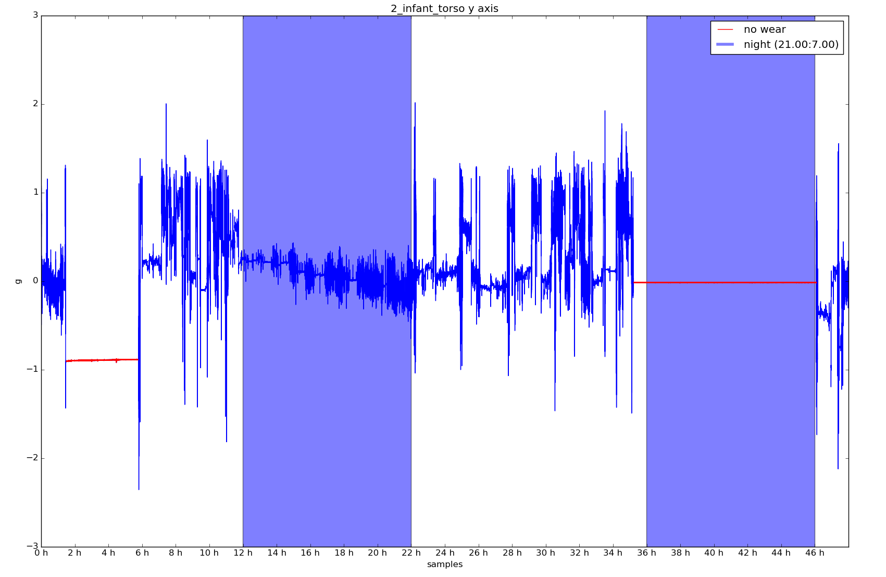

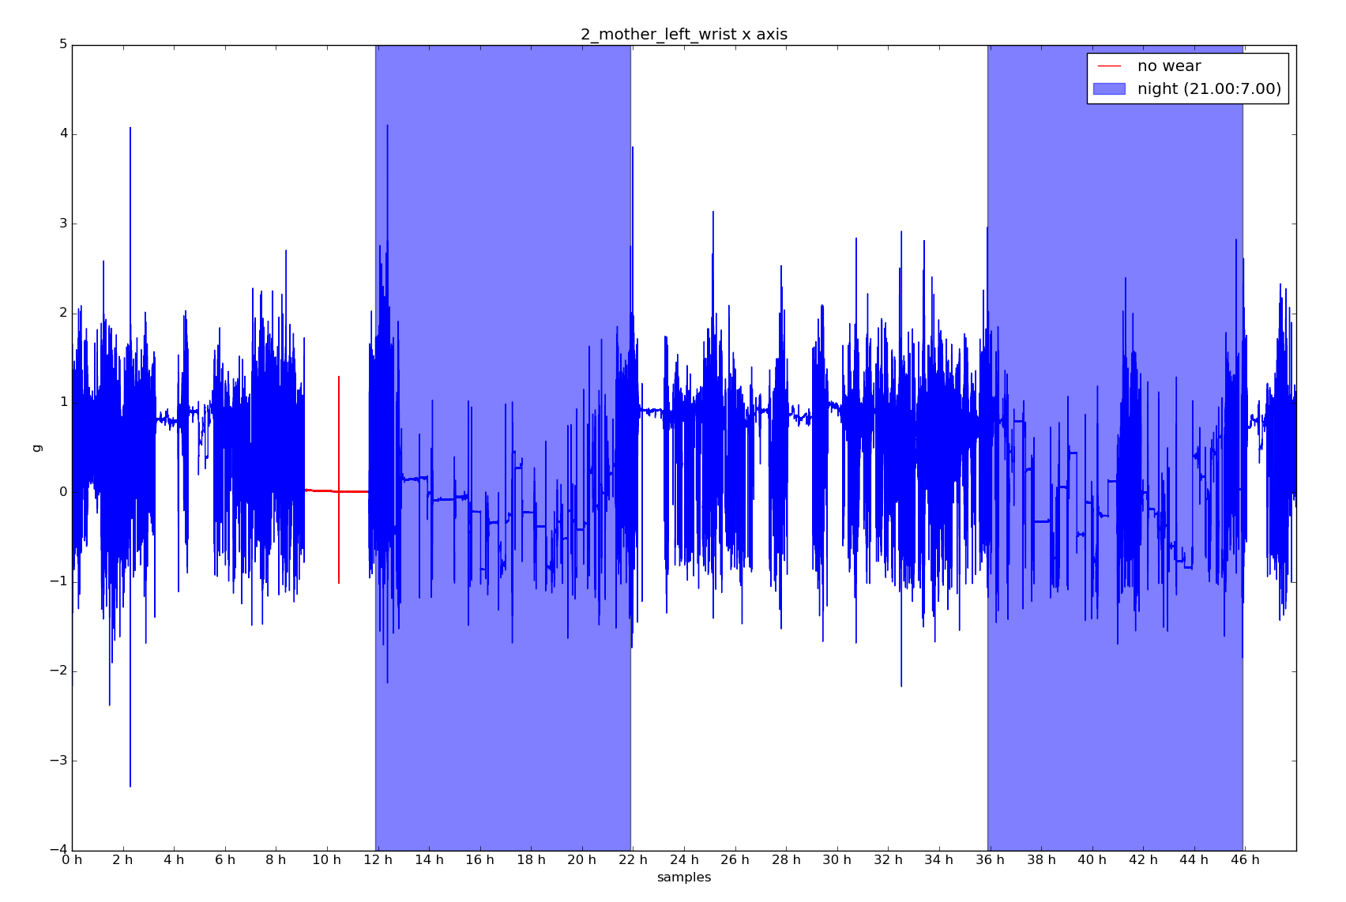

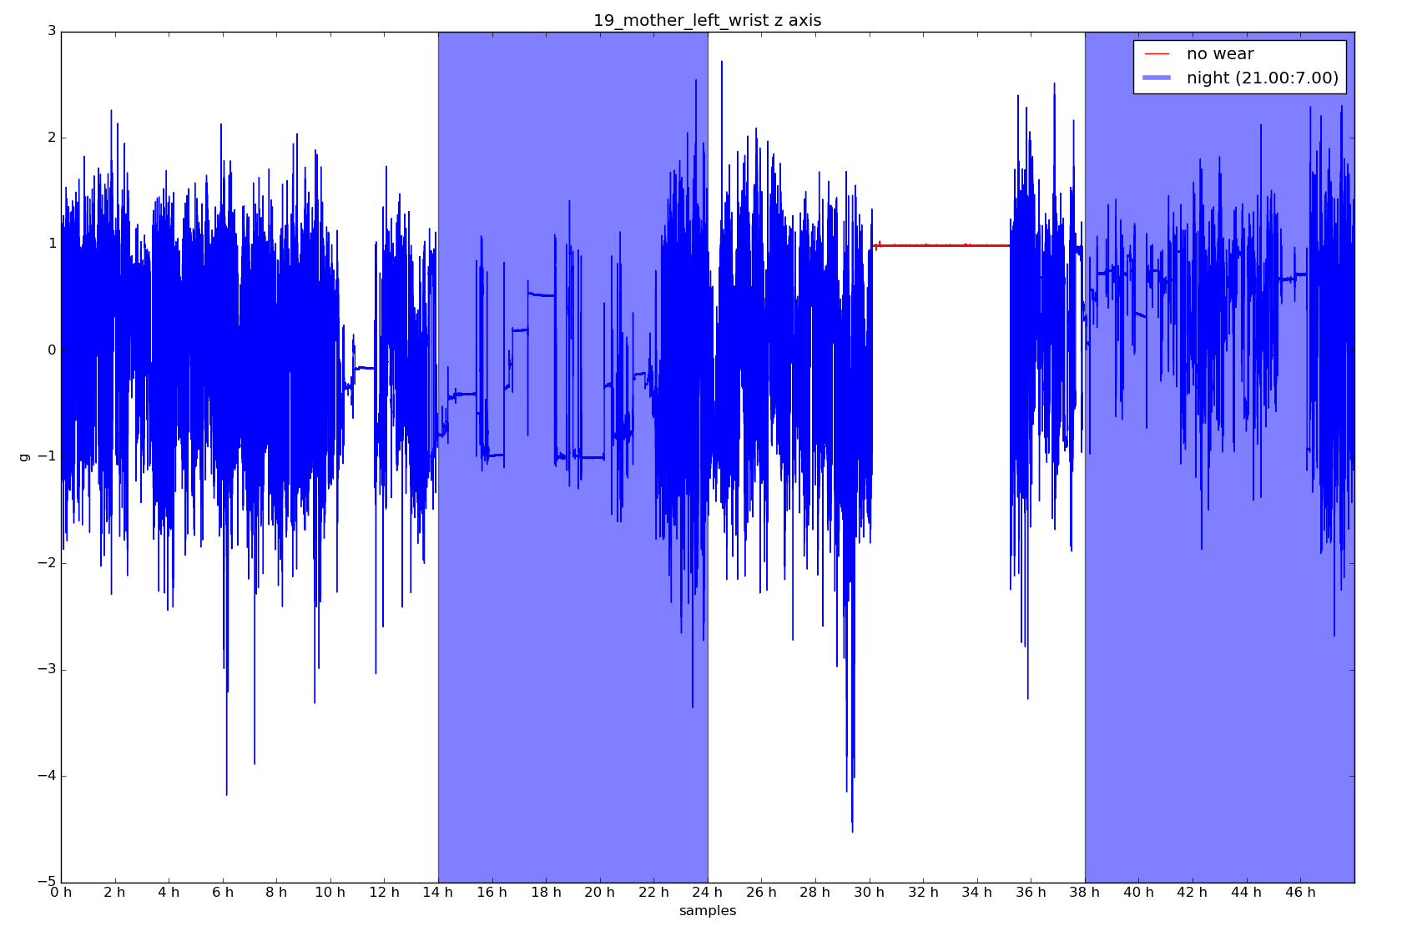

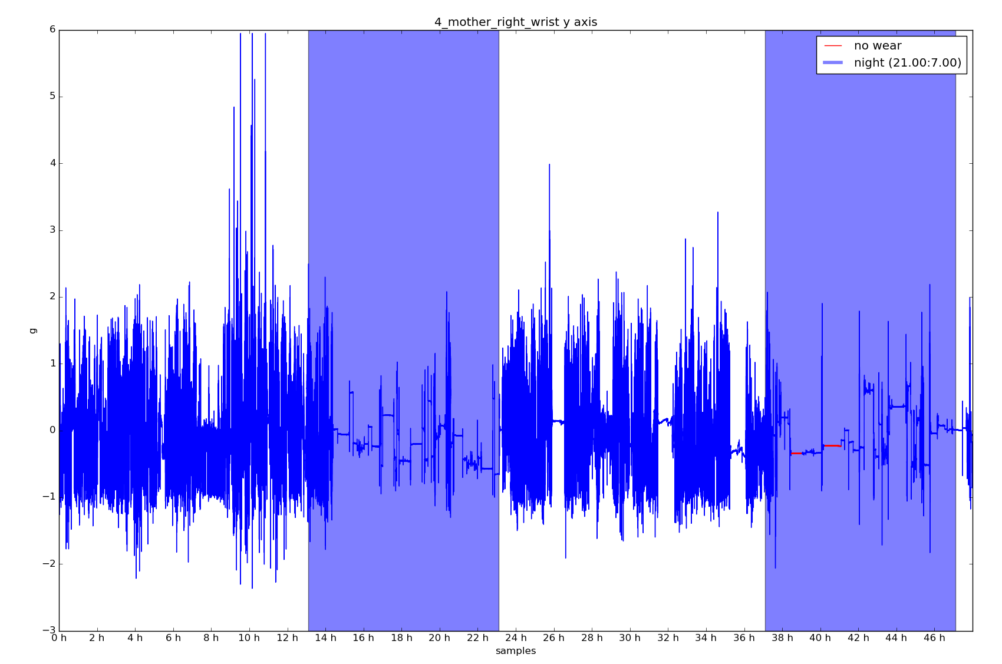

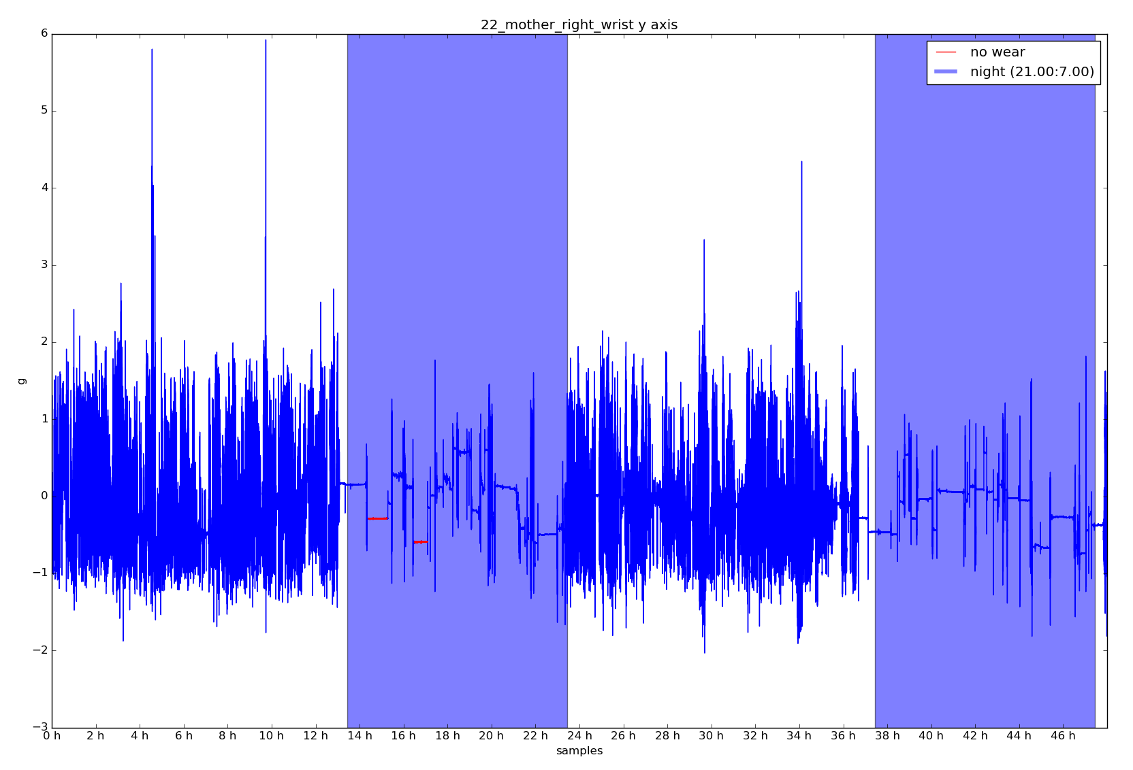

Since infants torso and ankle are the main measurements for this project, the no-wear blocks from infant torso and ankle were removed from all three measurements, but mothers was set to nan to note correlation is not possible there.
Here are the plots where all three measurements have all three axis plotted together and no-wear time from infant torso and ankle are noted in all three:
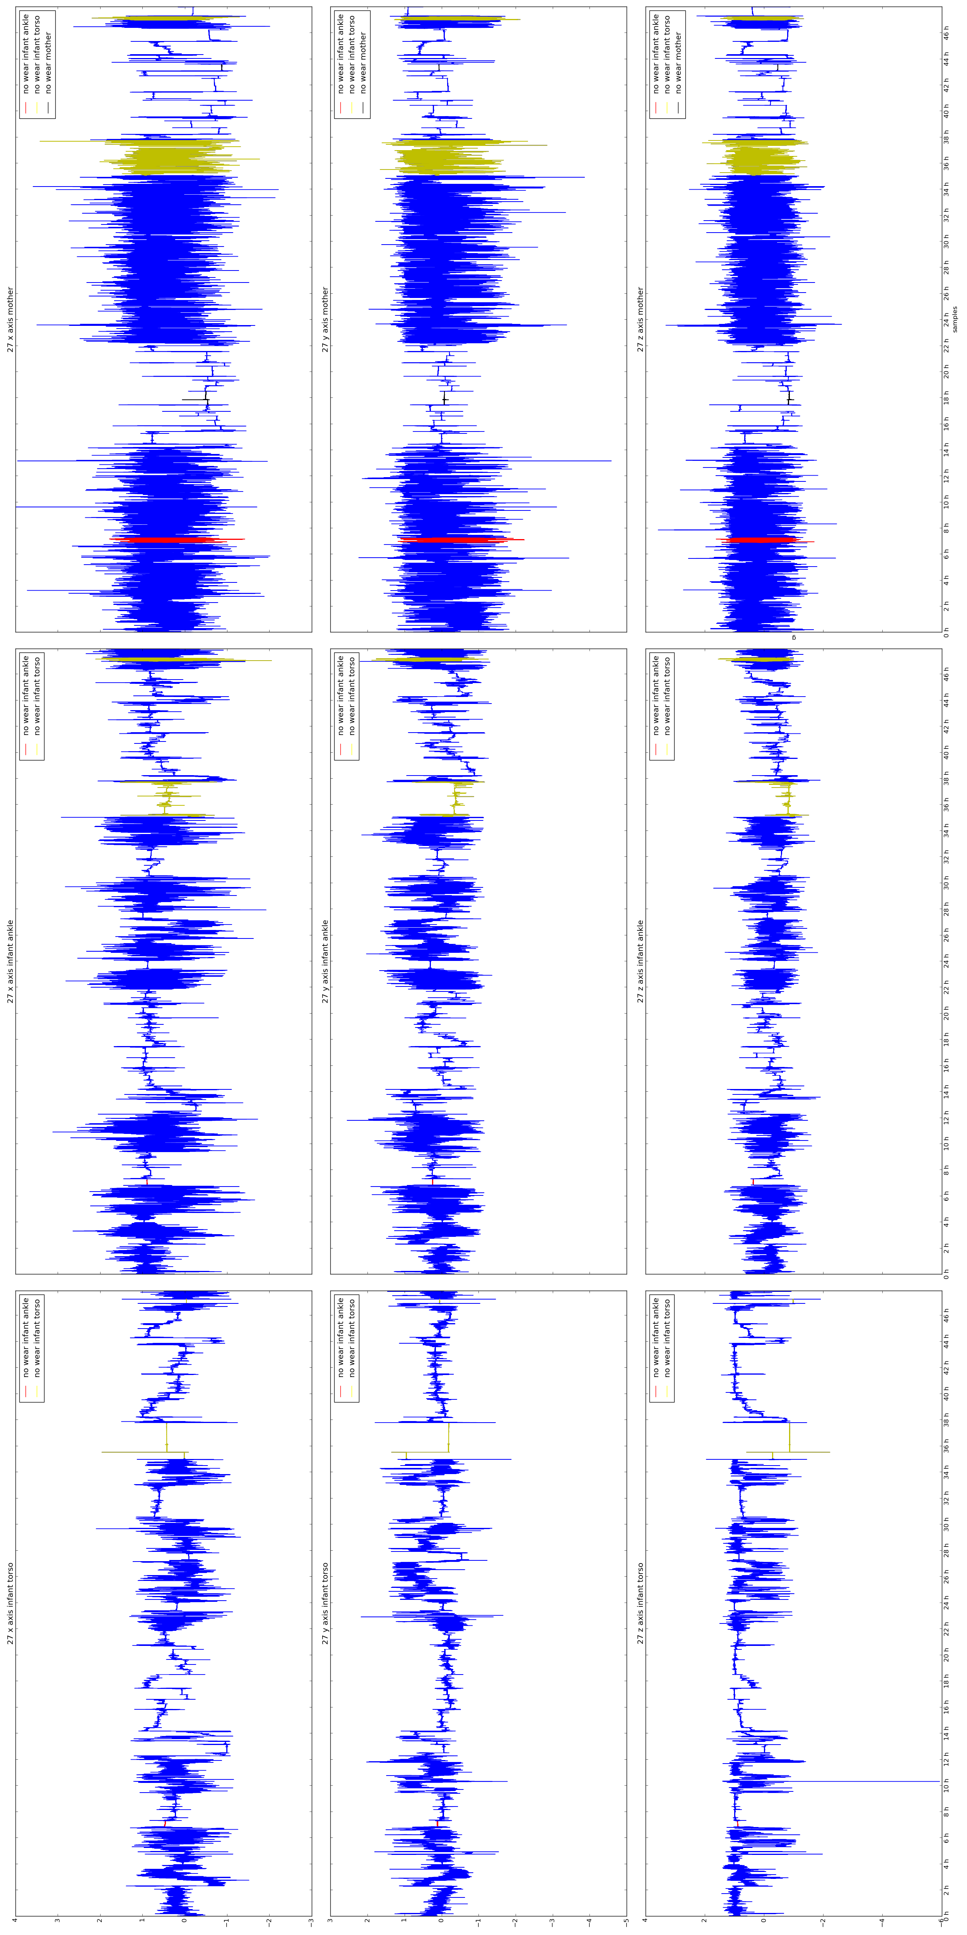

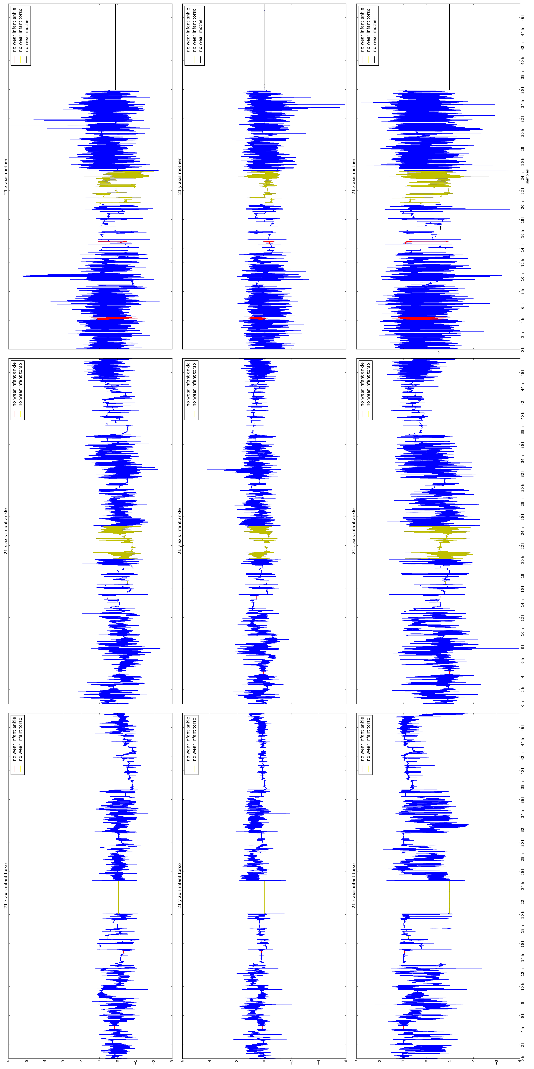
The summary output of no-wear time removal is in the end of document.

CORRECTION OF INFANT BEING MOVED

To properly extract infants PA, the amplitudes caused by infant being moved rather then moving himself need to be removed, corrected. Since the two monitors can freely rotate, the three axis are not always aligned the same, so I tested all 6 combinations with each test and took the best. Although simple, local(5 minutes windows) correlation between infant torso and ankle already gives good results, there is the issue, that there are roughly different cases:
-infant is still and being moved slowly(holding infant, placing him, carrying infant and walking slowly….)
-infant is still and being moved a lot(carrying infant and walking fast, rocking infant, shaking infant(hopefully not)….)
-infant moves himself and being moved slowly
-infant moves himself and being moved a lot

the last two cases, especially the last one can result in poor correlations, although there is visible baseline drifts or shifts that are exact same in both measurements. I could try with different correlation tests, but for now I tried to extract baselines with different degrees of fitness and correlate those, and when correlation is significant, such baseline can simply be subtracted each from its own measurement.
This way different degrees of signal similarity can be tested, from fitting close(infant not moving, but being moved a lot) or loosely(infant moving himself and being moved) . I am still in the processes of finishing this up, so I am not sure how much of blocks where the infant moves a lot himself while being moved a lot by somebody else will go undetected like this.

Some examples of correlation, without examining the baseline:
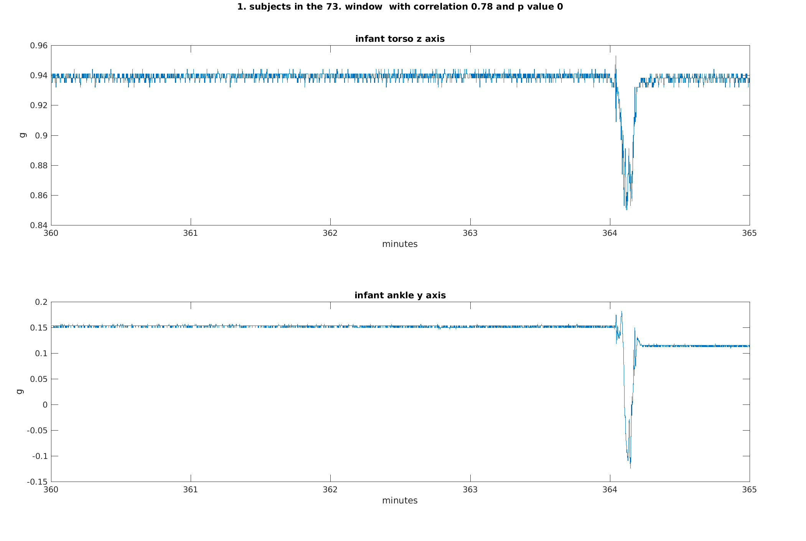

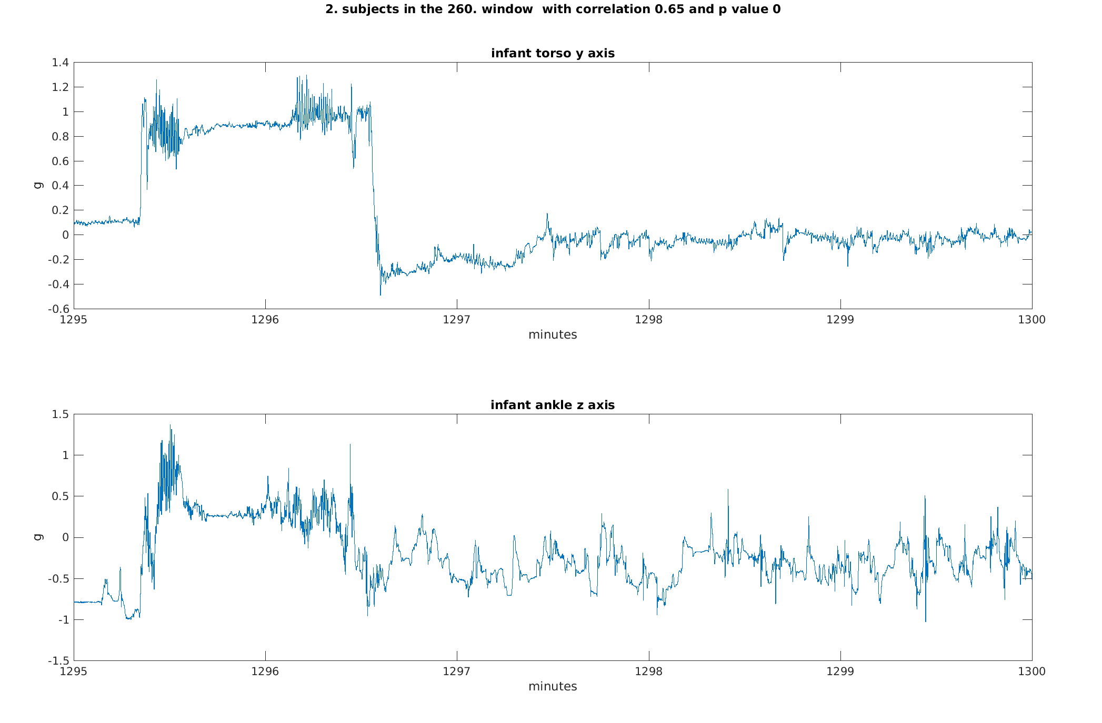

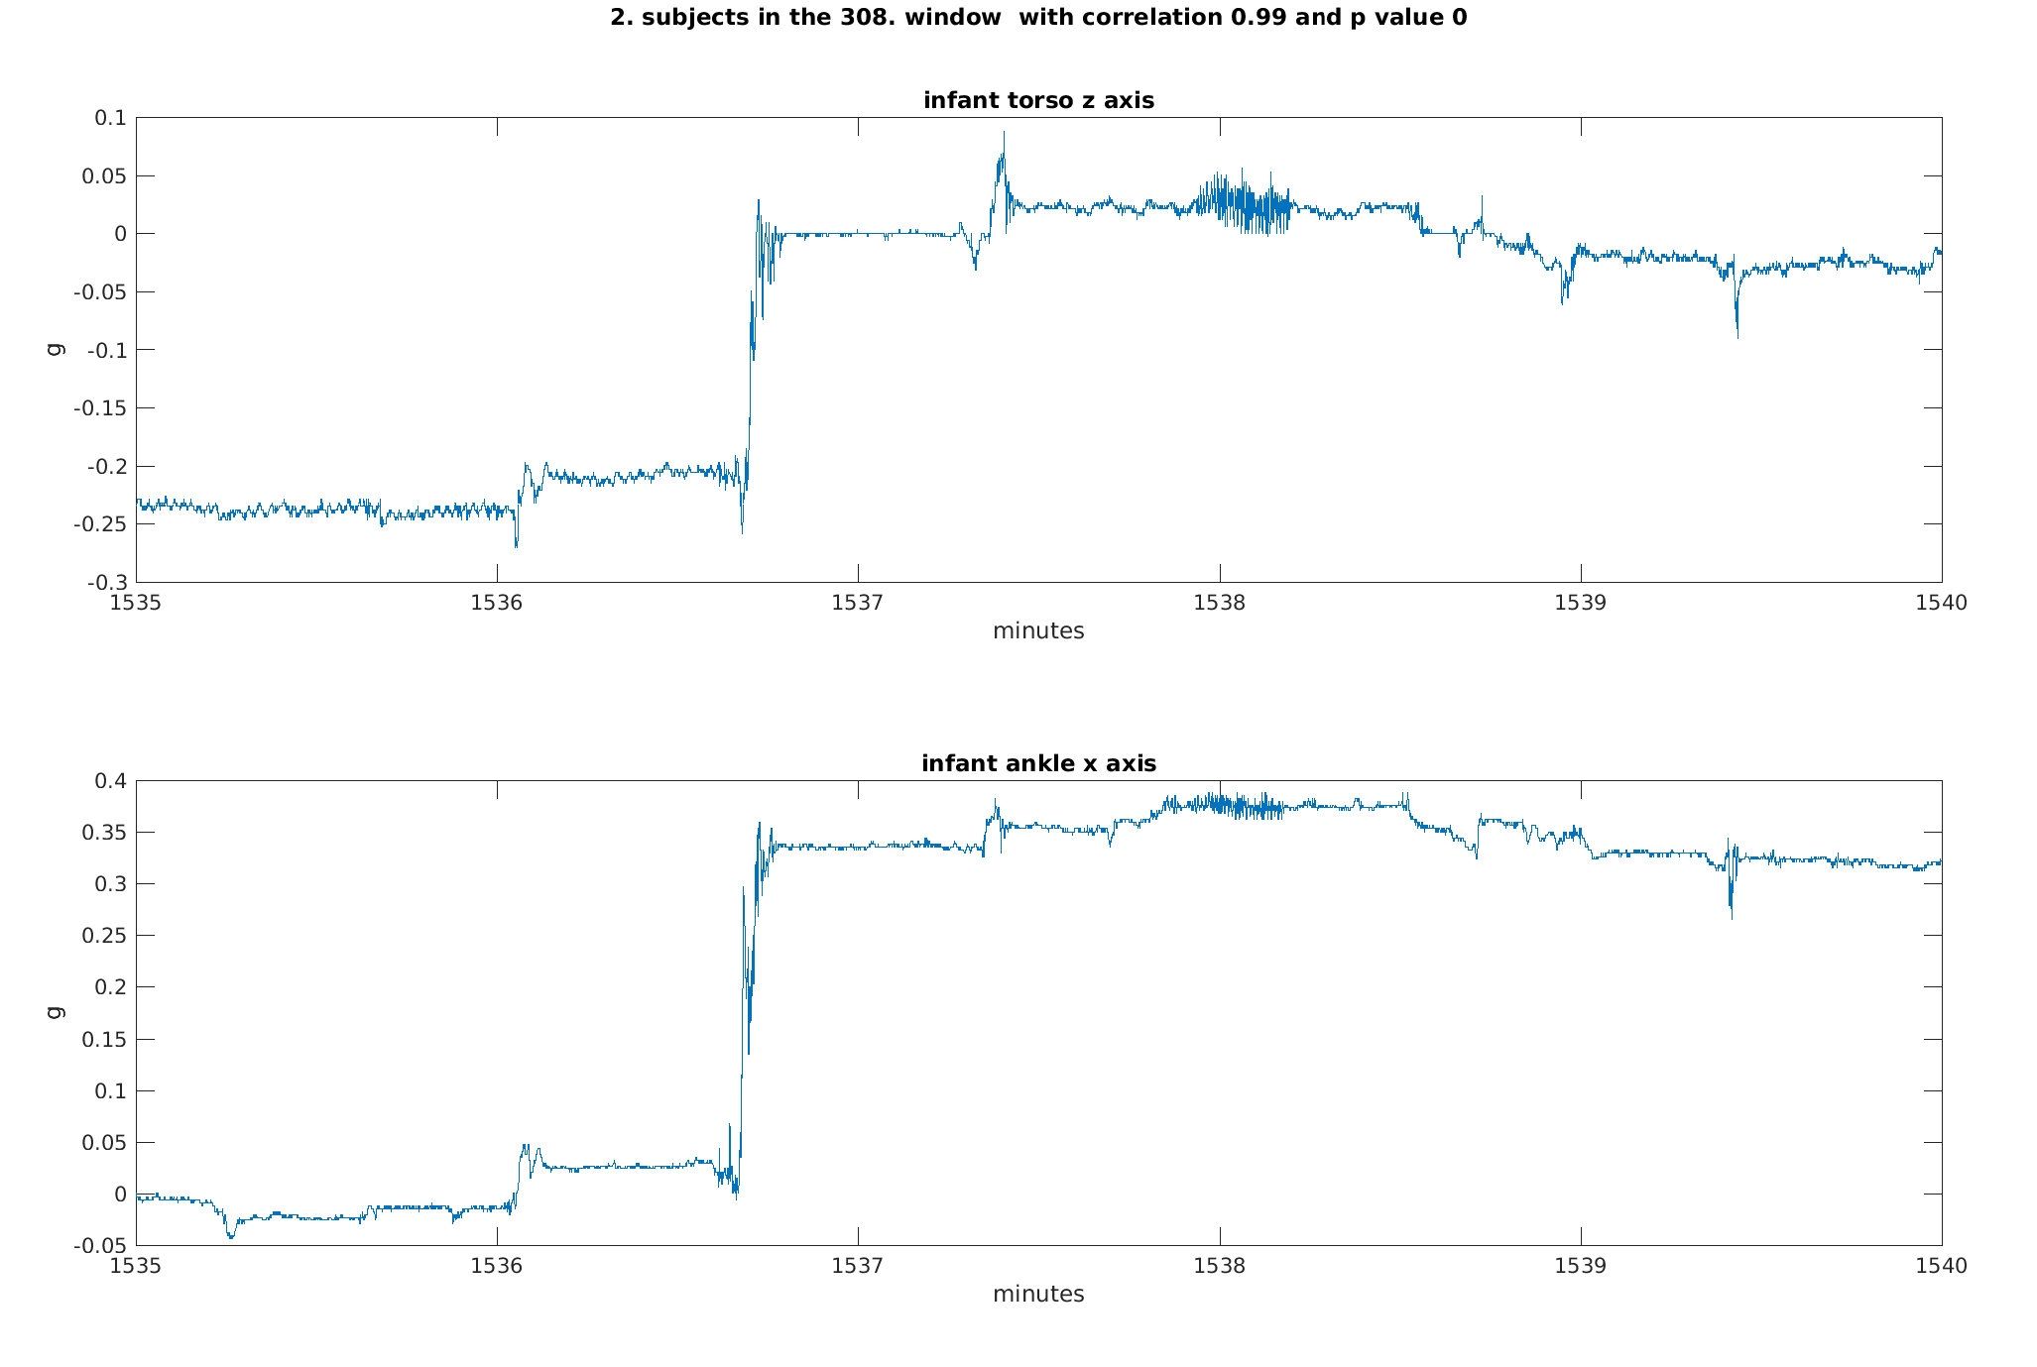

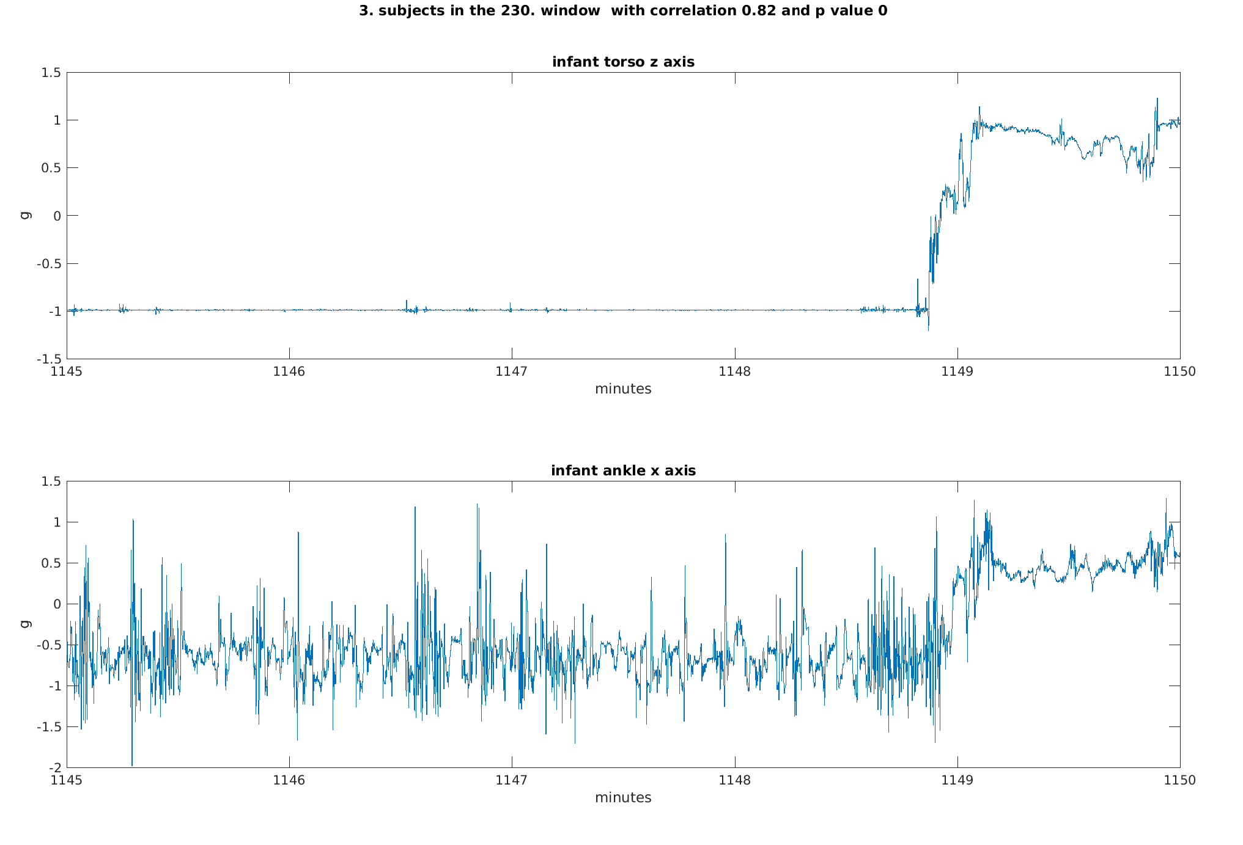

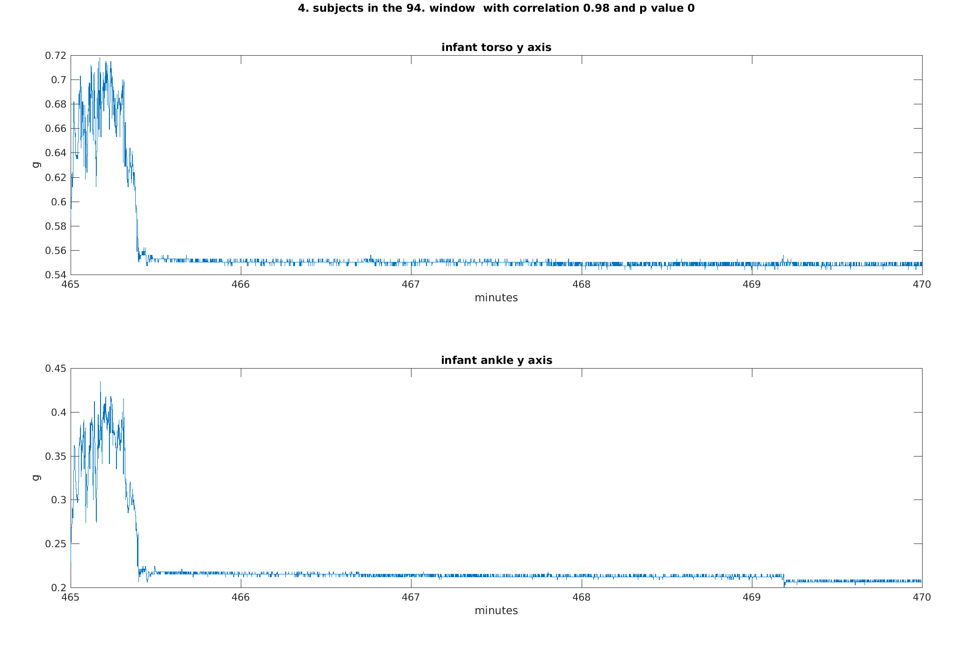

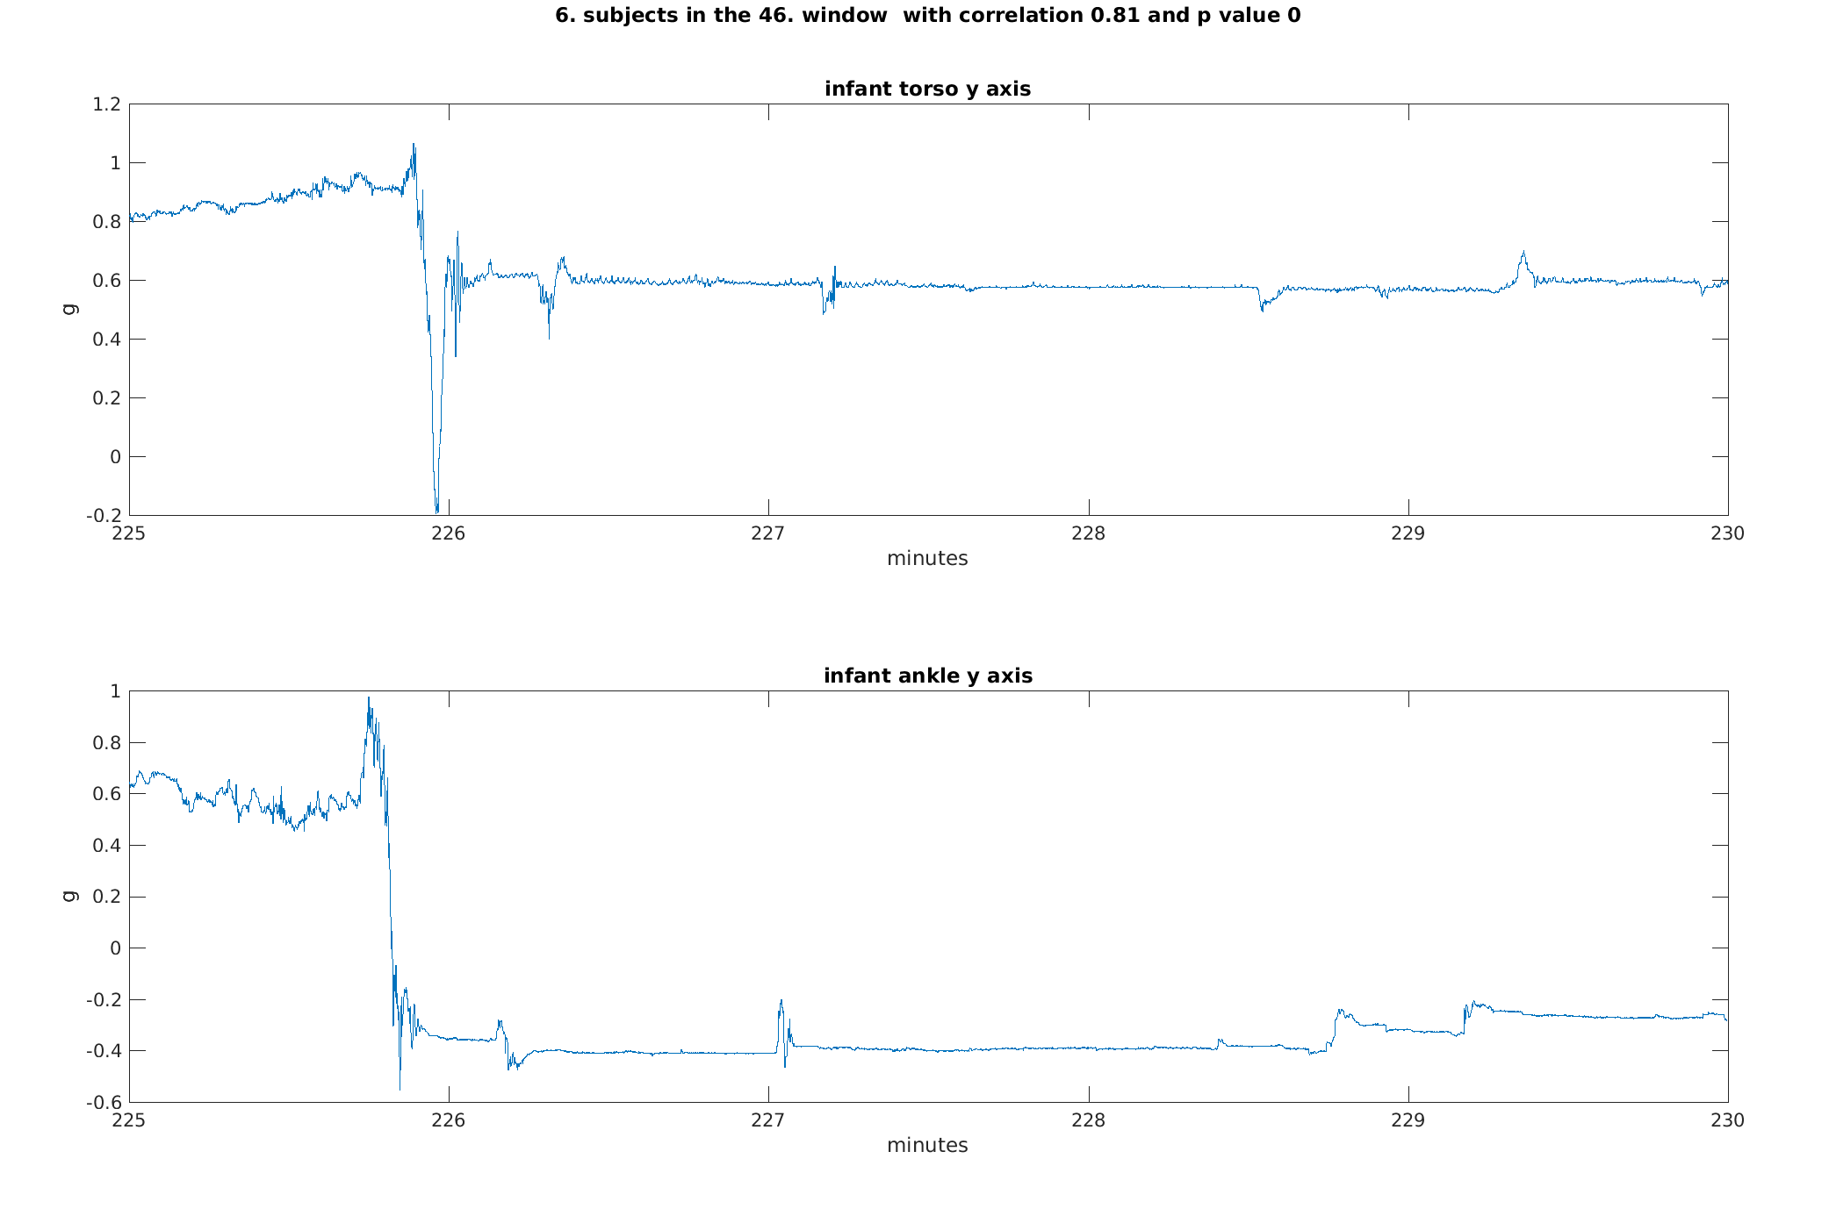

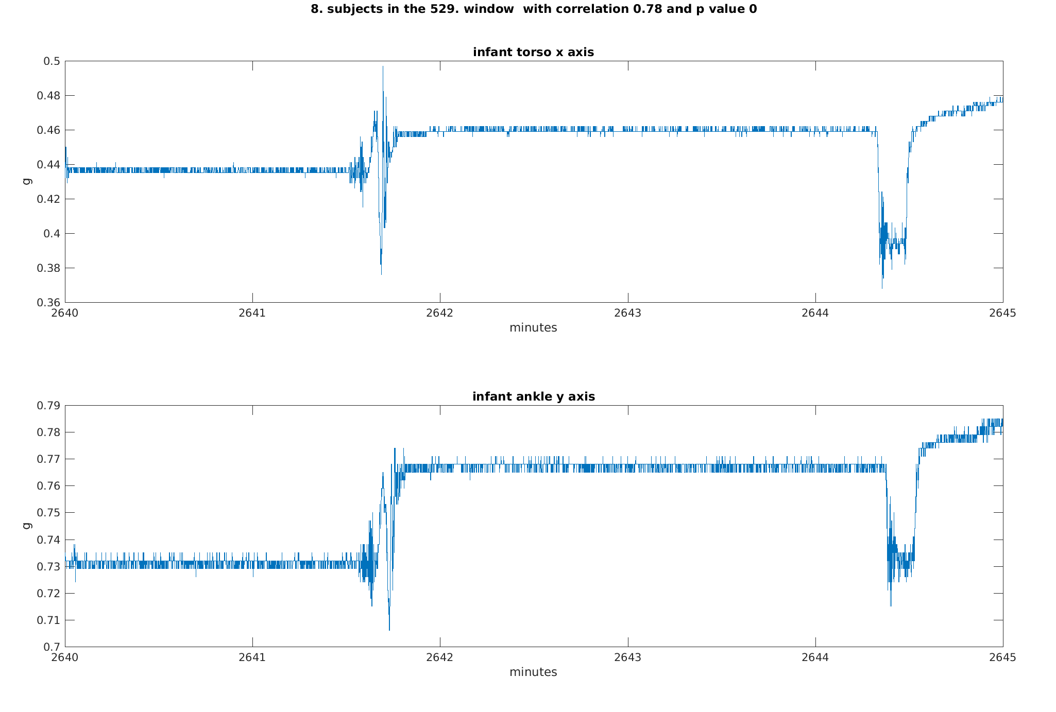

Examples with examining the baseline:

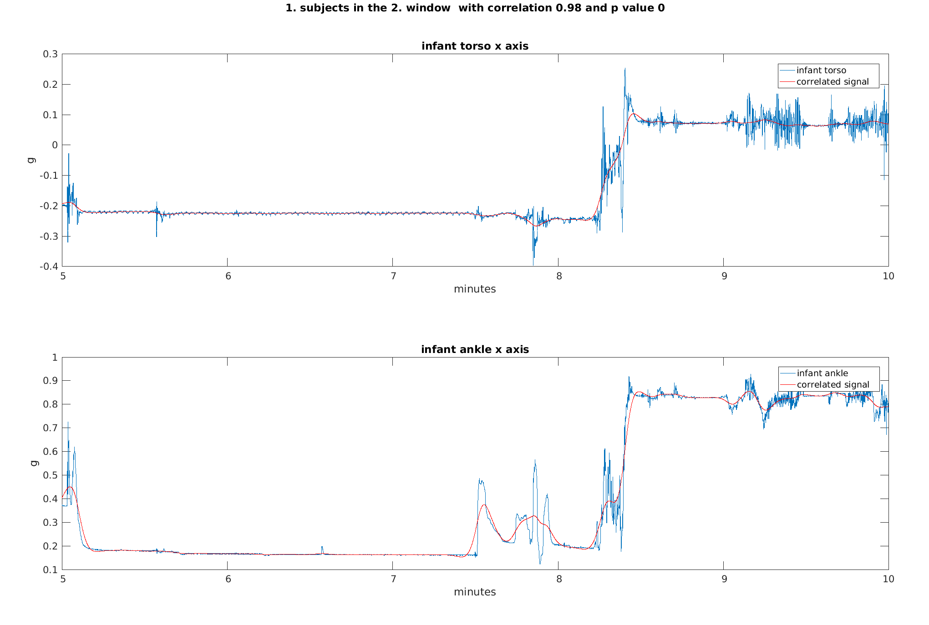

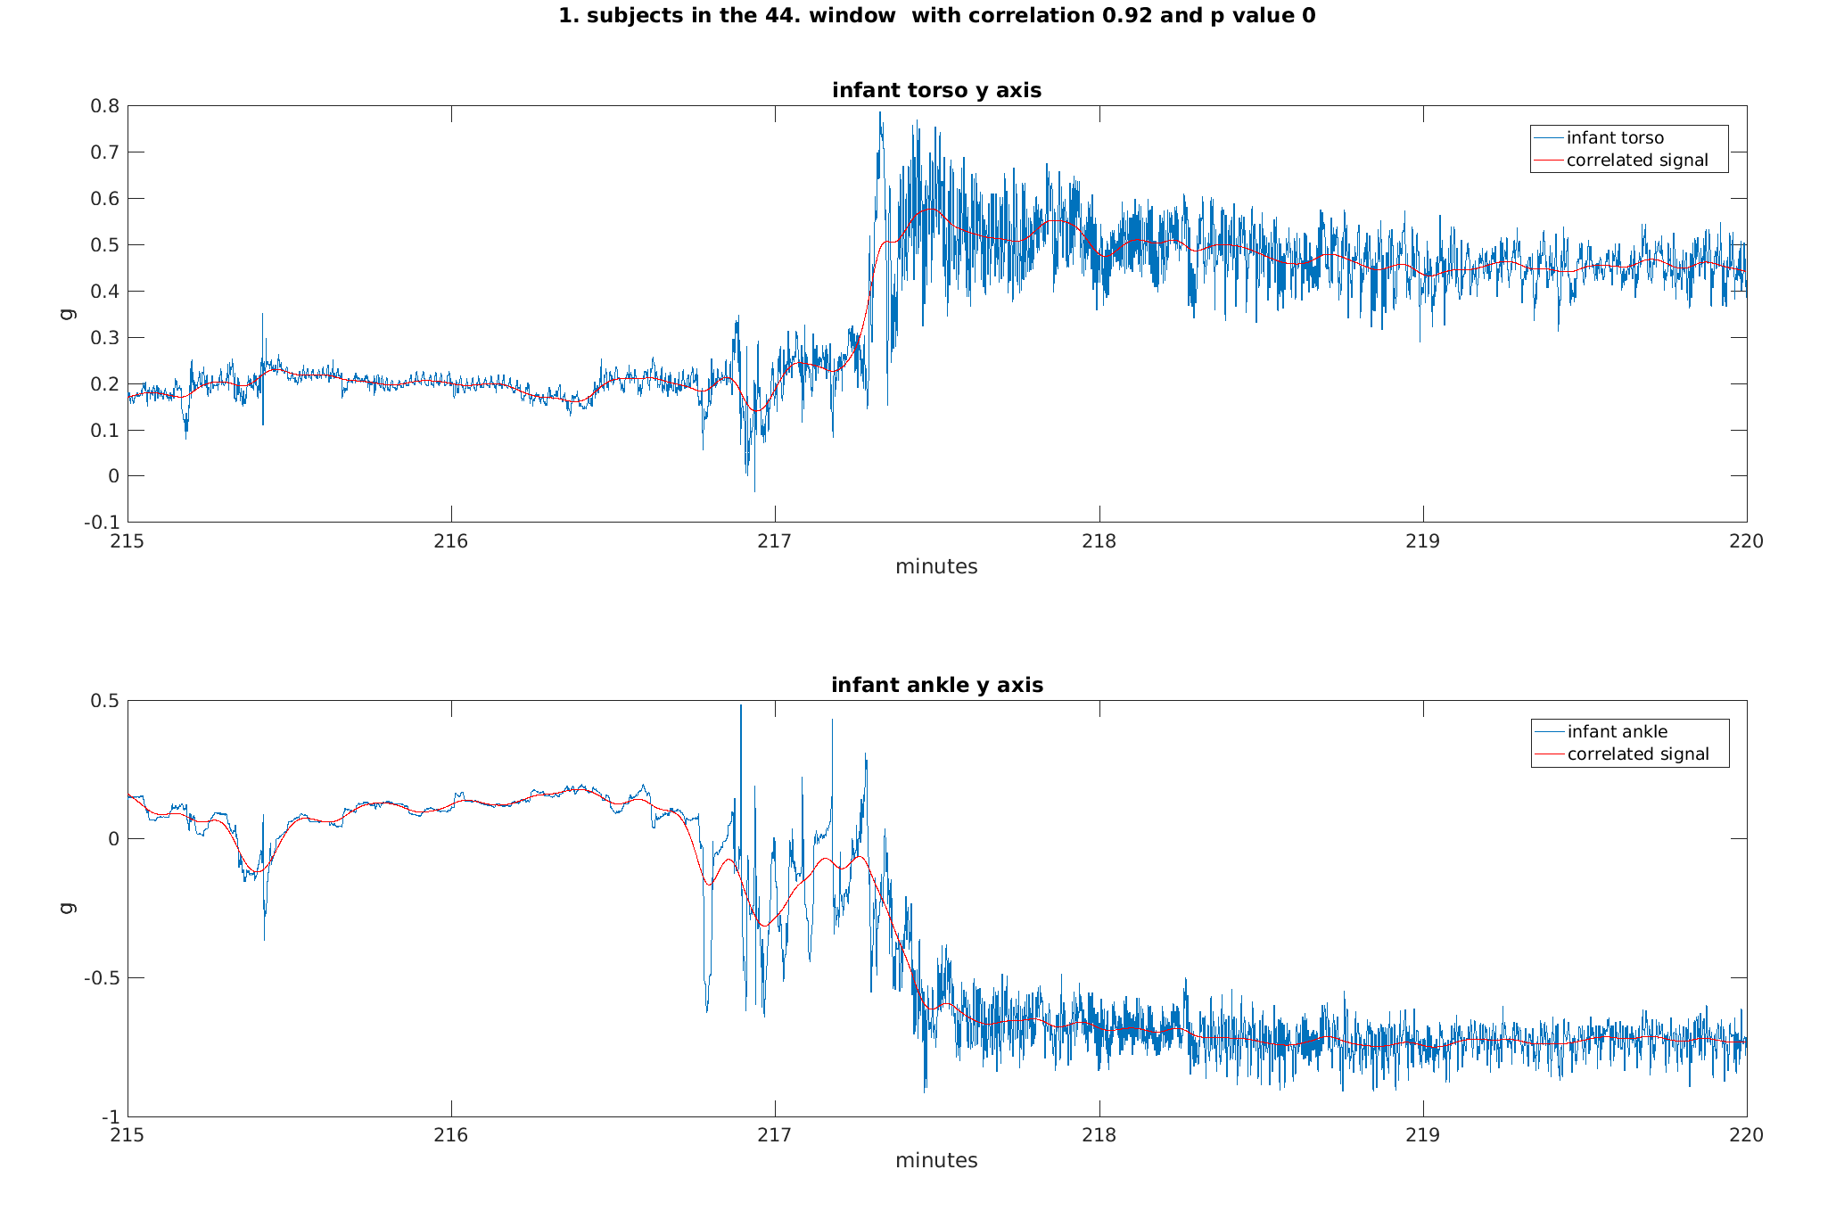

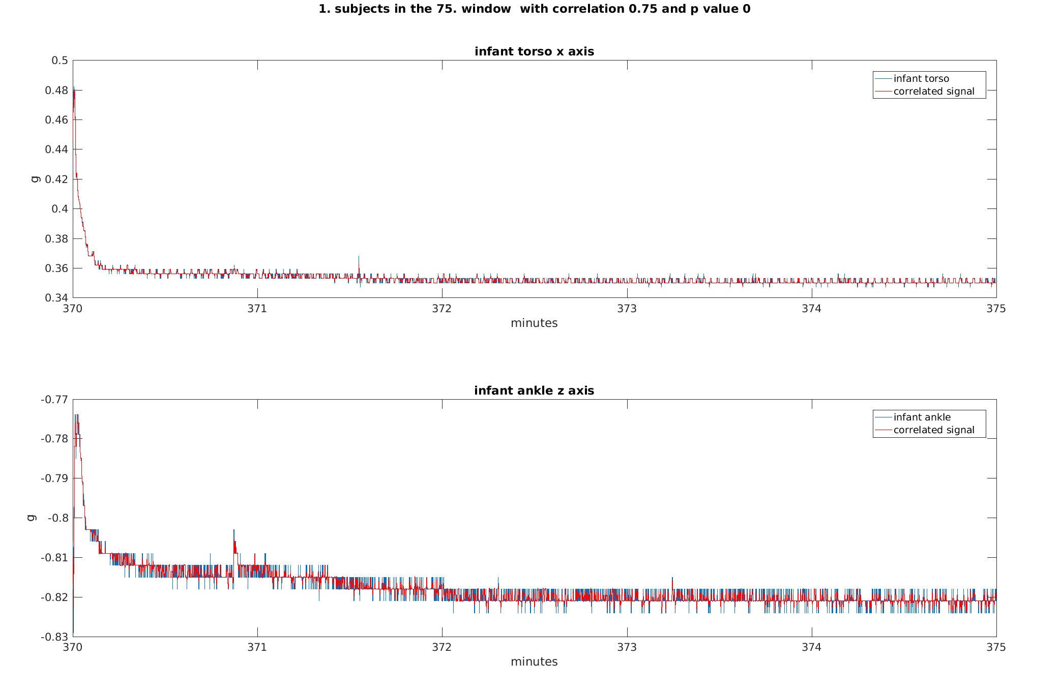

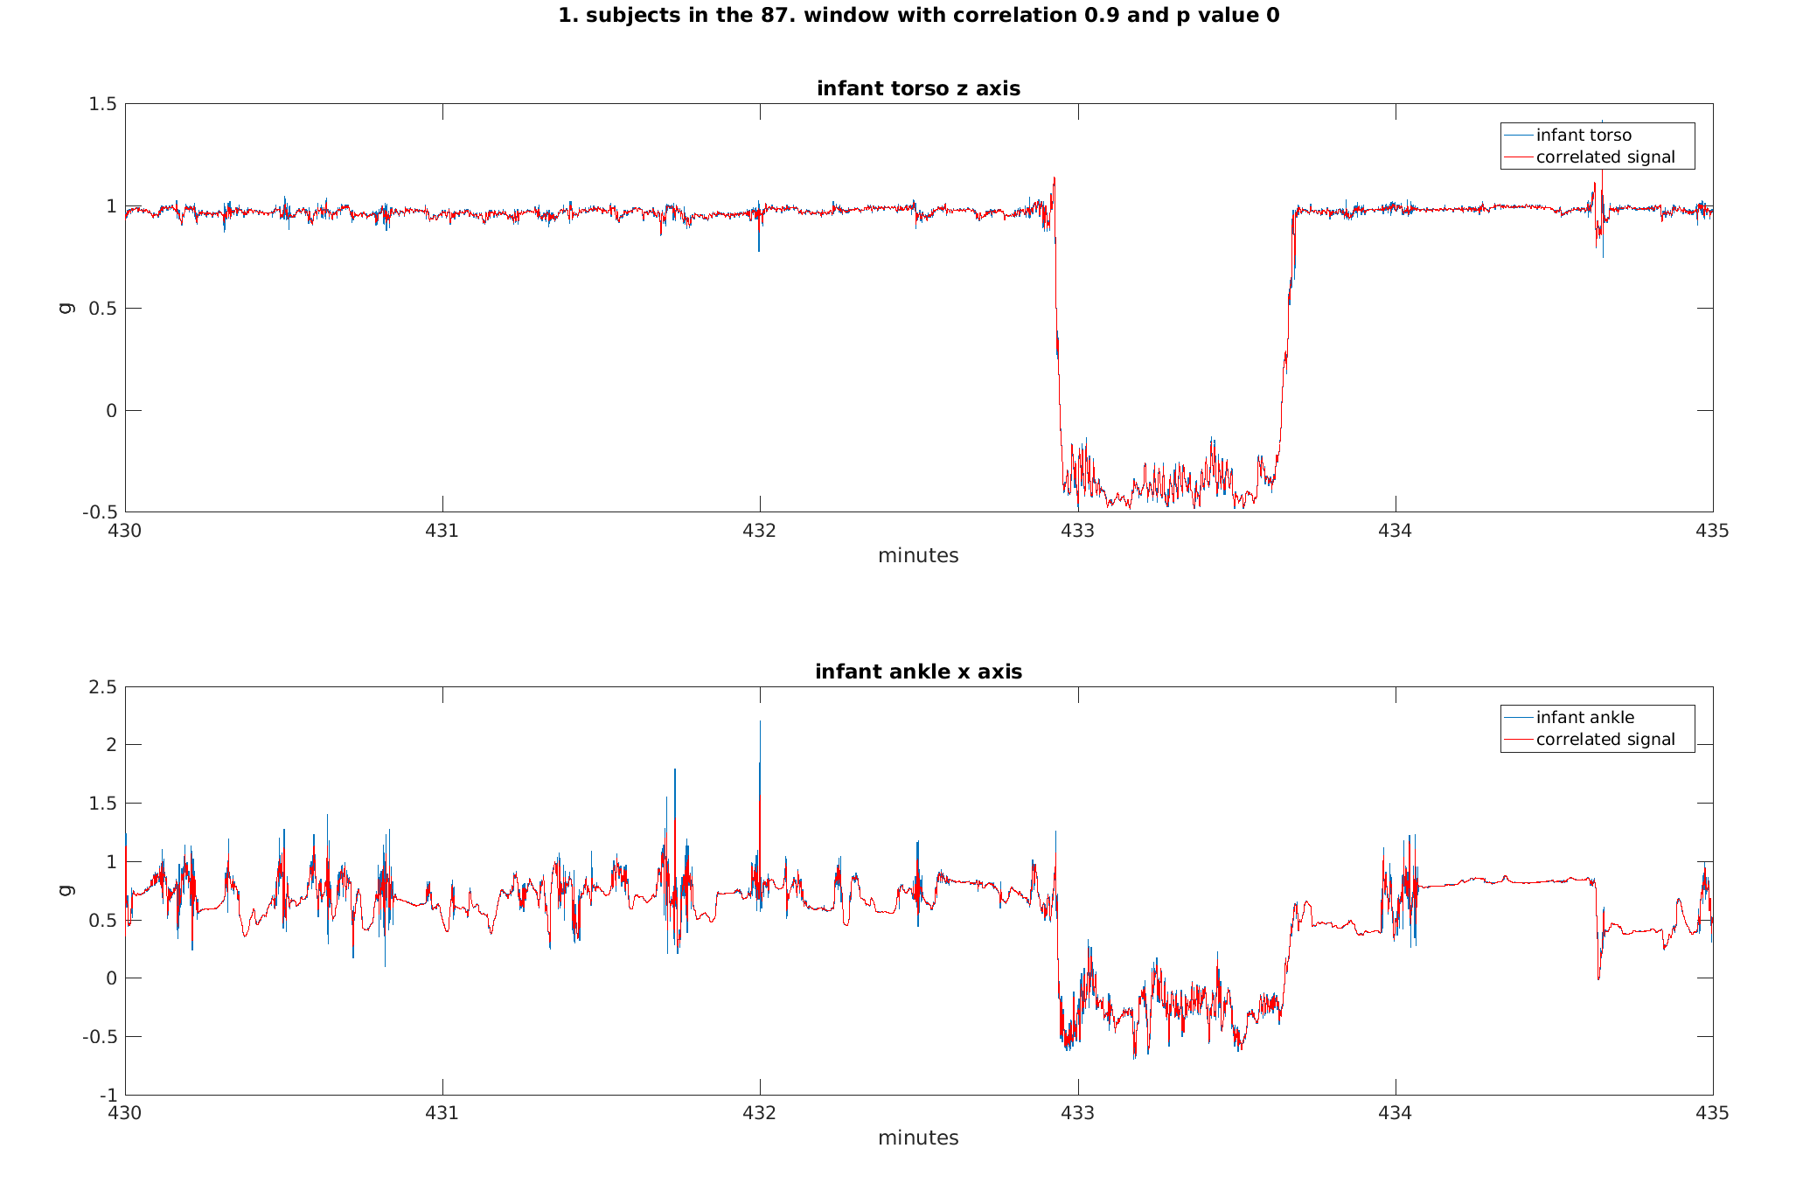

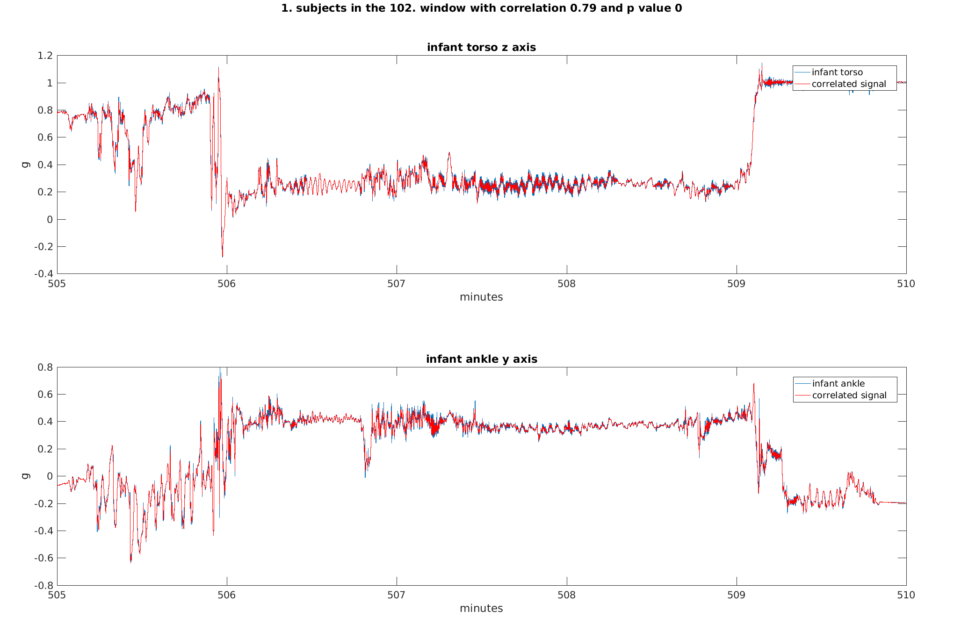

At the moment I am implementing a way to check for a a correlation in the baseline at different degrees and then doing a further closer examination and possible check for neighbor blocks as with no-wear. I am not sure yet which degrees should I include and how to choose the best, sometimes I notice that the baseline is too loose and sometimes I feel like it is too fit in a sense that the signals are not so closely similar, so further windowing for the blocks that are correlated might help. Another problem might be that the monitors rotate in the 5 minute block, so negative significant correlation should also be considered, example above( r is stated absolute), but when allowing negative correlations, sometimes the axis are not aligned the best way. For now it seems that with baseline extraction, the baselines end up being more or less the same anyway, but one simple solution would be to take summary output of all three variables, like in one of your papers (Separating movement and gravity…) and then I wouldn't have to check all 6 possible alignments. But I would have to check and compare the correlation results as I don't really have a proper way to validate if the infant was really moved or not. I am not sure how well this could work, but I could try and check correspondence of blocks detected as infant being moved with infant torso TA changes, since infant doesn't have posture. So this is still something I need to finish and check. In the end I plan to check the correlation with the mothers wrist for the blocks that are detected as correlated. Also I was already checking what random correlation the signals produce, for the inner one, so if I just randomize points within the window, the correlation is not significant, but when I check for outer one, so if I take random windows from one signal and correlate with the current, I get a lot of significant correlations, from 0 to 70 % out of a 100 random windows. I will check auto cross correlation for each measurement, maybe some movement is just really so frequent...
I also tried simple fft, and correlate the power spectrum, but the results weren't so good, since it summarizes the window too much, so I would need to take really small windows and it might still not be ok, since the outer random correlation was ridiculously high, which makes me think there are too many false positives, where on the other hand, due to not perfect axis alignment between the monitors, the real correlations go missed. If I implement the summary over three axis, I will try with that, maybe it could be better.
I haven't done anything yet with wavelet transform.
For now I will definitely spend a few days more to tune the parameters for the baseline extraction and correlation and if that goes well I will then extract the PA, probably based on windowed std, and then depending on your needs extract different levels, for example short/long/light/intense activity…

SCRIPT SUMMARY OUTPUTS:

NO-WEAR TIME:

subjects 1
0.7% of INFANT TORSO data points were removed as a consequence of either infant torso or ankle no wear time blocks
0.7% of INFANT ANKLE data points were removed as a consequence of either infant torso or ankle no wear time blocks
0.7% of MOTHER data points were removed as a consequence of either infant torso or ankle no wear time blocks
subjects 2
31.7% of INFANT TORSO data points were removed as a consequence of either infant torso or ankle no wear time blocks
31.6% of INFANT ANKLE data points were removed as a consequence of either infant torso or ankle no wear time blocks
31.6% of MOTHER data points were removed as a consequence of either infant torso or ankle no wear time blocks
subjects 3
0.7% of INFANT TORSO data points were removed as a consequence of either infant torso or ankle no wear time blocks
0.7% of INFANT ANKLE data points were removed as a consequence of either infant torso or ankle no wear time blocks
0.7% of MOTHER data points were removed as a consequence of either infant torso or ankle no wear time blocks
subjects 4
4.3% of INFANT TORSO data points were removed as a consequence of either infant torso or ankle no wear time blocks
4.3% of INFANT ANKLE data points were removed as a consequence of either infant torso or ankle no wear time blocks
4.3% of MOTHER data points were removed as a consequence of either infant torso or ankle no wear time blocks
subjects 5
0.0% of INFANT TORSO data points were removed as a consequence of either infant torso or ankle no wear time blocks
0.0% of INFANT ANKLE data points were removed as a consequence of either infant torso or ankle no wear time blocks
0.0% of MOTHER data points were removed as a consequence of either infant torso or ankle no wear time blocks
subjects 6
0.5% of INFANT TORSO data points were removed as a consequence of either infant torso or ankle no wear time blocks
0.5% of INFANT ANKLE data points were removed as a consequence of either infant torso or ankle no wear time blocks
0.5% of MOTHER data points were removed as a consequence of either infant torso or ankle no wear time blocks
subjects 7
4.0% of INFANT TORSO data points were removed as a consequence of either infant torso or ankle no wear time blocks
4.0% of INFANT ANKLE data points were removed as a consequence of either infant torso or ankle no wear time blocks
4.0% of MOTHER data points were removed as a consequence of either infant torso or ankle no wear time blocks
subjects 8
1.8% of INFANT TORSO data points were removed as a consequence of either infant torso or ankle no wear time blocks
1.7% of INFANT ANKLE data points were removed as a consequence of either infant torso or ankle no wear time blocks
1.7% of MOTHER data points were removed as a consequence of either infant torso or ankle no wear time blocks
subjects 9
13.0% of INFANT TORSO data points were removed as a consequence of either infant torso or ankle no wear time blocks
13.0% of INFANT ANKLE data points were removed as a consequence of either infant torso or ankle no wear time blocks
13.0% of MOTHER data points were removed as a consequence of either infant torso or ankle no wear time blocks
subjects 10
3.3% of INFANT TORSO data points were removed as a consequence of either infant torso or ankle no wear time blocks
3.3% of INFANT ANKLE data points were removed as a consequence of either infant torso or ankle no wear time blocks
3.3% of MOTHER data points were removed as a consequence of either infant torso or ankle no wear time blocks
subjects 11
2.9% of INFANT TORSO data points were removed as a consequence of either infant torso or ankle no wear time blocks
3.0% of INFANT ANKLE data points were removed as a consequence of either infant torso or ankle no wear time blocks
3.1% of MOTHER data points were removed as a consequence of either infant torso or ankle no wear time blocks
subjects 12
0.7% of INFANT TORSO data points were removed as a consequence of either infant torso or ankle no wear time blocks
0.7% of INFANT ANKLE data points were removed as a consequence of either infant torso or ankle no wear time blocks
0.7% of MOTHER data points were removed as a consequence of either infant torso or ankle no wear time blocks
subjects 13
2.3% of INFANT TORSO data points were removed as a consequence of either infant torso or ankle no wear time blocks
2.3% of INFANT ANKLE data points were removed as a consequence of either infant torso or ankle no wear time blocks
2.3% of MOTHER data points were removed as a consequence of either infant torso or ankle no wear time blocks
subjects 14
6.8% of INFANT TORSO data points were removed as a consequence of either infant torso or ankle no wear time blocks
6.8% of INFANT ANKLE data points were removed as a consequence of either infant torso or ankle no wear time blocks
6.8% of MOTHER data points were removed as a consequence of either infant torso or ankle no wear time blocks
subjects 15
2.8% of INFANT TORSO data points were removed as a consequence of either infant torso or ankle no wear time blocks
2.8% of INFANT ANKLE data points were removed as a consequence of either infant torso or ankle no wear time blocks
3.0% of MOTHER data points were removed as a consequence of either infant torso or ankle no wear time blocks
subjects 16
2.1% of INFANT TORSO data points were removed as a consequence of either infant torso or ankle no wear time blocks
2.1% of INFANT ANKLE data points were removed as a consequence of either infant torso or ankle no wear time blocks
2.1% of MOTHER data points were removed as a consequence of either infant torso or ankle no wear time blocks
subjects 17
7.1% of INFANT TORSO data points were removed as a consequence of either infant torso or ankle no wear time blocks
7.1% of INFANT ANKLE data points were removed as a consequence of either infant torso or ankle no wear time blocks
7.1% of MOTHER data points were removed as a consequence of either infant torso or ankle no wear time blocks
subjects 18
7.1% of INFANT TORSO data points were removed as a consequence of either infant torso or ankle no wear time blocks
7.1% of INFANT ANKLE data points were removed as a consequence of either infant torso or ankle no wear time blocks
7.1% of MOTHER data points were removed as a consequence of either infant torso or ankle no wear time blocks
subjects 19
0.7% of INFANT TORSO data points were removed as a consequence of either infant torso or ankle no wear time blocks
0.7% of INFANT ANKLE data points were removed as a consequence of either infant torso or ankle no wear time blocks
0.7% of MOTHER data points were removed as a consequence of either infant torso or ankle no wear time blocks
subjects 20
1.6% of INFANT TORSO data points were removed as a consequence of either infant torso or ankle no wear time blocks
1.6% of INFANT ANKLE data points were removed as a consequence of either infant torso or ankle no wear time blocks
1.6% of MOTHER data points were removed as a consequence of either infant torso or ankle no wear time blocks
subjects 21
11.3% of INFANT TORSO data points were removed as a consequence of either infant torso or ankle no wear time blocks
11.3% of INFANT ANKLE data points were removed as a consequence of either infant torso or ankle no wear time blocks
11.3% of MOTHER data points were removed as a consequence of either infant torso or ankle no wear time blocks
subjects 22
8.5% of INFANT TORSO data points were removed as a consequence of either infant torso or ankle no wear time blocks
8.7% of INFANT ANKLE data points were removed as a consequence of either infant torso or ankle no wear time blocks
8.4% of MOTHER data points were removed as a consequence of either infant torso or ankle no wear time blocks
subjects 23
0.7% of INFANT TORSO data points were removed as a consequence of either infant torso or ankle no wear time blocks
0.7% of INFANT ANKLE data points were removed as a consequence of either infant torso or ankle no wear time blocks
0.7% of MOTHER data points were removed as a consequence of either infant torso or ankle no wear time blocks
subjects 24
7.4% of INFANT TORSO data points were removed as a consequence of either infant torso or ankle no wear time blocks
7.5% of INFANT ANKLE data points were removed as a consequence of either infant torso or ankle no wear time blocks
7.6% of MOTHER data points were removed as a consequence of either infant torso or ankle no wear time blocks
subjects 25
24.5% of INFANT TORSO data points were removed as a consequence of either infant torso or ankle no wear time blocks
24.5% of INFANT ANKLE data points were removed as a consequence of either infant torso or ankle no wear time blocks
24.5% of MOTHER data points were removed as a consequence of either infant torso or ankle no wear time blocks
subjects 26
5.6% of INFANT TORSO data points were removed as a consequence of either infant torso or ankle no wear time blocks
5.6% of INFANT ANKLE data points were removed as a consequence of either infant torso or ankle no wear time blocks
5.6% of MOTHER data points were removed as a consequence of either infant torso or ankle no wear time blocks
subjects 27
6.8% of INFANT TORSO data points were removed as a consequence of either infant torso or ankle no wear time blocks
6.8% of INFANT ANKLE data points were removed as a consequence of either infant torso or ankle no wear time blocks
6.8% of MOTHER data points were removed as a consequence of either infant torso or ankle no wear time blocks
subjects 28
1.0% of INFANT TORSO data points were removed as a consequence of either infant torso or ankle no wear time blocks
1.0% of INFANT ANKLE data points were removed as a consequence of either infant torso or ankle no wear time blocks
1.0% of MOTHER data points were removed as a consequence of either infant torso or ankle no wear time blocks

