New results, by excluding the extremes of the variables. Numbers for when not excluding extremes are in previous documents.

For each variable, the extremes are removed:
-by making a transformed variable, by log transforming and standardizing
-then in the original variable, set NA to those values that are below -4 and above 4 in the transformed variable
-for the continuous and % of TEI, log transform and standardize bmi and nutrient variables
-for the categorized only log transform bmi to ensure normality and leave the scores as they are

This kind of exclusion has been criticized, Yan send a paper on this, where there is a different proposed way, I can try with that kind of exclusion as well.

Beta coefficients are calculated as before and for several different models.
Mainly we are planning to work with variables expressed in % of total energy intake (except for fiber and salt) and categorized based on guidelines, but nevertheless, I had put together details of several associations, just to get a clearer picture.
I checked the association with bmi, using:

- raw continuous variables(log transformed and standardized), fitted together or separately,

- continuous variables expressed in % of total energy intake, fitted together or separately,

- variables categorized based on guidelines, also fitted together or separately (most of variables have to be expressed in % of TEI to be able to apply recommendations, except for fiber and salt).

Regarding the variables that have only two categories, we discussed with Alaitz and decided it is best and used in other papers, that we set the highest score, so just 1 and 2.

Same as before, I have marked some numbers/variables:

non-significant
wrong direction of association
direction of association different in other data or model

Plots for bmi after extremes are removed, taking several different SD cutpoints:

original bmi, not log transformed and standardized, without any extremes excluded

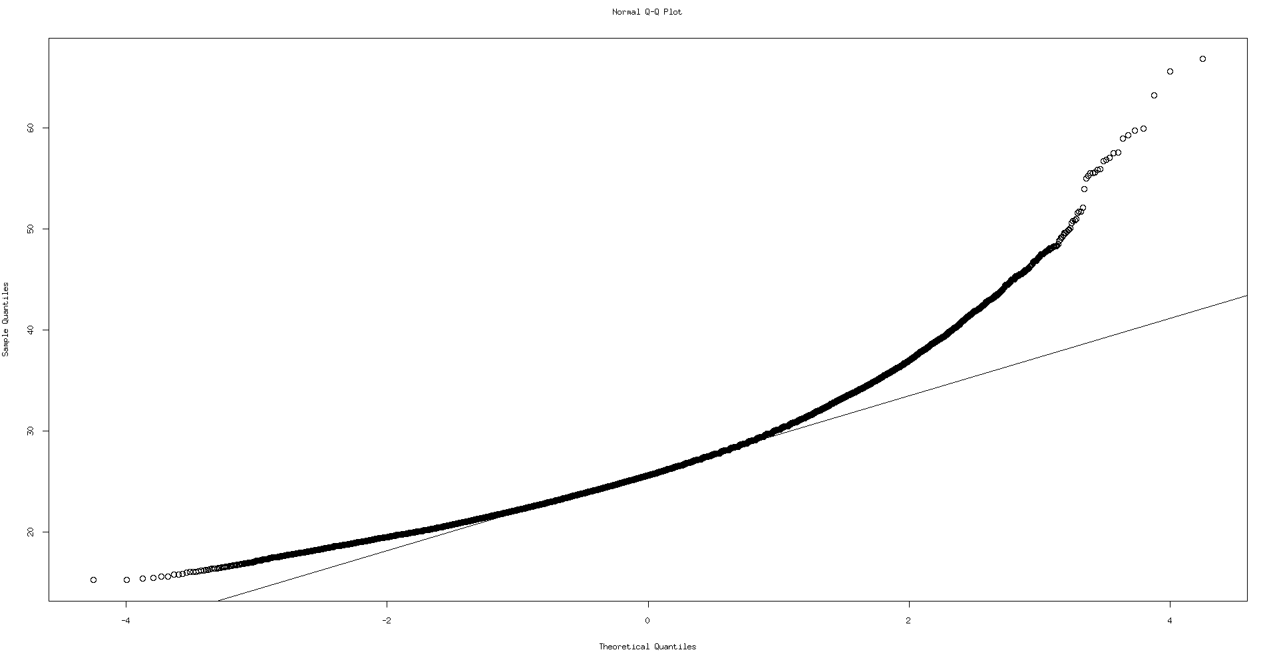
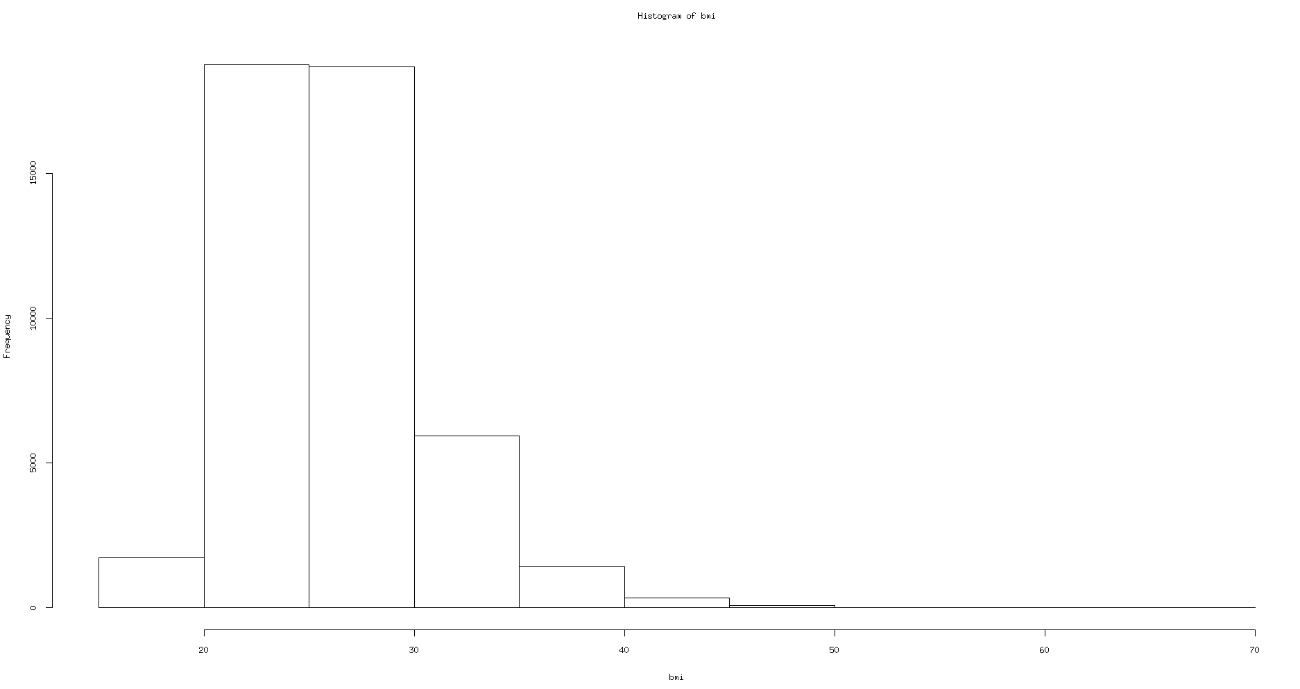

log transformed and standardized bmi, without any exclusion of extremes
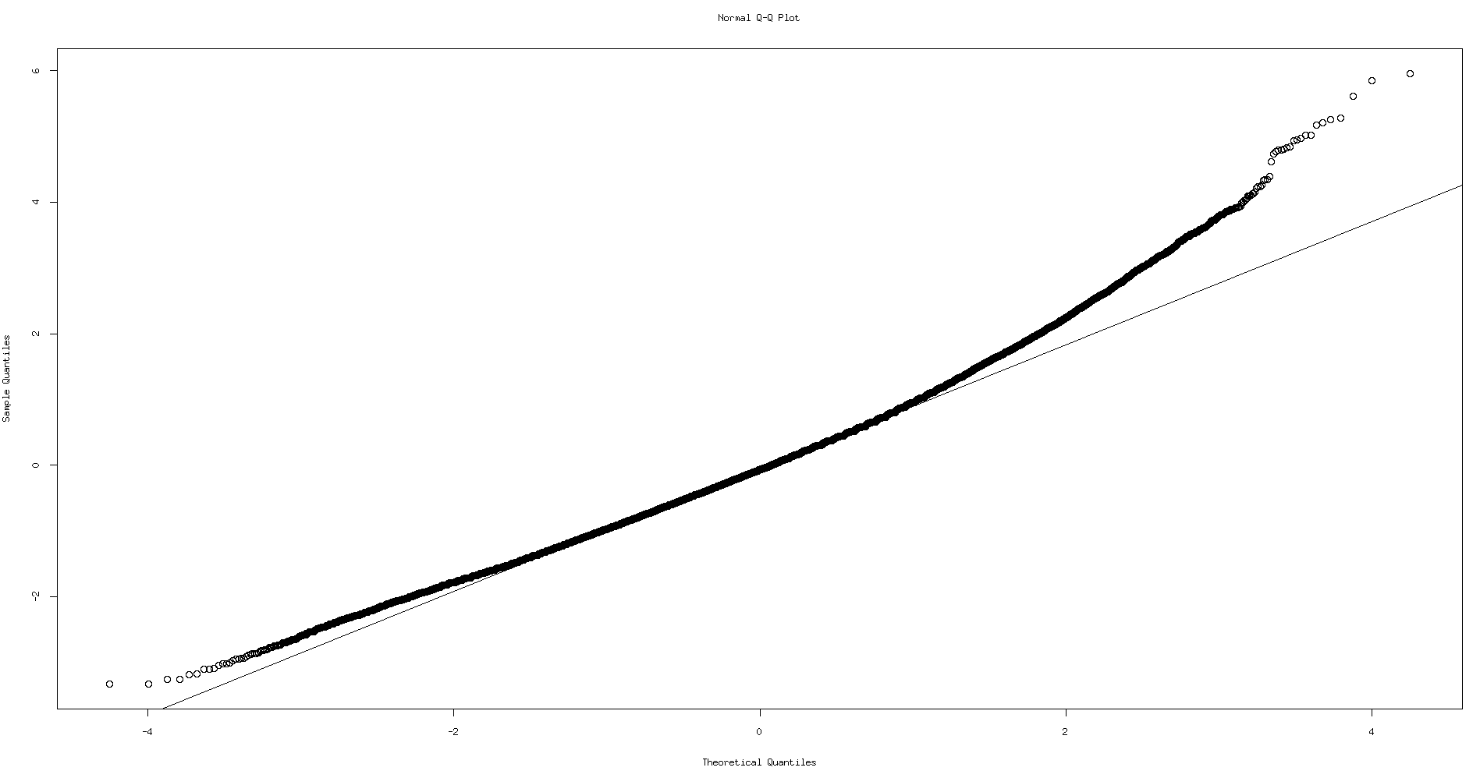
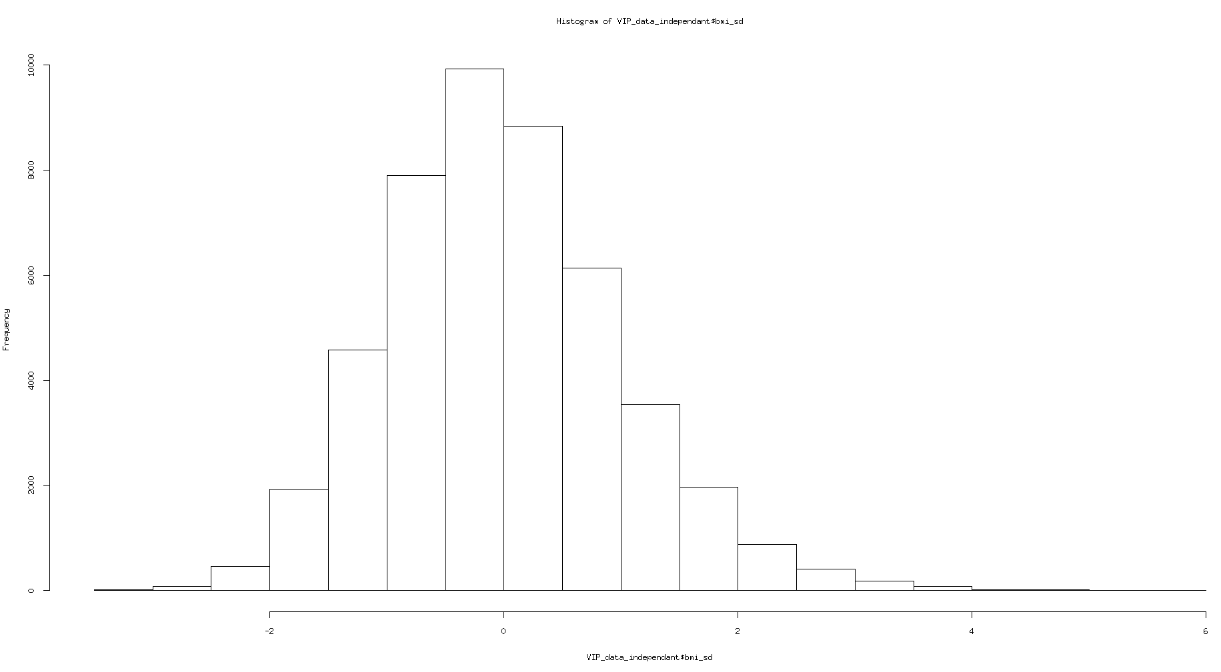
log transformed and standardized bmi, after excluding those that are below and above 3SD (313 subjects):
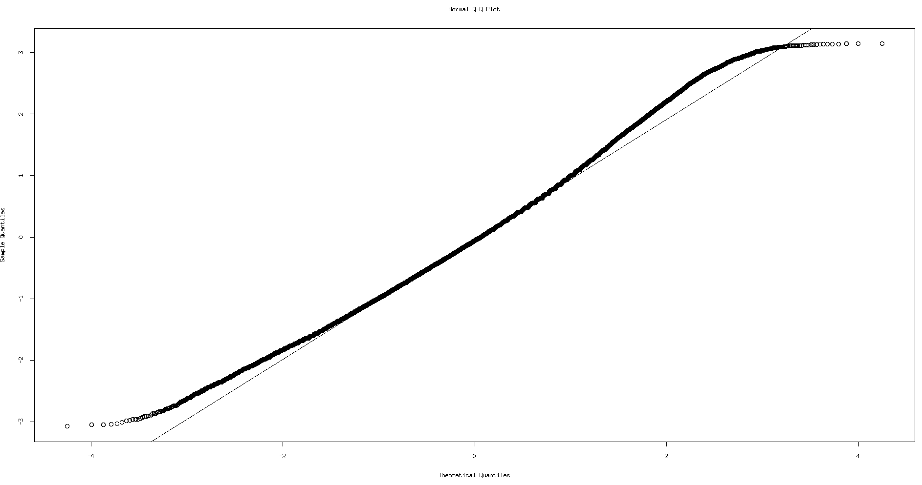
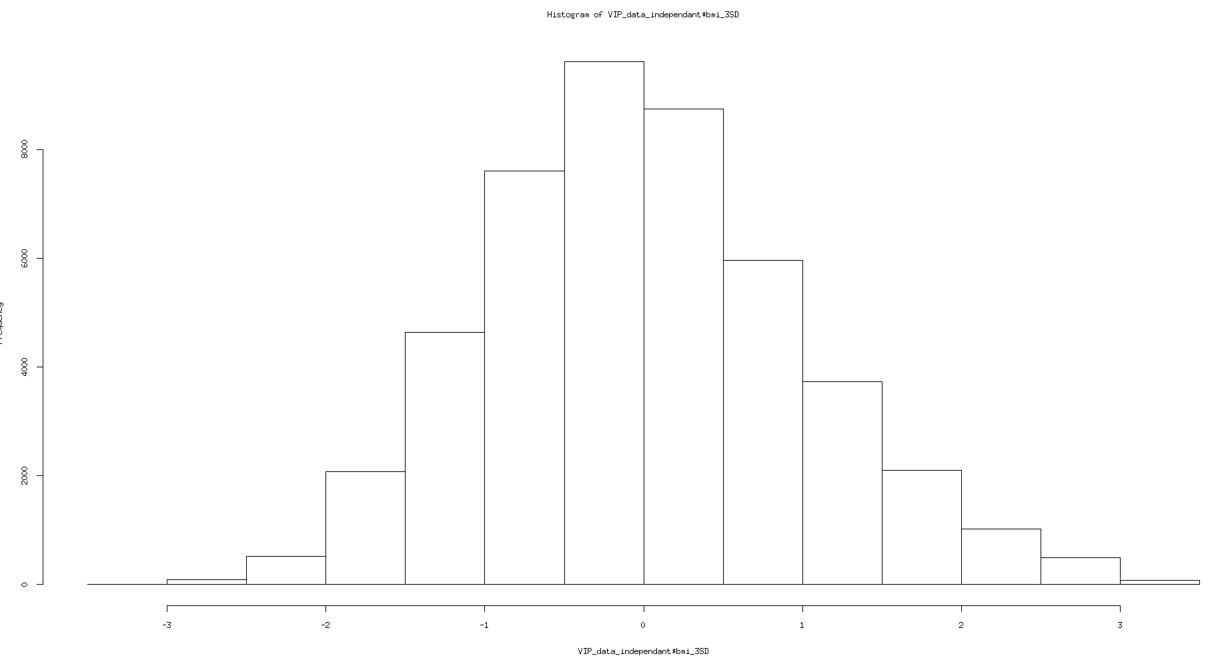

log transformed and standardized bmi, after excluding those that are below and above 3.5SD (116 subjects):
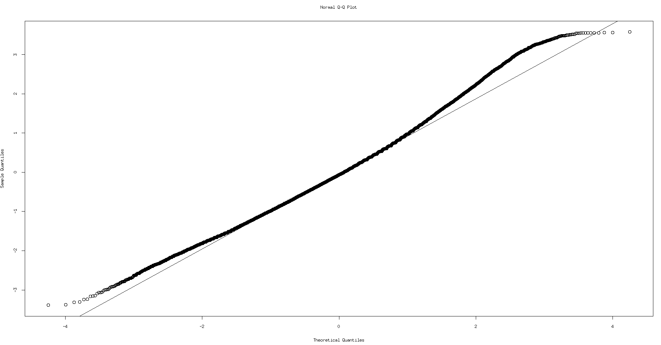
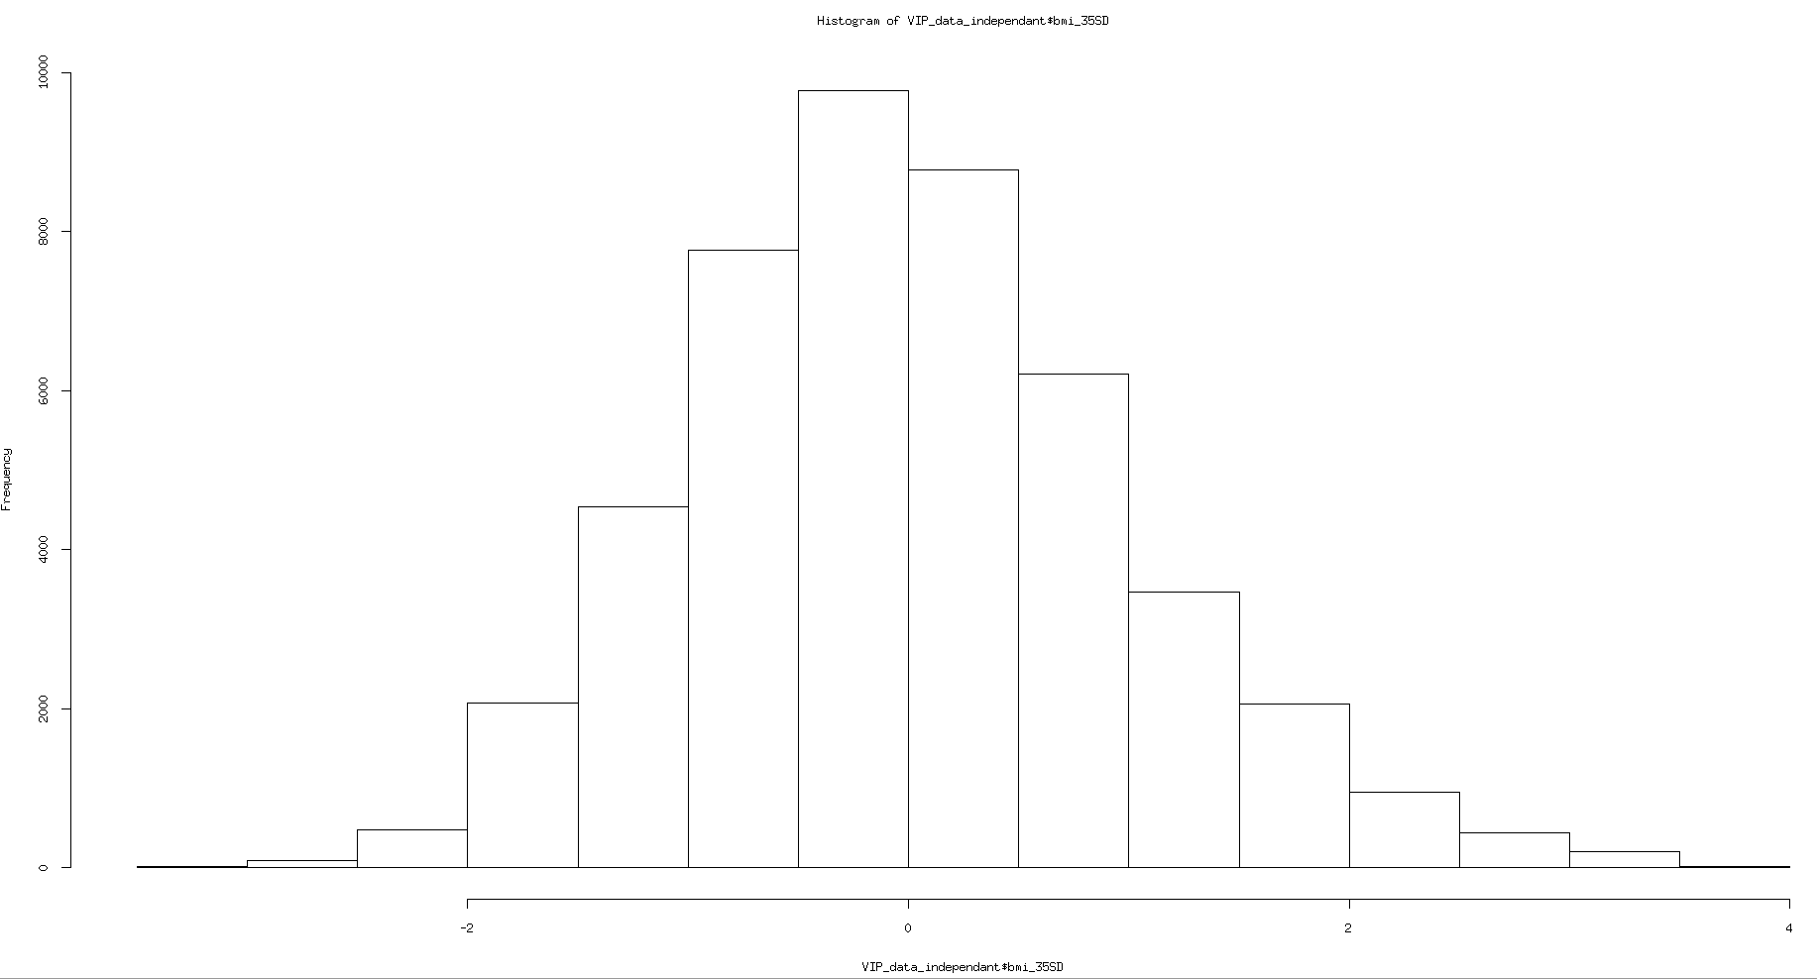

log transformed and standardized bmi, excluding those that are below and above 4SD (38 subjects):

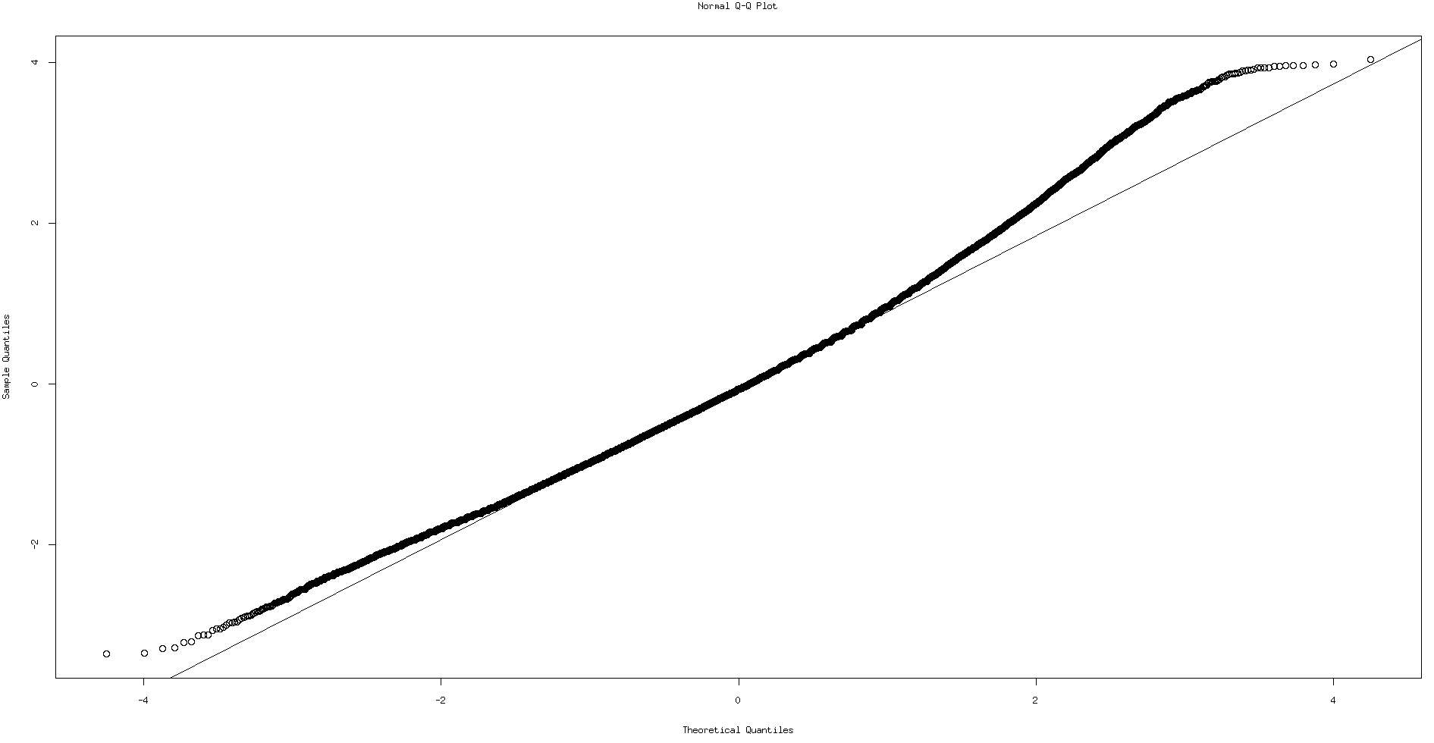

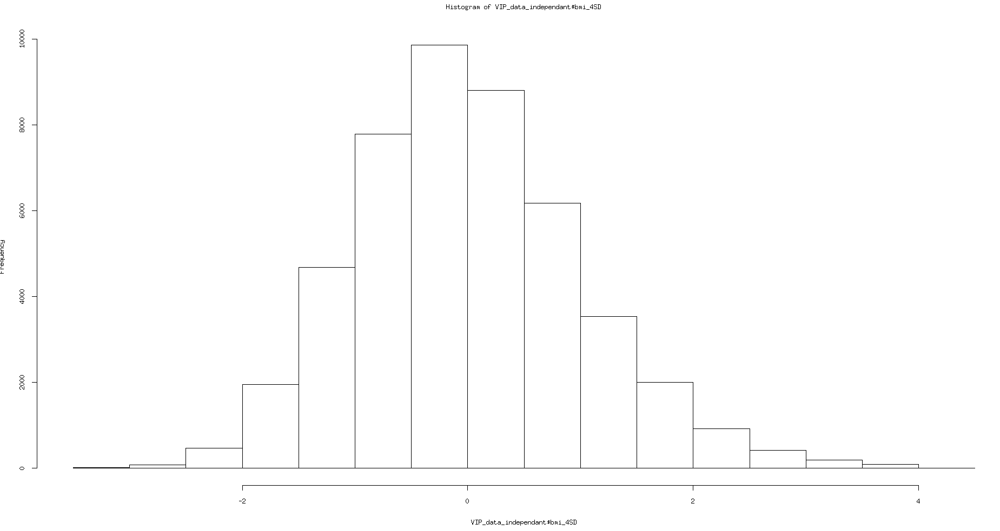

Independent dataset of Swedish only (47107 subjects):

Pairwise Pearson correlation coefficient for all variables , raw, as in g per day, included in the model:
rcorr( cbind(bmi,POLYsum1_transformed,MONOsum1_transformed,mfetsum1_transformed,fettsum1_transformed,sacksum1_transformed,kolhsum1_transformed,FA_transformed,protsum1_transformed,fibesum1_transformed,NATRsum1_transformed),type="pearson")

 | bmi | POLYsum1 | MONOsum1 | mfetsum1 | fettsum1 | sacksum1 | kolhsum1 | FA | protsum1 | fibesum1 | NATRsum1
bmi | 1
POLYsum1 | 0.07 | 1
MONOsum1 | 0.09 | 0.80 | 1
mfetsum1 | 0.05 | 0.63 | 0.91 | 1
fettsum1 | 0.07 | 0.80 | 0.97 | 0.96 | 1
sacksum1 | -0.02 | 0.23 | 0.29 | 0.30 | 0.32 | 1
kolhsum1 | 0.02** | 0.42 | 0.45 | 0.44 | 0.48 | 0.70 | 1
FA | 0.05 | 0.98 | 0.74 | 0.57 | 0.75 | 0.24 | 0.42 | 1
protsum1 | 0.10 | 0.60 | 0.73 | 0.69 | 0.74 | 0.34 | 0.68 | 0.56 | 1
fibesum1 | 0.00 n.s. | 0.35 | 0.24 | 0.19 | 0.26 | 0.41 | 0.78 | 0.36 | 0.52 | 1
NATRsum1 | 0.10 | 0.68 | 0.81 | 0.71 | 0.79 | 0.32 | 0.63 | 0.64 | 0.88 | 0.48 | 1
all p-values < 2e-16, except where marked

Pairwise Pearson correlation coefficient for all variables, expressed as % of TEI, included in the model:

Raw continuous variables, fitted together by: glm(bmi~age + agesq + gender_factor + year + ffq_factor + POLYsum1_transformed + MONOsum1_transformed + mfetsum1_transformed + fettsum1_transformed + sacksum1_transformed + kolhsum1_transformed + FA_transformed + protsum1_transformed + fibesum1_transformed + NATRsum1_transformed, family = gaussian(link = "identity"))

 | Regression coefficient | Variance explained | p-value
POLYsum1 | 0.5990539 | 0.000359 | 5.21e-05
MONOsum1 | 0.4934630 | 0.000418 | 1.24e-05
mfetsum1 | -1.6356688 | 0.003114 | < 2e-16
fettsum1 | 1.1059859 | 0.000555 | 4.79e-07
acids | -0.0175674 | 0.001208 | 1.10e-13
kolhsum1 | -0.3281385 | 0.000748 | 5.14e-09
sacksum1 | -0.9322543 | 7e-06 | 0.585453
protsum1 | 0.5610824 | 0.002982 | < 2e-16
NATRsum1 | 0.3152880 | 0.000718 | 1.04e-08
fibesum1 | -0.2264846 | 0.00073 | 7.88e-09

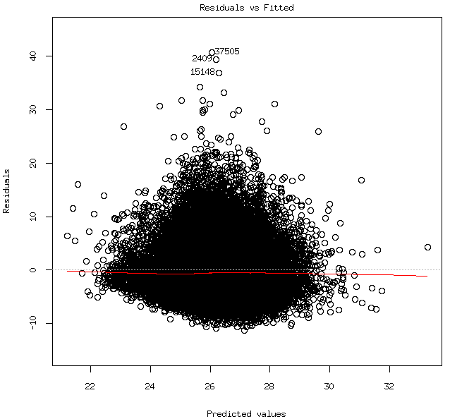
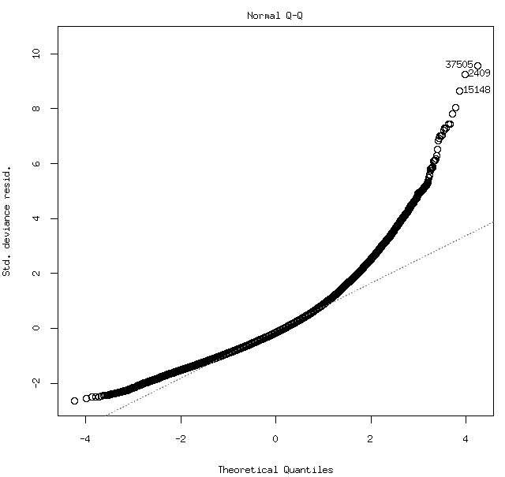

Raw continuous, fitted separately by: glm(bmi~age + agesq + gender_factor + year + ffq_factor + VIP_data_independant[,c(variable)], family = gaussian(link = "identity"))

 | Regression coefficient | Variance explained | p-value
POLYsum1 | 0.2040732 | 0.001759 | < 2e-16
MONOsum1 | 0.3031544 | 0.003339 | < 2e-16
mfetsum1 | 0.0614008 | 0.000147 | 0.0097074
fettsum1 | 0.1881207 | 0.001329 | < 2e-16
acids | 0.1363734 | 0.000809 | < 2e-16
kolhsum1 | -0.040163 | 7.3e-05 | 0.0677203
sacksum1 | -0.1268329 | 0.000767 | < 2e-16
protsum1 | 0.3610829 | 0.005985 | < 2e-16
NATRsum1 | 0.4121994 | 0.007223 | < 2e-16
fibesum1 | -0.0541303 | 0.000149 | 0.009225

Continuous expressed in % of TEI, fitted together by: glm(bmi~age + agesq + gender_factor + year + ffq_factor + POLYsum1_ofTEI_transformed + MONOsum1_ofTEI_transformed + mfetsum1_ofTEI_transformed + fettsum1_ofTEI_transformed + sacksum1_ofTEI_transformed + kolhsum1_ofTEI_transformed + FA_ofTEI_transformed + protsum1_ofTEI_transformed + fibesum1_ofTEI_transformed + NATRsum1_ofTEI_transformed, family = gaussian(link = "identity"))

 | Regression coefficient | Variance explained | p-value
POLYsum1 | 0.4800456 | 0.000457 | 4.94e-06
MONOsum1 | 0.2430660 | 0.00031 | 0.000171
mfetsum1 | -0.9320629 | 0.002762 | < 2e-16
fettsum1 | 0.7560991 | 0.000814 | 1.08e-09
acids | -0.7062288 | 0.001276 | 2.28e-14
kolhsum1 | 0.0445714 | 1.5e-05 | 0.406487
sacksum1 | 0.0016700 | 0 | 0.950096
protsum1 | 0.3475617 | 0.003203 | < 2e-16
NATRsum1 | 0.1723705 | 0.000773 | 2.84e-09
fibesum1 | -0.1721206 | 0.000654 | 4.67e-08

Continuous expressed in % of TEI, fitted separately by: glm(bmi~age + agesq + gender_factor + year + ffq_factor + VIP_data_independant[,c(variable)], family = gaussian(link = "identity"))

 | Regression coefficient | Variance explained | p-value
POLYsum1 | 0.1588141 | 0.001181 | < 2e-16
MONOsum1 | 0.3235834 | 0.004089 | < 2e-16
mfetsum1 | -0.0412288 | 7.7e-05 | 0.0609774
fettsum1 | 0.1415299 | 0.000853 | < 2e-16
acids | 0.0759219 | 0.000279 | 0.0003564
kolhsum1 | -0.281902 | 0.003236 | < 2e-16
sacksum1 | -0.2124712 | 0.002211 | < 2e-16
protsum1 | 0.4837918 | 0.011704 | < 2e-16
NATRsum1 | 0.5100663 | 0.012844 | < 2e-16
fibesum1 | -0.191649 | 0.001513 | < 2e-16

Categorized according to the recommended cut points, fitted together by: glm(bmi~age + agesq + gender_factor + year + ffq_factor + POLYsum1_ofTEI_categorized_g + MONOsum1_ofTEI_categorized_g + mfetsum1_ofTEI_categorized_g + fettsum1_ofTEI_categorized_g + sacksum1_ofTEI_categorized_g + kolhsum1_ofTEI_categorized_g + FA_ofTEI_categorized_g + protsum1_ofTEI_categorized_g + fibesum1_categorized_g + NATRsum1_categorized_g, family = gaussian(link = "identity"))

 | Regression coefficient | Variance explained | p-value
POLYsum1 | 0.1099463 | 0.000154 | 0.00810
MONOsum1 | 0.3012363 | 0.000467 | 3.87e-06
mfetsum1 | -0.6099049 | 0.000954 | 4.08e-11
fettsum1 | 0.1496284 | 0.000146 | 0.00974
acids | 0.0630988 | 8e-06 | 0.53503
kolhsum1 | -0.0949347 | 6.1e-05 | 0.09418
sacksum1 | 0.0826964 | 2.3e-05 | 0.30691
protsum1 | 1.1729414 | 0.002883 | < 2e-16
NATRsum1 | 0.4858922 | 0.001805 | 3.73e-05
fibesum1 | 0.2635006 | 0.000373 | < 2e-16

Categorized according to the recommended cut points, fitted separately by: glm(bmi~age + agesq + gender_factor + year + ffq_factor + VIP_data_independant[,c(variable)], family = gaussian(link = "identity"))

 | Regression coefficient | Variance explained | p-value
POLYsum1 | 0.2215384 | 0.000743 | < 2e-16
MONOsum1 | 0.3588432 | 0.000943 | < 2e-16
mfetsum1 | -0.1572909 | 8.6e-05 | 0.0471491
fettsum1 | 0.2623853 | 0.000851 | < 2e-16
acids | -0.1876798 | 8.1e-05 | 0.0541129
kolhsum1 | -0.3118413 | 0.00124 | < 2e-16
sacksum1 | -0.159644 | 9e-05 | 0.0424843
protsum1 | 1.2827382 | 0.00356 | < 2e-16
NATRsum1 | 0.487762 | 0.002123 | < 2e-16
fibesum1 | 0.1398369 | 0.000132 | 0.0141008

The 2 visits subset of Swedish only ( 33114 subjects in each visit),
visit==1 (33114 subjects):

Pairwise Pearson correlation coefficient for all variables(raw, as in g per day) included in the model:
rcorr( cbind(bmi,POLYsum1_transformed,MONOsum1_transformed,mfetsum1_transformed,fettsum1_transformed,sacksum1_transformed,kolhsum1_transformed,FA_transformed,protsum1_transformed,fibesum1_transformed,NATRsum1_transformed),type="pearson")

 | bmi | POLYsum1 | MONOsum1 | mfetsum1 | fettsum1 | sacksum1 | kolhsum1 | FA | protsum1 | fibesum1 | NATRsum1
bmi | 1
POLYsum1 | 0.07 | 1
MONOsum1 | 0.08 | 0.80 | 1
mfetsum1 | 0.01** | 0.67 | 0.89 | 1
fettsum1 | 0.04 | 0.82 | 0.94 | 0.97 | 1
sacksum1 | -0.03 | 0.32 | 0.39 | 0.42 | 0.43 | 1
kolhsum1 | 0.03 | 0.56 | 0.59 | 0.57 | 0.61 | 0.68 | 1
FA | 0.07 | 0.98 | 0.75 | 0.62 | 0.77 | 0.33 | 0.56 | 1
protsum1 | 0.09 | 0.62 | 0.72 | 0.71 | 0.74 | 0.40 | 0.79 | 0.60 | 1
fibesum1 | 0.03 | 0.42 | 0.33 | 0.28 | 0.34 | 0.35 | 0.78 | 0.44 | 0.58 | 1
NATRsum1 | 0.09 | 0.71 | 0.81 | 0.74 | 0.80 | 0.39 | 0.74 | 0.69 | 0.89 | 0.54 | 1
all p-values < 2e-16, except where marked

Raw continuous variables, fitted together by: glm(bmi~age + agesq + gender_factor + year + ffq_factor + POLYsum1_transformed + MONOsum1_transformed + mfetsum1_transformed + fettsum1_transformed + sacksum1_transformed + kolhsum1_transformed + FA_transformed + protsum1_transformed + fibesum1_transformed + NATRsum1_transformed, family = gaussian(link = "identity"))

 | Regression coefficient | Variance explained | p-value
POLYsum1 | 4.329e-01 | 0.000378 | 0.000522
MONOsum1 | 9.475e-02 | 4.2e-05 | 0.246351
mfetsum1 | -1.798e+00 | 0.004927 | < 2e-16
fettsum1 | 1.497e+00 | 0.001505 | 4.42e-12
acids | -7.683e-01 | 0.001663 | 3.40e-13
kolhsum1 | -3.002e-01 | 0.000701 | 2.33e-06
sacksum1 | -1.583e-02 | 7e-06 | 0.635929
protsum1 | 6.007e-01 | 0.004119 | < 2e-16
NATRsum1 | 1.934e-01 | 0.000342 | 0.000978
fibesum1 | -3.677e-02 | 2.7e-05 | 0.354084

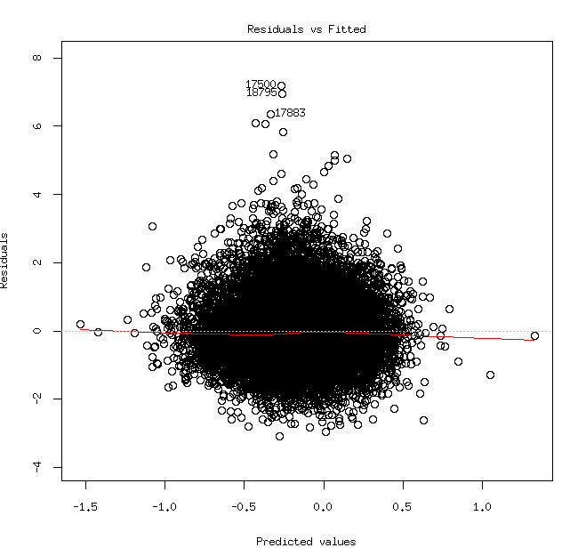
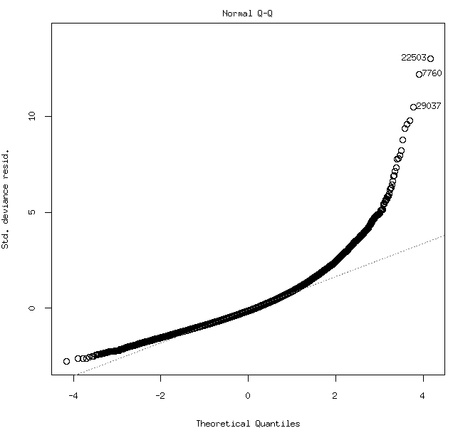

Raw continuous, fitted separately by: glm(bmi~age + agesq + gender_factor + year + ffq_factor + VIP_data_independant[,c(variable)], family = gaussian(link = "identity"))

 | Regression coefficient | Variance explained | p-value
POLYsum1 | 0.1060793 | 0.000685 | 3e-06
MONOsum1 | 0.0781947 | 0.000323 | 0.0013459
mfetsum1 | -0.1051945 | 0.000634 | 7e-06
fettsum1 | 0.0025845 | 0 | 0.9135259
acids | 0.0809107 | 0.00041 | 0.0003029
kolhsum1 | 0.0303871 | 6.5e-05 | 0.1504342
sacksum1 | -0.1086266 | 0.000842 | 2e-07
protsum1 | 0.2449353 | 0.004022 | < 2e-16
NATRsum1 | 0.276346 | 0.004523 | < 2e-16
fibesum1 | 0.0572951 | 0.000257 | 0.0042038

Continuous expressed in % of TEI, fitted together by: glm(bmi~age + agesq + gender_factor + year + ffq_factor + POLYsum1_ofTEI_transformed + MONOsum1_ofTEI_transformed + mfetsum1_ofTEI_transformed + fettsum1_ofTEI_transformed + sacksum1_ofTEI_transformed + kolhsum1_ofTEI_transformed + FA_ofTEI_transformed + protsum1_ofTEI_transformed + fibesum1_ofTEI_transformed + NATRsum1_ofTEI_transformed, family = gaussian(link = "identity"))

 | Regression coefficient | Variance explained | p-value
POLYsum1 | 3.242e-01 | 0.000492 | 7.56e-05
MONOsum1 | 4.483e-02 | 3e-05 | 0.329414
mfetsum1 | -9.775e-01 | 0.004545 | < 2e-16
fettsum1 | 8.942e-01 | 0.001775 | 5.54e-14
acids | -5.353e-01 | 0.001746 | 8.91e-14
kolhsum1 | 8.690e-02 | 6.9e-05 | 0.139751
sacksum1 | -1.156e-02 | 6e-06 | 0.666132
protsum1 | 3.347e-01 | 0.004085 | < 2e-16
NATRsum1 | 9.843e-02 | 0.000383 | 0.000481
fibesum1 | -3.314e-02 | 3.6e-05 | 0.283955

Continuous expressed in % of TEI, fitted separately by: glm(bmi~age + agesq + gender_factor + year + ffq_factor + VIP_data_independant[,c(variable)], family = gaussian(link = "identity"))

 | Regression coefficient | Variance explained | p-value
POLYsum1 | 0.0856582 | 0.000535 | 3.7e-05
MONOsum1 | 0.0465608 | 0.000133 | 0.0397995
mfetsum1 | -0.2083109 | 0.0031 | < 2e-16
fettsum1 | -0.072357 | 0.000367 | 0.0006278
acids | 0.0539485 | 0.000216 | 0.0086657
kolhsum1 | -0.0345755 | 8.5e-05 | 0.0998065
sacksum1 | -0.1588909 | 0.001899 | < 2e-16
protsum1 | 0.3724594 | 0.010604 | < 2e-16
NATRsum1 | 0.3768771 | 0.010549 | < 2e-16
fibesum1 | 0.0367767 | 8.7e-05 | 0.0957426

Categorized according to the recommended cut points, fitted together by: glm(bmi~age + agesq + gender_factor + year + ffq_factor + POLYsum1_ofTEI_categorized_g + MONOsum1_ofTEI_categorized_g + mfetsum1_ofTEI_categorized_g + fettsum1_ofTEI_categorized_g + sacksum1_ofTEI_categorized_g + kolhsum1_ofTEI_categorized_g + FA_ofTEI_categorized_g + protsum1_ofTEI_categorized_g + fibesum1_categorized_g + NATRsum1_categorized_g, family = gaussian(link = "identity"))

 | Regression coefficient | Variance explained | p-value
POLYsum1 | 6.525e-02 | 7.7e-05 | 0.117809
MONOsum1 | 4.347e-02 | 1.7e-05 | 0.465114
mfetsum1 | -5.020e-01 | 0.000869 | 1.44e-07
fettsum1 | -1.820e-01 | 0.000241 | 0.005616
acids | -1.728e-01 | 7.6e-05 | 0.119654
kolhsum1 | -2.162e-01 | 0.000418 | 0.000263
sacksum1 | -1.266e-01 | 0.000125 | 0.046424
protsum1 | 8.620e-01 | 0.001104 | 3.05e-09
NATRsum1 | 3.097e-01 | 0.001179 | 9.05e-10
fibesum1 | 5.002e-02 | 2.3e-05 | 0.392393

Categorized according to the recommended cut points, fitted separately by: glm(bmi~age + agesq + gender_factor + year + ffq_factor + VIP_data_independant[,c(variable)], family = gaussian(link = "identity"))

 | Regression coefficient | Variance explained | p-value
POLYsum1 | 0.0907435 | 0.000175 | 0.0182951
MONOsum1 | -0.0126073 | 2e-06 | 0.8064681
mfetsum1 | -0.4241771 | 0.000848 | 2e-07
fettsum1 | -0.0809161 | 9.9e-05 | 0.0765824
acids | -0.2191146 | 0.000131 | 0.0408488
kolhsum1 | -0.110991 | 0.000213 | 0.0092061
sacksum1 | -0.2487395 | 0.000513 | 5.33e-05
protsum1 | 0.9824838 | 0.00148 | < 2e-16
NATRsum1 | 0.3305855 | 0.001572 | < 2e-16
fibesum1 | -0.1027124 | 0.000123 | 0.0476973

The 2 visits subset ( 66228 subjects),
visit==2 ( 33114 subjects):

Pairwise Pearson correlation coefficient for all variables(raw, as in g per day) included in the model, bmi added for comparison:
rcorr( cbind(bmi,POLYsum1_transformed,MONOsum1_transformed,mfetsum1_transformed,fettsum1_transformed,sacksum1_transformed,kolhsum1_transformed,FA_transformed,protsum1_transformed,fibesum1_transformed,NATRsum1_transformed),type="pearson")

 | bmi | POLYsum1 | MONOsum1 | mfetsum1 | fettsum1 | sacksum1 | kolhsum1 | FA | protsum1 | fibesum1 | NATRsum1
bmi | 1
POLYsum1 | 0.08 | 1
MONOsum1 | 0.11 | 0.80 | 1
mfetsum1 | 0.08 | 0.62 | 0.92 | 1
fettsum1 | 0.10 | 0.79 | 0.98 | 0.96 | 1
sacksum1 | -0.02** | 0.28 | 0.34 | 0.33 | 0.36 | 1
kolhsum1 | 0.03 | 0.46 | 0.49 | 0.46 | 0.50 | 0.70 | 1
FA | 0.06 | 0.98 | 0.74 | 0.57 | 0.74 | 0.29 | 0.46 | 1
protsum1 | 0.13 | 0.59 | 0.73 | 0.69 | 0.74 | 0.36 | 0.70 | 0.56 | 1
fibesum1 | 0.00 i.s. | 0.39 | 0.26 | 0.20 | 0.28 | 0.40 | 0.78 | 0.40 | 0.54 | 1
NATRsum1 | 0.13 | 0.67 | 0.81 | 0.69 | 0.77 | 0.34 | 0.65 | 0.63 | 0.88 | 0.50 | 1
all p-values < 2e-16, except where marked

Raw continuous variables, fitted together by: glm(bmi~age + agesq + gender_factor + year + ffq_factor + POLYsum1_transformed + MONOsum1_transformed + mfetsum1_transformed + fettsum1_transformed + sacksum1_transformed + kolhsum1_transformed + FA_transformed + protsum1_transformed + fibesum1_transformed + NATRsum1_transformed, family = gaussian(link = "identity"))

 | Regression coefficient | Variance explained | p-value
POLYsum1 | 5.144e-01 | 0.000287 | 0.00230
MONOsum1 | 4.466e-01 | 0.000262 | 0.00360
mfetsum1 | -1.927e+00 | 0.004702 | < 2e-16
fettsum1 | 1.610e+00 | 0.001109 | 2.08e-09
acids | -1.010e+00 | 0.001481 | 4.35e-12
kolhsum1 | -8.809e-02 | 6.1e-05 | 0.15853
sacksum1 | -1.813e-01 | 0.000826 | 2.33e-07
protsum1 | 5.398e-01 | 0.00312 | < 2e-16
NATRsum1 | 2.470e-01 | 0.000511 | 4.74e-05
fibesum1 | -2.839e-01 | 0.001278 | 1.25e-10

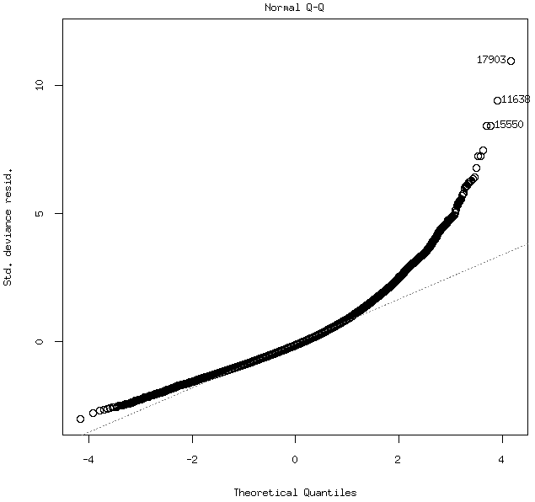
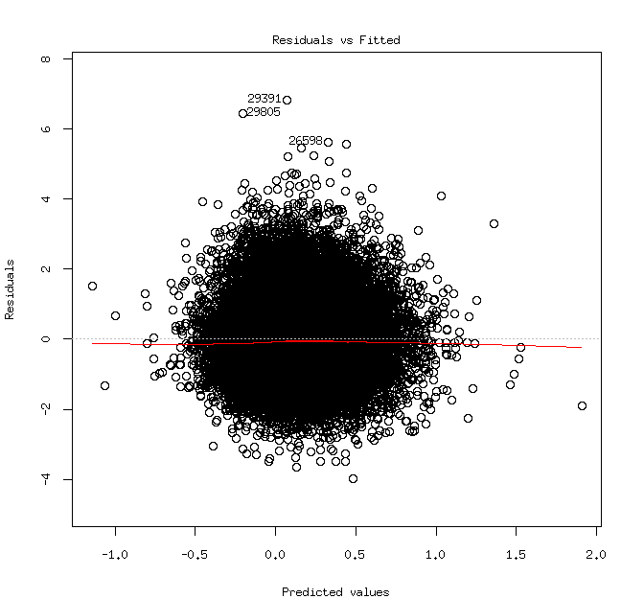

Raw continuous, fitted separately by: glm(bmi~age + agesq + gender_factor + year + ffq_factor + VIP_data_independant[,c(variable)], family = gaussian(link = "identity"))

 | Regression coefficient | Variance explained | p-value
POLYsum1 | 0.2075034 | 0.002141 | < 2e-16
MONOsum1 | 0.3415456 | 0.004986 | < 2e-16
mfetsum1 | 0.1156133 | 0.000583 | 1.39e-05
fettsum1 | 0.2407354 | 0.00245 | < 2e-16
acids | 0.1315379 | 0.00088 | 1e-07
kolhsum1 | -0.0007506 | 0 | 0.9752463
sacksum1 | -0.1812365 | 0.001842 | < 2e-16
protsum1 | 0.4033973 | 0.008609 | < 2e-16
NATRsum1 | 0.4496075 | 0.010221 | < 2e-16
fibesum1 | -0.0300287 | 5.4e-05 | 0.1857612

Continuous expressed in % of TEI, fitted together by: glm(bmi~age + agesq + gender_factor + year + ffq_factor + POLYsum1_ofTEI_transformed + MONOsum1_ofTEI_transformed + mfetsum1_ofTEI_transformed + fettsum1_ofTEI_transformed + sacksum1_ofTEI_transformed + kolhsum1_ofTEI_transformed + FA_ofTEI_transformed + protsum1_ofTEI_transformed + fibesum1_ofTEI_transformed + NATRsum1_ofTEI_transformed, family = gaussian(link = "identity"))

 | Regression coefficient | Variance explained | p-value
POLYsum1 | 0.3992368 | 0.000351 | 0.000748
MONOsum1 | 0.1763958 | 0.00013 | 0.040343
mfetsum1 | -1.1323844 | 0.004352 | < 2e-16
fettsum1 | 1.2026031 | 0.00188 | 6.09e-15
acids | -0.7423517 | 0.001502 | 3.07e-12
kolhsum1 | 0.3109844 | 0.000867 | 1.17e-07
sacksum1 | -0.1255568 | 6e-04 | 1.05e-05
protsum1 | 0.3799312 | 0.004332 | < 2e-16
NATRsum1 | 0.1475537 | 0.000635 | 5.81e-06
fibesum1 | -0.2148042 | 0.001155 | 9.61e-10

Continuous expressed in % of TEI, fitted separately by: glm(bmi~age + agesq + gender_factor + year + ffq_factor + VIP_data_independant[,c(variable)], family = gaussian(link = "identity"))

 | Regression coefficient | Variance explained | p-value
POLYsum1 | 0.1271074 | 0.000929 | < 2e-16
MONOsum1 | 0.3168217 | 0.004969 | < 2e-16
mfetsum1 | -0.0076495 | 3e-06 | 0.7546639
fettsum1 | 0.162972 | 0.001328 | < 2e-16
acids | 0.0402379 | 9.5e-05 | 0.0795438
kolhsum1 | -0.2624236 | 0.003475 | < 2e-16
sacksum1 | -0.2939958 | 0.005146 | < 2e-16
protsum1 | 0.4935001 | 0.014374 | < 2e-16
NATRsum1 | 0.508124 | 0.015301 | < 2e-16
fibesum1 | -0.1922141 | 0.001817 | < 2e-16

Categorized according to the recommended cut points, fitted together by: glm(bmi~age + agesq + gender_factor + year + ffq_factor + POLYsum1_ofTEI_categorized_g + MONOsum1_ofTEI_categorized_g + mfetsum1_ofTEI_categorized_g + fettsum1_ofTEI_categorized_g + sacksum1_ofTEI_categorized_g + kolhsum1_ofTEI_categorized_g + FA_ofTEI_categorized_g + protsum1_ofTEI_categorized_g + fibesum1_categorized_g + NATRsum1_categorized_g, family = gaussian(link = "identity"))

 | Regression coefficient | Variance explained | p-value
POLYsum1 | 0.0570714 | 4.7e-05 | 0.216702
MONOsum1 | 0.2352016 | 0.000354 | 0.000715
mfetsum1 | -0.4311723 | 0.000695 | 2.09e-06
fettsum1 | 0.2128727 | 0.000319 | 0.001322
acids | 0.2400015 | 0.000119 | 0.050148
kolhsum1 | -0.0298615 | 7e-06 | 0.625836
sacksum1 | -0.2140844 | 0.000144 | 0.031122
protsum1 | 1.0617234 | 0.002321 | < 2e-16
NATRsum1 | 0.6812422 | 0.003633 | < 2e-16
fibesum1 | 0.2377727 | 0.000397 | 0.000337

Categorized according to the recommended cut points, fitted separately by: glm(bmi~age + agesq + gender_factor + year + ffq_factor + VIP_data_independant[,c(variable)], family = gaussian(link = "identity"))

 | Regression coefficient | Variance explained | p-value
POLYsum1 | 0.1821857 | 0.000586 | 1.33e-05
MONOsum1 | 0.3238795 | 0.001015 | < 2e-16
mfetsum1 | -0.0302204 | 5e-06 | 0.6909235
fettsum1 | 0.2967705 | 0.001178 | < 2e-16
acids | -0.0352855 | 3e-06 | 0.7655599
kolhsum1 | -0.2952981 | 0.001295 | < 2e-16
sacksum1 | -0.4216125 | 0.000581 | 1.45e-05
protsum1 | 1.2621739 | 0.003386 | < 2e-16
NATRsum1 | 0.6820745 | 0.004294 | < 2e-16
fibesum1 | 0.0585875 | 3.1e-05 | 0.318958

Number of subjects in each category for each variable:

Visit 1:

 | Number of subject with 0 | Number of subject with 1 | Number of subject with 2
POLYsum1 | 16615 | 14781 | 565
MONOsum1 | 7206 | 24707 | 48
mfetsum1 | 0 | 2089 | 29872
fettsum1 | 1629 | 25027 | 5305
acids | 0 | 30809 | 1152
kolhsum1 | 8071 | 22895 | 995
sacksum1 | 0 | 28072 | 3889
protsum1 | 456 | 31336 | 169
NATRsum1 | 0 | 21555 | 10406
fibesum1 | 0 | 5772 | 26189

 | bmi<18.5 | 18.5=<bmi<25 | 25=<bmi<30 | 30=<bmi
bmi | 239 | 18067 | 11841 | 2834

Visit 2:

 | Number of subject with 0 | Number of subject with 1 | Number of subject with 2
POLYsum1 | 13017 | 18247 | 1132
MONOsum1 | 6915 | 25363 | 118
mfetsum1 | 0 | 3275 | 29121
fettsum1 | 2106 | 23745 | 6545
acids | 0 | 31186 | 1210
kolhsum1 | 11314 | 20042 | 1040
sacksum1 | 0 | 30569 | 1827
protsum1 | 332 | 31265 | 799
kolesum1 | 10691 | 10690 | 11015
NATRsum1 | 0 | 25636 | 6760
fibesum1 | 0 | 5769 | 26627

 | bmi<18.5 | 18.5=<bmi<25 | 25=<bmi<30 | 30=<bmi
bmi | 185 | 13890 | 14043 | 4971

Three different diet scores:
-diet score 1: combining all individual scores as they are, not a good idea, since some are very correlated, some are categorized opposite the direction of association with bmi...
-diet score 2: combining all individual scores, but multiplying them with the standardized beta coefficient of the continuous variable from an independent data set
-diet score 3: combining only scores from the variables which are complying with the guidelines used to create the scores and are not included in the other variables

visit=1:
 | Regression coefficient, unstandardized | Variance explained | p-value
diet score 1 | -1.055e-02 | 1e-05 | 0.57117
diet score 2 | 2.952e-01 | 0.001622 | 6.65e-13
diet score 3 | 5.322e-01 | 0.002004 | 1.35e-15

visit=2:
 | Regression coefficient, unstandardized | Variance explained | p-value
diet score 1 | 1.720e-01 | 0.002377 | < 2e-16
diet score 2 | 0.6205540 | 0.006883 | <2e-16
diet score 3 | 1.0357356 | 0.007899 | < 2e-16

Diet score details:

diet score 1 with categories 7 to 16:

visit=1:

score | Number of subjects | bmi (number of subjects who are)
score | Number of subjects | underweight | normal | overweight | obese
7 | 69 | 0 | 34 | 25 | 8
8 | 520 | 0 | 263 | 199 | 57
9 | 152 | 2 | 623 | 392 | 122
10 | 3917 | 26 | 2240 | 1308 | 326
11 | 1060 | 74 | 6048 | 3655 | 819
12 | 11131 | 85 | 5947 | 4099 | 963
13 | 4044 | 33 | 2008 | 1579 | 400
14 | 464 | 0 | 24 | 167 | 51
15 | 22 | 0 | 14 | 5 | 3
16 | 2 | 0 | 1 | 0 | 1

visit=2:

score | Number of subjects | bmi (number of subjects who are)
score | Number of subjects | underweight | normal | overweight | obese
7 | 143 | 0 | 66 | 61 | 16
8 | 814 | 2 | 400 | 312 | 100
9 | 1568 | 12 | 717 | 626 | 210
10 | 4256 | 18 | 1866 | 1802 | 570
11 | 10254 | 68 | 4441 | 4279 | 1451
12 | 11696 | 61 | 4901 | 4965 | 1764
13 | 3232 | 14 | 1091 | 1485 | 641
14 | 393 | 4 | 104 | 187 | 97
15 | 34 | 0 | 12 | 13 | 9
16 | 6 | 0 | 2 | 2 | 2

diet score 2 is continuous due to multiplication and ranges from -0.86547 to 4.84430, might not be a good scale and having negative scoring. To get a feeling of the distribution I made a standardized score and took part based on SD, so I divided the score in ten parts(as first score) and looked at the subject counts:

visit=1:

part of score | Number of subjects | bmi (number of subjects who are)
part of score | Number of subjects | underweight | normal | overweight | obese
1 | 48 | 2 | 32 | 10 | 4
2 | 90 | 0 | 56 | 27 | 7
3 | 687 | 7 | 380 | 247 | 50
4 | 3967 | 34 | 2325 | 1273 | 314
5 | 13231 | 103 | 7590 | 4386 | 1091
6 | 8630 | 49 | 4506 | 3311 | 740
7 | 5082 | 34 | 2447 | 2081 | 501
8 | 156 | 0 | 64 | 64 | 27
9 | 56 | 4 | 17 | 25 | 12
10 | 14 | 0 | 5 | 5 | 4

visit=2:

part of score | Number of subjects | bmi (number of subjects who are)
part of score | Number of subjects | underweight | normal | overweight | obese
1 | 25 | 0 | 12 | 13 | 0
2 | 32 | 0 | 15 | 14 | 3
3 | 651 | 1 | 283 | 288 | 79
4 | 4051 | 27 | 1860 | 1672 | 492
5 | 12990 | 82 | 5849 | 5269 | 1773
6 | 10784 | 53 | 4365 | 4685 | 1676
7 | 3019 | 14 | 971 | 1426 | 608
8 | 446 | 2 | 140 | 186 | 115
9 | 378 | 0 | 98 | 172 | 108
10 | 20 | 0 | 7 | 7 | 6

diet score 3 is continuous due to multiplication and ranges from 0.6275989 to 4.3454448. To get a feeling of the distribution I divided the score in 10 parts( as first score) and looked at the subject counts::

visit=1:

part of score | Number of subjects | bmi (number of subjects who are)
part of score | Number of subjects | underweight | normal | overweight | obese
1 | 235 | 3 | 148 | 70 | 14
2 | 149 | 3 | 80 | 57 | 7
3 | 72 | 0 | 34 | 31 | 5
4 | 1313 | 9 | 712 | 458 | 130
5 | 17187 | 127 | 9768 | 5799 | 1421
6 | 6079 | 45 | 3256 | 269 | 491
7 | 6757 | 42 | 3355 | 2678 | 652
8 | 5 | 0 | 1 | 4 | 0
9 | 88 | 0 | 42 | 35 | 11
10 | 76 | 1 | 26 | 28 | 19

visit=2:

part of score | Number of subjects | bmi (number of subjects who are)
part of score | Number of subjects | underweight | normal | overweight | obese
1 | 44 | 0 | 19 | 25 | 0
2 | 266 | 2 | 116 | 113 | 35
3 | 12 | 0 | 4 | 7 | 1
4 | 1872 | 6 | 890 | 750 | 226
5 | 18904 | 122 | 8446 | 7779 | 2537
6 | 8743 | 41 | 3357 | 3874 | 1469
7 | 1756 | 7 | 525 | 836 | 387
8 | 24 | 0 | 12 | 9 | 3
9 | 484 | 1 | 140 | 222 | 119
10 | 291 | 0 | 91 | 117 | 83

29.3. gotten so far, have to rerun the rest of below after applying the corrections Alaitz suggested.

For PA only the following variables had sufficient data: g1_a, g1_b, g1_c, g1_d, g3_a, g3_b, g6.
The variables g1_N are related since they are seasonal variables and we were discussing to combine them, so I had checked several different combinations:

1. Separate variables.
2. Combining all g1_N
3. Combining only the significant g1_N

Visit 1:

1.Separate variables:

 | Regression coefficient, unstandardized | Regression coefficient, standardized | p-value
g1_a | -0.026707 | -0.035912 | 0.01397
g1_b | -0.001490 | -0.002117 | 0.85631
g1_c | -0.006834 | -0.009016 | 0.52182
g1_d | -0.028987 | -0.031211 | 0.00242
g3_a | -0.005845 | -0.006559 | 0.31450
g3_b | -0.004055 | -0.005348 | 0.46532
g6 | -0.054040 | -0.063570 | < 2e-16

2.Combining all g1_N:

 | Regression coefficient, unstandardized | Regression coefficient, standardized | p-value
g1_abcd | -0.014986 | -0.070790 | < 2e-16
g3_a | -0.005632 | -0.006320 | 0.32869
g3_b | -0.003804 | -0.005016 | 0.48647
g6 | -0.053058 | -0.062415 | < 2e-16

3.Combining only the significant g1_N:

 | Regression coefficient, unstandardized | Regression coefficient, standardized | p-value
g1_ad | -0.031370 | -0.071011 | < 2e-16
g3_a | -0.005596 | -0.006279 | 0.33173
g3_b | -0.005429 | -0.007159 | 0.31257
g6 | -0.053258 | -0.062651 | < 2e-16

Visit 2:

1.Separate variables:

 | Regression coefficient, unstandardized | Regression coefficient, standardized | p-value
g1_a | -0.0253117 | -0.0332984 | 0.02985
g1_b | 0.0006195 | 0.0008662 | 0.94453
g1_c | -0.0009063 | -0.0011778 | 0.93659
g1_d | -0.0666347 | -0.0716823 | 3.49e-11
g3_a | -0.0402458 | -0.0420984 | 3.26e-10
g3_b | -0.0169811 | -0.0228948 | 0.00373
g6 | -0.0680579 | -0.0912764 | < 2e-16

2.Combining all g1_N:

 | Regression coefficient, unstandardized | Regression coefficient, standardized | p-value
g1_abcd | -0.020930 | -0.097848 | < 2e-16
g3_a | -0.042628 | -0.044591 | 2.12e-11
g3_b | -0.013237 | -0.017847 | 0.021643
g6 | -0.068313 | -0.091619 | < 2e-16

3.Combining only the significant g1_N:

 | Regression coefficient, unstandardized | Regression coefficient, standardized | p-value
g1_ad | -0.044993 | -0.100966 | < 2e-16
g3_a | -0.042335 | -0.044284 | 2.83e-11
g3_b | -0.014702 | -0.019822 | 0.00904
g6 | -0.068315 | -0.091621 | < 2e-16

Variance explained calculated separately and adjusting only for the basic variables, since PA variables have missing values in mixed places.

Visit 1:
 | Variance explained | p-value
g1_a | 0.006326 | < 2e-16
g1_b | 0.005051 | < 2e-16
g1_c | 0.005886 | < 2e-16
g1_d | 0.005701 | < 2e-16
g3_a | 0.000649 | 5.212801e-06
g3_b | 0.002416 | < 2e-16
g6 | 0.005676 | < 2e-16
g1_abcd | 0.006849 | < 2e-16
g1_ad | 0.006977 | < 2e-16

Visit 2:
 | Variance explained | p-value
g1_a | 0.012533 | < 2e-16
g1_b | 0.009751 | < 2e-16
g1_c | 0.01193 | < 2e-16
g1_d | 0.013767 | < 2e-16
g3_a | 0.006293 | < 2e-16
g3_b | 0.010456 | < 2e-16
g6 | 0.012445 | < 2e-16
g1_abcd | 0.014299 | < 2e-16
g1_ad | 0.01496 | < 2e-16

Probably best to keep just g1_a, g1_d and g6 for the final PA score, out of all combinations, the beta coefficient and r² were the biggest:

Visit 1:

 | Regression coefficient, unstandardized | Regression coefficient, standardized | Variance explained | p-value
PA score | -0.038565 | -0.102699 | 0.010857 | < 2e-16

Visit 2:

 | Regression coefficient, unstandardized | Regression coefficient, standardized | Variance explained | p-value
PA score | -0.0559818 | -0.1538940 | 0.023603 | < 2e-16

PA score details:

PA score with categories 0 to 10:

visit=1:

category | Number of subjects | bmi (number of subjects who are)
category | Number of subjects | underweight | normal | overweight | obese
0 | 7514 | 60 | 3562 | 3032 | 834
1 | 4669 | 26 | 2250 | 1934 | 440
2 | 3882 | 16 | 2118 | 1422 | 310
3 | 2803 | 17 | 1614 | 970 | 190
4 | 3226 | 30 | 1845 | 1058 | 285
5 | 2596 | 17 | 1527 | 843 | 197
6 | 2593 | 25 | 1593 | 804 | 160
7 | 1919 | 12 | 1174 | 605 | 120
8 | 1243 | 9 | 846 | 326 | 58
9 | 625 | 7 | 442 | 156 | 18
10 | 213 | 2 | 152 | 51 | 6

visit=2:

category | Number of subjects | bmi (number of subjects who are)
category | Number of subjects | underweight | normal | overweight | obese
0 | 7230 | 35 | 2476 | 3292 | 1424
1 | 3774 | 19 | 1276 | 1769 | 707
2 | 2969 | 10 | 1185 | 1325 | 448
3 | 3823 | 17 | 1622 | 1694 | 488
4 | 3370 | 23 | 1463 | 1403 | 477
5 | 2313 | 14 | 1093 | 896 | 309
6 | 2487 | 12 | 1250 | 939 | 285
7 | 1947 | 14 | 998 | 762 | 171
8 | 1299 | 6 | 773 | 416 | 103
9 | 929 | 9 | 546 | 338 | 36
10 | 326 | 2 | 208 | 100 | 16

Combining diet score and PA(PA reverse scoring):

Separate:

diet score 1
Visit 1:

 | Regression coefficient, standardized | p-value
diet score 1 | 0.002307 | 0.71732
PA score | 0.103639 | < 2e-16

Visit 2:

 | Regression coefficient, standardized | p-value
diet score 1 | 0.057348 | < 2e-16
PA score | 0.147512 | < 2e-16

diet score 2
Visit 1:

 | Regression coefficient, standardized | p-value
diet score 2 | 0.072328 | < 2e-16
PA score | 0.104734 | < 2e-16

Visit 2:

 | Regression coefficient, standardized | p-value
diet score 2 | 0.101192 | < 2e-16
PA score | 0.151720 | < 2e-16

diet score 3
Visit 1:

 | Regression coefficient, standardized | p-value
diet score 3 | 0.048991 | < 2e-16
PA score | 0.100540 | < 2e-16

Visit 2:

 | Regression coefficient, standardized | p-value
diet score 3 | 0.092354 | < 2e-16
PA score | 0.145231 | < 2e-16

Summed (best results when summing the standardized diet and PA scores):

diet score 1
Visit 1:

 | Regression coefficient, standardized | Variance explained | p-value
diet score 1 + PA score | 0.067369 | 0.004034 | < 2e-16

Visit 2:

 | Regression coefficient, standardized | Variance explained | p-value
diet score 1 + PA score | 0.1213241 | 0.012926 | < 2e-16

diet score 2
Visit 1:

 | Regression coefficient, standardized | Variance explained | p-value
diet score 2 + PA score | 0.076094 | 0.005849 | < 2e-16

Visit 2:

 | Regression coefficient, standardized | Variance explained | p-value
diet score 2 + PA score | 0.102899 | 0.010333 | < 2e-16

diet score 3

Visit 1:

 | Regression coefficient, standardized | Variance explained | p-value
diet score 3 + PA score | 0.088926 | 0.007851 | < 2e-16

Visit 2:

 | Regression coefficient, standardized | Variance explained | p-value
diet score 3 + PA score | 0.1319158 | 0.016556 | < 2e-16

More robust score:

I had also made another attempt to create a more robust risk score, by categorizing variables based on the location in the standard normal distribution. I tried different cutpoints and categories, using 1*SD or 2*SD. For example, if using 1*SD as cutpoint and 4 categories, then for variables which are to be positively associated with bmi, I had set
0 : [,-1) ,
1 : [-1, 0),
2: [0,1),
3: [1,)
For variables which are to be negatively associated with bmi, I had set the categories the other way around. I had tried this since I observed better results with some variables, where the categorizing based on recommendations changed the direction of association with bmi or the association became insignificant. But with some variables, the results were worst. I had used the distribution of the raw continuous variables and expressed as % of TEI. The best results are using…

The independent dataset of Swedish only (47107 subjects):

Categorizing the % of TEI based on location in standardized normal distribution, fitted together by: glm(bmi~age + agesq + gender_factor + year + ffq_factor + POLYsum1_ofTEI_categorized_n + MONOsum1_ofTEI_categorized_n + mfetsum1_ofTEI_categorized_n + fettsum1_ofTEI_categorized_n + sacksum1_ofTEI_categorized_n + kolhsum1_ofTEI_categorized_n + FA_ofTEI_categorized_n + protsum1_ofTEI_categorized_n + fibesum1_categorized_n + NATRsum1_categorized_n, family = gaussian(link = "identity"))

 | Regression coefficient | Variance explained | p-value
POLYsum1 | 0.2613463 | 0.00028 | 0.000349
MONOsum1 | 0.4604947 | 0.001224 | 7.70e-14
mfetsum1 | -0.3915533 | 0.001003 | 1.30e-11
fettsum1 | 0.0330560 | 4e-06 | 0.659415
acids | 0.2187564 | 0.000212 | 0.001873
kolhsum1 | -0.0448882 | 1e-05 | 0.503266
sacksum1 | -0.0573420 | 4.1e-05 | 0.171973
protsum1 | 0.5994689 | 0.004369 | < 2e-16
NATRsum1 | 0.5125242 | 0.002858 | < 2e-16
fibesum1 | 0.2200713 | 0.000548 | 5.67e-07

Categorizing the % of TEI based on location in standardized normal distribution, fitted separately by: glm(bmi~age + agesq + gender_factor + year + ffq_factor + VIP_data_independant[,c(variable)], family = gaussian(link = "identity"))

 | Regression coefficient | Variance explained | p-value
POLYsum1 | 0.2475245 | 0.000865 | < 2e-16
MONOsum1 | 0.4823759 | 0.003044 | < 2e-16
mfetsum1 | -0.0504075 | 3.5e-05 | 0.2089986
fettsum1 | 0.2280955 | 0.000693 | < 2e-16
acids | -0.1233607 | 0.000219 | 0.0015748
kolhsum1 | -0.4235747 | 0.002052 | < 2e-16
sacksum1 | -0.3331994 | 0.001611 | < 2e-16
protsum1 | 0.7470236 | 0.008214 | < 2e-16
NATRsum1 | 0.5777928 | 0.004808 | < 2e-16
fibesum1 | 0.0974485 | 0.000155 | 0.0077181

Categorizing the raw variable, based on location in standardized normal distribution, fitted together by:
glm(bmi~age + agesq + gender_factor + year + ffq_factor + POLYsum1_categorized_n + MONOsum1_categorized_n + fettsum1_categorized_n + mfetsum1_categorized_n + sacksum1_categorized_n + kolhsum1_categorized_n + FA_categorized_n + protsum1_categorized_n + fibesum1_categorized_n + NATRsum1_categorized_n, family = gaussian(link = "identity"))

 | Regression coefficient | Variance explained | p-value
POLYsum1 | 0.1011252 | 3.1e-05 | 0.2354
MONOsum1 | 0.4798268 | 0.000821 | 9.22e-10
mfetsum1 | -0.4747318 | 0.001102 | 1.31e-12
fettsum1 | -0.1235618 | 4.1e-05 | 0.1733
acids | 0.0400984 | 5e-06 | 0.6222
kolhsum1 | -0.2242919 | 0.00035 | 6.40e-05
sacksum1 | -0.1988698 | 0.000449 | 6.05e-06
protsum1 | 0.5289741 | 0.002022 | < 2e-16
NATRsum1 | 0.4824163 | 0.00155 | < 2e-16
fibesum1 | 0.3320282 | 0.001072 | 2.62e-12

Categorizing the raw variable, based on location in standardized normal distribution, fitted separately by: glm(bmi~age + agesq + gender_factor + year + ffq_factor + VIP_data_independant[,c(variable)], family = gaussian(link = "identity"))

 | Regression coefficient | Variance explained | p-value
POLYsum1 | 0.2845415 | 0.001134 | < 2e-16
MONOsum1 | 0.438291 | 0.002517 | < 2e-16
mfetsum1 | 0.075288 | 7.7e-05 | 0.0607732
fettsum1 | 0.2632603 | 0.000921 | < 2e-16
acids | -0.232696 | 0.00076 | < 2e-16
kolhsum1 | -0.0465577 | 3.3e-05 | 0.2229115
sacksum1 | -0.20525 | 0.000626 | 1e-07
protsum1 | 0.5213218 | 0.004197 | < 2e-16
NATRsum1 | 0.5777928 | 0.004808 | < 2e-16
fibesum1 | 0.0974485 | 0.000155 | 0.0077181

The 2 visits subset of Swedish only ( 33114 subjects in each visit),
visit==1 (33114 subjects):

Categorizing the % of TEI based on location in standardized normal distribution, fitted together by: glm(bmi~age + agesq + gender_factor + year + ffq_factor + POLYsum1_ofTEI_categorized_n + MONOsum1_ofTEI_categorized_n + mfetsum1_ofTEI_categorized_n + fettsum1_ofTEI_categorized_n + sacksum1_ofTEI_categorized_n + kolhsum1_ofTEI_categorized_n + FA_ofTEI_categorized_n + protsum1_ofTEI_categorized_n + fibesum1_categorized_n + NATRsum1_categorized_n, family = gaussian(link = "identity"))

 | Regression coefficient | Variance explained | p-value
POLYsum1 | 2.820e-01 | 0.000565 | 2.22e-05
MONOsum1 | 2.497e-01 | 0.000621 | 8.76e-06
mfetsum1 | -4.409e-01 | 0.001914 | 5.86e-15
fettsum1 | -4.077e-02 | 1e-05 | 0.57149
acids | 2.103e-01 | 0.000327 | 0.00125
kolhsum1 | -2.831e-02 | 7e-06 | 0.64550
sacksum1 | -1.048e-01 | 0.000211 | 0.00950
protsum1 | 4.610e-01 | 0.003943 | < 2e-16
NATRsum1 | 3.099e-01 | 0.001494 | 0.21306
fibesum1 | 5.391e-02 | 4.9e-05 | 5.33e-12

Categorizing the % of TEI based on location in standardized normal distribution, fitted separately by: glm(bmi~age + agesq + gender_factor + year + ffq_factor + VIP_data_independant[,c(variable)], family = gaussian(link = "identity"))

 | Regression coefficient | Variance explained | p-value
POLYsum1 | 0.1395885 | 0.00041 | 0.000301
MONOsum1 | 0.0990943 | 0.000191 | 0.0137052
mfetsum1 | -0.3037979 | 0.001958 | < 2e-16
fettsum1 | -0.1114747 | 0.000262 | 0.0038718
acids | -0.0546606 | 6.1e-05 | 0.163207
kolhsum1 | -0.0478943 | 4.9e-05 | 0.2124676
sacksum1 | -0.2619674 | 0.001571 | 0
protsum1 | 0.5487643 | 0.006925 | 0.5487643
NATRsum1 | 0.3867049 | 0.003099 | < 2e-16
fibesum1 | -0.0942184 | 0.000223 | 0.0077647

Categorizing the raw variable, based on location in standardized normal distribution, fitted together by:
glm(bmi~age + agesq + gender_factor + year + ffq_factor + POLYsum1_categorized_n + MONOsum1_categorized_n + fettsum1_categorized_n + mfetsum1_categorized_n + sacksum1_categorized_n + kolhsum1_categorized_n + FA_categorized_n + protsum1_categorized_n + fibesum1_categorized_n + NATRsum1_categorized_n, family = gaussian(link = "identity"))

 | Regression coefficient | Variance explained | p-value
POLYsum1 | 2.701e-01 | 0.00037 | 0.000598
MONOsum1 | 8.608e-02 | 4.4e-05 | 0.238781
mfetsum1 | -5.021e-01 | 0.001719 | 1.37e-13
fettsum1 | 1.765e-02 | 1e-06 | 0.843679
acids | 2.110e-01 | 0.000242 | 0.005500
kolhsum1 | -1.532e-01 | 0.000237 | 0.006048
sacksum1 | -1.769e-01 | 0.000536 | 3.61e-05
protsum1 | 3.678e-01 | 0.001385 | 3.14e-11
NATRsum1 | 4.060e-01 | 0.001523 | 3.34e-12
fibesum1 | 2.498e-02 | 9e-06 | 0.587909

Categorizing the raw variable, based on location in standardized normal distribution, fitted separately by: glm(bmi~age + agesq + gender_factor + year + ffq_factor + VIP_data_independant[,c(variable)], family = gaussian(link = "identity"))

 | Regression coefficient | Variance explained | p-value
POLYsum1 | 0.1697378 | 0.000592 | 1.41e-05
MONOsum1 | 0.1011289 | 0.000198 | 0.0119913
mfetsum1 | -0.1371225 | 0.000378 | 0.0005243
fettsum1 | 0.0224524 | 1e-05 | 0.5736579
acids | -0.1081224 | 0.00024 | 0.0057262
kolhsum1 | 0.0377398 | 3.4e-05 | 0.2973921
sacksum1 | -0.1674143 | 0.000637 | 6.7e-06
protsum1 | 0.3381225 | 0.002588 | < 2e-16
NATRsum1 | 0.3867049 | 0.003099 | < 2e-16
fibesum1 | -0.0942184 | 0.000223 | 0.0077647

