Regarding the diet score and sugar issues:
As you have read in Alaitz update, we had tried many different things and got all sorts of unexpected results. We explored the sugar variable a bit more, but there are others and I am still not sure what can we really say about sugar.

Food items/variables that could contain a lot of added sugar are “cornflakes” , “pancakes and vaffles” , “ice cream”, “sweets and chocolate” , “sugar, honey and jam” , “cookies” , “soft drinks, sodas, juice” (some of these were separate variables in long questionnaire and then merged into one variable in the short questionnaire)

partial pearsons correlation coefficient between bmi and those variables in grams, as well as for fruit and vegetables, adjusting for basic covariates, like age, gender, etc. :

cornflakes R : 0.003 , p-value : 0.548 N.S.

pancakes_vaffles R : 0.021 , p-value : <2e-16 S. positive correlation

icecream R : -0.005 , p-value : 0.29 N.S.

sweets_chocolate R : 0.002 , p-value : 0.593 N.S.

sugar_honey_jam R : -0.055 , p-value : <2e-16 S. negative correlation

cookies R : -0.023 , p-value : <2e-16 S. negative correlation

softdrinks_sodas_juice R : 0.037 , p-value : <2e-16 S. positive correlation

fruit R : 0.001 , p-value : 0.901 N.S.

vegetables R : 0.004 , p-value : 0.387 N.S.

looking from this, only pancakes, vaffles and soft drinks, sodas, juice are significantly positively correlated with bmi, while sugar, honey, jam and cookies are significantly negatively correlated with bmi and the rest being non significant.

combining all the sugar variables together :

sugar_food R : 0.0193 , p-value : 2.856823e-05

is significantly positively correlated with bmi, but R is smaller then soft drinks, sodas and juice alone, even if combining only the significant and positively associated variables.

bmi was log transformed here, but nevertheless it is still skewed and spearmans rank correlation test might have had to be used:

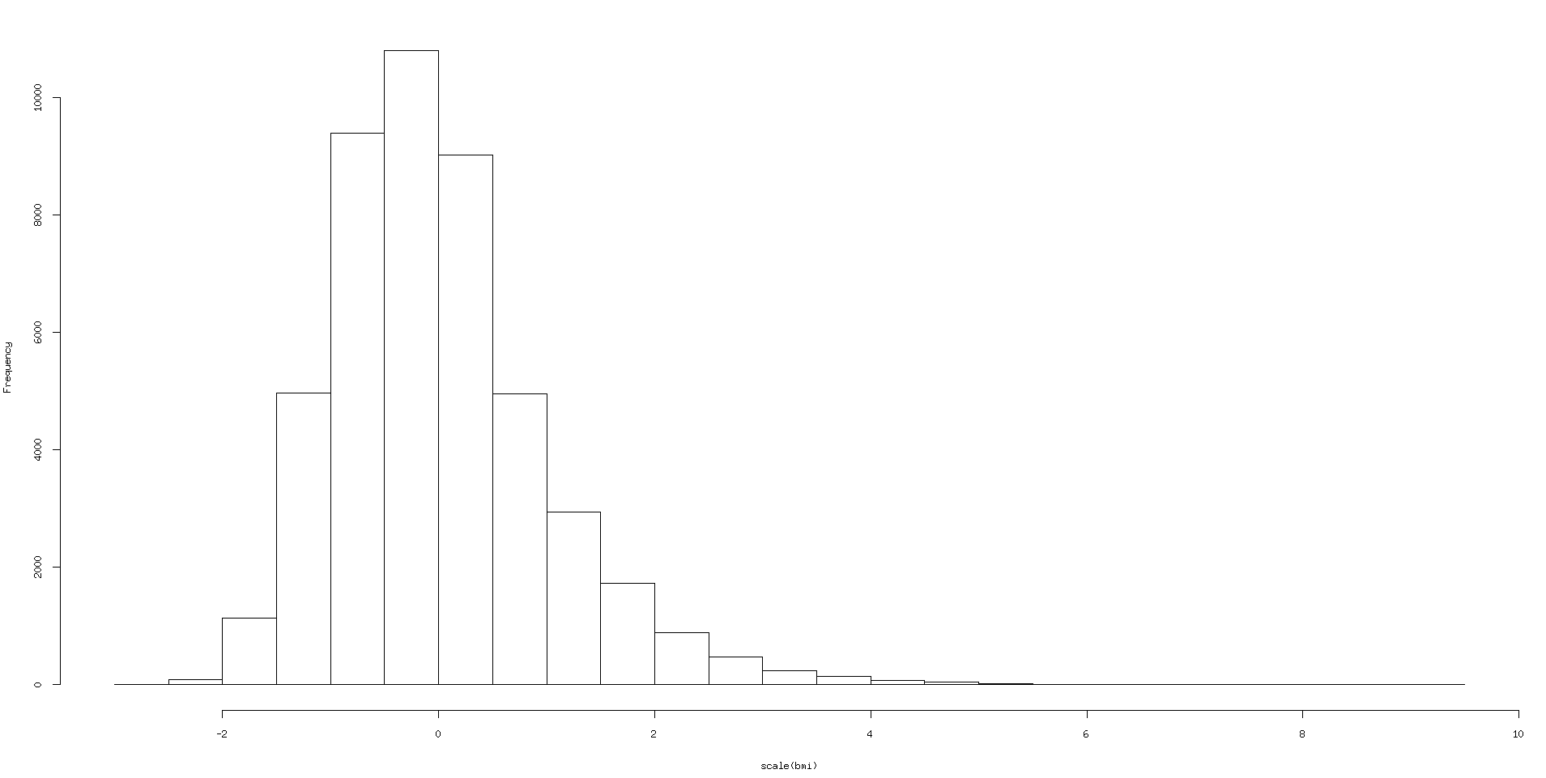

And the results are then a bit different:

cornflakes R : 0.016 , p-value : <2e-16 S. positive correlation

pancakes_vaffles R : 0.026 , p-value : <2e-16 S. positive correlation

icecream R : 0 , p-value : 0.979 N.S.

sweets_chocolate R : -0.002 , p-value : 0.596 N.S.

sugar_honey_jam R : -0.072 , p-value : <2e-16 S. negative correlation

cookies R : -0.022 , p-value : <2e-16 S. negative correlation

softdrinks_sodas_juice R : 0.039 , p-value : <2e-16 S. positive correlation

fruit R : -0.009 , p-value : 0.051 N.S. (.)

vegetables R : -0.002 , p-value : 0.67 N.S.

combining all the sugar variables together :

sugar_food R : -0.0040 , p-value : 0.3809859

sugar food is not significantly correlated with bmi.
if combining only the significant positively associated variables:

sugar_food R : 0.0219 , p-value : 1.992928e-06,

but still smaller R then soft drinks, sodas and juice alone.

In any case, both tests showed sugar, honey, jam and cookies are significantly negatively correlated with bmi.

It is not so simple and I am worried about the results of all our analysis since we assumed normality of bmi and I am wondering if we should try with glm (http://dx.doi.org/10.1590/S0102-311X2008000200027 ), maybe multiply bmi with 100 and model it as count data of dekagrams per m².

Considering fruit and vegetables, they are significantly positively correlated with the variable sacksum which is supposed to be sucrose and is our variable for sugar(partial correlation adjusted for basic covariates):

fruit and sacksum R 0.2897502 , p-value : <2e-16
vegetables and sacksum R 0.1101743 , p-value : <2e-16

and they most probably contribute a lot to the negatively associated sacksum, but it is not the only thing and it seems as if added sugar containing food items can be negatively associated with bmi as well.
So I am not sure what one can conclude here with such a simple analysis.

Amongst our variables, there is also saturated fat, trans fat, and carbohydrates that are supposed to be obesogenic if consumed too much, but are all significantly negatively associated with bmi.

I think it is very hard to conclude anything with such a simple analysis, since diet is such a complex variable to measure and to analyze. Especially since we work with macro and micro nutrients.
There is a positive side to working with macro and micro nutrients, since the large amount of different food items is summarized, but on the other hand, a lot of information is lost, since digestion and absorption of macro nutrients is dependent on the food source.
Macronutrients are ingested in a food matrix, so the bioaccessibility and bioavailabilty is different for each food item . (https://doi.org/10.1016/j.foodhyd.2011.02.026)

For example, saturated fat has been shown to be positively associated with incident cardiovascular disease only in meat source, while for dairy it was negatively associated and non-significantly associated in butter and plant sources.(doi: 10.3945/ajcn.112.037770 )
In our case these have been all mixed together and the resulting saturated fat is significantly negatively associated with bmi.

Other source of confounding might be the composition of a persons diet, for example, some one who consumes a lot of added sugar, might consequentially eat less meat. Carbohydrates intake has been recommended to be limited, but in our data, it is significantly negatively associated with bmi. But at the same time, carbohydrates will be turned into fat only if the total energy intake exceeds the persons needs, so the rest of the persons diet plays a big role and I am not sure if just adjusting for total energy intake is sufficient here.

Then another source of confounding might be the food synergy or antagonism when actually being digested and absorbed . For example intake of fiber, antioxidants, whole grains, vegetables etc. (doi:10.1016/j.foodhyd.2011.02.026),(https://www.ncbi.nlm.nih.gov/pubmed/12936941) , (doi:10.1017/S0029665112003011), (Nutritional Health
Strategies for Disease Prevention, 14th chapter DOI 10.1007/978-1-61779-894-8)
at the same time, this is conditional on the food source and whole diet (DOI:10.1021/jf1040977)

Taking all this into account, analyzing diet more thoroughly would require a lot more time and effort and Yan is already working on this.

So we had avoided all this by simply taking all the significantly associated macro and micro nutrients and model bmi with all together, since the variation they contain, seems to explain some of the variation in bmi in this population, but we can not really say what is the source of that variation, but most likely, it is not just the variation of that particular nutrient variable.

So in our case, we had just made up a very simple model of nutrients vs bmi, took the effect sizes for each nutrient to multiply the corresponding nutrient and sum them all up to get a diet score. What a certain value of a diet score actually represents in terms of the amount of each nutrient we dont know anymore at that point.

