I have added PA and alcohol to the diet score. Variable representing PA is g6 and variable for alcohol is alkosum1.

Results for model assessment in previous update, here are the results for diet, PA and alcohol put together as environment score.

Continuous BMI:

full_model<-lm(basic_residuals_bmi~diet_score+g6+alkosum1_TEI_adjusted_norm_sd)

 | beta | vif | p-value
diet score | 0.876992 | 1.005146 | <2e-16
PA | -0.081397 | 1.003445 | <2e-16
alcohol | -0.041880 | 1.008257 | <2e-16

adjusted R² : 0.05594

With these effect sizes I multiplied each component created in visit 1 and visit2 and added all three together in a final environment score.

Independent:
full_model<-lm(basic_residuals_bmi~environment_score)

environment_score beta : 1
p-value : <2e-16
adjusted R² : 0.05599

Visit 1:
full_model<-lm(basic_residuals_bmi~environment_score)

environment_score beta : 0.866377
p-value : <2e-16
adjusted R² : 0.04057

Visit 2:
full_model<-lm(basic_residuals_bmi~environment_score)

environment_score beta : 1.002757
p-value : <2e-16
adjusted R² : 0.05668

Categorized BMI:

Visit1:
bmi_category_model_multi_log_reg<-multinom(bmi_category ~ age + agesq + gender_factor + year + ffq_factor + environment_score,
data=VIP_data_subset_visit1_complete_cases)
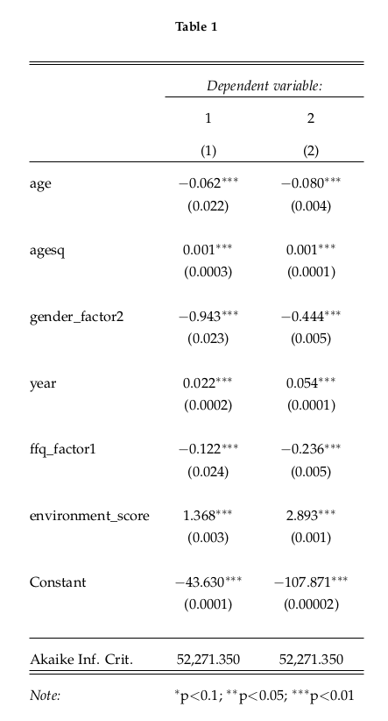

if I am not mistaken, the effect sizes are in log odds, so taking exp(), then with every increase in unit of environment score, the odds of being in overweight category are bigger by 3.927488 and the odds of being in obese category are bigger by 18.04737 as oppose to being in normal category, but to calculate the actual odds the intercept must also be taken into account (not 100% sure on the interpretation).

boxplot of the environment score per bmi category in visit 1:
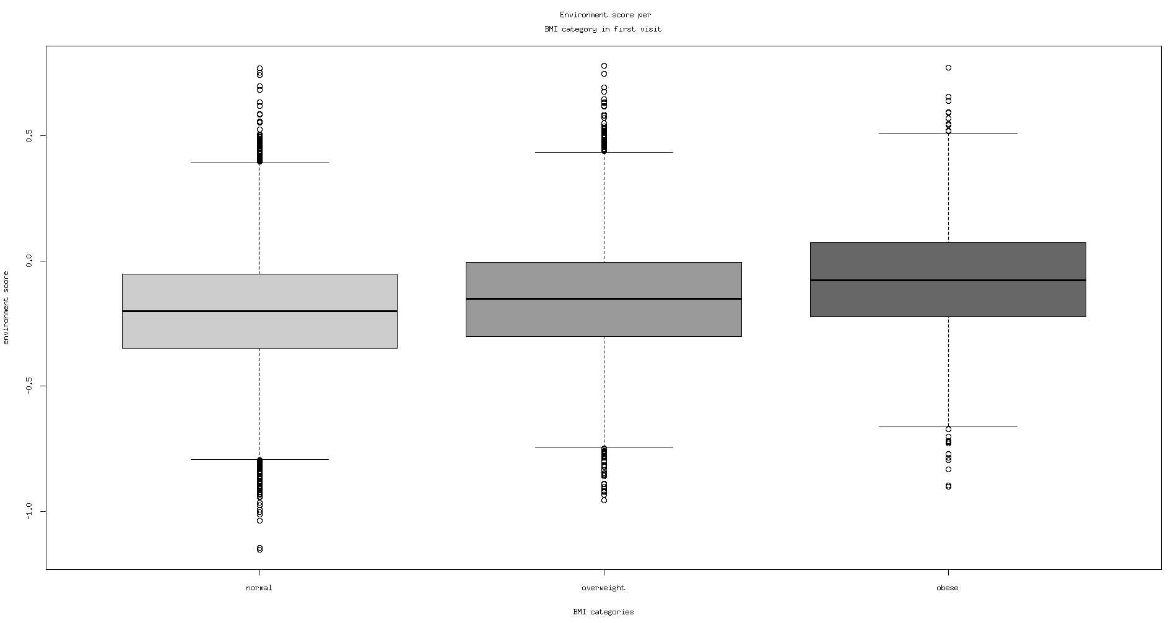

Visit2:
bmi_category_model_multi_log_reg<-multinom(bmi_category ~ age + agesq + gender_factor + year + ffq_factor + environment_score,
data=VIP_data_subset_visit2_complete_cases)
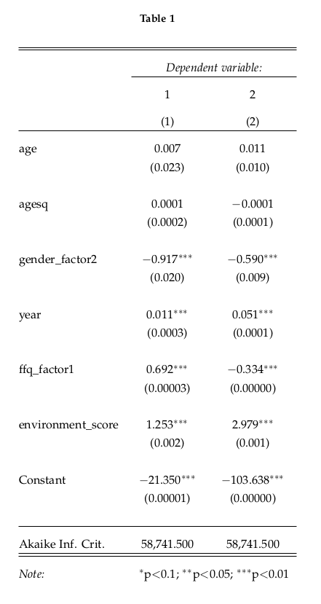

similar as before, with every increase in unit of environment score, the odds of being in overweight category are bigger by exp(1.253)=3.50083 and the odds of being in obese category are bigger by exp(2.979)=19.66814 as oppose to being in normal category.

boxplot of the environment score per bmi category in visit 2:

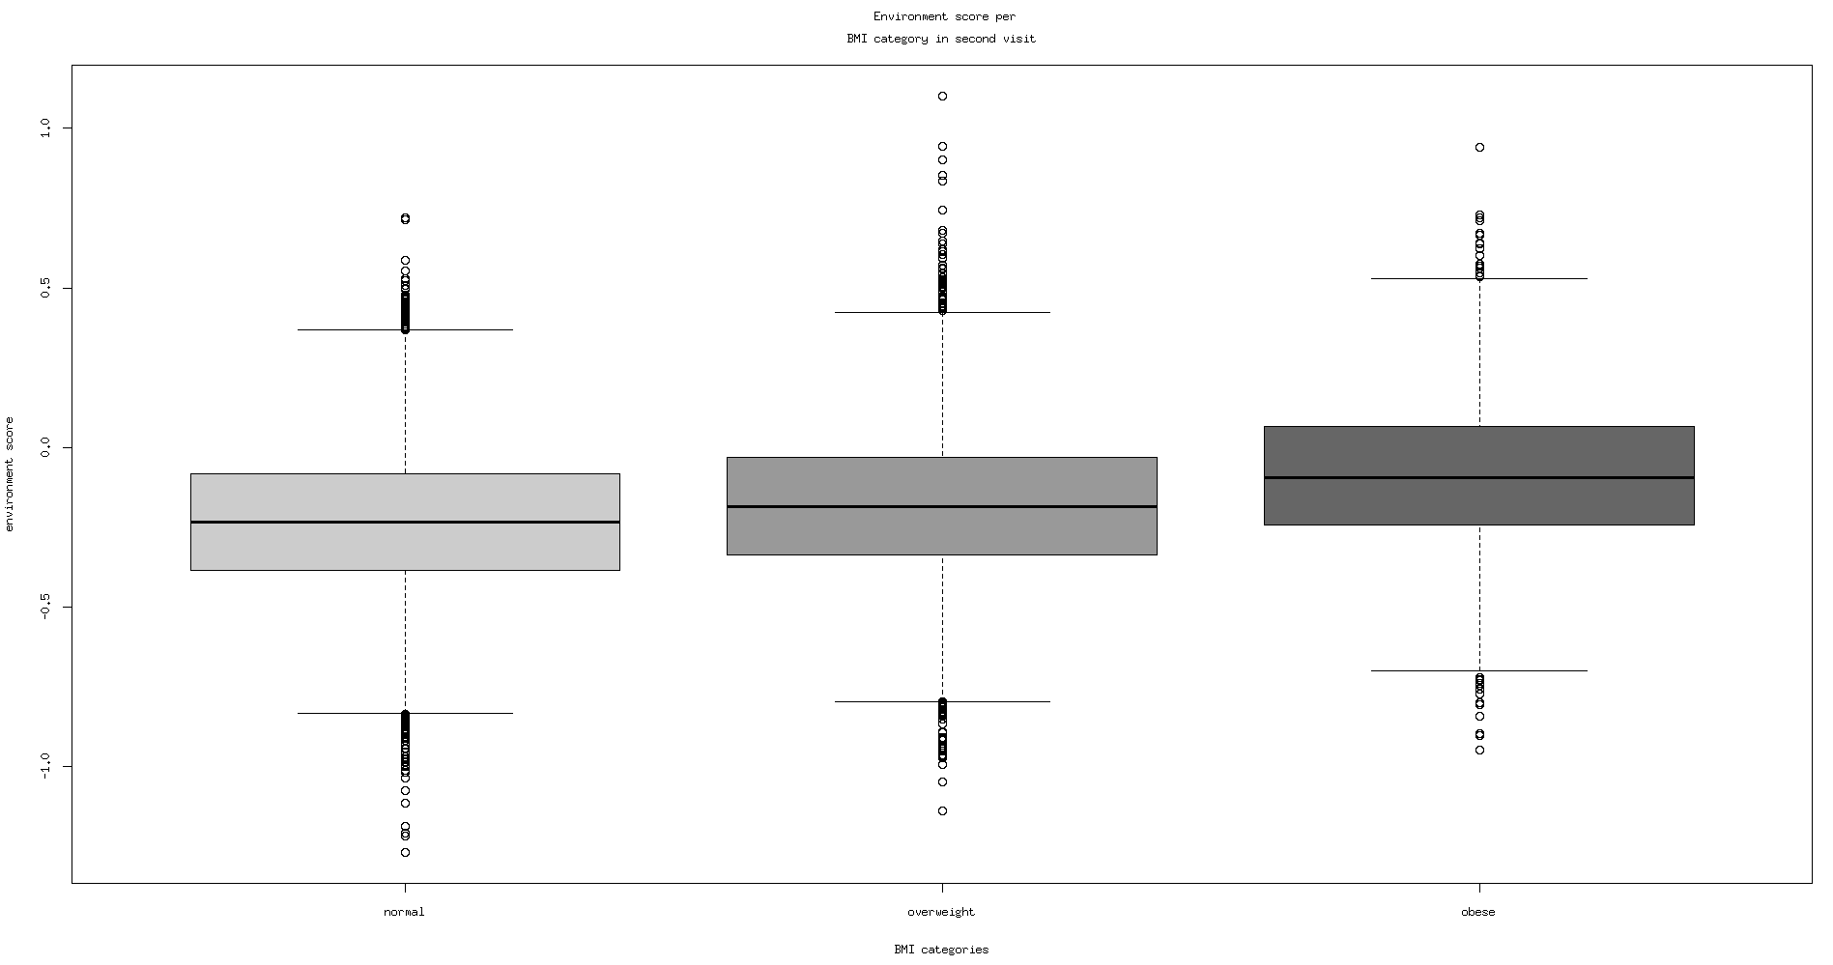

The next step is to use this environment score to identify those subjects that have an obesogenic environment , but are normal weight.
We are still not sure what is the best approach to this. We could set a cut off point in the environment score and define all above that as obesogenic environment. It might be hard to set the optimal cut off point and justify what ever choice we make.

Alaitz had an idea to divide the z-scores : bmi z-score/environment z-score
and then set a cut off point somewhere below one for the ratio, so we would end up looking at those that have a small bmi, but a large environment score.
The problem with setting a cut off point is similar as before.
Another problem here is that people with all kinds of bmi and environment score values can be selected like this, as long as the environment z-score is sufficiently bigger than bmi z-score, so even people who are actually overweight, but not obese, but still have an extremely high environment score.

Visit 1 z-scores of environment and bmi:

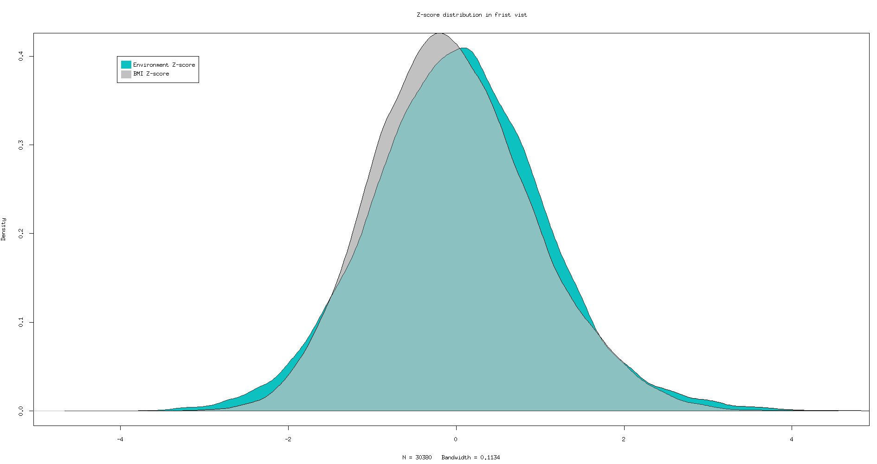

Visit 2 z-scores of environment and bmi:
