Looking at PTZ and bout length as a high active state, I have a dataframe with subjects, bout lengths and timeframes:

> head(AllPTZ)
Subject BoutLength TimeFactor
1 1 1
1 1 1
1 3 1
1 1 1
1 1 1
1 2 1

I am sending you this dataframe, saved a table and R code, so you can check things for yourself as well and here is what I have checked:

1. I extracted max per each of 144 subjects(example for first few, run the code if you want to see all):

> max_bouts_PTZ<-merge(aggregate(BoutLength ~ Subject, data = AllPTZ, FUN = max), AllPTZ)

> max_bouts_PTZ<-max_bouts_PTZ[order(max_bouts_PTZ[,1]),]

> max_bouts_PTZ<-max_bouts_PTZ[!duplicated(max_bouts_PTZ[,1]),]

> head(max_bouts_PTZ)
Subject BoutLength TimeFactor
1 13 11
2 16 12
3 15 5
4 13 6
5 12 3
6 17 2

out of this I checked the min, max, mean and sd of the max values:

> min(max_bouts_PTZ$BoutLength)
[1] 8
> max(max_bouts_PTZ$BoutLength)
[1] 53
> mean(max_bouts_PTZ$BoutLength)
[1] 17.21528
> sd(max_bouts_PTZ$BoutLength)
[1] 6.177065

So the minimum is 8, which is quite low, but sorting the maximum bout lengths and looking at the occurrences, the majority is from 10 to 20 long :

> hist(max_bouts_PTZ$BoutLength)$counts
[1] 6 56 51 19 7 3 1 0 0 1
> hist(max_bouts_PTZ$BoutLength)$breaks
[1] 5 10 15 20 25 30 35 40 45 50 55
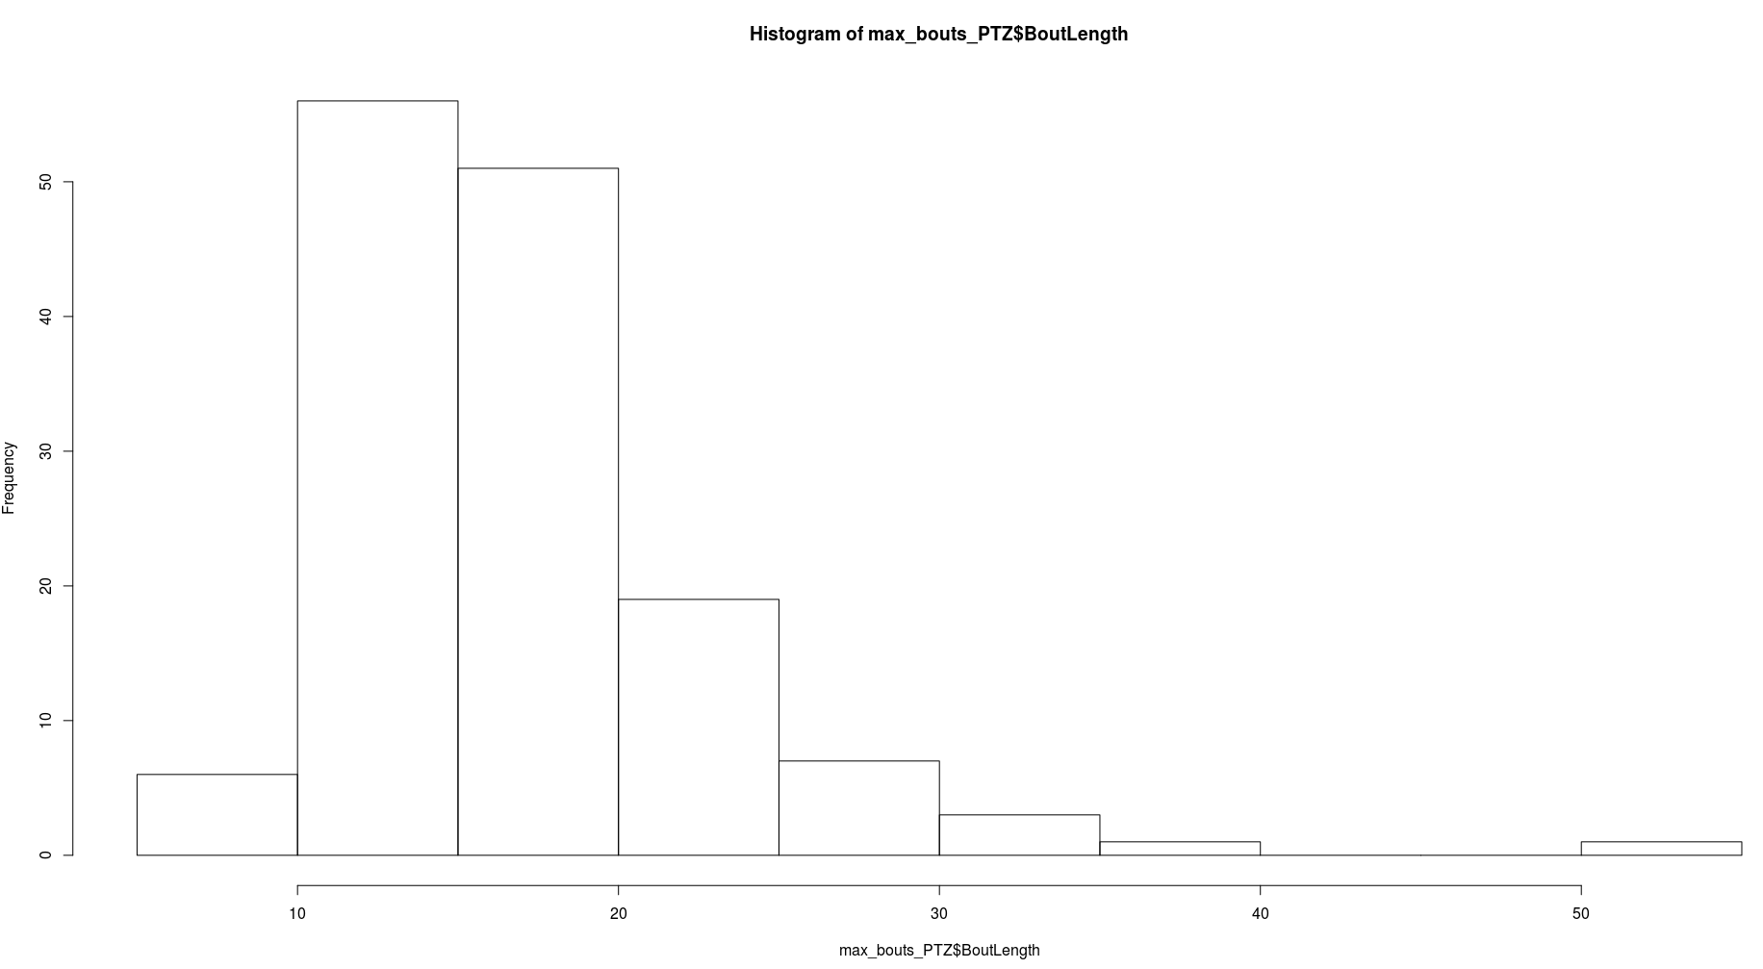

More precisely, the proportions of max bout lengths of all subjects, bigger then 10,15 and 20:

> length(max_bouts_PTZ$BoutLength[max_bouts_PTZ$BoutLength>10])/144
[1] 0.9583333
> length(max_bouts_PTZ$BoutLength[max_bouts_PTZ$BoutLength>15])/144
[1] 0.5694444
> length(max_bouts_PTZ$BoutLength[max_bouts_PTZ$BoutLength>20])/144
[1] 0.2152778

Looking at the occurrences regarding the time frame:

> hist(max_bouts_PTZ$TimeFactor)$counts
[1] 16 15 13 11 11 18 14 12 6 5 13 10
> hist(max_bouts_PTZ$TimeFactor)$breaks
[1] 1 2 3 4 5 6 7 8 9 10 11 12 13

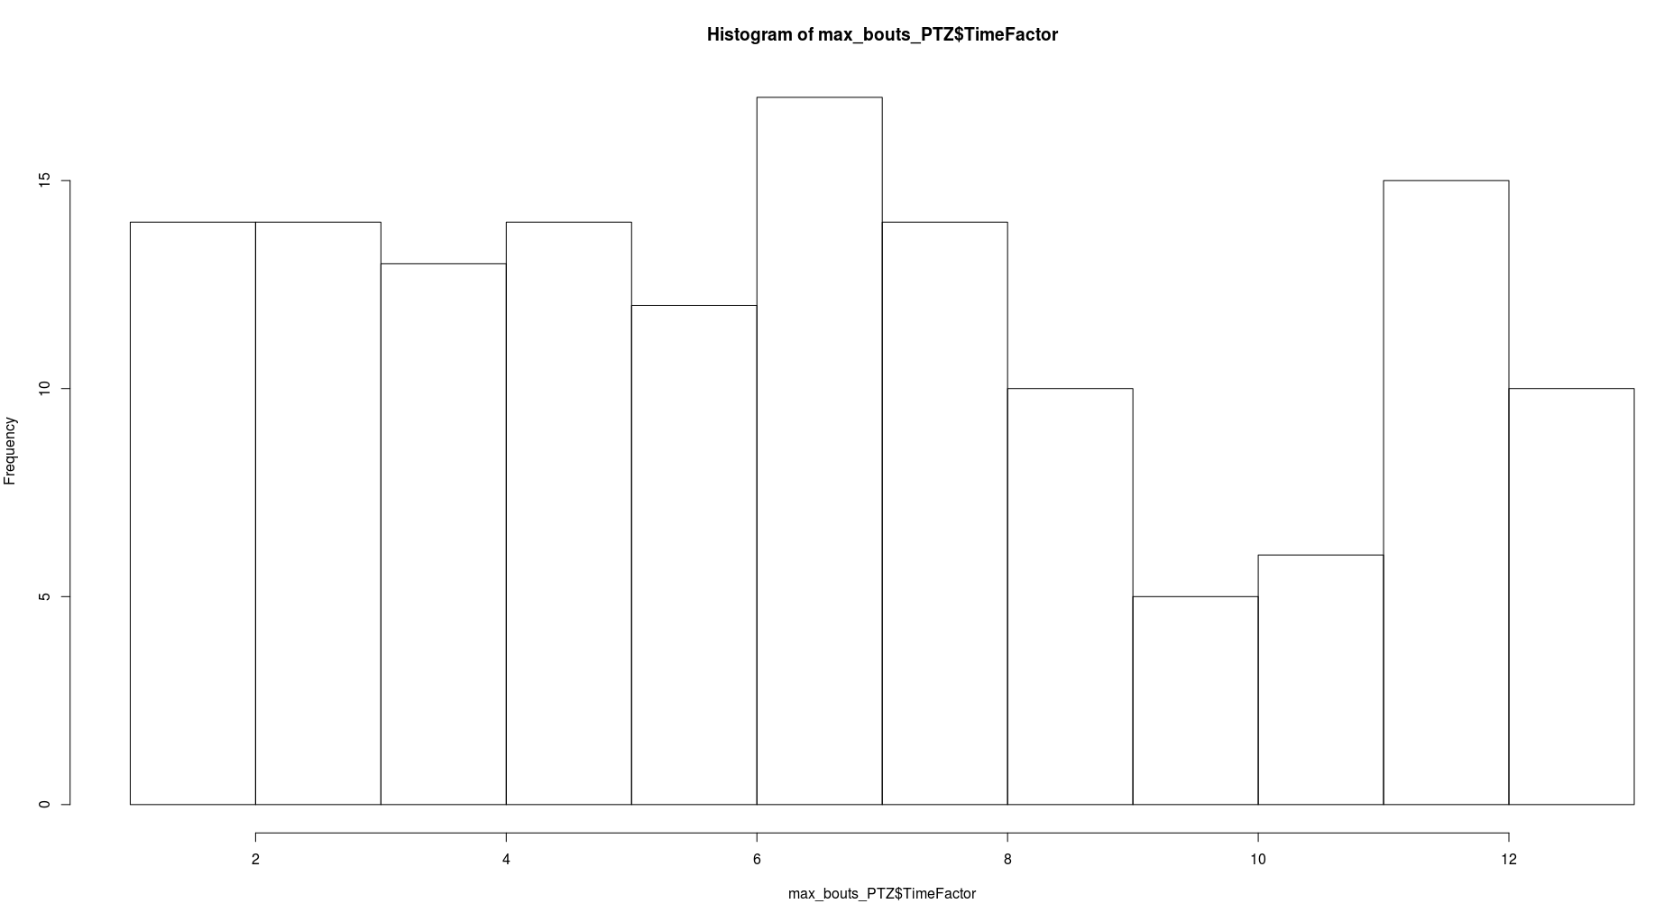

Going a bit further and checking the first five max length bouts:

> max_5_bouts_PTZ<-aggregate(BoutLength ~ Subject, data = AllPTZ, function(x){return(-sort(-x)[1:5])})

> head(max_5_bouts_PTZ)

Subject BoutLength.1 BoutLength.2 BoutLength.3 BoutLength.4 BoutLength.5
1 13 13 11 11 11
2 16 11 10 10 10
3 15 12 12 12 11
4 13 12 11 11 11
5 12 11 10 10 9
6 17 9 9 9 9

The mean of the first five max:

> mean_max_5_bouts_PTZ<-as.data.frame(cbind(max_5_bouts_PTZ$Subject,apply(max_5_bouts_PTZ[,-1],1,mean)))

> colnames(mean_max_5_bouts_PTZ)<-c("Subject","MeanBoutLength_Max_5")

> min(mean_max_5_bouts_PTZ$MeanBoutLength_Max_5)
[1] 7.2
> max(mean_max_5_bouts_PTZ$MeanBoutLength_Max_5)
[1] 28.2
> mean(mean_max_5_bouts_PTZ$MeanBoutLength_Max_5)
[1] 13.77778
> sd(mean_max_5_bouts_PTZ$MeanBoutLength_Max_5)
[1] 4.120025

And the distribution:

> hist(mean_max_5_bouts_PTZ$MeanBoutLength_Max_5)$counts
[1] 3 19 38 28 27 11 8 2 3 1 3 1
> hist(mean_max_5_bouts_PTZ$MeanBoutLength_Max_5)$breaks
[1] 6 8 10 12 14 16 18 20 22 24 26 28 30
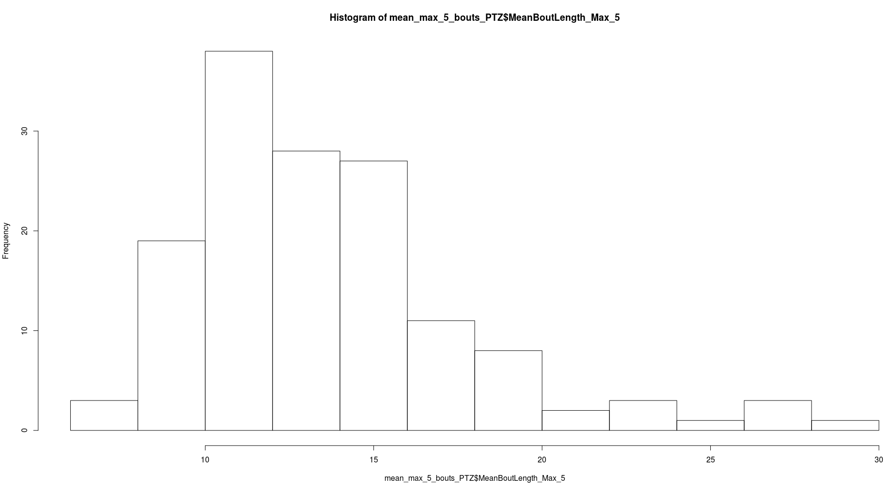

Proportions of mean first five max bout lengths bigger than 10, 15, 20:
>length(mean_max_5_bouts_PTZ$MeanBoutLength_Max_5[mean_max_5_bouts_PTZ$MeanBoutLength_Max_5>10])/144
[1] 0.8472222
>length(mean_max_5_bouts_PTZ$MeanBoutLength_Max_5[mean_max_5_bouts_PTZ$MeanBoutLength_Max_5>15])/144
[1] 0.2708333
>length(mean_max_5_bouts_PTZ$MeanBoutLength_Max_5[mean_max_5_bouts_PTZ$MeanBoutLength_Max_5>20])/144
[1] 0.06944444

Count the number of bouts equal or longer than the minimum maximum bout length of all subjects, which is 8.

> count_high_active_PTZ<-aggregate(BoutLength ~ Subject, data = AllPTZ, function(x){return(length(x[x>=8]))})

> colnames(count_high_active_PTZ)<-c("Subject","CountBoutsOver_8")
>
> min(count_high_active_PTZ$CountBoutsOver_8)
[1] 1
>
> max(count_high_active_PTZ$CountBoutsOver_8)
[1] 127
>
> mean(count_high_active_PTZ$CountBoutsOver_8)
[1] 27.80556
>
> sd(count_high_active_PTZ$CountBoutsOver_8)
[1] 24.43495

And the distribution:

> hist(count_high_active_PTZ$CountBoutsOver_8)$counts
[1] 24 51 28 13 5 9 3 3 3 0 2 2 1
>
> hist(count_high_active_PTZ$CountBoutsOver_8)$breaks
[1] 0 10 20 30 40 50 60 70 80 90 100 110 120 130
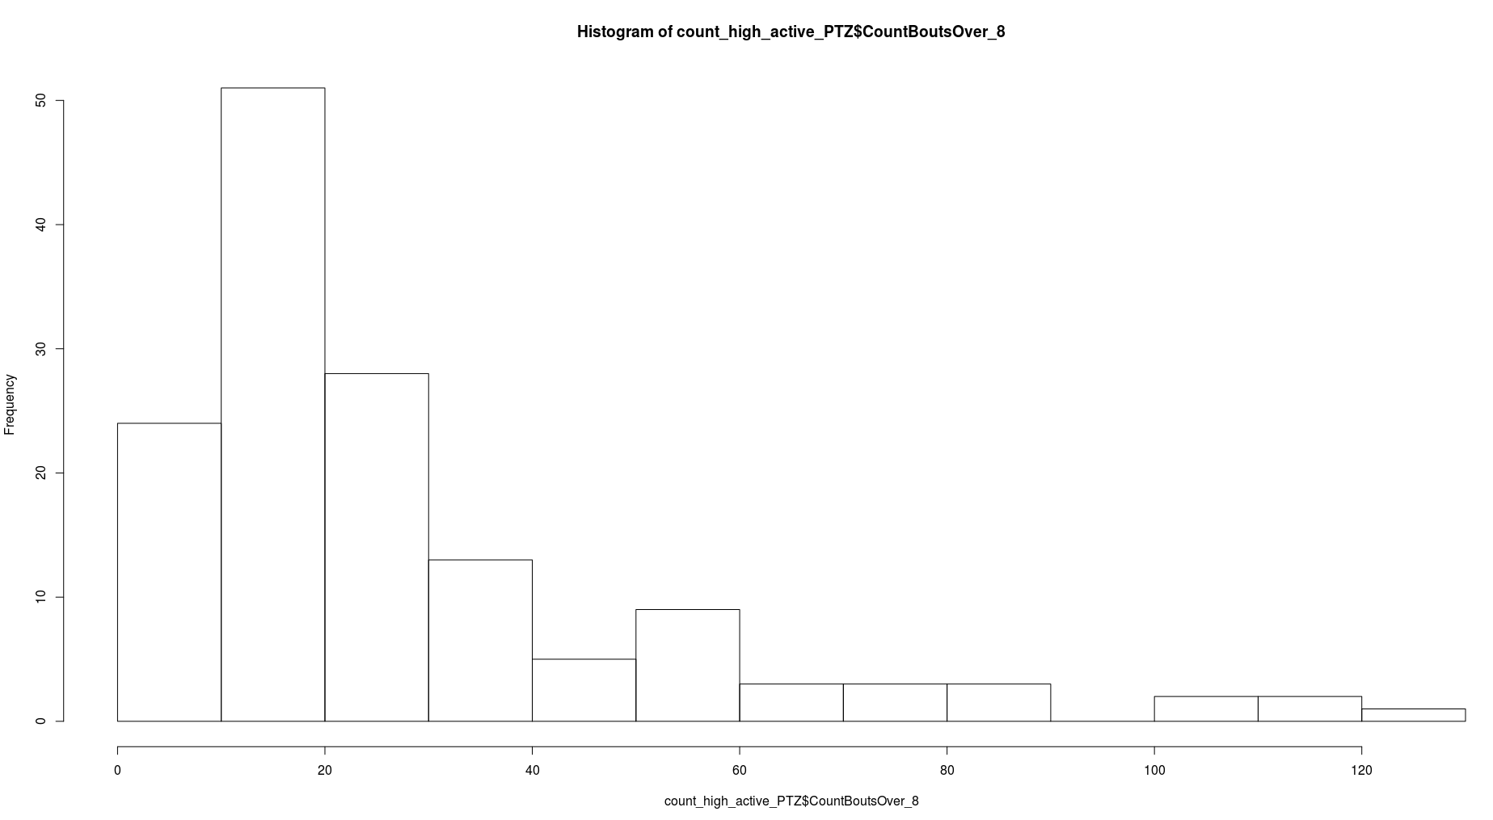

Proportions of these counts bigger than 5, 10, 20 (these counts=total number of bouts bigger than the minimum maximum bout length):

>length(count_high_active_PTZ$CountBoutsOver_8[count_high_active_PTZ$CountBoutsOver_8>5])/144
[1] 0.9305556
>length(count_high_active_PTZ$CountBoutsOver_8[count_high_active_PTZ$CountBoutsOver_8>10])/144
[1] 0.8333333
>length(count_high_active_PTZ$CountBoutsOver_8[count_high_active_PTZ$CountBoutsOver_8>15])/144
[1] 0.625

It might help to see the distribution of the first 3 max length bouts, so you know when to look, although it seems almost uniform:

> max_3_bouts_time_frames<- max_bouts_PTZ$TimeFactor

> get_time_frames<-merge(aggregate(BoutLength ~ Subject, data = AllPTZ, function(x){return(-sort(-x)[2])}),AllPTZ)
> get_time_frames<-get_time_frames[order(get_time_frames[,1]),]
> get_time_frames<-get_time_frames[!duplicated(get_time_frames[,1]),3]

> max_3_bouts_time_frames<-c(max_5_bouts_time_frames,get_time_frames)

> get_time_frames<-merge(aggregate(BoutLength ~ Subject, data = AllPTZ, function(x){return(-sort(-x)[3])}),AllPTZ)
> get_time_frames<-get_time_frames[order(get_time_frames[,1]),]
> get_time_frames<-get_time_frames[!duplicated(get_time_frames[,1]),3]

> max_3_bouts_time_frames<-c(max_5_bouts_time_frames,get_time_frames)

> hist(max_3_bouts_time_frames)$counts
[1] 50 61 39 59 47 58 60 45 35 29 53 40

> hist(max_3_bouts_time_frames)$breaks
[1] 1 2 3 4 5 6 7 8 9 10 11 12 13

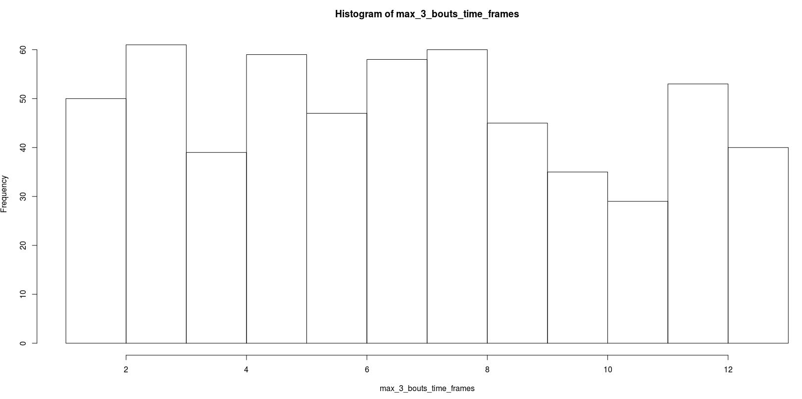
Mean number of bouts longer than 4, 6, 8, 10, 15 per time frame, over all subjects. Note that they can not be exactly seen as mean per subject as the mean is over all counts pooled together, not per subject summed.

> mean_count_long_bouts_15_PTZ<-aggregate(BoutLength ~ TimeFactor, data = AllPTZ, function(x){return(length(x[x>=15])/144)})
> colnames(mean_count_long_bouts_15_PTZ)<-c("TimeFactor","MeanCountLongBouts")
> mean_count_long_bouts_15_PTZ
TimeFactor MeanCountLongBouts
1 1 0.0625000
2 2 0.1666667
3 3 0.2430556
4 4 0.2361111
5 5 0.3194444
6 6 0.2500000
7 7 0.2708333
8 8 0.2638889
9 9 0.1527778
10 10 0.1666667
11 11 0.1041667
12 12 0.1736111
13 13 0.1597222
> plot(mean_count_long_bouts_15_PTZ$TimeFactor,mean_count_long_bouts_15_PTZ$MeanCountLongBouts)
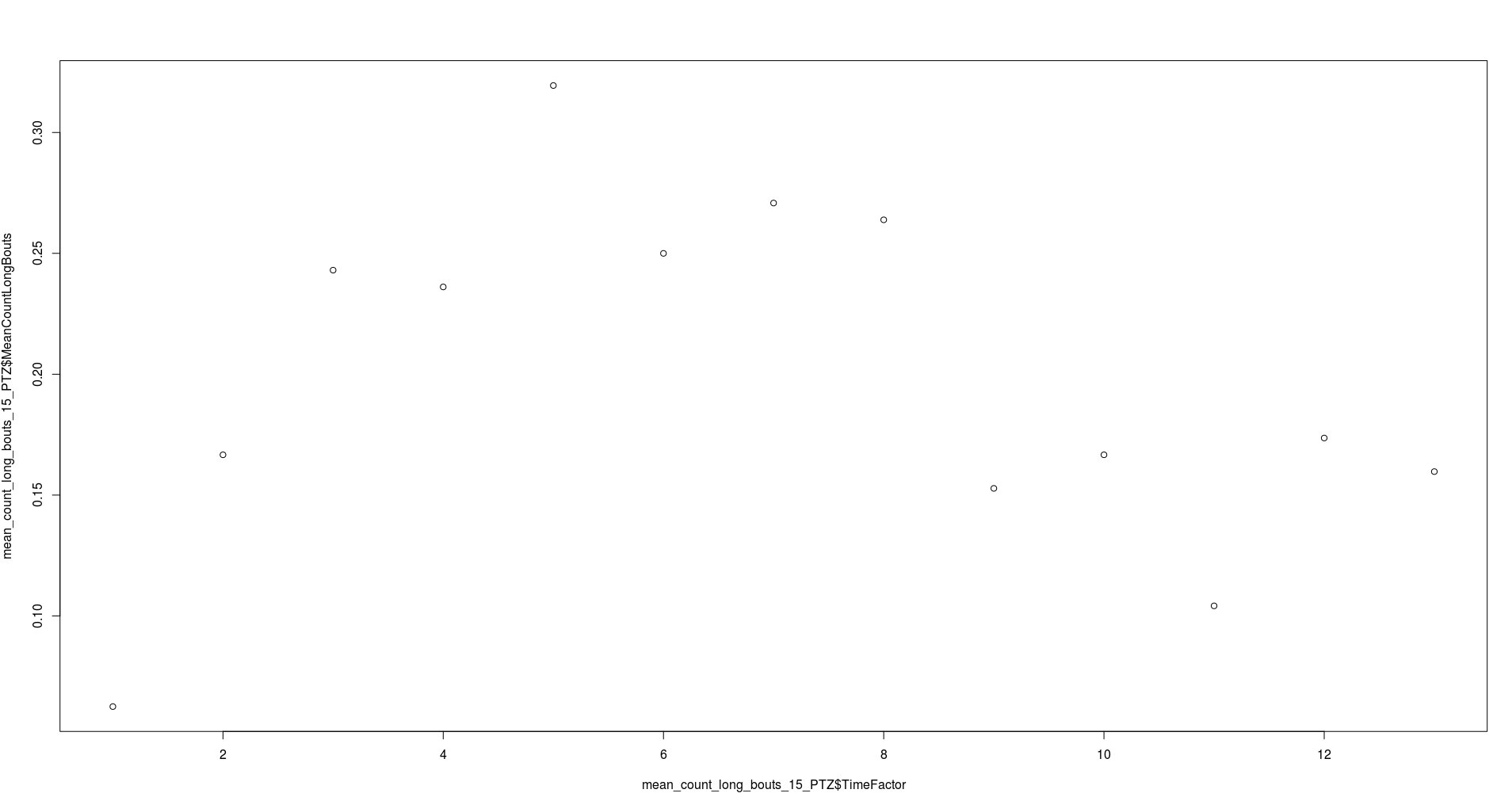

> mean_count_long_bouts_10_PTZ<-aggregate(BoutLength ~ TimeFactor, data = AllPTZ, function(x){return(length(x[x>=10])/144)})
> colnames(mean_count_long_bouts_10_PTZ)<-c("TimeFactor","MeanCountLongBouts")
> mean_count_long_bouts_10_PTZ
TimeFactor MeanCountLongBouts
1 1 0.2430556
2 2 0.7847222
3 3 1.0138889
4 4 1.1666667
5 5 1.1666667
6 6 0.9722222
7 7 1.2569444
8 8 1.1736111
9 9 1.0069444
10 10 0.8541667
11 11 0.9652778
12 12 1.0763889
13 13 1.1388889
> plot(mean_count_long_bouts_10_PTZ$TimeFactor,mean_count_long_bouts_10_PTZ$MeanCountLongBouts)
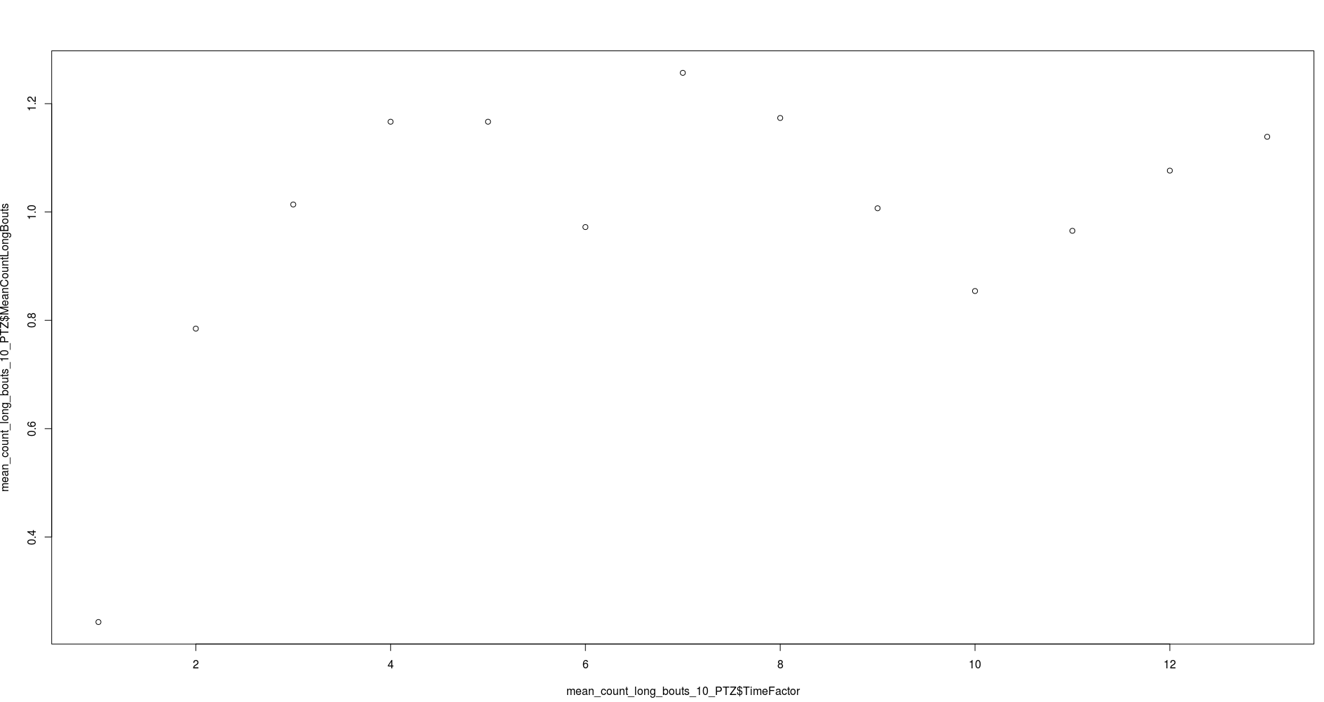

> mean_count_long_bouts_8_PTZ<-aggregate(BoutLength ~ TimeFactor, data = AllPTZ, function(x){return(length(x[x>=8])/144)})
> colnames(mean_count_long_bouts_8_PTZ)<-c("TimeFactor","MeanCountLongBouts")
> mean_count_long_bouts_8_PTZ
TimeFactor MeanCountLongBouts
1 1 0.7777778
2 2 1.8888889
3 3 2.2500000
4 4 2.4027778
5 5 2.2152778
6 6 2.2500000
7 7 2.3750000
8 8 2.3541667
9 9 2.1666667
10 10 2.1111111
11 11 2.4097222
12 12 2.2708333
13 13 2.3333333
> plot(mean_count_long_bouts_8_PTZ$TimeFactor,mean_count_long_bouts_8_PTZ$MeanCountLongBouts)
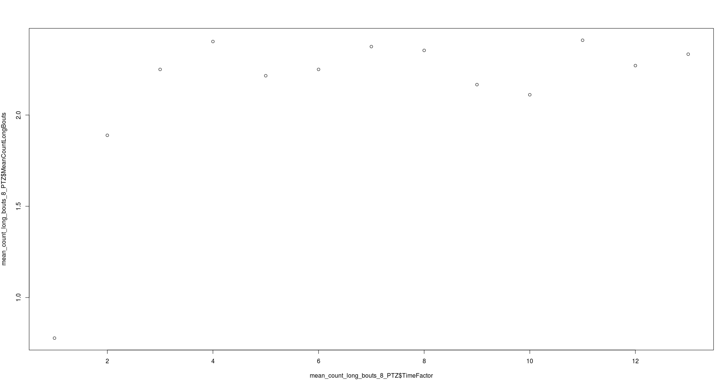

> mean_count_long_bouts_6_PTZ<-aggregate(BoutLength ~ TimeFactor, data = AllPTZ, function(x){return(length(x[x>=6])/144)})
> colnames(mean_count_long_bouts_6_PTZ)<-c("TimeFactor","MeanCountLongBouts")
> mean_count_long_bouts_6_PTZ
TimeFactor MeanCountLongBouts
1 1 2.465278
2 2 4.576389
3 3 4.979167
4 4 5.201389
5 5 4.854167
6 6 5.402778
7 7 5.131944
8 8 5.208333
9 9 5.076389
10 10 5.000000
11 11 5.326389
12 12 5.048611
13 13 5.402778
> plot(mean_count_long_bouts_6_PTZ$TimeFactor,mean_count_long_bouts_6_PTZ$MeanCountLongBouts)

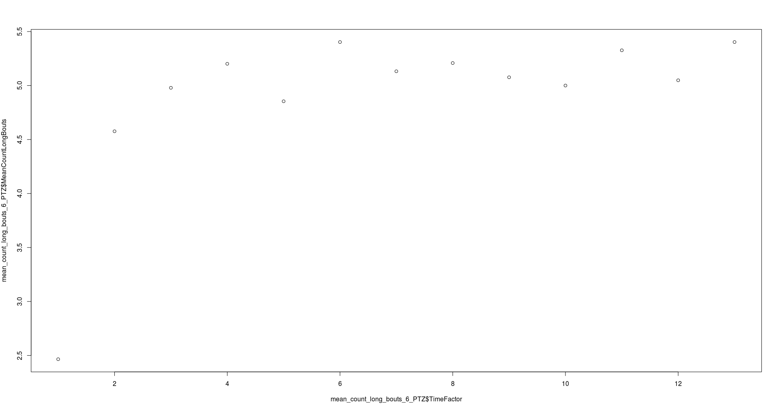

> mean_count_long_bouts_4_PTZ<-aggregate(BoutLength ~ TimeFactor, data = AllPTZ, function(x){return(length(x[x>=4])/144)})
> colnames(mean_count_long_bouts_4_PTZ)<-c("TimeFactor","MeanCountLongBouts")
> mean_count_long_bouts_4_PTZ
TimeFactor MeanCountLongBouts
1 1 11.11806
2 2 12.15972
3 3 12.46528
4 4 12.70833
5 5 12.07639
6 6 12.73611
7 7 12.31250
8 8 12.71528
9 9 12.67361
10 10 12.19444
11 11 12.59722
12 12 12.48611
13 13 12.86806
> plot(mean_count_long_bouts_4_PTZ$TimeFactor,mean_count_long_bouts_4_PTZ$MeanCountLongBouts)
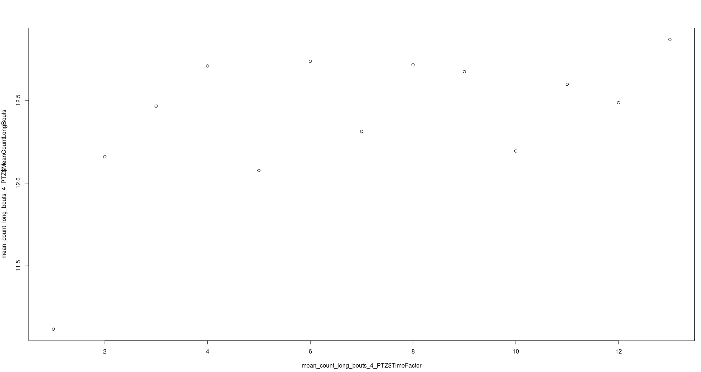

Box plots of bouts of length from 8 to 16 and over 16 per time frame(characteristics of longer bouts per time, over all subjects=they are in the box)

PTZ_long_bouts_8_16<-aggregate(BoutLength ~ TimeFactor, data = AllPTZ, function(x){return(x[x>=8 & x<16])})
boxplot(sapply(PTZ_long_bouts_8_16[,2], '[', seq(max(sapply(PTZ_long_bouts_8_16[,2],length)))))
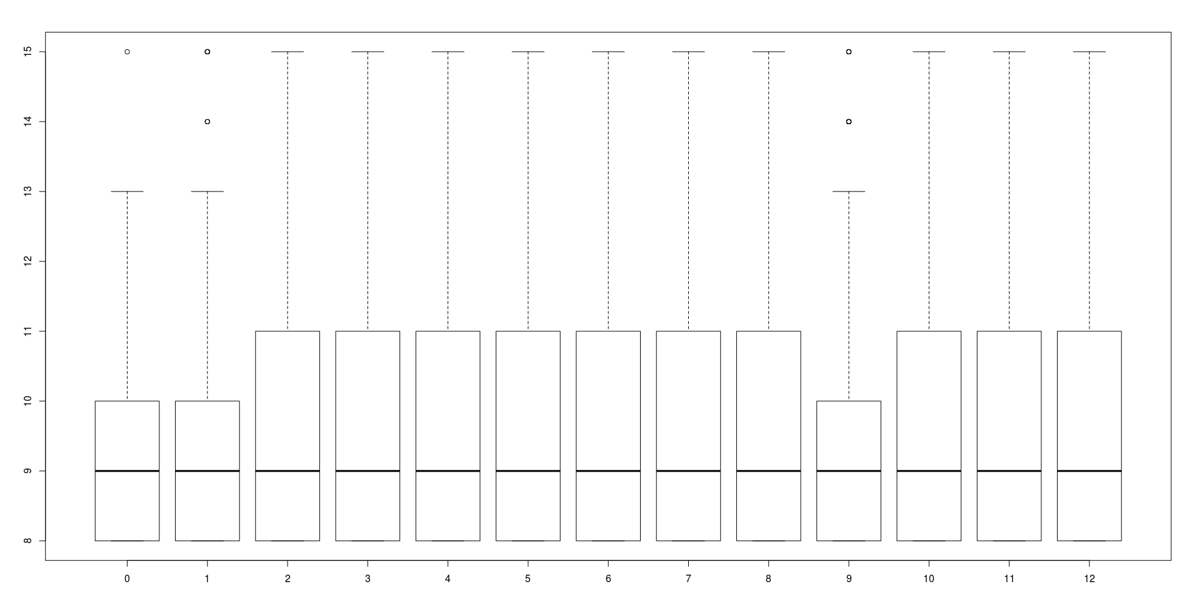

Sorry for the missing labels, x is time frame (0-12=1-13), y is bout length and as you can see from the ylim, they go from 8 up to but not including 16.

Same here except the bout length is from including 16 and over:
PTZ_long_bouts_16<-aggregate(BoutLength ~ TimeFactor, data = AllPTZ, function(x){return(x[x>=16])})
boxplot(sapply(PTZ_long_bouts_16[,2], '[', seq(max(sapply(PTZ_long_bouts_16[,2],length)))))

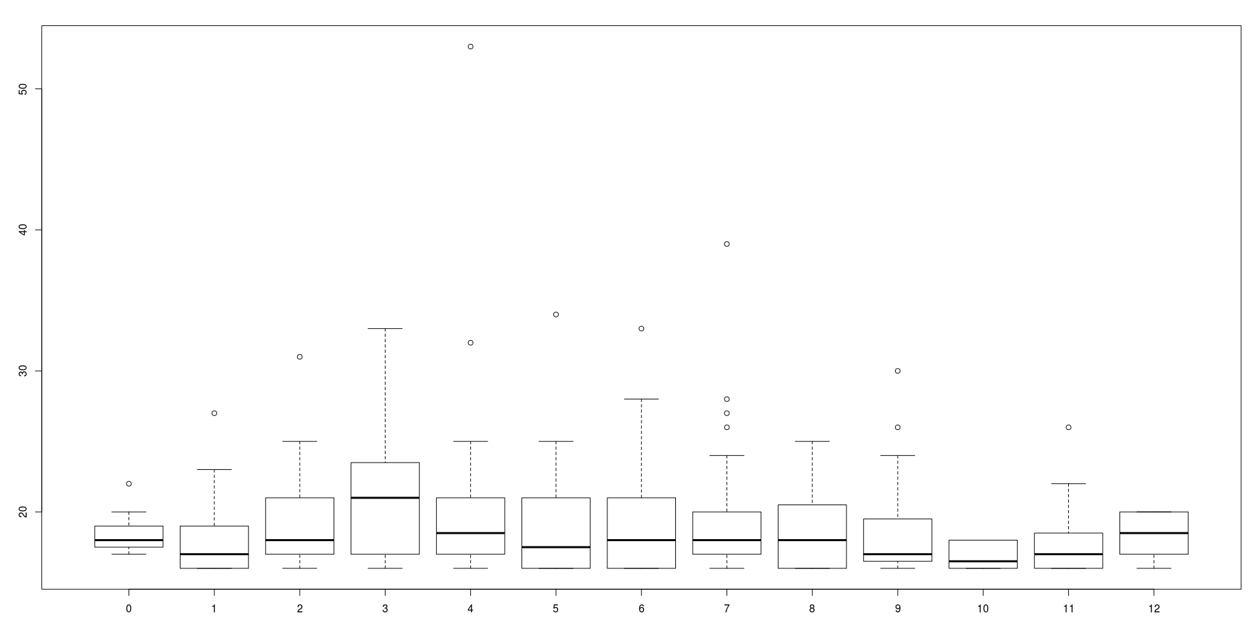

Last, the boxplots of counts of bouts longer then 8,12,6 per time frame over all subjects(subjects form the box)

count_longer_8_bouts_PTZ<-aggregate(BoutLength ~ Subject, data = AllPTZ[AllPTZ$TimeFactor==1,], function(x){return(length(x[x>=8]))})

for(time_frame in 2:13){
count_longer_8_bouts_PTZ<-cbind(count_longer_8_bouts_PTZ, aggregate(BoutLength ~ Subject, data = AllPTZ[AllPTZ$TimeFactor==time_frame,], function(x){return(length(x[x>=8]))})[,2])
}

colnames(count_longer_8_bouts_PTZ)<-c("Subject","TimeFrame1","TimeFrame2","TimeFrame3","TimeFrame4","TimeFrame5","TimeFrame6","TimeFrame7","TimeFrame8","TimeFrame9","TimeFrame10","TimeFrame11","TimeFrame12","TimeFrame13")

boxplot(count_longer_8_bouts_PTZ[,-1])

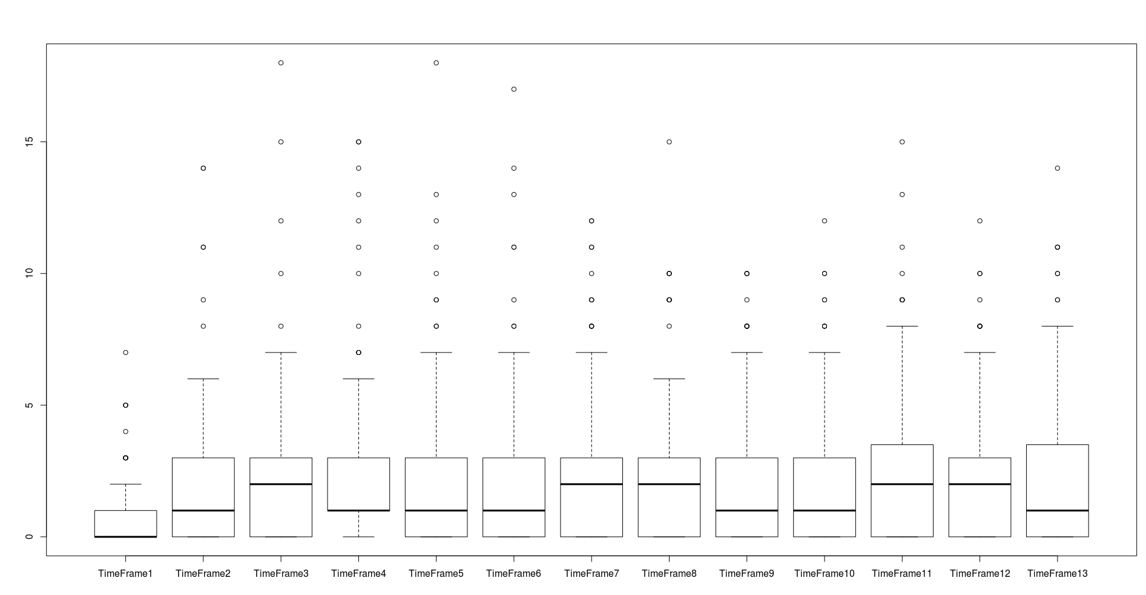

count_longer_12_bouts_PTZ<-aggregate(BoutLength ~ Subject, data = AllPTZ[AllPTZ$TimeFactor==1,], function(x){return(length(x[x>=12]))})

for(time_frame in 2:13){
count_longer_12_bouts_PTZ<-cbind(count_longer_12_bouts_PTZ, aggregate(BoutLength ~ Subject, data = AllPTZ[AllPTZ$TimeFactor==time_frame,], function(x){return(length(x[x>=12]))})[,2])
}

colnames(count_longer_12_bouts_PTZ)<-c("Subject","TimeFrame1","TimeFrame2","TimeFrame3","TimeFrame4","TimeFrame5","TimeFrame6","TimeFrame7","TimeFrame8","TimeFrame9","TimeFrame10","TimeFrame11","TimeFrame12","TimeFrame13")

boxplot(count_longer_12_bouts_PTZ[,-1])

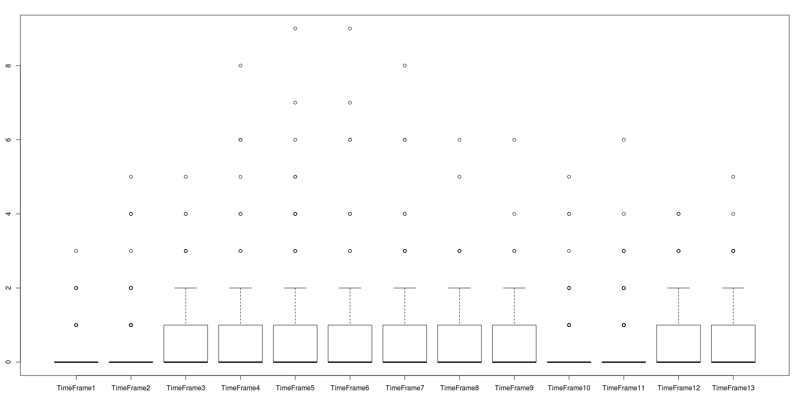

count_longer_6_bouts_PTZ<-aggregate(BoutLength ~ Subject, data = AllPTZ[AllPTZ$TimeFactor==1,], function(x){return(length(x[x>=6]))})

for(time_frame in 2:13){
count_longer_6_bouts_PTZ<-cbind(count_longer_6_bouts_PTZ, aggregate(BoutLength ~ Subject, data = AllPTZ[AllPTZ$TimeFactor==time_frame,], function(x){return(length(x[x>=6]))})[,2])
}

colnames(count_longer_6_bouts_PTZ)<-c("Subject","TimeFrame1","TimeFrame2","TimeFrame3","TimeFrame4","TimeFrame5","TimeFrame6","TimeFrame7","TimeFrame8","TimeFrame9","TimeFrame10","TimeFrame11","TimeFrame12","TimeFrame13")

boxplot(count_longer_6_bouts_PTZ[,-1])

