UPDATE 11.11.2016

SHORT INTRODUCTION
Zebrafish experiment is run in two parts.
Part A is the “natural behavior” part, where movement of healthy fish is being recorded for 4 groups in 3 different models. The 4 groups are a control group and three groups with different dosage of the novel drug being tested. The 3 different models are constant light, constant dark and constant switching from light to dark.
Part B is the “disease behavior”, where the fish from the above part are given a substance to induce a “disease” state. Three different substances are given, serving for three “disease” states, low dose of Apomorphine, serving as sedated/low active state, high dose of Apomorphine, serving as a hyperactive state and PTZ, also serving as a hyperactive state. Part B of the experiment is always run in dark for all 4 groups and all three “disease” inducing substances.
At the moment, there are 12 drugs being tested, for 12 subjects(fish) for 65 minutes in 5 minute grouping.
This resulted in 12 recordings of 12 healthy subjects(144 x 65 minute groups of action sequences) as a control group and 12 recordings of 12 subjects as a control group given “disease” inducing PTZ.
Same is available for other conditions, but Fredrik has suggested I start by analyzing these two, as they are supposed to be the most different(sleeping fish in the dark versus hyper active fish in the dark) and it is a good way to get started and familiarize with the data.

ANALYSIS
Action sequences are made up of bouts consisting of various turns. There has been a debate regarding the length of bouts, whether they are sufficiently long to be analyzed as a separate unit, instead of analyzing the entire action sequence of the 5 minute grouping. In the last, there is the issue of the unknown time period between the bouts, resulting in impaired comparison between action sequences.
For that purpose I extracted(for all 144 subjects, for both conditions):
-lengths of 5 minute action sequences
-number of bouts per 5 minute action sequence
-mean length of a bout per 5 minute action sequence(excluding the direction indicators, but including the m indicators for joint turns, see notes in the end though)
-standard deviation of the length of a bout per 5 minute action sequence

First I visualized the results:

LENGTH OF ACTION SEQUENCE
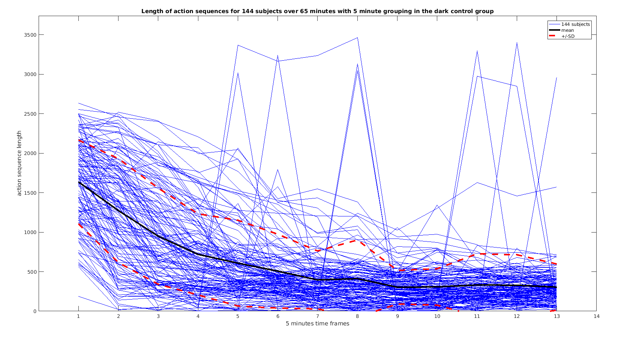
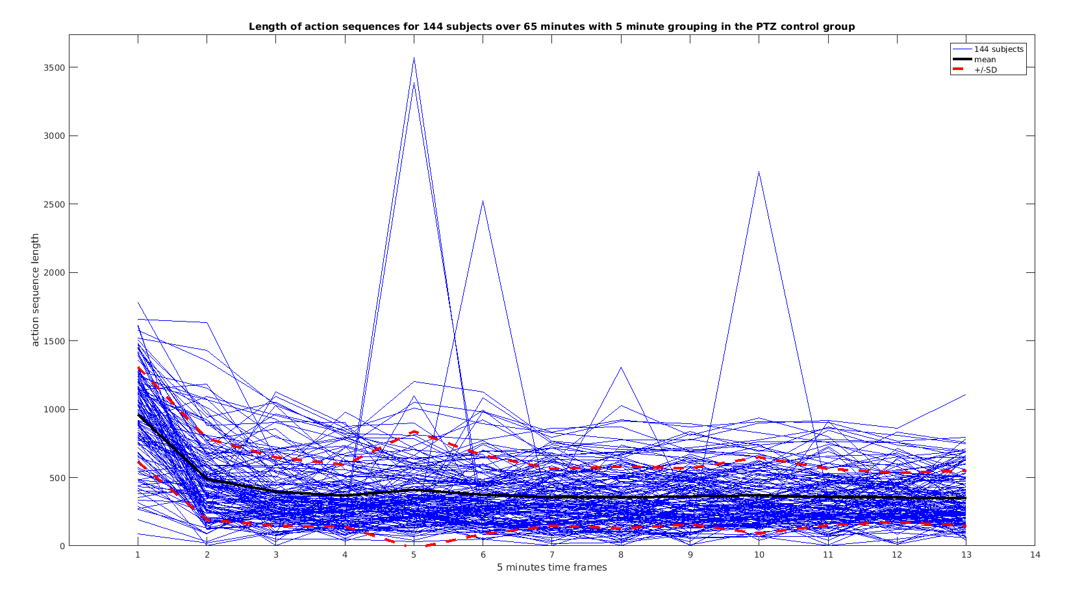
There seems to be a few outliers, which dont drastically influence the mean and SD. In both states, healthy and “disease” induced, the length of sequence appears to go down as the experiments progresses, probably due to fish falling a sleep in the dark, I did expect the PTZ to have longer action sequences, since the fish are supposed to be more active, but it could be that this is shown in longer bouts per action sequence and not in the overall length of the action sequence itself.
NUMBER OF BOUTS PER ACTION SEQUENCE
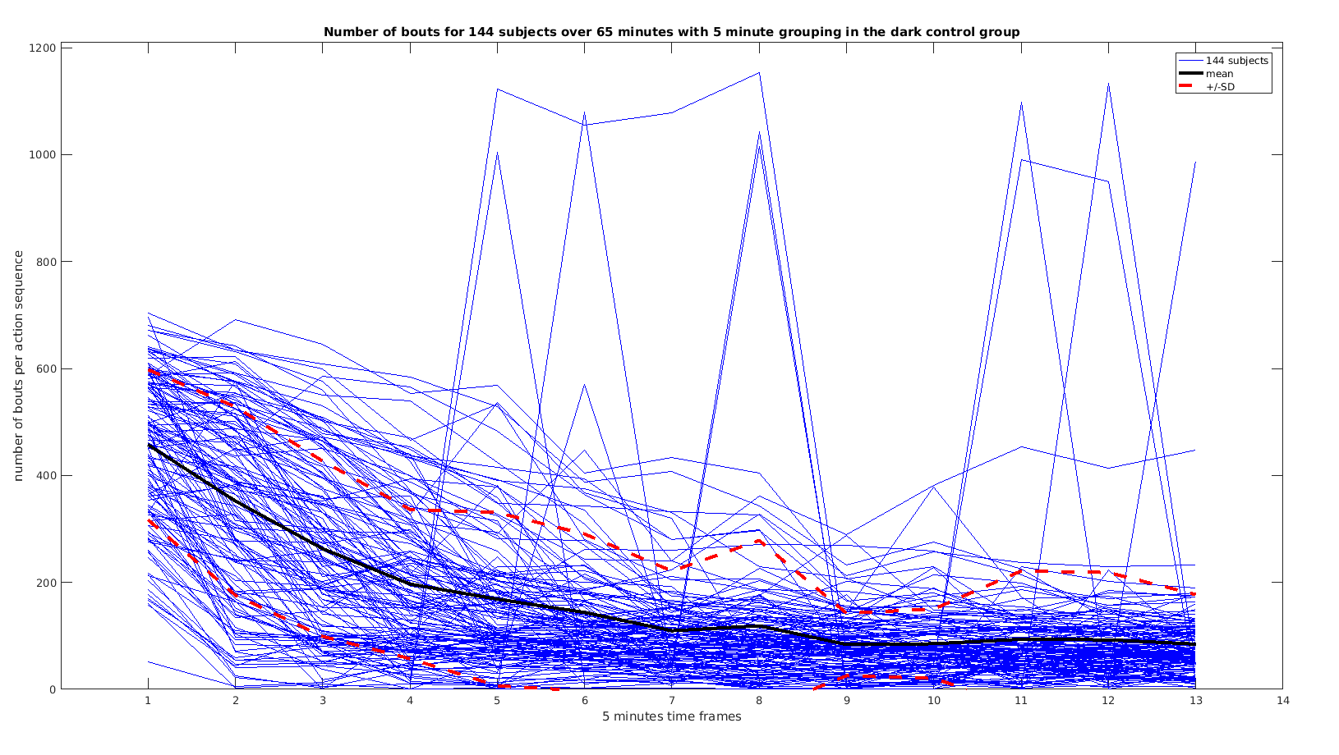
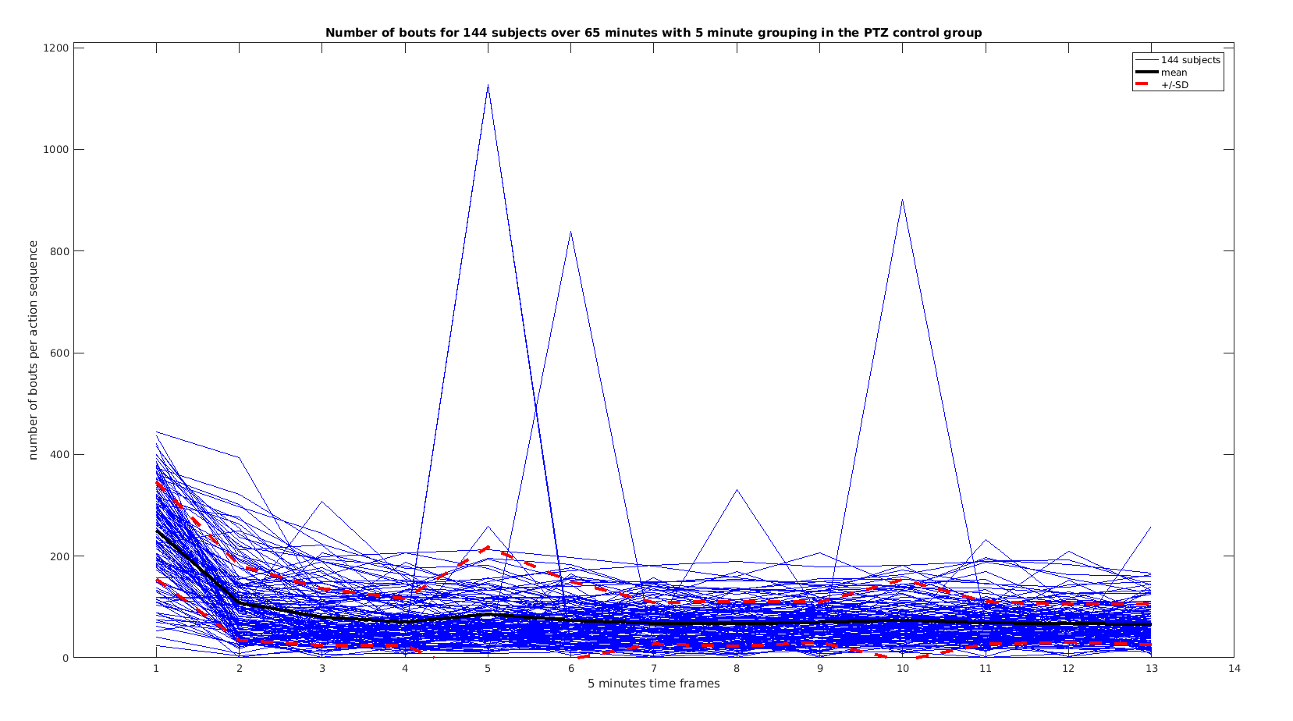
Again outliers in similar time frames, not influencing the mean and SD(some fish had nightmares :) ?)
There appears to be substantially less bouts per action sequence in the PTZ induced “disease” state, with smaller SD. Considering the length of the action sequences was not so substantially smaller, could really suggest that in this state fish do less but longer bouts.

MEAN LENGTH OF A BOUT PER ACTION SEQUENCE
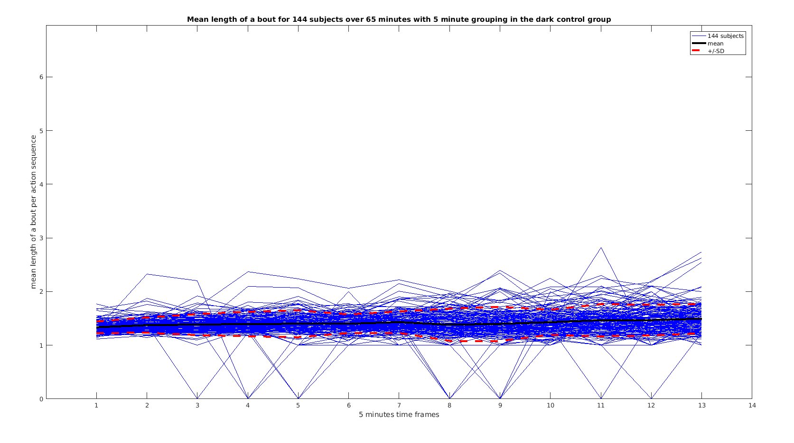
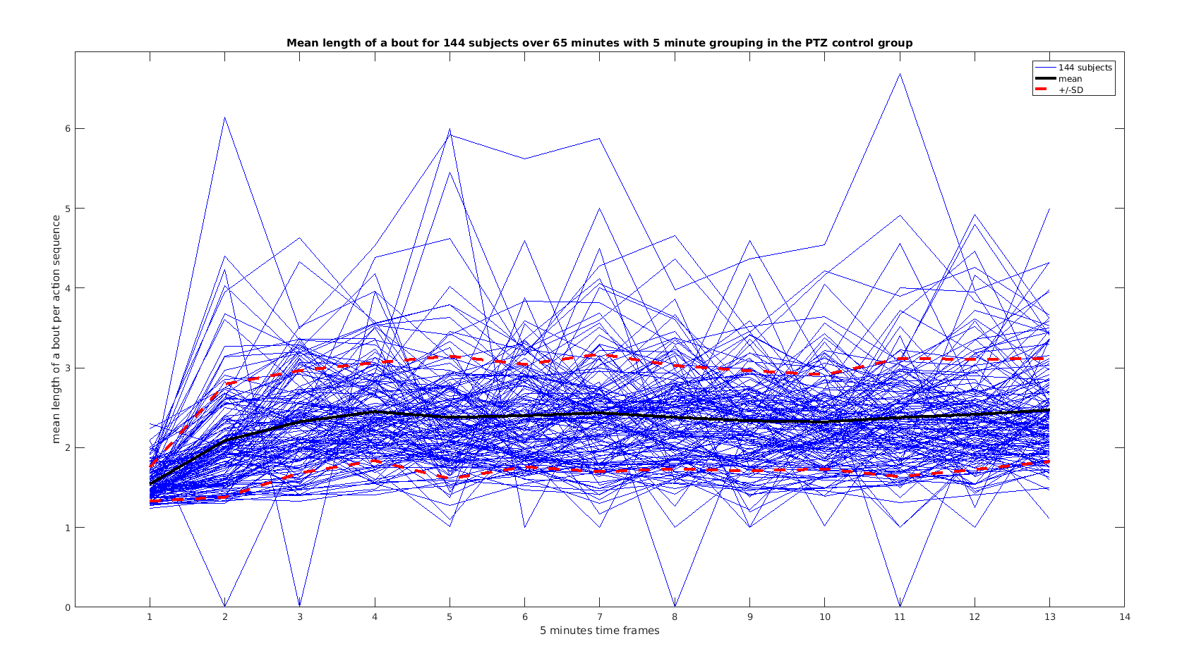
As anticipated the PTZ induced “disease” state appears to have longer bouts than the healthy state, at the same time there seems to be more variation between the subjects and the time frames of the experiment, this is more evident in the plot of SD of bout length per action sequence, next page.

STANDARD DEVIATION OF LENGTH OF A BOUT PER ACTION SEQUENCE
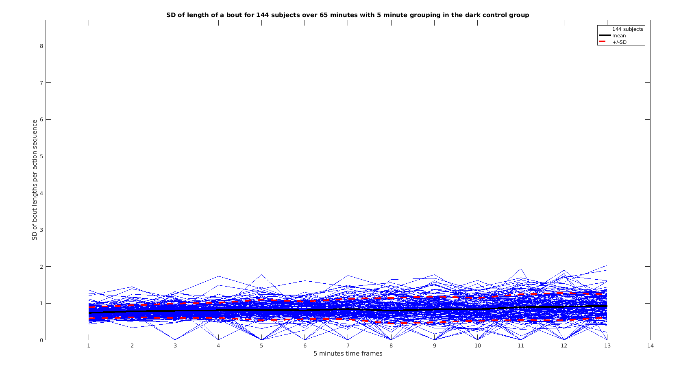
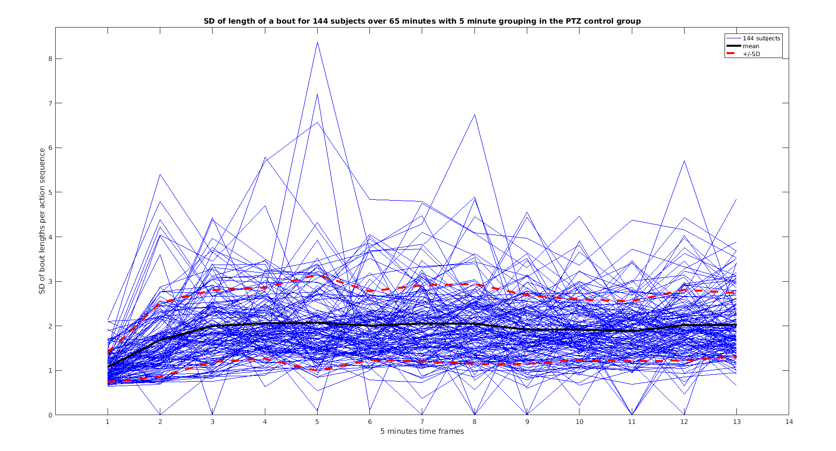
Apparent increased standard deviation of the bout lengths per action sequence, seen in the PTZ induced “disease” state.

Visualization showed some distinct features of each state, the healthy and PTZ induced “disease” state. To better compare these features I ran some simple tests:

t.test(DarkLengths,PTZLengths)

Welch Two Sample t-test

data: DarkLengths and PTZLengths
t = 7.1371, df = 230.361, p-value = 1.231e-11
alternative hypothesis: true difference in means is not equal to 0
95 percent confidence interval:
143.3705 252.7162
sample estimates:
mean of x mean of y
621.0247 422.9814

So indeed healthy state fish have longer action sequences than PTZ induced “disease” state, by factor of 1.4 .

> t.test(DarkNumberOfBouts,PTZNumberOfBouts)

Welch Two Sample t-test

data: DarkNumberOfBouts and PTZNumberOfBouts
t = 11.5844, df = 194.777, p-value < 2.2e-16
alternative hypothesis: true difference in means is not equal to 0
95 percent confidence interval:
70.28408 99.12578
sample estimates:
mean of x mean of y
173.06694 88.36201

Number of bouts per action sequence is greater in healthy state than PTZ induced “disease” state, by a factor of 1.95, which is more then the above factor.

> t.test(DarkmeanLengthOfBout,PTZmeanLengthOfBout)

Welch Two Sample t-test

data: DarkmeanLengthOfBout and PTZmeanLengthOfBout
t = -23.5336, df = 178.172, p-value < 2.2e-16
alternative hypothesis: true difference in means is not equal to 0
95 percent confidence interval:
-0.9645540 -0.8153071
sample estimates:
mean of x mean of y
1.412708 2.302639

Mean length of a bout per action sequence is greater in PTZ induced “disease” state than in healthy state.
> t.test(DarksdLengthOfBout,PTZsdLengthOfBout)

Welch Two Sample t-test

data: DarksdLengthOfBout and PTZsdLengthOfBout
t = -24.7808, df = 182.572, p-value < 2.2e-16
alternative hypothesis: true difference in means is not equal to 0
95 percent confidence interval:
-1.1574426 -0.9867241
sample estimates:
mean of x mean of y
0.8328472 1.9049306

The standard deviation of bout lengths per action sequence is greater in PTZ induced “disease” state than in healthy state.

RELEVANT CONCLUSIONS FROM THIS ANALYSIS
Very simple and basic sequence analysis of action sequences can reveal differences between the healthy and PTZ induced “disease” state.

The bouts are very short(excluding the direction indication). Averaging over all subjects, over all action sequences, the mean length of a bout in the healthy state is 1.41 with a mean standard deviation 0.83 and in the PTZ induced “disease” the mean length is 2.30 with a mean standard deviation 1.90. This raises doubt whether bouts can be analyzed as separate units.
Most probably, the entire actions sequences will have to be analyzed and the issue of unknown time between the bouts will have to be addressed and resolved, either by including that information in the sequence or by establishing that this information is irrelevant to the analysis and can be left out, resulting in removing b from the sequences or keeping b as an indicator of a steady state of any duration.

NOTES

I am not sure how to interpret m in the sequence, it is supposed to be defined as joined turns, but I am not sure how.
S for scoot, sometimes has the direction indicated and sometimes not, I did not notice this for any other turn.

PLANNED WORK UNTIL/FOR NEXT WEEK
I will do similar analysis but extracting proportions of various turns per action sequence, or pairs of turns etc.
I will also check the lengths of action sequences and bouts for other conditions.

