UPDATE 18.11.2016

I had examined the sequence lengths even further for the rest of the control groups(3 healthy and 3 disease). I am attaching all the plots in separate zips, grouped according to the descriptive statistics for all 6 control groups. The results were as expected and reflected the conditions in the which the experiment was taken. The healthy control group recorded in light/dark periods clearly reflects this alternation, while the control group under light will reflect more activity over all the recording. The plots also showed that the disease control group for fish exposed to light and then given a low dose of Apomorphine in dark, have a very low average sequence length, which is expected since fish are in a sedated state. Such short sequence length could potentially present a problem, as the amount of information in the sequence could end up being insufficient for further analysis.
So I had removed the b from the sequences and examine the lengths and their proportions of scoots for all 6 control groups. I plotted the proportion of sequences smaller or equal then 100,20,10,4 and equal to zero(note that this is cumulative, sequences smaller than 4, are also smaller then 10,20,100 etc.)
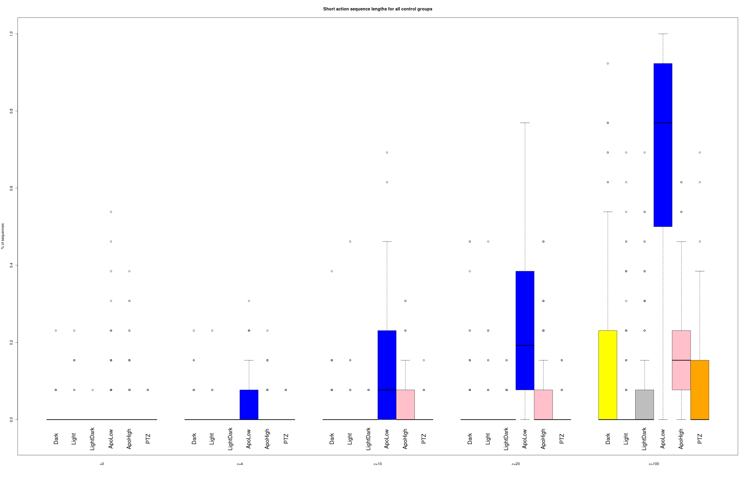
As seen before, the Apo Low control group has quite short sequences, the median of sequences smaller or equal then 20 is at a fifth while the upper quartile is at around 40%, considering that this is still including the direction indications, the amount information here can be really small. When examining further, the majority of sequences in Apo Low are less or equal then 100. To get a better picture of the amount of information they contain I also checked the proportion of scoots and O bends to have another example.
Proportions of scoots in the short sequences for each threshold(4,10,20,100):
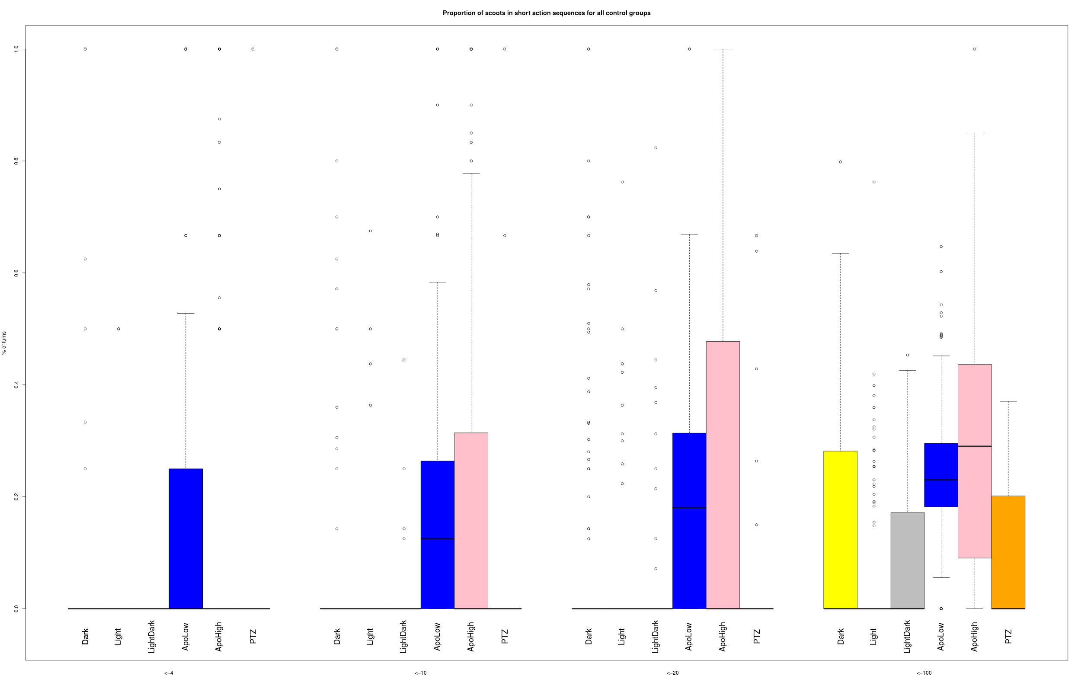
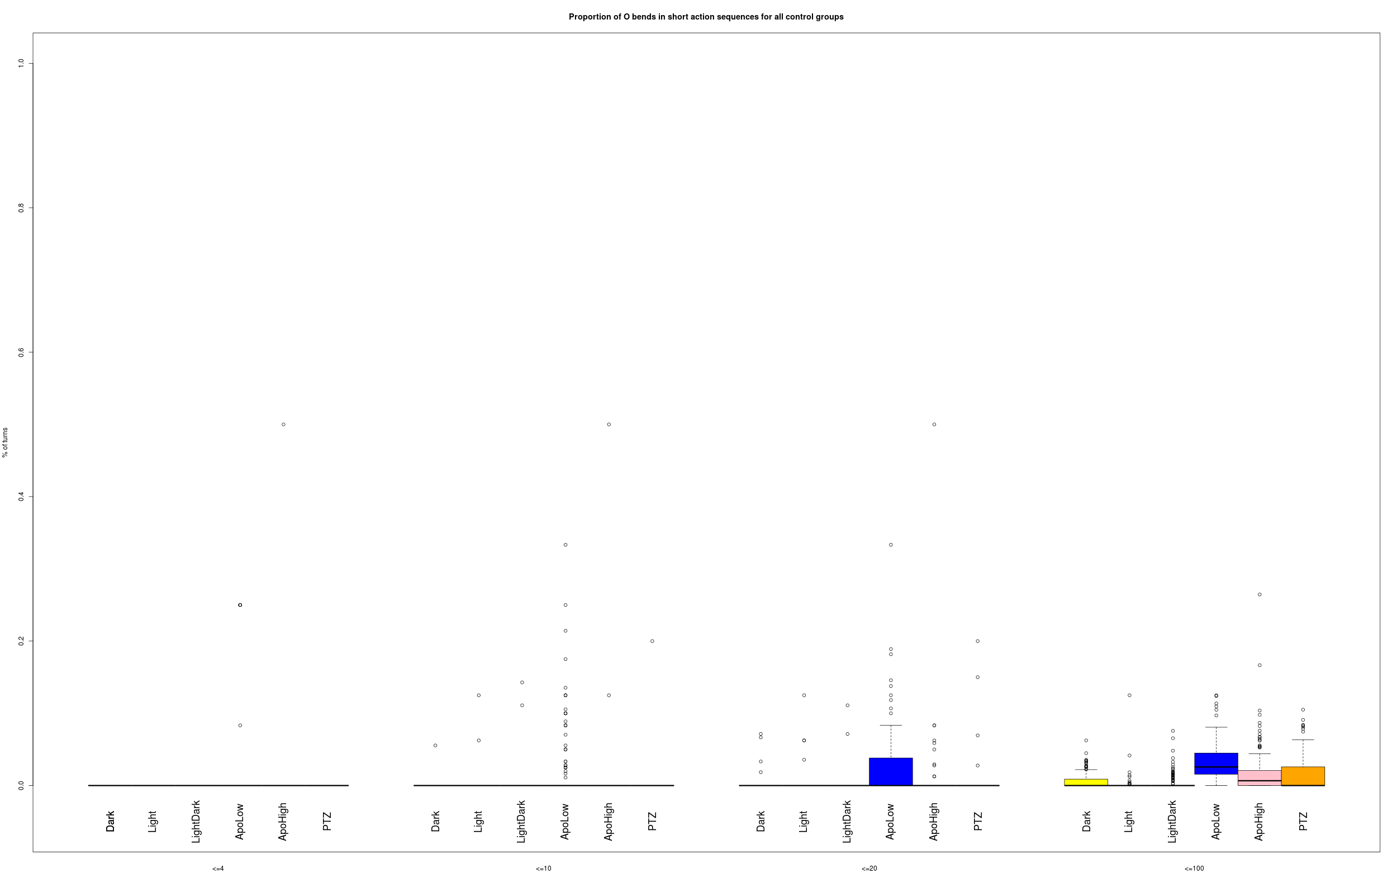
The proportions of scoots are not critically high, although higher then for example O bends. Nevertheless, when sequences are equal or smaller 20, the amount of information is already low and if considering the median proportion of scoots is around 20% with a maximum over 60% this amount will get even lower.
In these plots all the time information regarding the progression through experiment is lost.
The information from the 5 minute grouping/recording could be used to examine how the action sequence changes as the experiment progresses.
I have done some boxplots grouped according to the 5 minute time grouping. For some descriptive statistics I had already plotted the line plot, so the grouped boxplots will therefor be similar to those.
I had added the proportions of turns to the statistics combining either all the control groups or turns for each control group. I am attaching the plots in a zip.
Overall, there are some distinct differences among the control groups, I noticed the three light/dark conditions of the healthy control groups seem to have an apparent affect on the proportion of bends.
Statistical analysis should be done to properly check this effect, but I think you have already done all that and had seen these differences, so I did not go much into this, but if anybody thinks I should check this, let me know, could just be a good practice and preparation for further analysis.

THIS WEEKS WORK:
As Fredrik suggested, I will now try to analyze the periods of high and low activity, starting with PTZ.
I will try to examine how the action sequence changes through the 65 minute experiment, while separating the bouts into high or low activity bouts and see if I can extract any kind of information that could help explain how the drug influences the movement.

NOTES:
PCAP1 in the Light/Dark condition is missing recordings, there should be 12(subjects)*4(control+3*dosage of drug)*13 time grouping=624, but the file contains only 528, looking into it, I notice there is no 12th and 13th recording, only 11, so 11*12*4=528

