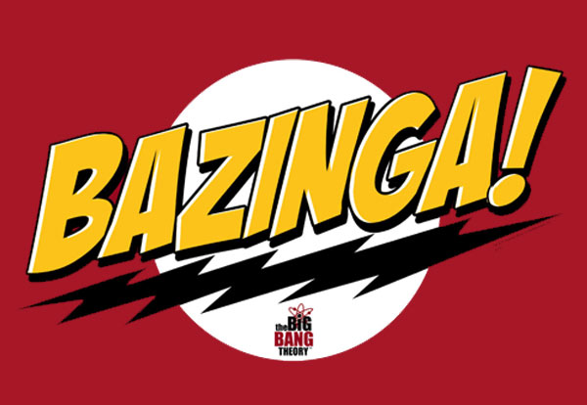

Software Requirements Specification

Version 1.0

February 9, 2012

PAAC Demonstration System

|  |  |  |
| --- | --- | --- |
| List Of Revisions | | |
| Date | Name | Description |
|  |  |  |
|  |  |  |
|  |  |  |
|  |  |  |
|  |  |  |
|  |  |  |

# Table of Contents

List Of Revisions 2

Table of Contents 3

1 Introduction 4

1.1 Product Overview 4

1.2 Purpose 4

1.3 Scope 4

1.4 Reference 4

1.5 Definitions and Abbreviations 4

2 Overall Description 4

2.1 Product Perspective 4

2.2 Product Functions 4

2.3 User Characteristics 4

2.3.1 Dispatcher 4

2.3.2 Transit Schedule Manager 4

2.3.3 Track Manager 4

2.3.4 Viewer 5

2.4 General Constraints 5

2.5 Assumptions and Dependencies 5

3 Specific Requirements 5

3.1 External Interface Requirements 5

3.1.1 User Interfaces 5

3.1.2 Software Interfaces 5

3.1.3 Communications Protocols 7

3.1.4 Memory Constraints 7

3.1.5 Operation 7

3.1.6 Product function 7

3.2 Software System Attributes 9

3.2.1 Reliability 9

3.2.2 Availability 9

3.2.3 Security 9

3.2.4 Maintainability 9

3.2.5 Portability 9

3.2.6 Performance 9

3.3 Database Requirements 9

3.4 Other Requirements 9

4 Additional Materials 9

# Introduction

## Product Overview

The final system will be a software prototype of a Centralized Traffic Control (CTC) Center and Signaling System for a light-rail passenger transit system. The software will be used for a demonstration of a proposed North Shore Extension of the Port Authority of Allegheny County (PAAC).

## Purpose

The purpose of this document is to define a set of requirements that will dictate all of the functions and features required by the system.

## Scope

The scope of this document includes an overall description of the system, a list of specific functions and features the system will have, as well as the framework needed for the design of the CTC user interface.

## Reference

1. IEEE-830 Software Requirements Specification
2. NSC-009 PAAC Bid Package

## Definitions and Abbreviations

**Authority** – how far in distance the train is permitted to travel.

**Block** – a section of a railway line

**Setpoint** – the target distance that an automatic control system aims to reach

**CTC** – Centralized Traffic Control

**GUI** – graphical user interface

# Overall Description

## Product Perspective

The Train Control System for Port Authority Allegheny County (PAAC) North Shore Connector enables the CTC Office to view the data and status of trains and tracks graphically and send control commands to trains and tracks. The context diagram in Figure 1 illustrates the external entities and relationships.

Figure 1 - Product perspective diagram

## Product Functions

This software will act as a prototype for a train system that will be installed for the PAAC North Shore Extension transit system. Its primary function will be to operate the transit in a safe manner so as to transport passengers from one station to another automatically. It will simulate the five main components in a transit system: CTC office (GUI), wayside controller (track controller), track (blocks, switches, signals), train controller, and train (multiple cars).

## User Characteristics

### Dispatcher

This user shall be authorized to suggest to trains their speed limit and authority, or to suggest that they stop, or change their route or destination.

### Transit Schedule Manager

This user shall be authorized to schedule trains, including their departure time and location, route and destination.

### Track Manager

This user shall be authorized to add or remove track, or close track for maintenance.

### Viewer

This user shall be trained to understand the CTC Office GUI.

# Specific Requirements

## External Interface Requirements

### User Interfaces

##### The CTC Office GUI shall issue the following outputs to the track controller

###### Train authority

###### Track speed limit

###### Route information system

###### Track closure signal

### Software Interfaces

#### The system shall have a model of a train that includes the following:

##### Train inputs shall include the following:

###### Track circuit input shall be composed of the following inputs from the train controller:

Acceleration command

Brake command

Emergency brake command

Door open

Door close

Light control:

lights on

lights off

Temperature control:

heat on

heat off

AC on

AC off

Announce station

Announce stop

##### Train outputs to the train controller shall include the following

###### velocity

#### The system shall have a model of the transit system track layout.

##### The track model shall take the following inputs from the track controller:

###### Signal state

Stop

Slow

Proceed

Full Speed ahead

###### Speed limit

###### Acceleration limit

###### Deceleration limit

###### Transponder input

###### Track circuit input

###### Inputs originating from the CTC Office:

Speed

authority

Route information system

##### The track model shall issue the following outputs

###### To the track controller

Track speed limit

CTC-issued speed limit

CTC-issued authority

Block state

Train present

Broken rail

Track circuit failure

Power failure

Railway crossing state

Open

Closed

signal state

Stop

Slow

Proceed

Full Speed ahead

#### The system shall have a train controller.

##### The train controller shall take the following inputs:

###### Inputs from the track:

The train controller shall take as input the track signal from the track.

The train controller shall decode the track signal to determine:

Track speed limit

CTC-issued speed limit

CTC-issued authority

Route information system

Acceleration limit

Deceleration limit

Transponder input

Track circuit input

Train station indicator

Tunnel indicator

###### Inputs from the train:

velocity

###### Other inputs:

The train controller shall take as input a boolean indicating whether it is day or night.

##### The train controller shall issue the following commands to the train.

###### Acceleration command

###### Brake command

###### Emergency brake command

###### Door open

###### Door close

###### Light control:

Lights on

Lights off

###### Temperature control:

heat on

heat off

AC on

AC off

###### Announce station

###### Announce stop

#### The system shall have a track controller.

##### The track controller shall receive the following inputs from the CTC office:

###### Train authority

###### Track speed limits

###### Route information system

###### Track closure signal

##### The track controller shall issue the following outputs to the CTC office:

###### Block state

Train present

Broken rail

Track circuit failure

Power failure

###### Railway crossing state

Open

Closed

###### signal state

Stop

Slow

Proceed

Full Speed ahead

###### train state

Train speed

Train direction

##### The track controller shall be a programmable unit that operates according to Boolean logic provided by the CTC.

###### The program shall be specifiable separately from the implementation of the track controller.

### Communications Protocols

#### Communication shall be passed from module to module as follows:

##### CTC office to track controller

##### Track controller to Track block

##### Track block to train controller

##### Train controller to train

### Memory Constraints

The simulation should not exceed 2GB of memory while running.

### Operation

The system will ultimately need to be operated by the CTC office. The CTC will need to determine the trains overall authority, but once obtained, the train system shall be able to automatically execute its authority.

### Product function

#### The CTC shall perform the following functions:

##### The system shall provide the following functions to the four user types

###### The GUI shall enable the Dispatcher to

Suggest authority to a train.

Suggest a speed limit to a train.

Issue a stop suggestion to a train.

Suggest a destination change to a train.

Suggest a route change to a train.

###### The GUI shall enable the Transit Schedule Manager to schedule a train by:

Setting the departure time of the train

Setting the departure location of the train

Setting the destination of the train

Suggesting the route of the train

###### The GUI shall enable the Track Manager to close track sections for maintenance.

###### The GUI shall enable the Viewer to

Monitor trains.

View the current state of the entire transit system.

View throughput metrics.

#### The train model shall perform the following functions:

##### The model shall obey acceleration limits.

##### The model shall obey velocity limits.

##### Train movement shall account for the terrain of the track.

##### The train shall support the existence of multiple cars.

###### Each train car shall have a defined “zero-passenger” mass.

###### The “zero-passenger” mass of each car shall be the same.

###### Each train car shall support the existence of multiple passengers, up to a defined capacity.

###### The total mass of each car shall consist of the combined masses of the passengers and the “zero-passenger” mass.

The mass of each passenger shall be the same.

Each passenger that boards shall increase the mass of the car by the mass of the passenger.

Each passenger that leaves shall decrease the mass of the car by the mass of the passenger.

###### The mass of the train shall consist of the combined masses of the cars and the engine.

Adding a train car shall increase the mass of the train by the mass of the car.

Removing a train car shall decrease the mass of the train by the mass of the car.

##### The model shall have the following three Failure Modes:

###### Train engine failure

###### Signal pickup failure

###### Brake failure

##### The model shall include a passenger emergency brake.

#### The track model shall perform the following functions:

##### The track shall be divided into blocks.

###### Each block shall have an associated grade.

###### Each block shall have an associated average elevation.

###### Each block shall have an associated speed limit.

###### Each block shall have an associated direction of travel.

A block may have both directions of travel associated with it.

##### The track model shall support branching via “switches”.

###### Each switch shall connect three pieces of track.

###### Each switch shall connect one “trunk” and two “branches”.

##### The track model shall include the following signals designated by the indicated colors:

###### Stop is designated by a red signal

###### Slow is designated by a yellow signal

###### Proceed is designated by a green and yellow signal

###### Full Speed ahead is designated by a green signal

##### The track model shall detect train presence

##### The track model shall have a track layout input method.

##### The track model shall include railway crossings.

##### The track model shall include stations for loading and unloading passengers.

##### The track model shall have the following three Failure Modes:

###### Broken Rail shall be a Failure Mode.

###### Track Circuit failure shall be a Failure Mode.

###### Power failure shall be a Failure Mode.

#### The train controller model shall perform the following functions:

##### The train controller shall regulate the speed of the train.

###### The train controller shall prevent the train from exceeding the track speed limit or the CTC-issued speed limit.

###### The train controller shall command the train to accelerate until it reaches the lower speed limit.

###### The train controller shall prevent the train from exceeding the authority.

The train controller shall calculate the distance the train will travel if it decelerates to a stop.

If this distance equals or exceeds the authority, the train controller shall command the train to stop.

##### The train controller shall open the doors at stations.

##### The train controller shall close the doors when departing a station.

###### The train controller shall close the doors before commanding the train to accelerate.

##### The train controller shall turn on the lights when visibility decreases.

###### The train controller shall turn on the headlights and interior lights when entering a tunnel.

###### The train controller shall turn on the headlights and interior lights when it is night.

##### The train controller shall turn off lights when visibility returns to an acceptable level.

###### The train controller shall turn off the headlights and interior lights when exiting a tunnel.

###### The train controller shall turn off the headlights and interior lights when it is day.

##### The train controller shall display text to announce the current station or stop upon arrival.

##### The train controller shall display text to announce the next station or stop upon departure.

##### The train controller shall monitor the train for faults.

###### If the train controller issues a brake command and detects that the velocity does not decrease (a brake failure), it shall issue an emergency brake command.

###### If the train controller issues an acceleration command and detects that the velocity does not increase (a train engine failure), it shall issue a brake command.

###### If the train controller fails to pick up the track signal (a signal pickup failure), it shall issue a brake command

#### The track controller model shall perform the following functions:

##### The track controller shall control the switching of the track.

##### The track controller shall control the railway crossing.

###### The track controller shall control the railway crossing lights.

###### The track controller shall control the railway crossing cross bar.

##### The track controller shall detect the state of each block, including

###### The presence of trains in a block

###### Broken rails in a block

###### A track circuit failure in a block

###### A power failure in a block

##### The track controller shall be a programmable unit that operates according to Boolean logic provided by the CTC.

###### The program shall be specifiable separately from the implementation of the track controller.

## Software System Attributes

### Reliability

The system shall operate a successful simulation in a fail-safe manner.

### Security

The CTC office GUI shall prompt for user authentication in order to allow access to the transit system. The user shall not be able to view transit system information or send commands to track controllers until the user has been successfully authenticated.

### Portability

The software requires Windows .NET Framework version 4.0.

### Performance

The system shall respond to user input in a timely manner and successfully simulate a realistic transit system.

## Database Requirements

### The CTC shall database the following:

#### User configured items

#### Login information

### The track shall database the following:

#### User configured track layouts

# Additional Materials

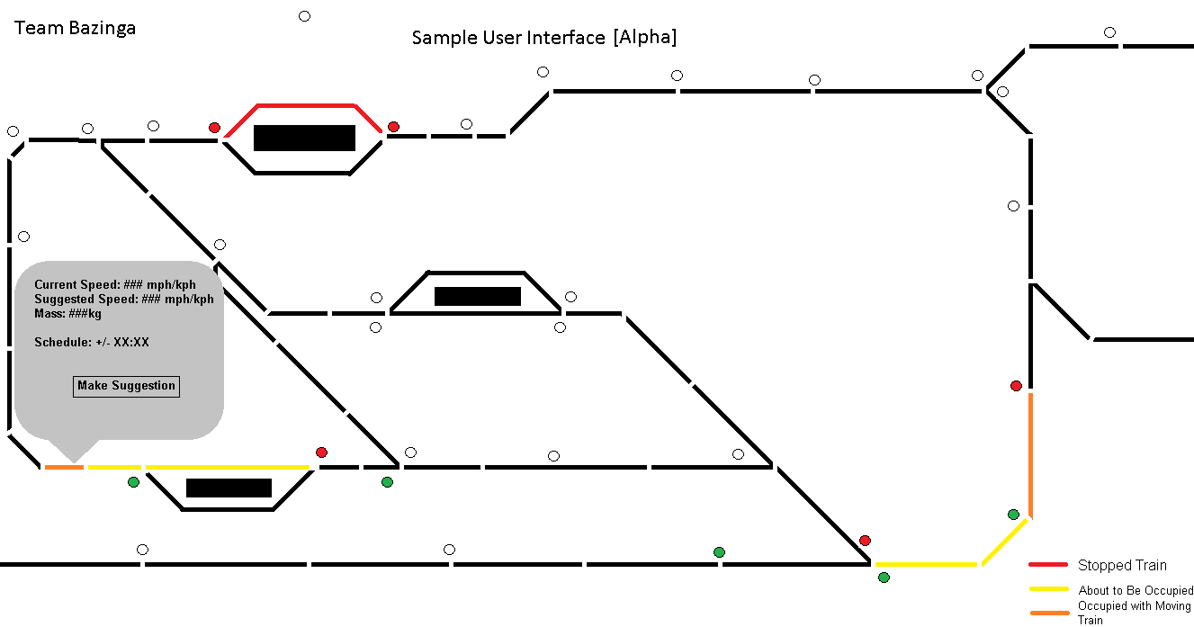

Figure 2 - CTC GUI sample sketch