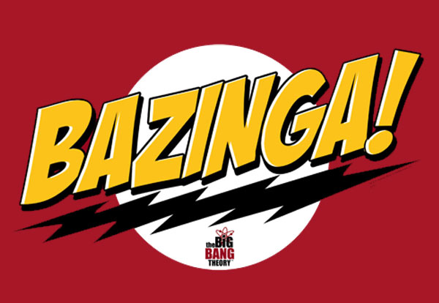

# Risk Assessment for the Track Model Module of the North Shore Transit Extension Train Control System

Ryan Mohan  
2/8/12

V 1.0

There are three categories of risks involved in this project. The level of risk is determined by its consequences; low risks are unlikely to cause any significant problems, while high risks are likely to create issues.

Low Risk

* The track incorrectly reports a broken rail

An incorrectly reported broken rail could cause the Track Controller to improperly reroute trains around the block. This would cause a delay in the scheduling but could be easily reported and fixed via a ground crew.

* Block of track assigned improper authority

The track controller should override this thus continuing safe operation of the train.

Medium Risk

* Any Communication Errors Between Modules

A failure for the Track to communicate with the Train or Track controller would put the train into a fail safe mode. This would be an inconvenience but, failing in a safe manner.

High Risk

* Track model holds incorrect limit’s for a block of track

An error in communication between the Track Controller and Track could set a blocks Authority, Speed Limit, Acceleration and Deceleration Limits to improper bounds. This could cause catastrophic failure if the train exceeds safe operating conditions it could cause derailment and a serious disaster.

* Track model holds incorrect train detection

An error in communication between the Track and Track Controller could incorrectly set an occupied block as unoccupied and vice versa. This could cause a collision between trains if the Track Controller did not properly know of a train’s presence.

* Track reports incorrect gradient and elevation levels to Train Controller

The train controller would be incorrectly calculating the trains velocity, acceleration and deceleration limits. This could cause a catastrophic failure in the Train Control System.

* Track Transponder fails to report station to Train Control.

This could cause the Train Controller to speed through a station unknowingly. This is a large safety risk to those at the station.