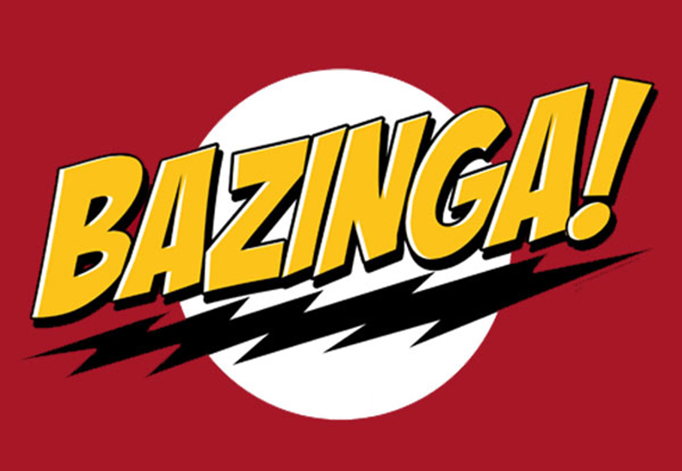

Project Risk Assessment – Train Controller

Version 1.0

February 9, 2012

PAAC Demonstration System

# Overview of Risks

This project presents a challenging task that will require efficiently managed resources, organized tasks and documentation, and good team collaborating skills. The disadvantage in this project is that there is no project manager. There is nobody to manage the team and make sure everyone stays on task and coordinates team decisions. This could present a significant problem as the project progresses and the members start focusing in on the components and lose track of the overall project. For this reason, system integration could be a disaster. We will have to make sure that we are communicating throughout the entire process; good documentation is paramount.

# Risks of the Project

This section introduces the risks during the process of the project development, and it is aiming to minimize any unforeseen and unexpected issues during the entire development period.

## Scheduling

Scheduling could present a potential problem in this project. The more people there are on a team, the more of a nightmare scheduling becomes, especially in integration. It will be difficult to work around 6 persons’ schedules to organize times for team meetings and design reviews. This could impact the results of the project severely.

## Resources

For this project, our team relies on many resources. These 3rd party services pose a potential risk to the project. We have already encountered numerous risks with GitHub, our source control and cloud storage service. I anticipate many problems with Visual Studio 2010 working in a shared team environment. These unexpected problems are bound to crop up, and they need to be accounted for in order to complete the project on time.

## Management

The one element that this project is missing is a manager; a person to oversee the project and always checking in, keeping an eye on the big picture. Without this key part of the team, system integration will be difficult and keeping the team focused and organized already seems to be a challenge. This could cause a serious problem for the project, perhaps we need to consider assigning a member to these duties.

# Risks during Operation

This section introduces the risks during the operation by client. Many unexpected situations occur during operation, and the system shall be designed to avoid fatal consequences.

## Hardware Failure

Hardware failure could present a series of problems in operation. Although the hardware system is designed to be robust enough to resist natural and human damage, it does have a small possibility of failing. In order to avoid the serious consequences of hardware failure, this module will be designed in a fail safe manner.