**

Track Model

Architecture and Design

Version 1.0

Ryan Mohan

March 22, 2012

|  |  |  |
| --- | --- | --- |
| List Of Revisions | | |
| Date | Name | Description |
| 3/22/2012 | Ryan Mohan | Initial design document v 1.0 |

# Table of Contents

List Of Revisions 2

Table of Contents 2

1 Introduction 3

1.1 Product Overview 3

1.2 Purpose 3

1.3 Scope 3

1.4 Reference 3

1.5 Definitions and Abbreviations 3

2 Purpose and Responsibilities 3

3 Architecture 4

4 Design 4

4.1 Region 4

4.2 Track Block 5

4.3 Signal 5

4.4 Track Type 5

4.5 Transponder 5

4.6 Class Diagram 5

4.7 Sequence Diagram 6

# Introduction

## Product Overview

The final system will be the track model used with the Train Control System.

## Purpose

The purpose of this document is to outline the software architecture and design of the track model and its associated classes.

## Scope

The scope of this document is to provide a medium-level description of the software architecture and design of the Track Model.

## Reference

1. IEEE-830 Software Requirements Specification
2. NSC-009 PAAC Bid Package
3. Centralized Traffic Control Graphical User Interface Software Requirements Specification
4. Bazinga System SRS
5. Bazinga-Mohan-Ryan-SubSRS
6. Bazinga-Mohan-Ryan-TP

## Definitions and Abbreviations

**Block** – a section of a railway line

**CTC** – Centralized Traffic Control

**GUI** – graphical user interface

**Region** – the track between two switches

**Signal** – The wayside signal next to each track block

# Purpose and Responsibilities

The purpose of the Track Model is to simulate any proposed track layout and design. Each layout is composed of track blocks, signals, switches, RR crossings, tunnels and stations. The purpose each of these track types is to correctly model their real life counterparts including signals transmitted, stored, and received. The track model will also communicate with the CTC, for a visual representation, and the Track controller. The below use cases show a CTC attendant opening or closing a block, and the use case of editing the track layout prior to runtime: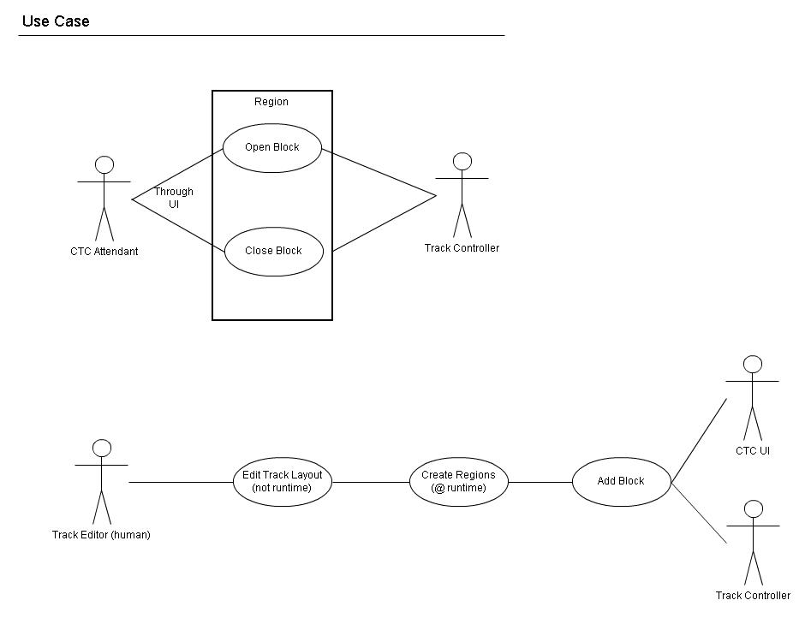

# 

Figure : Track Model Use Cases

# Architecture

The track model architecture is designed of several classes that together define a track block, its type, the associated track signal, transponder that the associated region in which the blocks reside. All appropriate data is contained within its corresponding class and accessible by the Track Controller for editing and the CTC for viewing and updating purposes.

# Design

## Region

The region is the primary listing of the blocks contained within a region. It is used to keep track of its contained blocks, the position of the train, and communicated with the Track Controller, outputting any requested information.

## Track Block

The track block is the primary data holding entity of the Track Model. A track block is contained within a region and holds all information regarding each block. The track block is the primary object within the Track model it may be any of the stated track types within the SubSRS. A track block may contain a transponder if and only if the track block is prior to a station. A track block also holds the track condition, either open, closed, or a failure mode.

## Signal

The Signal class holds the state of each Wayside signal associated with every block within a region. The signal class communicates with the Wayside Controller (Train Controller) to modify its state depending on the decisions made by the Wayside Controller.

## Track Type

The track type is associated with each and every track block. The track type defines what kind of block each piece of track is. Every track block can be either; a track, station, RR crossing, or tunnel.

## Transponder

The transponder is associated with any region that contains one or more station and is defined to be attached to the appropriate block prior to the station. The transponder holds the upcoming station name for announcement within the train.

## Class Diagram

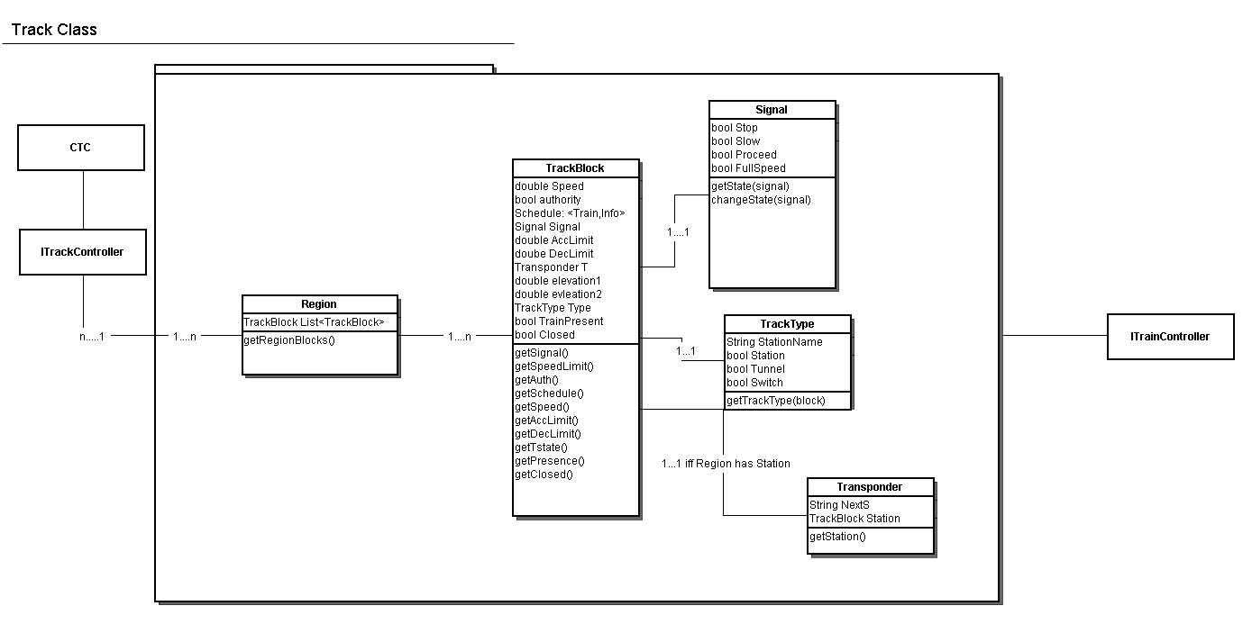

Figure : Track Model Class Diagram

## Sequence Diagram

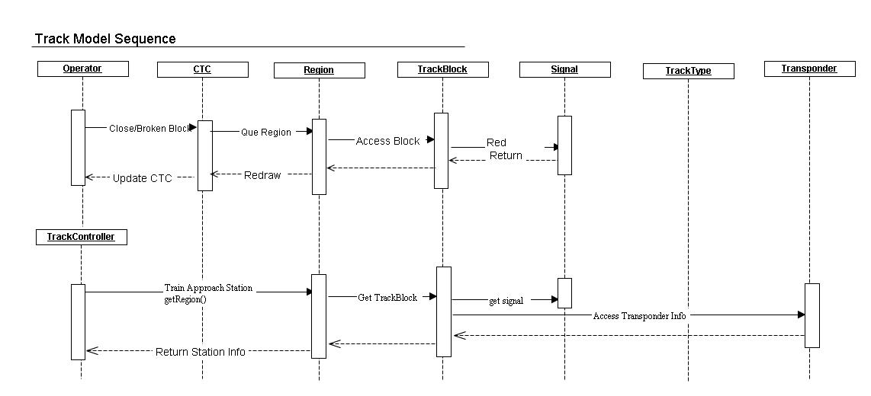

Figure : Track Sequence Diagrams for Closing a track block or transmitting a Transponder signal

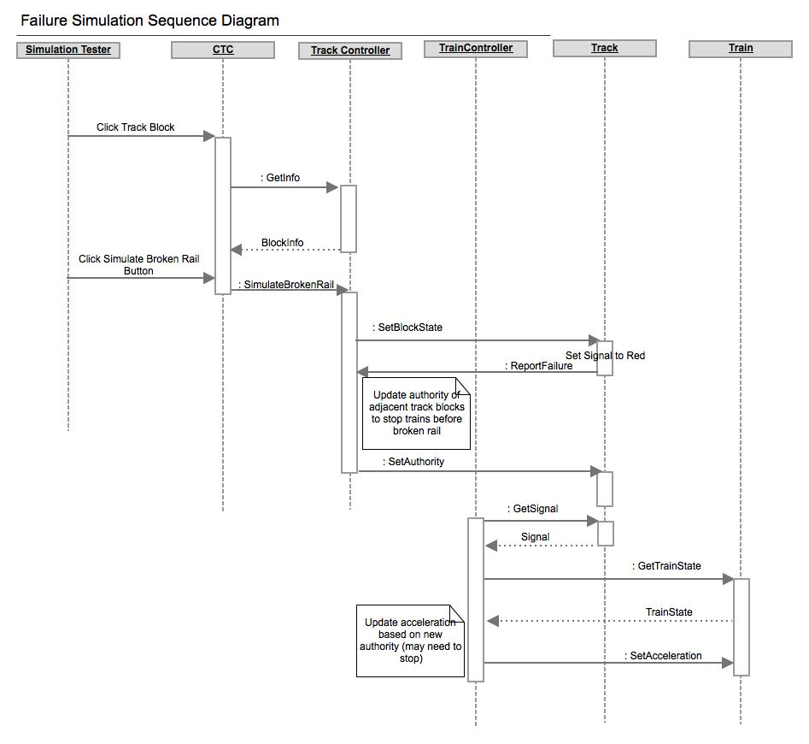

Figure : Simulate Broken Rail Sequence (Created by Jeremy)