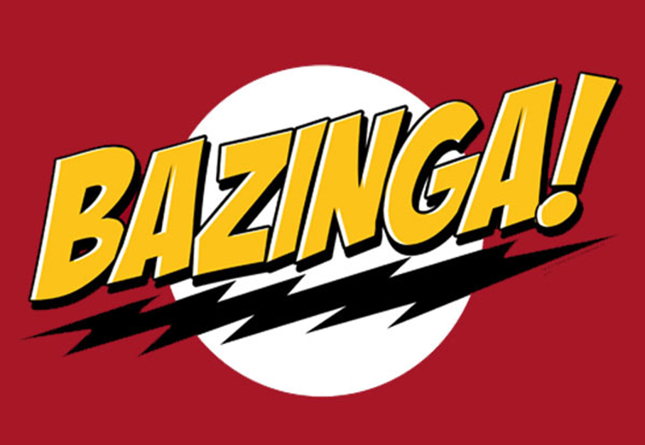

Software Requirements Specification – Track Controller

Version 1.1

march 22, 2012

PAAC Demonstration System

|  |  |  |
| --- | --- | --- |
| List Of Revisions | | |
| Date | Name | Description |
| 2/9/2012 | Sean Cardello | Initial creation of SRS. |
| 2/9/2012 | Zhipeng Liu | First revision |
| 3/22/2012 | Zhipeng Liu | Revision for work package 2 |

# Table of Contents

List Of Revisions 2

Table of Contents 2

1 Introduction 5

1.1 Product Overview 5

1.2 Purpose 5

1.3 Scope 5

1.4 Reference 5

1.5 Definitions and Abbreviations 5

2 Overall Description 5

2.1 Product Perspective 5

2.2 Product Functions 6

2.3 User Characteristics 6

2.3.1 Dispatcher 6

2.3.2 Transit Schedule Manager 6

2.3.3 Track Manager 6

2.3.4 Other Wayside Controllers 6

3 Specific Requirements 6

3.1 External Interface Requirements 6

3.1.1 Software Interfaces 6

3.1.2 Communications Protocols 8

3.1.3 Operation 8

3.1.4 Product function 9

3.2 Software System Attributes 9

3.2.1 Reliability 9

3.2.2 Security 9

3.2.3 Portability 9

3.2.4 Performance 10

r

# Introduction

## Product Overview

This part of the system will be a software prototype of the track controller of a Centralized Traffic Control (CTC) Center and Signaling System for a light-rail passenger transit system. The software will be used for a demonstration of a proposed North Shore Extension of the Port Authority of Allegheny County (PAAC). This module of the system will be responsible for controlling blocks of tracks including switching and communication between CTC office and train controller via the track. The wayside controller is a safety critical component of the system, thus it will need to be designed in a fail safe manner so as to avoid a catastrophic fatal event.

## Purpose

The purpose of this document is to define a set of requirements that will dictate all of the functions and features required by the wayside controller.

## Scope

The scope of this document includes an overall description of the controller, a list of specific functions and features it will have, as well as the list of necessary fail-safe features.

## Reference

* + 1. IEEE-830 Software Requirements Specification
    2. NSC-009 PAAC Bid Package
    3. PAAC Demonstration System Software Requirements Specification

## Definitions and Abbreviations

**Authority** – how far in distance the train is permitted to travel.

**Block** – a section of a railway line

**Setpoint** – the target distance that an automatic control system aims to reach

**CTC** – Centralized Traffic Control

**GUI** – graphical user interface

**Region** **–** All the tracks between two switches

# Overall Description

## Product Perspective

The Train Control System for Port Authority Allegheny County (PAAC) North Shore Connector enables the CTC Office to view the data and status of trains and tracks graphically and send control commands to trains and tracks. The CTC executes commands to the trains via the wayside controllers. The wayside controllers then “encode” this data into their corresponding track block which gets relayed to the train when it enters that particular block.

## Product Functions

This modules primary function will be to issue the CTC’s commands to the train is a safe manner. The wayside controller will evaluate instructions given by the CTC for safeness and correctness. It will then decide what the safest action is and send it to the train controller via the track block. The track controller’s other major functions include operating the signal lights pertaining to the track block, safely and effectively switching blocks to permit transit routes, and communicating with other wayside controllers to relay safety critical information.

## User Characteristics

The users of this module are the same users of the CTC Office since most of the CTC Office’s communications passed through the wayside controllers.

### Dispatcher

This user shall be authorized to suggest to trains their speed limit and authority, or to suggest that they stop, or change their route or destination. This is initiated through the CTC Office GUI but will ultimately be authorized by the wayside controller.

### Transit Schedule Manager

This user shall be authorized to schedule trains, including their departure time and location, route and destination. This information will be transmitted through the track controller module.

### Track Manager

This user shall be authorized to add or remove track, or close track for maintenance. All track changes and decisions will need to go through the wayside controllers, as they will need to know which track to controller.

This user shall also be authorized to assign track blocks to track regions.

### Other Wayside Controllers

Each wayside controller will need to communicate with the controllers directly adjacent to it. In other words, each controller needs to know if a train is approaching their blocks safely and/or it is leaving safely.

# Specific Requirements

## External Interface Requirements

### Software Interfaces

#### Inputs from CTC office:

##### Train authority

##### Route information

##### Track closure signal

#### Outputs to CTC office:

##### Block state

###### Train present

###### Broken rail

###### Track circuit failure

###### Power failure

##### Railway crossing state

###### Open

###### Closed

##### signal state

###### Stop

###### Slow

###### Proceed

###### Full Speed ahead

##### train authority

###### Train speed

###### Train direction

#### Inputs from track model:

##### Block Properties

###### Line

###### Section

###### Block Number

###### Block Length

###### Block Grade

###### Speed Limit

###### Infrastructure

###### Elevation

###### Cumulative Elevation

#### Inputs from track:

##### Block state

###### Train present

###### Broken rail

###### Track circuit failure

###### Power failure

##### Switch state

###### Switch position

###### Switch failure

#### Outputs to track:

##### Train authority

##### Track speed limits

##### Track closed for maintenance

##### Track switch states

##### Signal light states

#### Outputs to other wayside controllers:

##### Train authority

#### The track controller shall be a programmable unit that operates according to Boolean logic provided by the CTC.

##### The program shall be specifiable separately from the implementation of the track controller.

### Communications Protocols

#### Communication shall be passed from module to module as follows:

##### CTC Office to Track controller

##### Track controller to Track block

##### Track block to Train controller

### Operation

The system will ultimately need to be operated by the CTC office. The CTC will need to determine the trains overall authority, but once obtained, the train system shall be able to automatically execute its authority. Thus, given a route schedule, the transit system should be fully automatic.

### Product function

#### The track controller shall control the switching of the track in a safety critical manner

#### The track controller shall control the railway crossing

##### The track controller shall control the railway crossing lights

##### The track controller shall control the railway crossing cross bar

#### The track controller shall detect the state of each block, including:

##### The presence of trains in a block

##### Broken rails in a block

##### A track circuit failure in a block

##### A power failure in a block

#### The track controller shall be a programmable unit that operates according to Boolean logic provided by the CTC.

##### The program shall be specifiable separately from the implementation of the track controller.

## Software System Attributes

### Reliability

The system shall operate a successful simulation in a fail-safe manner. The wayside controller in a safety critical component that directly affects the transit system and the lives of people you ride it. Therefore, this component should be 100% reliable and should account for all possible failures.

### Security

The wayside controller shall operate in a secure manner. It is essential that the controller not be accessed or operated by any other component other than the CTC. Since this is a simulation and there is no actual physical entity, then physical tampering with the module is not a threat. However, the module will be built so as to “hide and abstract” crucial mechanisms within the software library.

### Portability

The software requires the target machines Windows .NET Framework version 4.0 and Windows 7 and with at least 4MB free disk space and 2GB memory.

### Performance

The system shall respond to user input in a timely manner and successfully simulate a realistic transit system. The wayside controller needs to make accurate decisions in a timely manner in order to operate safely and properly. It is safety critical the even under the most stressful conditions, the system and components operate in a fail-safe manner.