This is a test

This is a test, line 2

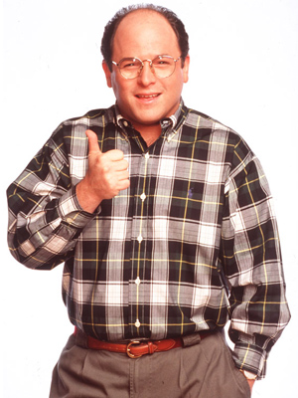

This is line below a picture, and I enabled track changes.