Blood Donation Management System

# Design Document

## Overview

*The System Design Document describes the system requirements, operating environment, system architecture, database design.*

# Introduction

## Purpose and Scope

There are lot patients increasing and they require external blood for medical treatment. It is more difficult to search for a blood donator manually in the critical situation. At the same time there are increasing in blood donors nowadays. Patients searching for blood donors in emergency period and they coming up with one or two blood donors. Sometimes there are lots of blood donors near the location but it is difficult to find them.

For this problem, this system is specially designed to create a bridge between blood donors and patients in a single gateway.

## System Overview

Online blood management system is used to donate blood for the patient or search blood donors near the patient location. System have Geographical map in the UI allows blood donors to choose the location and save users blood group and communication details. On the other hand patients can search for the blood donors near users location. Search results are shown in the map by pins. Patients can click on the pin to get details of the blood donor.

System uses MEAN stack for the application. MEAN is mongodb-express-Angular-Node.JS.

## Future Contingencies

In future system can have chat system for live communication between blood donors and patients. System can have more medical details about the blood related health issues. System can have medical clarification section. Currently there is no proper ways of management system for blood donors, this can be changed to have authentication feature in the system for the blood donors to manage their account.

# System Architecture

## Software Architecture

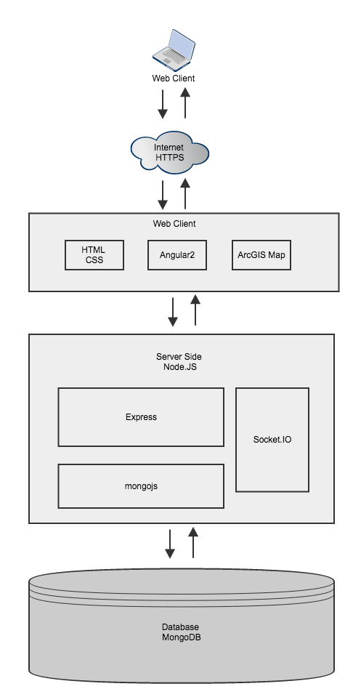

## Internal Communications Architecture

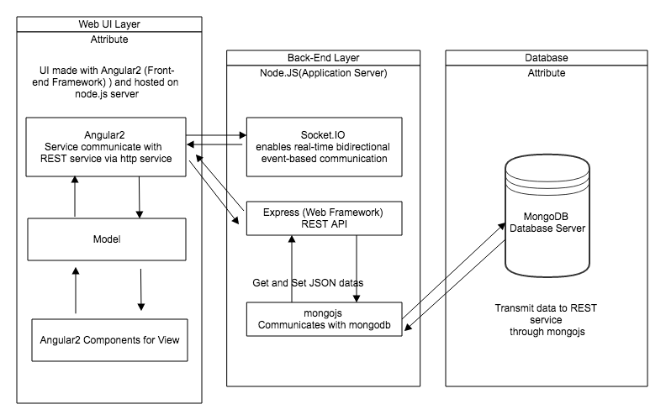

## Database Design

