Order Details
Order ID | 4198 | Date and time submitted: | 2018-03-29 14:07:13
Name | Sumit Phlananthachai | Email | singh@webcoursesbangkok.com
Have you shopped with us before? | No | Would you like to use your existing measurements on file for this order? | New Measurements
Phone |  | Company
Postcode | 10110 | Country | Thailand
City | Bangkok | State | Bangkok (กรุงเทพมหานคร)
Address | 160/1 Sukhumvit Road Between Sukhumvit Soi 6 & 8

Products
Name | Suits | Quantity | 1
Materials | Rg211132 | Fabrics suit | Rta3
Breast pocket | Single breasted | Buttons double breast pocket | None
Buttons single breast pocket | Two buttons | Vents | Single vent
Lapel | Peak lapel | Lapel size | Slim lapel
Sleeves | Surgeon cuffs | Pick stitching | No pick stitching
Name inside jacket | Dont add a name | Buttons | Blue horn button
Pleats | 2 pleat | Cuffs | No cuffs
Lining | No lining | Comments
Name to add inside product
Price

Name | Sports Jackets | Quantity | 1
Materials sports jackets | Rg2324 5 | Fabrics sports jacket | Rta7
Breast pocket | Single breasted | Buttons double breast pocket | None
Buttons single breast pocket | Two buttons | Vents | Single vent
Lapel | Notch lapel | Lapel size | Slim lapel
Sleeves | Surgeon cuffs | Pick stitching | Pick stitching
Name inside jacket | Dont add a name | Buttons | Blue horn button
Comments |  | Name to add inside product
Price

Name | Trousers | Quantity | 1
Materials | Rg1100010 | Pleats | 2 pleat
Cuffs | Cuffs | Lining | Half lined
Comments
Price

Name | Shirts | Quantity | 1
Materials shirt | Rg 20 | Collar | Semi spread collar
Collar stay | Built in collar stay | Pocket | Pocket shirt
Placket | Placket | Back pleat | Side back pleat
Cuffs_shirt | 2 button vertical cuff | Initials shirt | None
Initials type | None | Comments
Name to add inside product
Price

Name | Leather Belts | Quantity | 1
Belts | Solid | Comments | 34 inches
Price

Name | Tuxedo | Quantity | 1
Materials | Rg110002 | Fabrics tuxedo | Rta3
Breast pocket tuxedo | Single breasted | Buttons double bp tuxedo | None
Buttons single bp tuxedo | One button | Vents | Single vent
Lapel tuxedo | Peak lapel | Lapel size tuxedo | Slim lapel
Lapel satin | No satin on lapel | Sleeves | Surgeon cuffs
Name inside jacket | Dont add a name | Buttons tuxedo | Satin
Pleats | 2 pleat | Cuffs | Cuffs
Side satin | Satin down the side | Lining | Half lined
Comments |  | Name to add inside product
Price

Fabrics and Linings
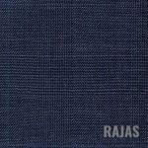
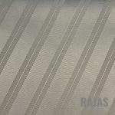

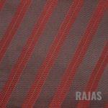

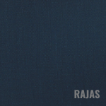
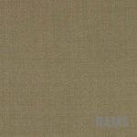

Measurement Form

Shirt

Neck | 34 | Chest | 34
Stomach | 34
Hips | 34 | Sleeves | 34
Length | 34 | Shoulders | 34
Bicep | 34

Jacket

Chest | 34 | Stomach | 34
Hips | 34 | Length | 34
Front | 34 | Back | 34
Sleeves | 34 | Shoulders | 34

Trousers

Waist | 34 | Hips | 34
Length | 34 | Inseam | 34
Cuff | 34 | Crotch | 34

Miscellaneous

Fit | Regular | Height | 34 | Weight | 34 | Age | 34
Posture | Forwards Stomach | Shoulders | Normal Shoulders Normal Neck

Price
Product Price Total |  | Mailing Price
Total
*Price does not include duties, if any, on the package.
Once payment is received, you can expect your package to arrive within 20 days from the date of payment. Once the package has been shipped, a tracking number will be emailed to you.
Payment for paypal is here: https://www.paypal.me/dressmesharp

