Order Details
Order ID | 4210 | Date and time submitted: | 2018-04-22 22:34:25
Name | Mark Ritzmann | Email | mark@ritzmann-garage.ch
Have you shopped with us before? | Yes | Would you like to use your existing measurements on file for this order? | Yes
Phone | 0794306077 | Company
Postcode | 8634 | Country | Switzerland
City | Hombrechtikon | State | Z&uuml;rich
Address | Gewerbestrasse 2

Products
Name | Suits | Quantity | 1
Materials | Rg898053 | Fabrics suit | Rtg4
Breast pocket | Single breasted | Buttons double breast pocket | None
Buttons single breast pocket | Two buttons | Vents | Double vent
Lapel | Notch lapel | Lapel size | Slim lapel
Sleeves | Surgeon cuffs | Pick stitching | Pick stitching
Name inside jacket | Name inside jacket | Buttons | Silver mop button
Pleats | No pleat | Cuffs | No cuffs
Lining | No lining | Comments
Name to add inside product
Price

Name | Sports Jackets | Quantity | 1
Materials sports jackets | Rg2329 2 | Fabrics sports jacket | Rtg4
Breast pocket | Single breasted | Buttons double breast pocket | None
Buttons single breast pocket | Two buttons | Vents | Double vent
Lapel | Notch lapel | Lapel size | Slim lapel
Sleeves | Surgeon cuffs | Pick stitching | Pick stitching
Name inside jacket | Name inside jacket | Buttons | Silver mop button
Comments |  | Name to add inside product
Price

Fabrics and Linings
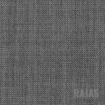
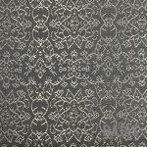
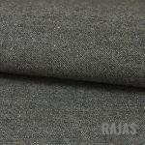

Price
Product Price Total |  | Mailing Price
Total
*Price does not include duties, if any, on the package.
Once payment is received, you can expect your package to arrive within 20 days from the date of payment. Once the package has been shipped, a tracking number will be emailed to you.
Payment for paypal is here: https://www.paypal.me/dressmesharp

