Apache Web Server Configuration – Part II

# II. Accessing Your Flash Drives on a Virtual Machine

* Due to some limitations, Oracle’s VirtualBox doesn’t natively support usb mounting. Flash drives inserted into your computer won’t be recognized by the VM.
* It is not entirely impossible however to access your flash drive from the VM. To do this, follow these steps.
  1. Insert your flash drive into your computer while the Virtual Machine is turned on.
  2. 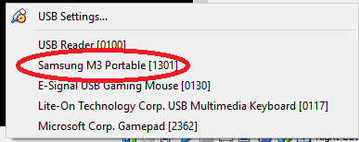On the lower right corner of the VM window is a tray of icons. Right Click the one that looks like a usb port and click on the name of your flash drive (Refer to the image below).
  3. On the VM, find the now captured flash drive by typing in the command

sudo fdisk -l

* 1. 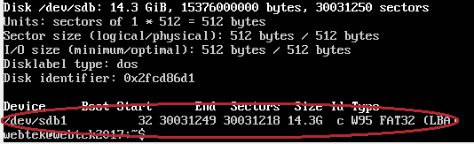At the bottom of the results, look for the drive that closely resembles the size of your drive. Take note of the Device name that matches it.

sudo mount /dev/sdb1 /media/usb1

* 1. In the *“/media/”* directory are folders that will contain the files of the flash drive you mounted. To mount the fash drive, type in the command
  2. If successfull, you will see the contents of the flash drive in the *“/media/usb1/”* directory