Apache Web Server Configuration – Part II

# Virtual Hosting

* Virtual Hosting is used whenever there is a need to host multiple websites on a single web server.
* In practice, only one server is dedicated to a website. However, due to the increasing amount of power a server can handle, it seems impractical to host only a single website.
* Apache web server supports Virtual Hosting through the use of Domain Names. Each virtual host is assigned a unique domain name (i.e [www.group5.org](http://www.group5.org)) that is matched to the server’s IP address (This means that each virtual host in the server share the same IP address).
* Apache Web Server also supports enabling/disabling virtual hosts without deleting said host.
* Setting up a virtual host in Apache is done through these steps
  1. On the server, set your working diresctory to *’/var/www/’* by using the command

cd /var/www/

* 1. Create a folder (It’s recommeded to name the folder in such a way that it best describes the website (i.e domainname.com)).

sudo mkdir domainname.com

* 1. Change the ownership of the folder you created to the Group (thingy) by using the command

sudo chown –R $GROUP:$GROUP domainname.com

* 1. Change the permission to the folder you created by using the command

sudo chmod –R 755 domainname.com

* 1. Using the *‘cd’* command, get in the folder you just created. This is where you will place your website (.html, .css, images, etc...). You can remotely create your website here by using your favorite text editors, but to add your website remotely using a flash drive, please refer to the instructions regarding “Accessing Your Flash Drives on a Virtual Machine”.
  2. Set your working directory to the Apache’s site configuration direcotry by using the command

cd /etc/apache2/sites-available

* 1. Copy the default configuration file *“000-default.conf”* to the same directory

sudo cp 000-default.conf www.domainname.com.conf

* 1. 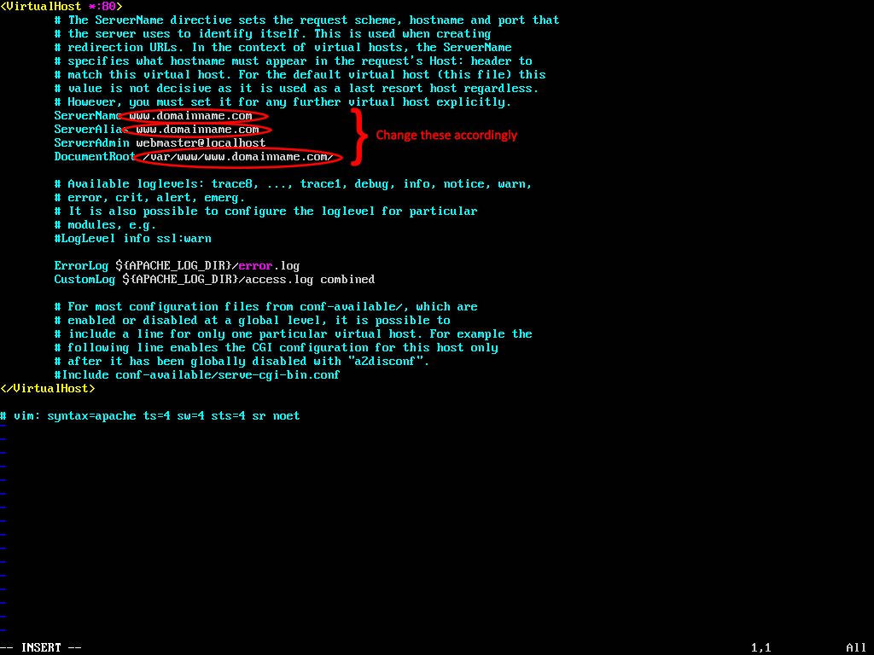Using your favorite text editor, edit the file you just copied. This will be the configuration file for your website. Refer to the image below

Sudo a2ensite www.domainname.com.conf

* 1. Enable the virtual host by using the command

sudo service apache2 restart

* 1. You will be prompted to restart the Web Server. To do this, use the command

Additional References

* <https://www.youtube.com/watch?v=Vd2aLTZDLQg>
* <https://httpd.apache.org/docs/2.4/vhosts/examples.html>
* <https://httpd.apache.org/docs/2.4/vhosts/>